Contents
Introduction 3
Geography 3
Base conditions 5
Base Year (2010) Population Validation 5
Base Year (2010) Employment Validation 7
Forecasting urban activity 8
Appendices 11
Appendix A: 2040 modeled regional conditions 12
Appendix B: Brownfield strategy modeling example 13
Appendix C: Urban activity reallocation function example 17
Appendix D: Summary of population and employment forecasts 18
Appendix E: Forecast validation checks 19
E1. Local employment validation 19
E2. Population density saturation 22
E3. Households compared to parcel counts 27
E4. Land capacity validation 30
Appendix F: Travel demand model summaries 40
F1. Trip generation 41
F2. Network supply 42
F3. Transit level of service 43
F4. Trip tables 44
F5. Highway level of service 45

Figures
Figure 1: CMAP Modeling Geography 4
Figure 2: 2010 Population Estimates 6
Figure 3: 2010 Employment Estimates 8
Figure 4: Summary of population and employment forecasts 18
Figure 5: 2010 assessment of local retail 20
Figure 6: 2040 preferred scenario assessment of local retail 21
Figure 7: Preferred scenario strategy effects on a disinvested community in the urban core 23
Figure 8: Preferred scenario strategy effects on a stable community in the urban core 24
Figure 9: Preferred Scenario Strategy effects on a dense suburban community with high transit accessibility 25
Figure 10: Preferred scenario strategy effects on a low density suburban community with little transit accessibility 26
Figure 11: 2010 households minus current count of residential parcels. 27
Figure 12: Oswego, Northeast Kendall/Northwest Will County 28
Figure 13: Wheatland Township, Will County 28
Figure 14: 2040 household values constrained to match or exceed 2010 parcel counts. 29
Figure 15: Trip Generation Summary 41
Figure 16: Network Supply 42
Figure 17: Transit Level of Service 43
Figure 18: Trip tables 44
Figure 19: Highway Level of Service 45

Introduction
This document is a primer on the methods used to develop datasets representing population and employment for long range plan strategy analyses and preferred scenario modeling. This document was prepared using Microsoft Office 2007 and permits direct user interaction with several of the data tables. If you are viewing this document using an earlier version of Microsoft Office or in another application such as Adobe Reader, you may not have the functionality to properly view the tables. Please contact CMAP to arrange for transmittal of the data tables in a suitable format.

Geography
The CMAP region covers seven northeastern Illinois counties; which is about 4,000 square miles. Our modeling system includes a much larger area (about 11,000 square miles) to encompass, to the extent practicable, the daily domestic economy of the region. This area includes:
- 7 full counties that comprise the CMAP planning region (Cook, DuPage, Kendall, Lake, Kane, McHenry, Will).
- 5 full Illinois counties adjacent the CMAP planning region (DeKalb, Grundy, Kankakee, Boone and Winnebago).
- 3 additional partial Illinois counties (Lee, Ogle, LaSalle).
- 3 full Wisconsin counties (Kenosha, Racine, Walworth).
- 3 full Indiana counties (Lake, Porter, LaPorte).

Figure 1: CMAP Modeling Geography
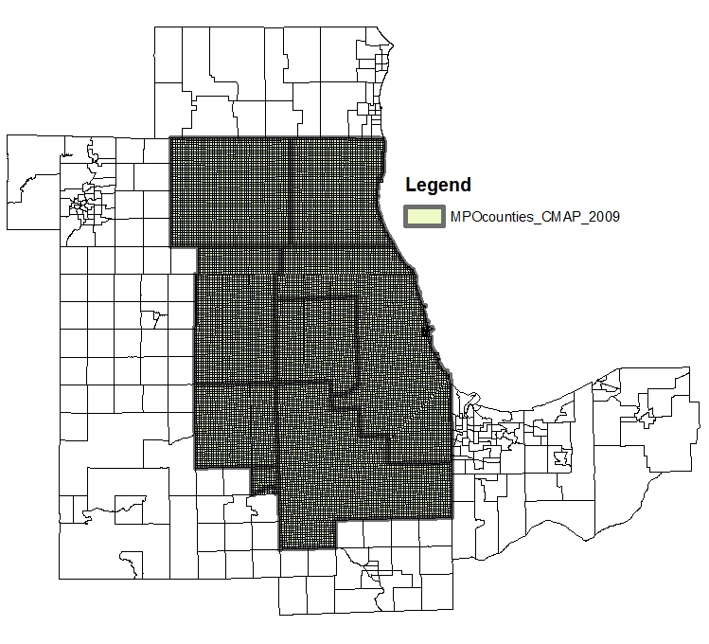
Geographic analyses of population and employment are based on statistical modeling units called subzones. The subzones covering downtown Chicago are comprised of a regular 1/16 square mile grid (approximately 4 square blocks). These and the remaining seven counties of the CMAP planning region follow a ¼ square mile grid based on Public Land Survey quarter-sections established by the General Land Office in the 1800’s. The remaining external counties are represented at higher aggregations of survey geography. In the current modeling system (subzone09), there are 16,819 subzones.

Base conditions
The base year for the long range plan projections is 2010. The current planning horizon is 2040. To begin the forecasting process, base year population and employment estimates by subzone were validated against observed data sources.

Base Year (2010) Population Validation
Characteristics of the population originate with the decennial Census. The most recent complete population enumeration is for the year 2000. 2010 Census results at the subzone level will not be available until 2011. Therefore, 2010 population estimates were prepared and validated from a variety of independent and current references. The 2010 base year population estimates are, most significantly, the product of correcting the 2010 subzone forecasts prepared previously with more recent Census estimates. Corrections are made primarily to adjust the forecast rate of growth that has become more apparent as the years proceed.
The US Census Bureau has produced annual estimates of population by Minor Civil Division (MCD) through 2008. Outside the city of Chicago, MCDs are roughly township-sized areas (commonly about 144 subzones) and are suitable for detecting and validating shifts from the originally estimated 2010 population. The Census, however, reports the entire city of Chicago as a single MCD, which is too large to provide meaningful indicators of variation at the subzone level. To capture variation in population change within the city, the census MCD estimate for Chicago has been apportioned to designated Community Areas (CA) based on housing activity reported by various government and real estate sources.
Census estimated population change between 2000 and 2007 by MCD/CA was then annualized. Three years of additional change was added to the 2007 estimate to produce a new 2010 estimate. There is also a parameter applied to the observed population values for community areas in Chicago. This is done to account for an observed sine wave of population levels in Chicago from 2000 to 2007 (i.e. a decline, then an increase). This parameter amplifies change in community areas experiencing higher rates of growth or decline. (Modeling note: this technique will be useful in any mature community in which rates of population change occur in response to economic cycles rather than vacant land conversion).
For use in statistical modeling, updated MCD/CA estimates of population were generalized to the household level and then apportioned to subzones based on the original allocations developed for households in the previous long range plan. Household components (adults, workers, children, income) were estimated using a base year population synthesis technique that iteratively applies household components to match observed Census distributions at the PUMA (Public Use Microdata Area).
To estimate this change in demographic composition, a synthetic population is generated using baseline census data for the region and updated with a set of regional accessibility indicators. For each future scenario, the impacts of the assumed demographic changes in terms of regional accessibility are evaluated against the accessibility indicators and new marginal control totals are generated from which the future population is drawn. The figure below reveals the effect of this correction. From the period 2003 to 2010, population growth in a ring of communities at the edge of the region (and some Chicago neighborhoods) was greater than originally expected with other Chicago neighborhoods and some southern suburbs growing more slowly than originally anticipated.
Figure 2: 2010 Population Estimates
Original 2010 Estimate  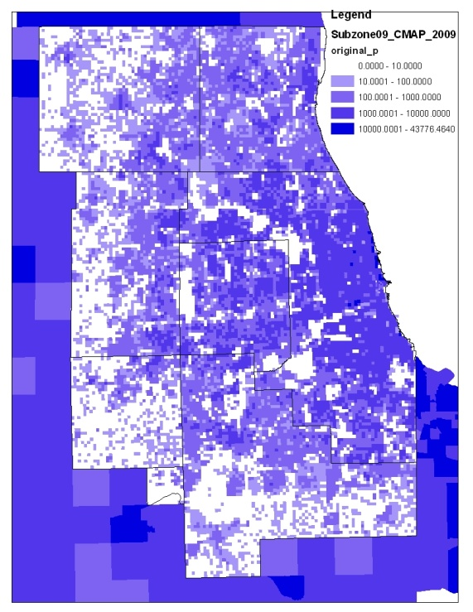 | New 2010 Estimate  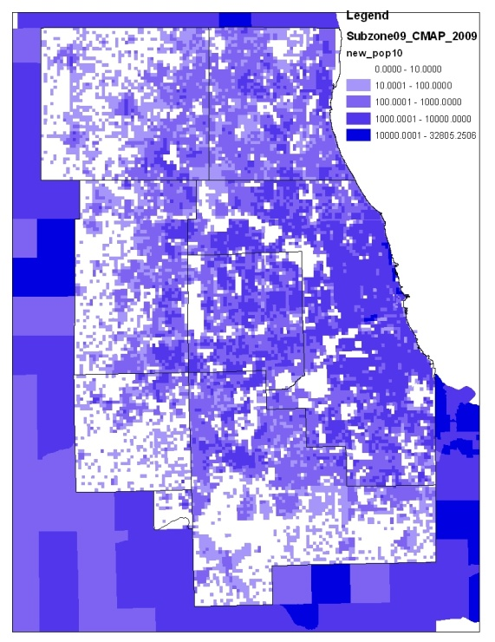 | New 2010 minus Original 2010 Estimate  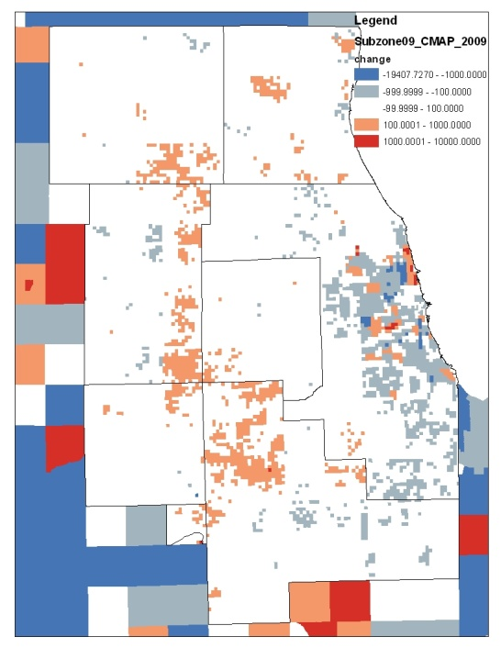

Base Year (2010) Employment Validation
The Illinois Department of Employment Security prepares reports of employee counts by employer address. These addresses are matched to geographic coordinates and summed by modeling subzone. A good deal of manual data cleaning is necessary, primarily to separate corporate from on-site employment rosters and to include employment sectors that do not participate in the State’s unemployment insurance program.
A comparison was made between the current 2007 employment estimates and the 2010 socioeconomic file produced for the previous long range plan. While county-wide totals were reasonably close, there was wide variation in sub-county (MCD/CA) allocations. Because the original employment variables were the product of an interpolation exercise, and because automatic address-matching was not available to locate them in 2003, the more recent data was used directly, rather than as a correction to original subzone estimates. Based on regional economic forecasts prepared by the University of Illinois, total employment levels were elevated at an observed level of 0.6% annually to arrive at the 2010 estimate.
In a significant departure from past practice, only wage and salary jobs with verifiable geographic addresses are included in the job estimates. These are adjusted to match totals published by the Bureau of Labor Statistics at the county level. While these represent the vast majority of jobs in the region, there are small sectors such as the self-employed that are not included. The reason for this departure is that the resulting wage and salary totals more closely match the number of workers in households estimated by the Census and more readily represent the work end of daily commuting on the region’s transportation system. We recognize that specific employment definitions will cause total employment values to vary significantly. This definition suits the constraints imposed by regional transportation and land use modeling, but may not be suitable for economic analyses that focus on commerce, industry, and labor force questions.

Figure 3: 2010 Employment Estimates
Original 2010 Estimate  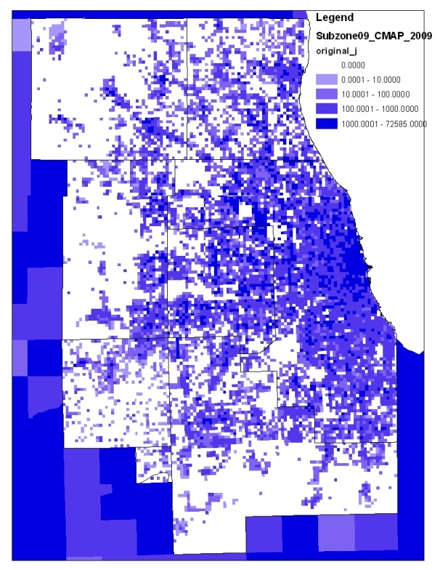 | New 2010 Estimate  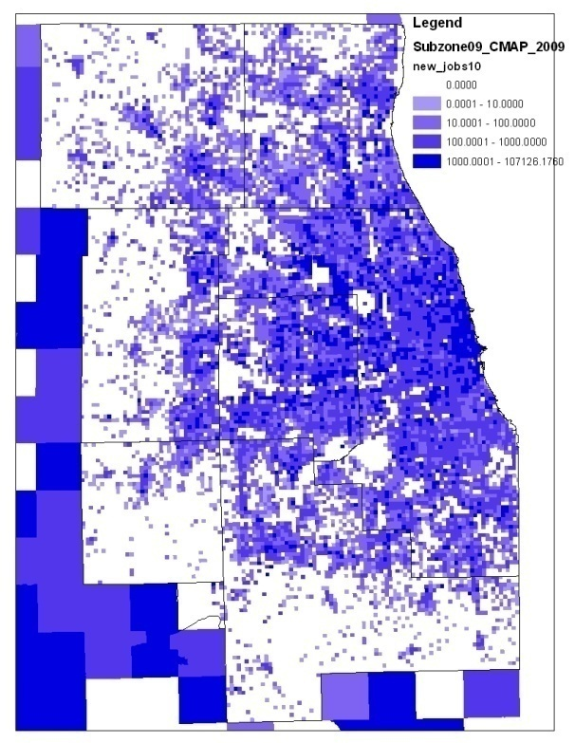 | New 2010 minus Original 2010 Estimate  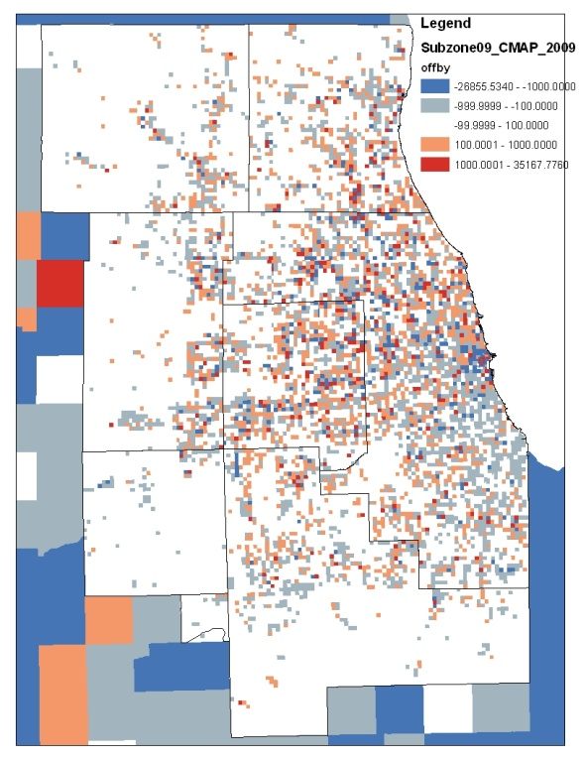

Forecasting urban activity
Population and employment forecasts are derived from statistical modeling procedures that estimate patterns of urban activity resulting from change in future land value or transportation accessibility. Change in land value or transportation accessibility, in turn, results from planning and policy interventions that define a particular scenario. Note, therefore, that all forecasts are estimated by systematically applying long range planning strategies under consideration. In fact, any set of forecasts is “scenario specific” and cannot be determined in the absence of clearly stated regional policies and their presumed effect on regional development patterns.
With regard to planning strategies that define a scenario, we are subscribing to the urban economic principle that socioeconomic activity will arrange itself spatially in response to changes in economic demand for urban commodities (primarily working and shopping opportunities), transportation accessibility and regulatory constraint. Therefore, a subzone’s population or employment level changes in response to variation in geographic attributes associated with these variables:
- Land value (reflecting land development potential).
- Accessibility (reflecting transportation connectivity to regional markets).
- Regulatory constraint (reflecting government intervention in market development).
Most land use and transportation strategies are expected to have compound equilibrating effects on themselves and others (i.e. for every action there is a reaction) as well as geographic ripple effects on locations for which there is a measurable spatial interaction. In CMAP’s regional modeling, capturing these effects is accomplished through the use of a composite variable called the “access product.” This value is calculated as the product of a subzone’s normalized mean land value and the generalized cost of traveling to all other locations in the region. Applied consistently, the result is a measure of transportation accessibility weighted by a consistent value representing a specific subzone’s attractiveness to subsequent urban development.
Urban activity is represented by two major classes of land use: residential and nonresidential. The proportion of residential to nonresidential activity within a single subzone is quantified using population and employment variables. As such, a single measure of urban activity: the sum of households and jobs in a subzone, is the primary forecasting variable.
To begin the forecasting exercise, a linear extrapolation was made from 2010 to 2040 through the forecasts adopted in 2006 as part of the 2030 Regional Transportation Plan update. These provide the starting point for a sequence of contextual evaluations that either dampen or enhance a subzone’s potential for future growth in urban activity.
A four-step procedure for incorporating the effects of selected regional planning policy was applied to render a scenario forecast.
- Step 1: Initial extrapolated values were applied to a baseline (i.e. no-build) transportation network to establish 2040 transportation system performance measures (e.g. highway congestion, transit level of service). This modeled application of the “access product” is used to equilibrate existing development projections with a nominal capacity for additional growth defined by existing transportation accessibility. The premise is that continued growth in highly congested areas with no transit accessibility will be dampened. The result of this step is called the “reference scenario”. A tabular summary of the transportation conditions resulting from this step is found in Appendix A: 2040 modeled regional conditions.
- Step 2: Land use and transportation strategy effects are specified mathematically as sensitivity equations that cause a subzone’s access product to change. Examples include redeveloping brownfields, improving transit frequencies or protecting open space. These strategies, combined to define a scenario, are expected to change a subzone’s prevailing land value or travel accessibility and thus attract or impede increased development. In the current application, the sensitivities themselves are assumptions based on relevant planning strategy research. An example of how land value and transportation sensitivities were operationalized in scenario development is shown in Appendix B: Brownfield strategy modeling example.
- Step 3: The updated “land value index” for each subzone is, in turn, combined with its generalized travel accessibility to the rest of the region. This places the subzone in its regional context and “transfers” the scenario’s compound strategy effects to other accessible locations. The result is a probability that subzones with strong transportation interactions will share the benefits of particular location specific strategies. The general form of this transfer is shown in Appendix C: Urban activity reallocation function example.
- Step 4: Forecast urban activity is then decomposed into constituent residential and non-residential components (i.e. households and jobs). The results of forecasting urban activity in this way are summaries in Appendix D: Summary of population and employment forecasts.
CMAP continuously refines and validates these long range planning assumptions.
Examples of additional test are shown in Appendix E: Forecast validation checks.
The first validation test of the 2040 forecasts is in demonstrating that the long range plan and transportation improvement program conform to the State Implementation Plan for air quality conformity. Summary tables of this analysis are shown in E4. Land Capacity Validation.

Appendices

Appendix A: 2040 modeled regional conditions
Below is a table summarizing the effect of changes in access product to typical transportation indicators. The 2040 reference indicators are the result of no-action. The 2040 preferred indicators are the result of GO TO 2040 preferred scenario land use and transportation strategies.
 | 2010 | 2040 reference | 2040 preferred
 | Daily Person Trips
 | 22.2M | 29.0M | 29.0M
 | Transit Share
 | 9.1% | 8.6% | 12.0%
 | Average Work Trip Duration (minutes)
Auto | 32 | 32 | 30
Transit | 53 | 55 | 47
 | Highway Network Congestion
 | 15% | 20% | 18%

Appendix B: Brownfield strategy modeling example
Below is an example of the process by which selected planning strategies were independently evaluated prior to being assembled into the preferred scenario. A novel land use strategy was aimed at establishing criteria for public subsidies to brownfield remediation.
Problem Statement: The persistence of brownfields is the byproduct of a market failure to assess full costs of environmental damage to the stewards of a contaminated parcel. A brownfield parcel’s future private market potential is inhibited by perceived or known costs associated with remediating its environmental condition. While unit remediation costs may be uniform, there is a disparity in the market valuation of brownfields that will result in low valued parcels being bypassed in the real estate market. This perpetuates their derelict state and generates further negative environmental externalities.
Planning Question: Should government subsidize remediation of low valued brownfield parcels?
Strategy: Subsidize Brownfield Redevelopment. A public subsidy is applied selectively to brownfield parcels with low land valuations to achieve parity in the real estate market.
Concept map
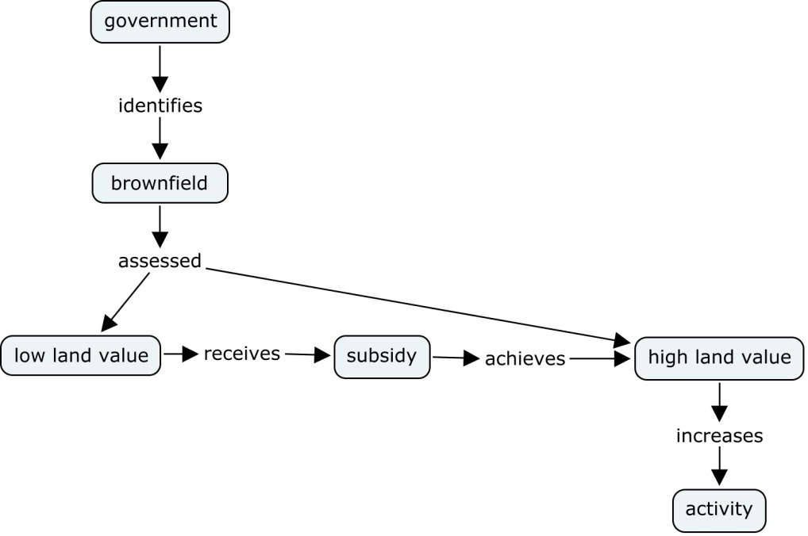
Units
Brownfield_count = Number of potential brownfield sites in a subzone.
Lvi = normalized land value index. The ratio of the subzone’s average land value above or below a regional mean value of zero .
Activity = the sum of households and jobs in a subzone.
Assumptions
If a subzone’s 2030 forecast activity is greater than 2007 activity by a specified amount, then brownfield remediation is already assumed included in the reference forecast.
If a subzone’s land value index is lower than the regional mean by a specified amount, the brownfields in that subzone are eligible for subsidy.
A financial analysis estimates that 3442 brownfield remediations can be subsidized by 2040.
Subzones receiving subsidies receive an “accessibility bonus” and activity is reallocated and land value adjusted accordingly.
Method
Lvi in selected brownfield subzones is increased by 10% per brownfield. The change in lvi is exponentiated to represent a probability that the subzone will interact differently with the rest of the region. This change probability is applied to transportation accessibility to predict a new level of activity, both for the brownfield subzone and those zones with which it interacts.
Note: even if a zone has remediated brownfields, it won’t attract new activity if it has comparatively little initial activity or interaction with the rest of the region. The sensitivity of this interaction, however, hasn’t been calibrated, so the degree to which the effect “spreads” can be adjusted (e.g. currently, we are only creating about 15 new activities in McHenry County). (Technical: this is parameter r2 in reallocate.by.pq.e2)
Constraints
Lvi greater than +0.024 imposed to meet financial constraint.

Calibration
There are 3441 Brownfields < +0.024 lvi, the strategy analysis indicated that this would create about 69,000 additional jobs.
Below is an image of the function as it appears in a spreadsheet.
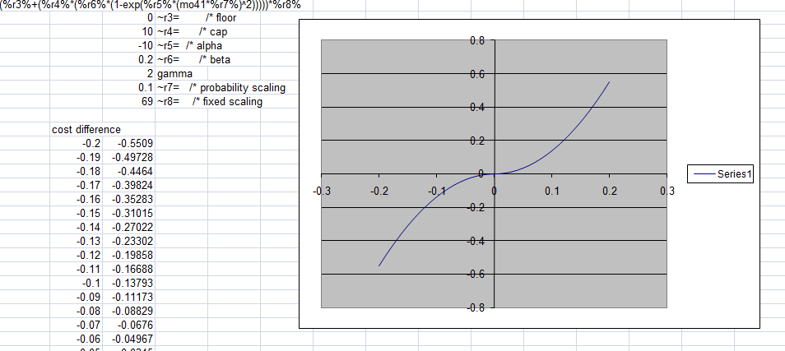

Result
The calibration was adjusted to achieve the desired target.
 |  | reference | bfld |  | reference | bfld
 |  | Hh | hh | +/- | jobs | jobs | +/-
dense | 1 | 1,330,083 | 1,360,656 | 30,573 | 1,786,848 | 1,815,900 | 29,052
high | 2 | 1,347,454 | 1,361,928 | 14,474 | 2,528,953 | 2,556,536 | 27,583
medium | 3 | 554,286 | 556,204 | 1,918 | 987,178 | 995,612 | 8,434
low | 4 | 515,998 | 516,322 | 324 | 474,160 | 476,114 | 1,954
sparse | 5 | 288,708 | 288,708 | - | 339,872 | 340,300 | 428
 |  | 4,036,529 | 4,083,819 | 47,290 | 6,117,011 | 6,184,462 | 67,451
Brownfield locations  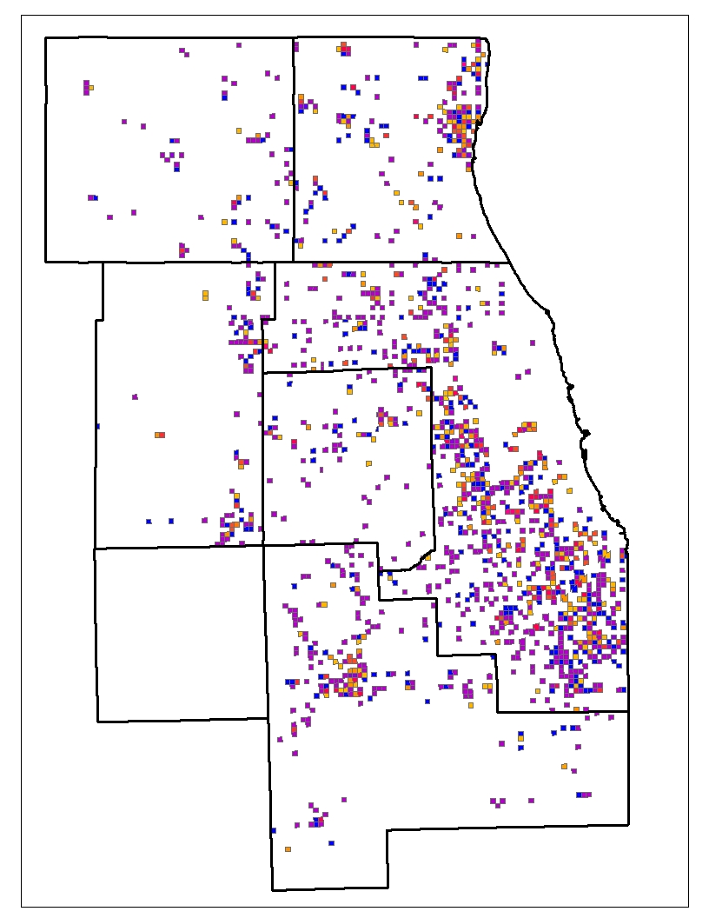 | Numerical change in activity: strategy minus reference.  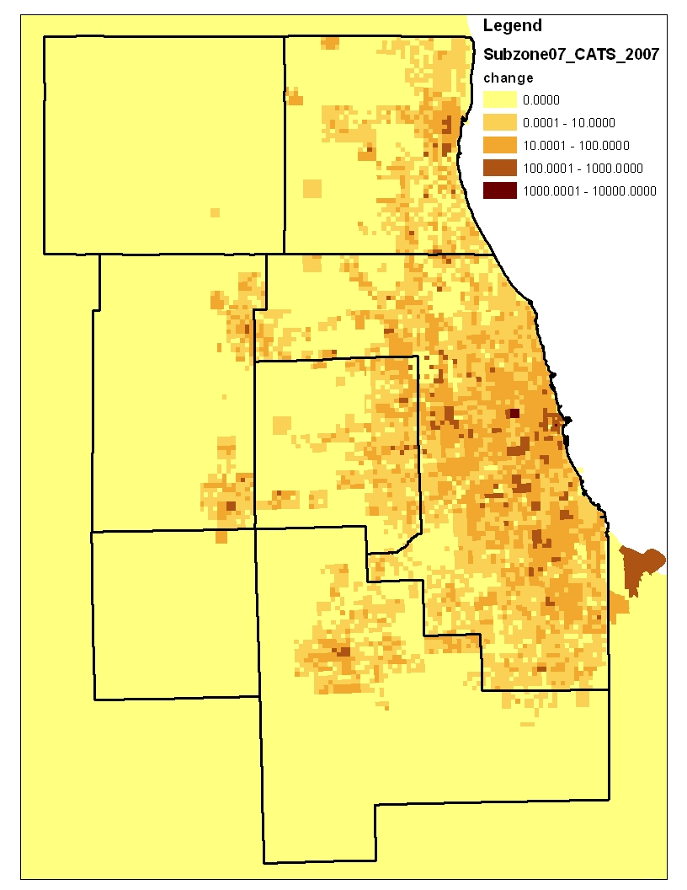 | Rate of change in activity: strategy divided by reference.  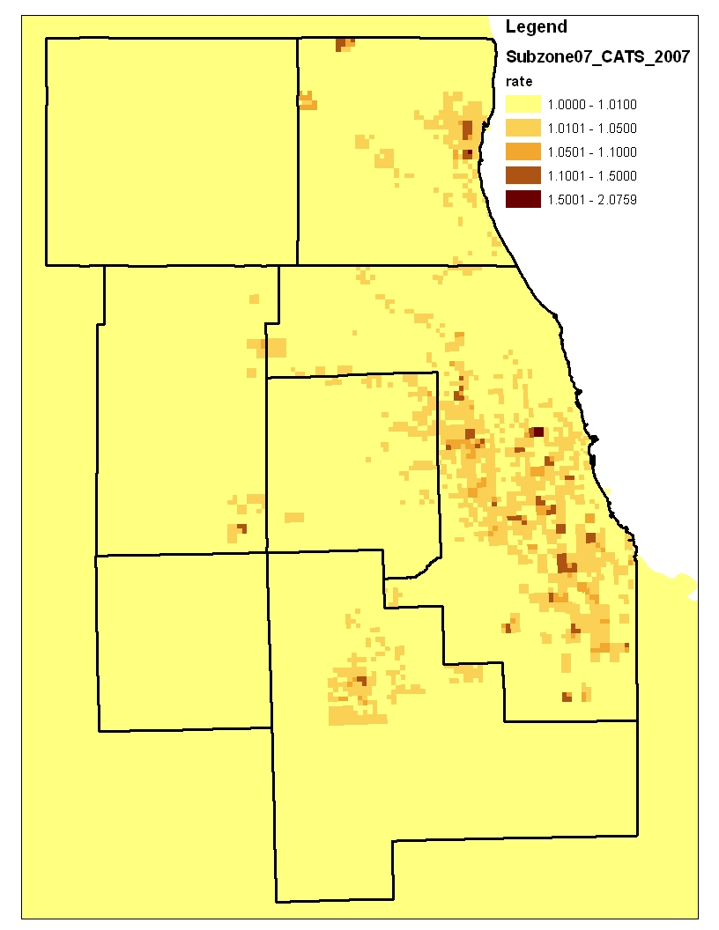

Appendix C: Urban activity reallocation function example
In this example, a change in cost (access product) between two scenarios is calibrated as change in the probability of urban activity. The access product in the reference scenario is 10. Depending on the change in access product associated with a particular strategy this will increase or decrease activity in the strategy scenario.
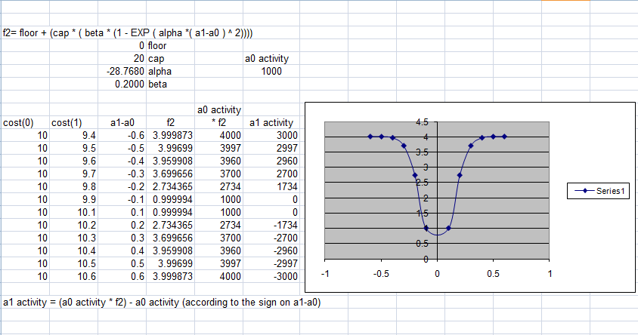

Appendix D: Summary of population and employment forecasts
The following table and charts summarize the expected outcomes of the GO TO 2040 Preferred Scenario in comparison to base conditions. These data are used for a variety of regional land use and transportation planning efforts.
Figure 4: Summary of population and employment forecasts

Appendix E: Forecast validation checks
The final preferred scenario forecast socioeconomic file was subjected to a number of tests for purposes of quality assurance and reasonableness. There is, of course, no absolute certainty in forecast results. Ongoing examination by dataset users assists CMAP in improving forecast validity.

E1. Local employment validation
In forecasting retail employment at the local level, a common rule of thumb is that local (i.e. retail) employment should be about 30% of local population. This might be accomplished by simply summing population and retail employment at the township level and checking the proportions. This method, however, will introduce discontinuities across township boundaries. One should also expect to find legitimate "hotspots" across the region where retail is concentrated (e.g. CBD, Woodfield, etc.).
A distance-based method was developed as an alternative to overcome the township discontinuity problem and provide a quick visual check of local job/population ratios when evaluating and interpreting scenario-based forecasts: 1. Home-based other trip productions are a proxy for household population. 2. Home-based other trip attractions are a proxy for retail job attractions. 3. Matrix math is used to identify the total number of HBO attractions within X miles of a single subzone's HBO productions. The log (ln) of productions in each subzone was divided by the log (ln) of the attractions within 10 miles. This value was mapped.
In comparing the base 2010 condition with the 2040 forecast, it does not appear that the preferred distribution of households and jobs significantly changes between the two. Therefore, no adjustment to retail job forecasts is needed.
Figure 5: 2010 assessment of local retail
trip attractions within 10 miles of the production zone (ln)  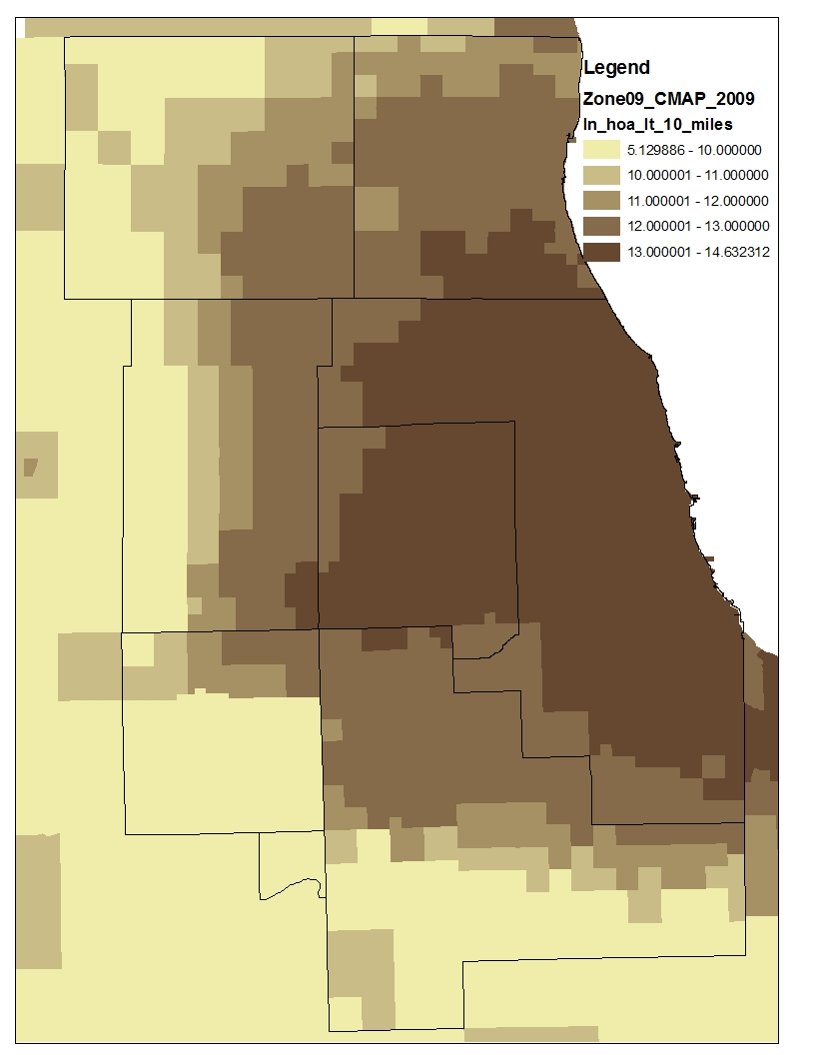 | trip productions/attr w/in 10 miles (ln).  red is no households, orange/yellow is marginal, white is o.k  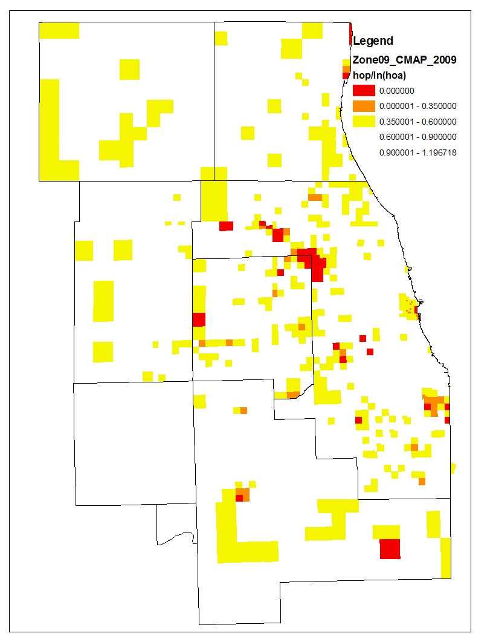
Figure 6: 2040 preferred scenario assessment of local retail
trip attractions within 10 miles of the production zone (ln)  -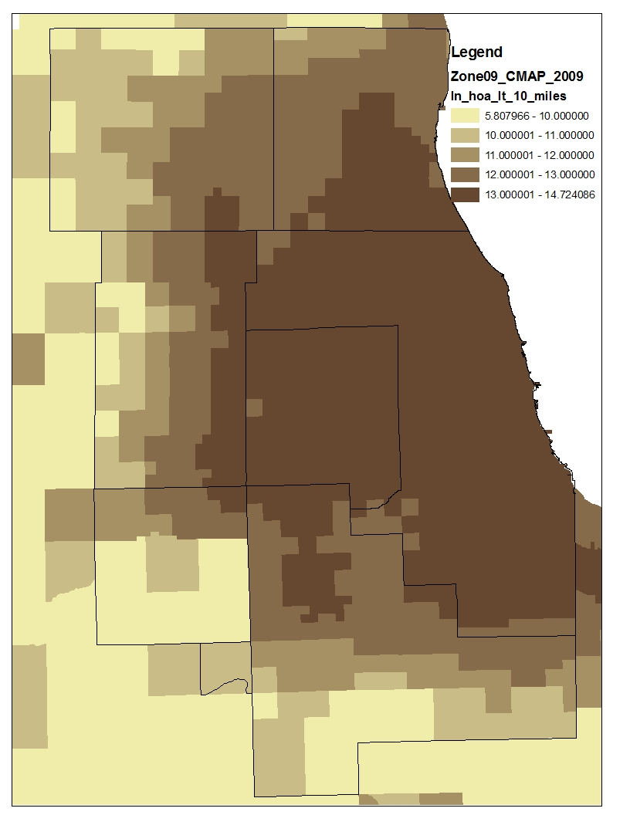 | trip productions/attr w/in 10 miles (ln).  red is no households, orange/yellow is marginal, white is o.k  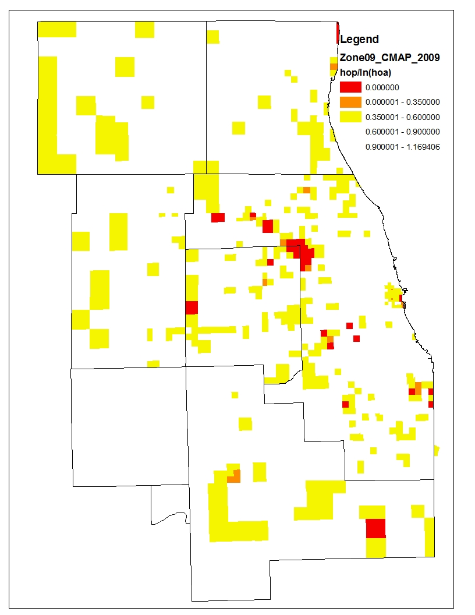

E2. Population density saturation
In forecasting population at the local level, a common rule of thumb is that that a conversion from rural to urban population densities follows a recognizable 3-stage cycle: 1) Stable low density, 2) a steady increase in density over a short period, and 3) stable urban density. When graphed this results in a distinctive S-shaped growth curve, the upper limit of which corresponds to the prevailing type of development: primarily urban or suburban.
The preferred scenario was examined over four types of townships representing different positions in the density evolution and prevailing density. CMAP acknowledges Suhail al Chalabi of the al Chalabi Group for preparing the historical graphs shown below.

The Near West Community Area in Chicago represents the preferred scenario’s strategy effects on a disinvested community that has experienced sharp declines in population density, but is forecast to continue rebounding with added emphasis on preservation and reinvestment strategies.
Figure 7: Preferred scenario strategy effects on a disinvested community in the urban core

The Kenwood/Hyde Park Community Area in Chicago represents the preferred scenario’s strategy effects on a mature community with a stable population and high land values.
Figure 8: Preferred scenario strategy effects on a stable community in the urban core

Naperville Township in southwest DuPage County represents the preferred scenario’s strategy effects on a robust suburban community with a strong employment core and good transit access. The township experienced rapid growth in the past 30 years and its growth would, in the absence of preferred strategies related to transit oriented development, soon plateau. In the preferred scenario, however, Naperville Township continues its climb past this plateau in response to strategies that encourage more compact development.
Figure 9: Preferred Scenario Strategy effects on a dense suburban community with high transit accessibility

Wayne Township in northwest DuPage County represents the preferred scenario’s strategy effects on a low density suburban community that emphasizes preservation of open space. The township experience rapid growth over the past 30 years and its growth would, in the absence of preferred strategies related to open space, continue to climb. In the preferred scenario, however, Wayne Township grows only moderately and remains less dense than its suburban counterparts.
Figure 10: Preferred scenario strategy effects on a low density suburban community with little transit accessibility

E3. Households compared to parcel counts
The statistical method used to estimate the reallocation of urban activity will not capture subzones with zero activity in the base year and will typically underestimate localized development booms wherein entire tracts of rural land are converted in a single transaction. This exercise compares the count of available residential parcels to the estimated number of households to correct mis-estimation with empirical data where possible.
In this exercise, we identify those subzones where land has been platted (i.e. residential parcels appear in the County Assessor’s file), but that the household estimating procedure did not detect sufficient growth for that subzone.
In the figure below, red indicates that the parcel count exceeds the household estimate by greater than 100. Blue indicates that estimated households exceed the parcel county by greater than 100.
Figure 11: 2010 households minus current count of residential parcels.
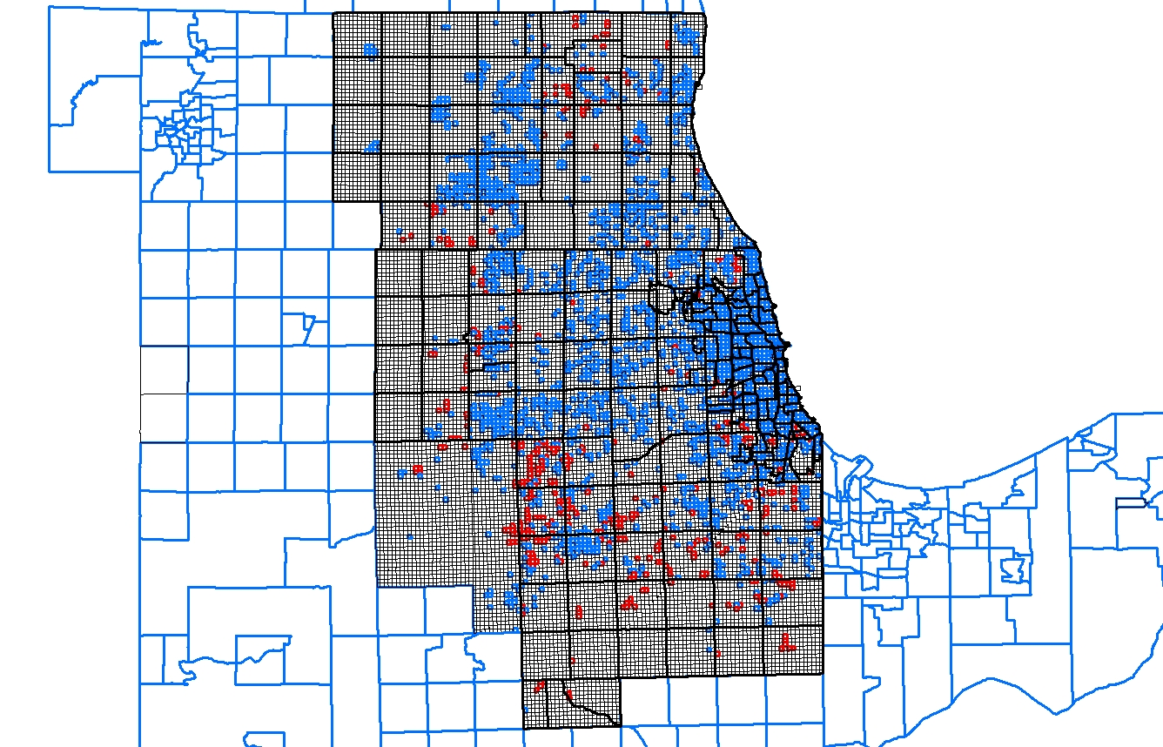

Figure 12: Oswego, Northeast Kendall/Northwest Will County
Focusing on a smaller area shows the typical forecasting problem when large tracts of land develop quickly. It’s clear that these are new subdivisions currently under development. In subzone 15333 (circled), we estimate zero households on 481 parcels.
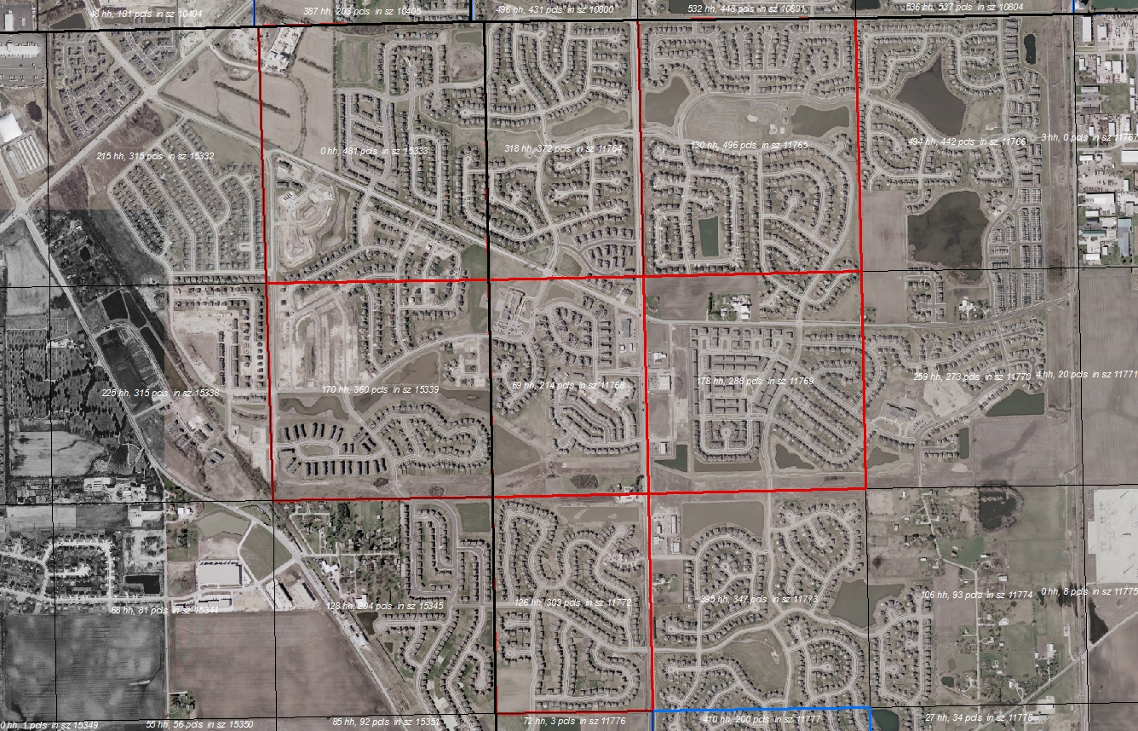
Figure 13: Wheatland Township, Will County
This problem becomes quite concentrated in rapidly growing areas; particularly along the Will and Kendall County border. 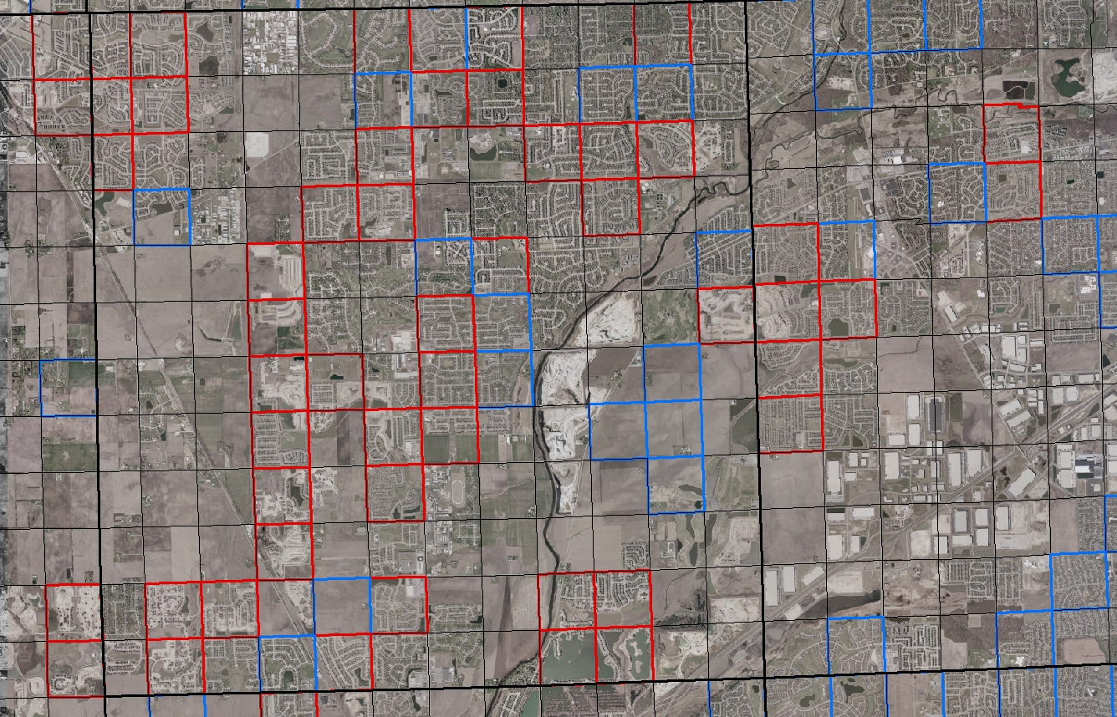
To correct the problem, 2040 household values were constrained to match or exceed the current parcel count. At the subzone level the correction looks reasonable, particularly on the fringe where the 2040 estimating process likely missed new development. This is a stopgap correction in anticipation of the 2010 Census release that will necessitate a complete revalidation of the forecasts.
Figure 14: 2040 household values constrained to match or exceed 2010 parcel counts.
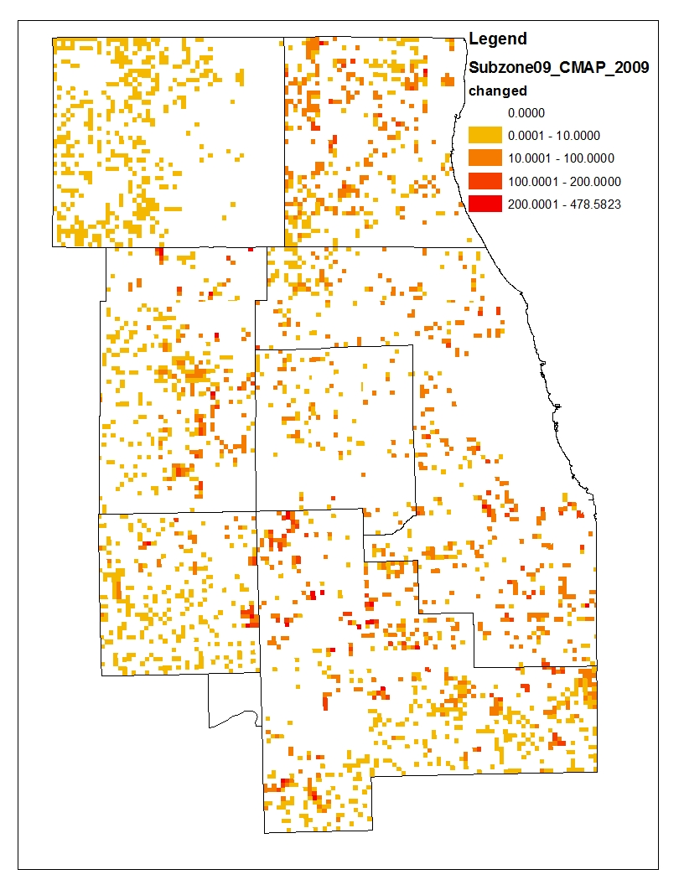

E4. Land capacity validation

Past versus projected household change

In townships where population has grown historically, household growth is projected to occur slightly more slowly than it has in the past. Townships with higher growth per decade between 1990 and 2010 also had higher growth in the preferred scenario between 2010 and 2040 (again, per decade). However, 19 townships had household losses between 1990 and 2010. Interestingly, the greater the 1990 – 2010 loss, the higher the rate of household growth from 2010 to 2040, as the graph below shows.

There are four clear outliers in the top half of the scatter plot above. One is the highest-growth township, which is in Chicago. The other three show projected growth that is well below historically high levels. These are the near north neighborhoods of Chicago as well as a township in south Cook containing parts of University Park, Richton Park, Matteson, etc. After excluding these outliers, it can be seen (figure below) that on average, the townships that grew during the 1990 – 2010 period are projected to grow 89% as fast over the 2010 – 2040 period.

The majority of the townships with historical losses are in western or southern Cook (figure below). Thus, the allocation of new population to previously population-losing areas in proportion to their loss represents the preferred scenario’s emphasis on reinvestment. No townships lose population in the preferred scenario — nor do any subzones, for that matter. This is consistent with the idea that the preferred scenario is meant to embody desirable future conditions in the region, but for it to happen would be a significant break from the past. From 1990 to 2000, 17 townships lost population. From 2000 to 2010, 24 townships lost population. The assumption of no future loss of population is typical of most regional planning exercises, as is the projection that communities will revive in proportion to their loss.

Partly because of the growth projected in historically declining townships, the GO TO 2040 household forecasts show a more “balanced” growth pattern than in the past two decades, with household growth occurring more uniformly across the region. The map below shows household growth per decade from 1990 to 2010 versus projected growth from 2010 to 2040. One obvious difference between the two periods is that growth in Cook County and eastern DuPage is projected to be higher than it has been in the past.

Redevelopment
The household forecasts for northern Cook and most of DuPage Counties seem to imply substantial redevelopment. In 32 out of 124 townships it will likely be necessary to replace lower density housing with higher density housing or to convert other non-vacant lands to residential in order to achieve projected household growth. Townships where significant redevelopment involving major density increases were identified in the following way:

- Agricultural or vacant land (excluding wetlands > 2.5 acres) polygons were selected from the 2005 CMAP Land Use Inventory (LUI). Polygons developed since 2005 were selected from the Development Database (NDD, January 2010 shapefile) and “erased” through geoprocessing from the 2005 agricultural or vacant land. This yielded an estimate of available developable land in 2010 after aggregating to the township level.
- Polygons from the NDD that had been developed since 2005 were added to the polygons identified as residential in the 2005 LUI. Aggregating the households in the 2010 subzone file to the township, then dividing by the estimate of 2010 residential land yielded average residential density in 2010. The parcels in NDD include more than just residential parcels, which makes overall density appear lower than it is, but the effect is small.
- An estimate of vacancy rates (i.e., 1 – households ÷ housing units) was developed for each township from the 2000 Census SF1 block file. Vacancy rates were assumed to be stable over the decade.
- The upper bound acreage needed to accommodate new households by 2040 in each township was estimated by assuming density in 2040 would be at least equal to 2010 density and that existing vacancies would absorb some households.

The results of step 4 are shown in the map below as the ratio between the amount of land needed to accommodate new households on available land at 2010 densities and the amount of vacant land that is actually available for development. If the ratio is greater than one, then some combination of (a) higher than current average densities for new development or (b) the redevelopment of non-vacant properties must take place. For example, a township with a ratio of 3 would either need to develop at an average density 3 times greater than current or have some mix of higher density and redevelopment of non-vacant properties. If the ratio is much higher than one, then substantial redevelopment of non-vacant properties is anticipated. The density of replacement housing units is unknown, but it must of course be higher than average 2010 density.

More broadly, the areas where redevelopment is anticipated conforms to expectations. Little private sector redevelopment would be expected where land value is low; conversely, high land values should predict potential for redevelopment. From the first scatter plot below, it can be seen that there is a positive relationship between the average value of land in the township and the ratio discussed above, although there is some noise in the relationship. Note that four outlier townships with very high ratios of land needed to available vacant land have been removed from the plot. The second scatter plot below compares projected household growth to per-acre land value. As expected, it can be seen that current land value predicts the need for density increases or redevelopment, but is not an especially good predictor for absolute population growth.

Availability of infill opportunities

As the household forecasts project redevelopment of non-vacant land, it is worth examining whether enough “soft sites” or underutilized land are available for redevelopment. The results of the investigation suggest that infill has a reasonable potential to accommodate much of the household growth. The work done for the Snapshot Report on Infill identified 184,967 acres of infill potential across the region. The data used to make the map on pp. 8-9 of the Infill snapshot were reanalyzed to get estimates of infill potential by township. Land with infill potential is that where the ratio of the assessed value of improvements to the assessed value of land is lower than a certain threshold (that threshold varying by property type or land use). Thus, for land to have infill potential means that the economic returns from redevelopment with higher-value structures would be greater than the returns from the present use of the land.

Infill estimates by township were developed as follows. The feature classes containing estimates of infill potential by county and property classification were merged into files of all properties in the county, excluding the vacant properties identified as having potential for infill since many (but not all) are presumably captured as vacant land in the 2005 LUI and would therefore be counted twice. The county files were then merged and then intersected with the townships. Following that operation, polygons coded as single family residential in the 2005 LUI were “erased” through geoprocessing. The acreage of infill potential was summarized on the township, revealing 177,325 acres of underutilized, non-vacant, non-single family land in the region, close to the estimate made in the Infill Snapshot.

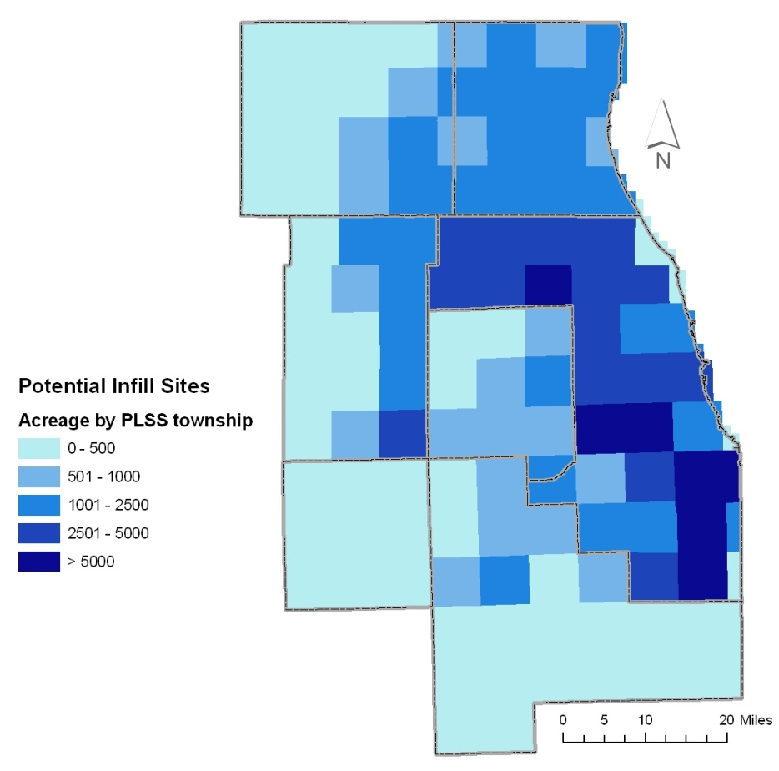

If the estimate of the amount and location of land with infill potential is approximately correct, it appears that a combination of higher densities in new development and redevelopment of non-vacant infill parcels can readily accommodate projected household growth. The table below shows the 32 townships where the ratio of land needed at 2010 densities is higher than the amount of land available. In 21 of these townships, enough land with infill potential is present to satisfy the need. For the eleven that do not (in orange in the table below), however, recall that density in redevelopments will be higher than prevailing densities, so that less land will be needed than the upper bound estimate. Current residential densities in these eight townships range from only 1.56 to 3.85, so there is presumably room for density increases.

Twp | Projected housing units | 2010 density (du/ac) | Available vacant land (ac) | Land needed at 2010 density (ac) | Available – Needed | Non-vacant land with infill potential
4312 | 9,097 | 2.12 | 622 | 4,295 | -3,673 | 1,307
3811 | 13,001 | 3.18 | 512 | 4,091 | -3,579 | 509
3709 | 19,448 | 1.93 | 6,685 | 10,058 | -3,374 | 444
3810 | 11,704 | 3.55 | 816 | 3,298 | -2,482 | 512
3512 | 14,969 | 1.90 | 5,615 | 7,866 | -2,252 | 871
4213 | 6,958 | 3.17 | 33 | 2,197 | -2,164 | 377
3911 | 8,395 | 3.67 | 643 | 2,288 | -1,646 | 1,091
4113 | 9,462 | 6.47 | 121 | 1,463 | -1,341 | 2,778
4212 | 6,598 | 2.97 | 888 | 2,220 | -1,332 | 4,777
4112 | 7,347 | 5.53 | 120 | 1,328 | -1,207 | 3,226
4211 | 7,248 | 4.27 | 636 | 1,698 | -1,062 | 2,676
3912 | 6,156 | 5.53 | 185 | 1,114 | -929 | 3,142
3910 | 4,620 | 3.43 | 453 | 1,348 | -895 | 513
4013 | 12,402 | 12.98 | 164 | 956 | -792 | 2,114
3808 | 17,170 | 4.99 | 2,666 | 3,440 | -774 | 2,679
3513 | 19,638 | 3.06 | 5,662 | 6,417 | -755 | 4,328
4210 | 4,550 | 3.30 | 674 | 1,378 | -704 | 3,972
4014 | 27,320 | 36.68 | 42 | 745 | -703 | 1,684
4011 | 6,273 | 3.85 | 960 | 1,628 | -668 | 502
4010 | 6,528 | 3.72 | 1,101 | 1,756 | -654 | 417
4311 | 6,489 | 2.40 | 2,150 | 2,703 | -553 | 2,032
4012 | 6,013 | 7.00 | 510 | 859 | -349 | 3,662
4111 | 4,472 | 5.38 | 534 | 832 | -298 | 9,657
3613 | 8,496 | 3.52 | 2,161 | 2,415 | -254 | 1,921
3713 | 5,695 | 5.12 | 870 | 1,112 | -243 | 2,847
4114 | 3,646 | 24.60 | 0 | 148 | -148 | 256
4008 | 4,598 | 1.68 | 2,597 | 2,742 | -145 | 1,553
4108 | 11,323 | 4.13 | 2,609 | 2,741 | -132 | 2,474
4110 | 5,612 | 4.53 | 1,113 | 1,238 | -125 | 3,140
4313 | 212 | 1.56 | 15 | 135 | -121 | 11
3809 | 9,698 | 4.31 | 2,213 | 2,251 | -38 | 717
3914 | 21,251 | 37.66 | 563 | 564 | -1 | 3,480

Appendix F: Travel demand model summaries
The first and most intensive use of the 2040 socioeconomic forecasts is to demonstrate that the long range plan and transportation improvement program conform to the State Implementation Plan (SIP) for Air Quality. This appendix provides tabular summaries taken from CMAP travel demand model output.
To facilitate your evaluation, the tables are embedded as Microsoft Excel Spreadsheets. For each category of model output, the primary table compares summaries from each analysis year associated with the air quality conformity demonstration. Note that the summary geography varies slightly from other tables in this document.

F1. Trip generation
Trip generation data reflects the travel activity generated by socioeconomic and land use forecasts at the subzone (approximately ¼ square mile) level. The table below is summed to the 7-county CMAP region plus Aux Sable Township in Grundy County.
Figure 15: Trip Generation Summary

F2. Network supply
Network supply is a coded representation of the highway and transit infrastructure. Highway data are summed by major facility type. Directional miles are roughly twice the centerline miles. Highway lane miles weight the directional miles by the number of lanes in each direction and serve as a common proxy for capacity. The bus and rail transit networks are summed by segment length covered by each mode.
Figure 16: Network Supply

F3. Transit level of service
Transit Level of Service is the coded representation of public transit schedules during the a.m. peak period. Modeled interaction between these schedules and trip generation are the significant determinants of transit ridership forecasts.
Figure 17: Transit Level of Service

F4. Trip tables
Trip tables are the result of modeled interactions between trip generation and network supply. These take the form of large matrix datasets that compare travel costs and benefits between zone pairs and estimate travel by highway and transit modes.
Figure 18: Trip tables

F5. Highway level of service
Highway level of service is the result of modeled interactions between trip tables and the highway network. Vehicle miles and hours of travel in the CMAP region under congested conditions and by trucks are summed. These data are a significant input to the estimated mobiles source emissions for the region.
Figure 19: Highway Level of Service

Note that this is residential density, i.e., the number of households in a township divided by the estimated area of residential land in the township.
Often referred to as the “commuter-shed.” The 2000 Census estimates that approximately 2.7% of the daily commutes in the 21-county modeling region cross the modeling region’s border.
Mathematically: pop_{t1} = pop_{t0} + ((pop_{t8} – pop_{t0})/9) + (pop_{t1} – pop_{t0}) *pop_{t0}_ca/pop_{t0}) * parameter. Where pop = MCD population, pop_ca = Community Area estimate, t equals year as numbered. The parameter value is found by observing its effect on the CA’s sum to the MCD total. Achieving an exact match will result in a straight line. The parameter value is altered judiciously to preserve the observed sine wave.
This is a significant methodological departure from past regional planning practice in which future land use patterns were inventoried at the municipal level and incorporated into a regional forecast subject to exogenous control totals. We recognize that many determinants of future regional patterns occur outside the realm of regional planning policy. We also admit to significant uncertainty about future conditions. We have chosen to refrain from guessing at these conditions in favor of preparing scenario-based forecasts that highlight anticipated benefits of responsible regional planning.
The proposal for a South Suburban Airport is included as a land use assumption in the preferred scenario.

