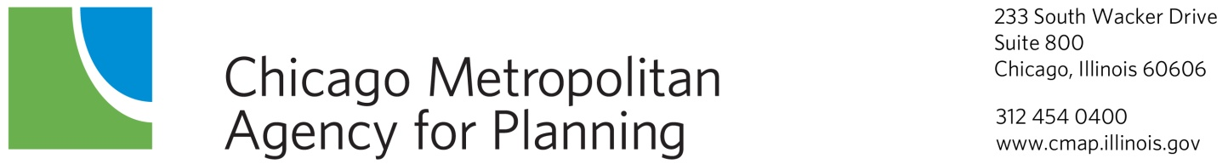

Regional Transportation Operations Coalition
Annotated Agenda
Thursday, February 8, 2012
9:30 a.m.

DuPage County Conference Room
233 S. Wacker Drive, Suite 800
Chicago, Illinois

1.0 Call to Order 9:30 a.m.

2.0 Agenda Changes and Announcements

- Approval of Minutes – December 8, 2011
ACTION REQUESTED: Approval

- CMAP Archive Data User Service Update
CMAP will provide an update on the status of the recently released RFP. CMAP is also working UIC to provide more information through the Gateway.
ACTION REQUESTED: Information

- Regional Traffic Signal Inventory Update & Enhancement
CMAP staff will provide an update on the progress of the inventory and the new format.
ACTION REQUESTED: Information & Discussion

- Strategic Regional Arterial System
The status of the SRA system will be discussed.
ACTION REQUESTED: Information & Discussion

- Congestion Management Process Update
CMAP staff will present a revision of the documentation for the Congestion Management Process
ACTION REQUESTED: Information & Discussion

- Other Business

- Next Meetings
The next meeting is scheduled for Thursday, April 19, 2012 at 9:30 a.m.

- Adjournment

