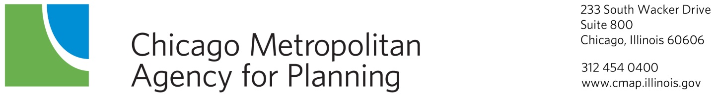

Economic Development Committee
Annotated Agenda
February 13, 2014
9:00am

DuPage County Conference Room
233 S. Wacker Drive, Suite 800
Chicago, Illinois
- Call to Order and Introductions 9:00 a.m.

- Agenda Changes and Announcements

- Approval of Minutes – January 9th, 2014
ACTION REQUESTED: Approval

- 2014 Legislative Agenda and Framework Discussion, Simone Weil, CMAP Staff
Staff has revised CMAP’s Legislative Agenda and Framework for 2014 to reflect policy priorities based on research developed at CMAP and issues that remain important to the implementation of GO TO 2040. CMAP intends to use the framework and agenda to inform the Governor, legislators, and other state policy makers during the upcoming legislative session. Staff will share these documents and discuss committee members’ legislative priorities impacting the implementation of GO TO 2040.
ACTION REQUESTED: Discussion

- DRAFT Mission/Vision presentation & discussion, Emily Plagman, CMAP Staff
As part of the transition to a new staff liaison, CMAP staff recently queried committee members about their interests for upcoming topics and what past activities have been useful for them. Members consistently reported interest in wanting a clear vision and mission to help further hone the committee’s purpose and subsequent work. Staff will share a draft vision and mission statement and request feedback and discussion about the text.
ACTION REQUESTED: Discussion

- Oswego LTA update, Nicole Woods, CMAP Staff
The purpose of the Village’s Market Analysis was to assist in creating new economic and community development strategies. The Market Analysis addresses three key features – 1)It identifies the current commercial subareas and related development; 2) It examines the potential for future commercial development; and 3) It develops recommendations and strategies that will optimize Oswego to meet current and future demand.
ACTION REQUESTED: Discussion

- GO TO 2040 Update, Drew Williams-Clark, CMAP Staff
Federal regulations mandate the update of GO TO 2040 by October of 2014. Staff are updating the financial plan, major capital projects, indicators, and implementation actions to inform the plan update. These components are expected to be complete in the early spring so that the plan can be drafted for public comment release at the June, 2014 meetings of the CMAP Board and MPO Policy Committee.

  - Updated Implementation Actions – Alex Beata, CMAP staff
As part of the GO TO 2040 plan update, the FY 2014 work plan calls for a review of the implementation action tables at the end of each of the twelve chapters in GO TO 2040. Specifically, the work plan calls for these actions to be updated to reflect their implementation status. Staff will present the final updated implementation action text.
ACTION REQUESTED: Discussion

- Other Business

- Public Comment
Public comment is encouraged throughout the meeting. The Chair will recognize non-committee members as appropriate. Non-committee members wishing to address the Committee should so signify by raising their hand in order to be recognized by the Chair. The Chair will have discretion to limit discussion.

- Next Meeting: The committee will meet next on March 13, 2014

- Adjournment

Economic Development Committee Members:

____Jerry Weber, Chair
____Oswaldo Alvarez
____ Greg Bedalov
____ Peter Creticos
____ Patrick Carey
____ JoAnn Eckmann
____ Joanna Greene
____ Reggie Greenwood
____ John Grueling
____Mark Harris
____ Emily Harris
____ Rand Hass
____ Bret Johnson
____ Gretchen Kosarko
____ Judith Kossy
____ MaryBeth Marshall
____ Sean McCarthy
____Lance Pressl
____Nick Provenzano
____ Jeremiah Boyle
____ Ed Sitar
____ Gary Skoog
____ Carrie Thomas

