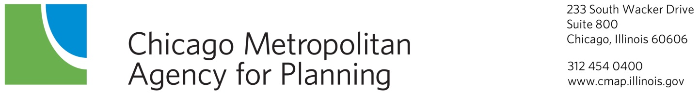

Economic Development Committee
DRAFT Minutes
February 13, 2014
9:00am

DuPage County Conference Room
233 S. Wacker Drive, Suite 800
Chicago, Illinois

Committee Members Present: JerryWeber (College of Lake County), Peter Creticos (Institute for Work and the Economy), Joanna Greene (Chicago Cook Workforce Partnership), Judith Kossy (Policy Planning Partners), MaryBeth Marshall (DuPage Workforce Board), Lance Pressl (Institute for Work and the Economy), Greg Bedalov (Choose Dupage), Patrick Carey (Cook County), Reggie Greenwood (South Suburban Mayors and Managers Association), John Grueling (Will County Center for Economic Development), Bret Johnson (Northwestern University Transportation Center), Ed Sitar (ComEd), Carrie Thomas (Chicago Jobs Council)

Staff Present: Elizabeth Schuh, Alex Beata, Emily Plagman, Nicole Woods, Drew Williams-Clark, Simone Weil, Jackie Murdock, Brian Peterson

- Call to Order and Introductions 9:00 a.m.

- Agenda Changes and Announcements

- Approval of Minutes – January 9th, 2014
ACTION REQUESTED: Approved

- 2014 Legislative Agenda and Framework Discussion, Simone Weil, CMAP Staff
Staff presented CMAP’s Legislative Agenda and Framework for 2014 to reflect policy priorities based on research developed at CMAP and issues that remain important to the implementation of GO TO 2040.

- DRAFT Mission/Vision presentation & discussion, Emily Plagman, CMAP Staff
Staff presented a draft Economic Development Committee mission statement for review and comment. A revised version will be presented at the April meeting.

- Oswego LTA update, Nicole Woods, CMAP Staff
LTA staff presented their work on Owsego’s Market Analysis which addresses three key features – 1)It identifies the current commercial subareas and related development; 2) It examines the potential for future commercial development; and 3) It develops recommendations and strategies that will optimize Oswego to meet current and future demand.

- GO TO 2040 Update, Drew Williams-Clark, CMAP Staff
Staff provided an update on the federally mandated update of GO TO 2040 financial plan, major capital projects, indicators, and implementation actions. These components are expected to be complete in the early spring so that the plan can be drafted for public comment release at the June, 2014 meetings of the CMAP Board and MPO Policy Committee.

  - Updated Implementation Actions – Alex Beata, CMAP staff
Staff presented final text of the updated GO TO 2040 implementation action tables.

- Other Business

- Public Comment

- Next Meeting: The committee will meet next on March 13, 2014

- Adjournment

