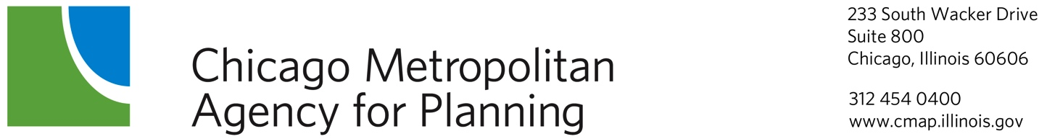

Economic Development Committee
Minutes
April 10, 2014--9:00 a.m.
DuPage County Conference Room

Committee Members Present: Jerry Weber, Chair (College of Lake County), Pat Carey, Vice Chair (Cook County), Oswaldo Alverez (Fry Foundation), Greg Bedalov (Choose DuPage), MaryBeth Marshall (DuPage Workforce Board), Lance Pressl (Institute for Work and the Economy), Ed Sitar (ComEd), Nick Provenzano (Representative Hultgren & McHenry County)

Staff Members Present: Lindsay Hollander, Jackie Murdock, Elizabeth Schuh, Brian Peterson Drew Williams-Clark, Simone Weil, Randy Blankenhorn

Guests Present: Jason Keller (Federal Reserve on behalf of Jere Boyle), Hector Garcia (ComEd), Chalen Daigle (McHenry County)

- Call to Order/Introductions 9:00 a.m.
The meeting was called to order at 9:05am.

- Agenda Changes and Announcements

- Approval of Minutes—March 13, 2014
Minutes were approved with all in favor.

- Approval of Mission Statement, Emily Plagman, CMAP Staff
Staff presented minutes for approval. Additional edits were requested to be made. A motion to table the minutes until May was made & approved unanimously.
ACTION TAKEN: Tabled pending edits requested.

- GO TO 2040 Update, Drew Williams-Clark, CMAP Staff
Staff presented the status of updates to GO TO 2040’s financial plan, major capital projects, indicators, and implementation actions, to be completed by October of 2014 with the public comment period expected at the June, 2014 meetings of the CMAP Board and MPO Policy Committee. Staff provided an update on the work that took place as a result of the indicators discussion that took place at the March meeting.

- Major Capital Projects and Congestion Pricing Policy – Jesse Elam, CMAP Staff
Staff presented on the benefits and costs of proposed capital projects to help prioritize them for inclusion within the plan’s fiscal constraint. Later in the spring, staff will present a recommended list of major capital projects to fit within the plan update’s fiscal constraint.

- CMAP’s Regional Tax Policy Principles – Lindsay Hollander, CMAP Staff
Staff presented on tax principles derived from GO TO 2040 to guide CMAP’s perspective on state and regional tax policy reform. CMAP believes that the discussion around the upcoming expiration of the 2011 income tax rate increase may create an opportunity for comprehensive tax policy reform, and CMAP’s regional perspective could play an important role in helping to guide tax policy reforms. The report had been presented to the board for approval the day prior and had not been approved for adoption.

- Subregional Drill Down, Elizabeth Schuh, CMAP Staff
Staff presented on the findings of the O’Hare Subregional Freight-Manufacturing Drill Down Airport which assesses the interaction of freight and manufacturing within the subregion and as well as how the cluster is supported by local infrastructure and planning.

- ComEd Business Retention Survey, Ed Sitar, ComEd
ComEd provided an update on their business retention survey, which they provide to communities and development partners to help better understand the local business climate and economy.

- Other Business
Staff provided a brief update to the committee on its state legislative monitoring activities and recent action taken by the board to support and oppose legislation that impacts the implementation of GO TO 2040.

- Public Comment
This is an opportunity for comments from members of the audience. The amount of time available to speak will be at the chair’s discretion. It should be noted that the exact time for the public comment period will immediately follow the last item on the agenda.

- Next meeting – May 8, 2014

- Adjournment
The meeting was called to a close at 11:10 am.

Respectfully Submitted,
Emily Plagman

