

MEMORANDUM

To: Working Committees and Partners

From: Bob Dean, Deputy Executive Director for Local Planning

Date: June 2014

Re: Local Technical Assistance (LTA) Program Evaluation, Part 1: Program Statistics and External Surveys

Over the next several months, CMAP will engage its working committees and other partners in an evaluation of the first three years of the LTA program, with the intent of using the results to focus future resources most effectively. This will be a multi-part discussion, held over a series of committee meetings. A rough timeline of topics is contained below, although please note that this may vary from committee to committee based on meeting schedules.
- Basic program statistics – June/July
- Results of external surveys by project sponsors – June/July
- Review of new applications – July/August
- Implementation progress – July/August
- Results of internal evaluation – August/September
- Results of municipal survey – August/September

This memo covers the first two bullets above – basic program statistics, and the results of external surveys by project sponsors. Committee and partner comments on the attached report are welcomed.

ACTION REQUESTED: Discussion.

Basic program information and statistics

Project delivery
The overall philosophy of the LTA program has been to identify projects that are priorities to accomplish, and then use a variety of methods to accomplish them, including staff assistance, consulting assistance, and grants. Three major types of assistance have been used to support the LTA program. The first type includes projects that are led entirely by CMAP staff, with no external contracts. The second type involves CMAP contracting directly with a consulting firm to complete a local planning project, or providing a grant to a local government to hire a consultant; in both cases, a competitive RFP process is used. The final type includes projects that are led by CMAP but also involve smaller contracts that are used to hire a contractor, either a consulting firm or a nonprofit partner, to contribute to a project.
Figure 1 – project accomplishment methods

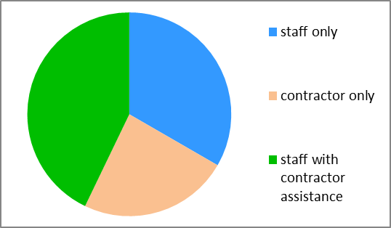
As Figure 1 shows, the LTA program has used each of these methods to accomplish projects. The most common arrangement has been projects that have been led by CMAP staff with assistance from specialized contractors to assist with portions of the projects that CMAP does not have the expertise to address. In these cases, the bulk of the work is done by CMAP staff, and contractors are used to prepare visualizations, analyze market conditions, assess the workforce development structure, or other specialized project elements.

The average size of a project in the LTA program, whether it is accomplished by staff assistance, consultant assistance, or a combination of these methods, is approximately $90,000-$100,000. While most projects are in this range, size varies considerably; some have been as small as $20,000 or as large as $250,000.

Over the past three years, the management of the LTA program has become systematized to a large degree. CMAP staff track time by project, which helps to estimate resources allocated to any given project and also improves CMAP’s understanding of the amount of time that different project stages take. Projects typically involve teams, with an explicit role on most projects for a project manager, project director, outreach staff, and a data/mapping expert, as well as other support as needed. Most project teams are formed from the Local Planning division of CMAP in which LTA is housed, but others are brought in from the Policy, Programming, Research and Analysis, and Communication divisions as needed.

Outreach and involvement
Outreach and involvement have been critical parts of the LTA program from its beginning. A broad consortium of partners was responsible for submitting the application to HUD to initiate the LTA program, and these partners have remained involved. CMAP tracks involvement of partners in its projects; of the 48 projects completed (as of April 2014) that were led by CMAP staff, 43 included the involvement of at least one external partner organization. Among staff-led projects that are currently underway, 40 of 43 involve at least one external partner.

The groups that have been most involved include the region’s transit agencies (CTA, Pace, Metra, and RTA), as well as two regional civic organizations, the Metropolitan Planning Council (MPC) and the Center for Neighborhood Technology (CNT). Other groups with frequent involvement include the Chicago Jobs Council (CJC), a workforce policy organization; the Metropolitan Mayors Caucus (MMC), an organization of the region’s municipalities; Openlands, an environmentally-focused nonprofit; and the Urban Land Institute (ULI), which represents groups in the development industry.

Stakeholder groups are involved in project selection as well. After receiving applications, CMAP discusses them with the region’s counties, Councils of Governments (COGs), transit agencies, and nonprofit partners, as well as CMAP’s working committees. These groups provide valuable insight into past work in many communities, and their involvement ensures that the projects selected for inclusion in the LTA program build from past and ongoing work by other organizations.

The LTA program includes a commitment to engage the general public. Each LTA project is assigned a dedicated community outreach staff person, whose primary responsibility is to engage residents and other stakeholders. This begins with a project outreach strategy, which describes activities and target populations appropriate for a given community’s demographics. Each outreach strategy targets stakeholders who will be most affected by the project, and includes a particular focus on individuals who have been traditionally left out of past planning processes. As the project progresses, the outreach staff and project managers work to incorporate the findings of the public engagement into the plan’s recommendations.

A diverse group of five full-time staff form CMAP’s outreach team, and significant resources are devoted to outreach. Typically, about 20% of the resources dedicated to an average project are spent on outreach, usually in the early stages of the project. This consistent allocation of resources has provided the LTA program with a reputation for extensive and effective outreach, and has helped to build local support for the plans that are produced.

In total, over the past three years, the LTA program has held over 250 outreach “events” – including meetings, focus groups, online interactive web surveys, and others – and reached over 18,000 individuals. Among the most successful tools is MetroQuest, an online, interactive web tool that allows the development of interactive online surveys and maps. Depending on the character of each community, in-person meetings can be just as valuable.

Project statistics
Since its initiation in 2011, over 70 projects have been completed through the LTA program, with 50 more underway and 20 more set to begin in the near future. For purposes of tracking progress, CMAP divides projects into several stages and regularly assesses their status. Early stages include project scoping and administration; later stages include completion of the existing conditions assessment (which corresponds to a project being approximately 50% complete), and preparation of a draft plan (90% completion). Figure 2 shows project status over time. Changes in the size of the colored sections indicate project progress over time, and the large changes in October of each year result from the addition of new projects. As this shows, the LTA program has made constant progress, and the rate of project advancement has accelerated as the process has become more efficient.

Figure 2 – project status timeline chart
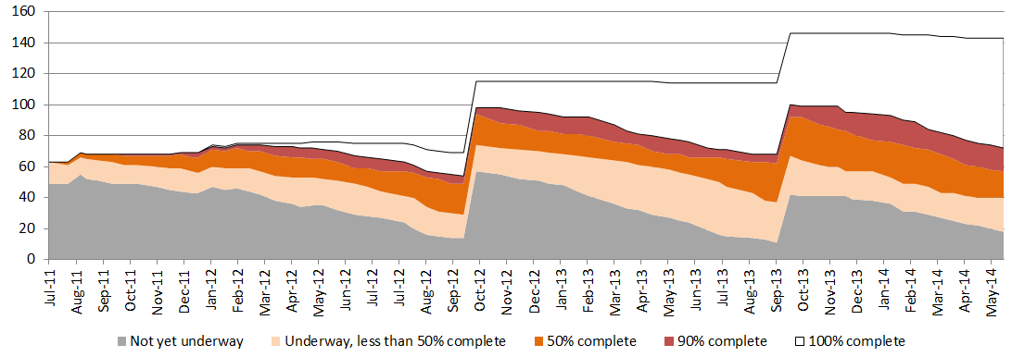

CMAP maintains a separate webpage for each completed project, as well as many ongoing projects. These are available on CMAP’s LTA website:
http://www.cmap.illinois.gov/programs-and-resources/lta/projects

To date, the most common projects in the LTA program have been comprehensive plans, with 33 projects of this type. Other common types include transportation plans, as well as plans that focus on a specific corridor or area (which may be within a single community or may cross municipal boundaries). Between them, projects in these three categories make up nearly 60% of the projects and 70% of the resources devoted to the LTA program. More information on project types is shown in Figure 3.

Figure 3 – project type
Project type | Total projects | Completed projects | Active/upcoming projects
Comprehensive plan | 33 | 14 | 19
Corridor or area plan | 28 | 16 | 12
Transportation plan | 23 | 11 | 12
Housing plan | 10 | 5 | 5
Water resources plan | 9 | 9 | 0
Zoning update | 9 | 1 | 8
Sustainability or green infrastructure plan | 8 | 3 | 5
Other | 23 | 11 | 12
Total | 143 | 70 | 73

As a supplement to the LTA program, CMAP’s Local Ordinances and Toolkits Program develops resources that help municipalities advance the goals of GO TO 2040. Each year, CMAP works with municipal officials and experts to deliver toolkits that describe the process of addressing a specific topic at the local level. Recent topics include parking, climate change adaptation, and immigrant integration. Currently, toolkits are underway on topics including aging in place, conservation design, sustainability planning, and complete streets; CMAP intends to also begin work on a toolkit on fair housing, if external funding support can be found.

By design, projects undertaken through the LTA program have touched all parts of the metropolitan area. Figure 4 shows that the geographies with the most projects are west and south suburban Cook County. This is expected, as the LTA program has focused on assisting low-capacity communities, and these areas contain the region’s greatest concentrations of small, low-income communities. The smallest number of projects (two) have been undertaken in Kendall County, which is also expected, as Kendall County is the region’s smallest county. Per capita, relatively few projects have taken place in the City of Chicago; CMAP is currently working with City staff to correct this imbalance in future years. This information is also shown spatially in Figure 5.

Figure 4 – number of projects by geography
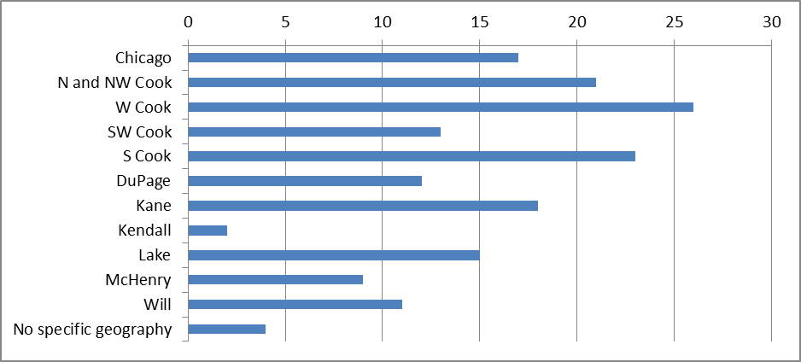

Figure 5 – project location map
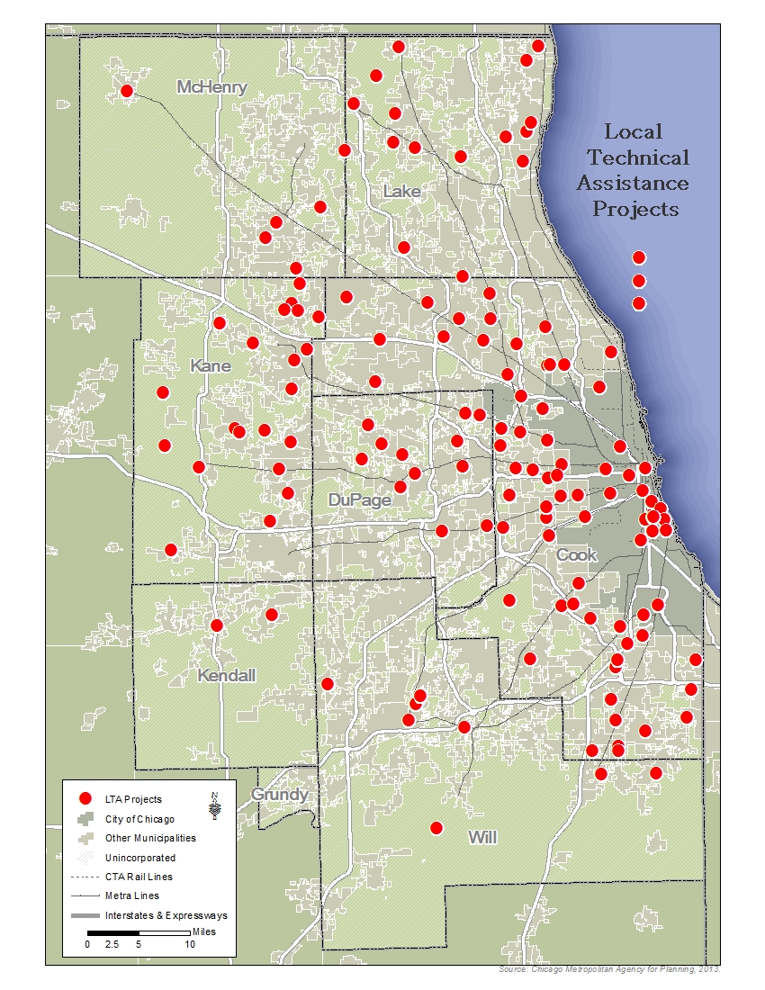
External survey results
Following the conclusion of each LTA project, CMAP sends a follow-up survey to the local project sponsor. Surveys are sent in batches approximately every six months; the most recent surveys were sent in February/March 2014, at which point approximately 55 projects had been completed. To date, 48 complete survey responses have been received.

Quantitative results
Compiled results to the survey questions are shown in Figures 6-9. The survey includes questions meant to gauge satisfaction with elements of the LTA program – the CMAP project team, overall outcome, responsiveness, outreach, technical work, and timeliness. As shown below, local sponsors have been very satisfied with the elements of the LTA program to date; at least 90% of respondents selected “agree” or “strongly agree” with each statement. There are slight differences in responses from question to question, but these are not significant.

Respondents were also asked to indicate whether implementation steps were clearly laid out, and most (90%) indicated that they were. Respondents were also asked whether implementation had begun yet. In 70% of the cases, implementation had begun at the time of the survey; in other cases, it had not yet begun at that point but has since been initiated.

Finally, respondents were asked whether they were likely to submit another project to the LTA program, or to recommend that others apply to the LTA program. Most respondents (90%) indicated that they were “likely” or “very likely” to do both.

Figure 6 – responses to survey question “I am satisfied with…”
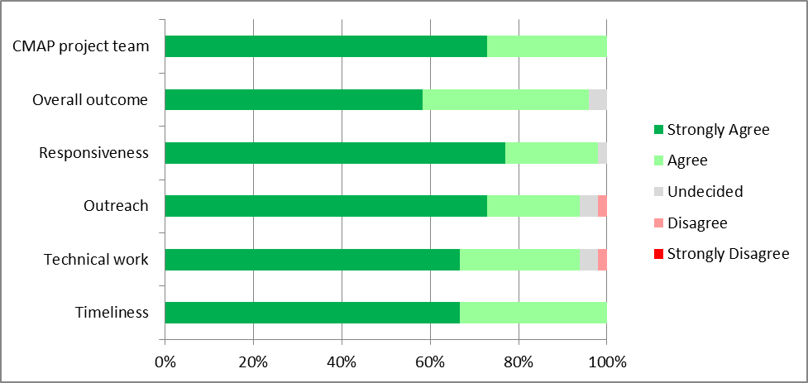

Figure 7– responses to survey question “Were implementation steps clearly laid out?”
Figure 8 – responses to survey question “Has implementation begun?”

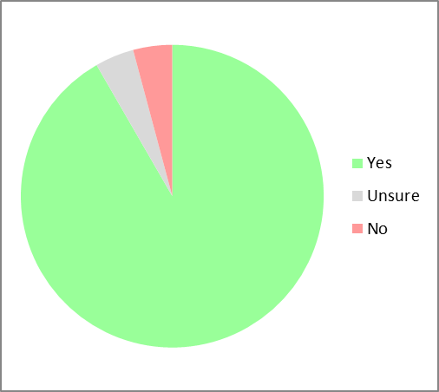
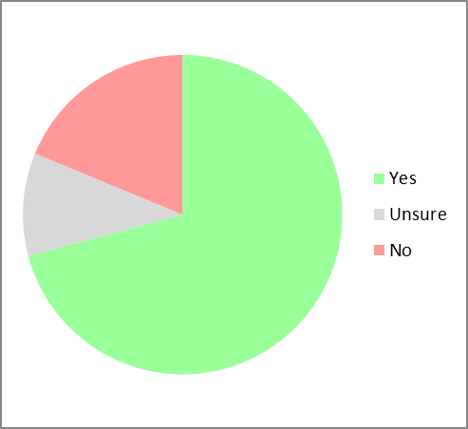

Figure 9 – responses to survey question “How likely are you to…”
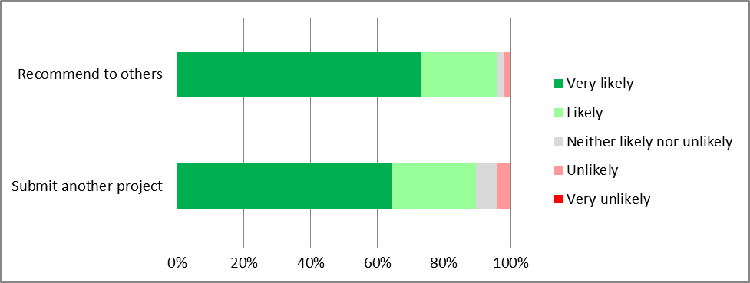

As noted earlier, projects are delivered using several methods, including allocation of staff time and funding for consultant contracts. Results for staff-led projects and consultant-led projects were compared, and no significant differences were observed.

Open-ended results
The survey also asked several open-ended questions about the program. The vast majority of responses to these questions were positive, and are not included below for sake of brevity. Instead, comments that included constructive criticism are summarized below. It should be noted that many of these were offered in response to a question that specifically asked what CMAP could improve upon in the future.
- Two respondents indicated that they underestimated the amount of their time that was necessary to produce a good product. This confirms CMAP’s own experience, which is that communities need to participate actively in an LTA project to get the best result.
- One respondent stated that completing the project on scope and on schedule seemed to be given higher priority than being flexible in response to shifting needs and priorities. However, other respondents commended the program for its flexibility. This highlights a continual tension in any program like LTA: responsiveness to changing community priorities versus adherence to the agreed-upon scope.
- Three respondents suggested that the outreach process for Homes for a Changing Region projects could be improved. Since receiving these comments, CMAP has already made some changes to the outreach process, including using MetroQuest, an online engagement tool, to supplement public meetings.
- Finally, many respondents requested that CMAP remain involved to assist with implementation. Respondents asked for help with securing infrastructure funding, applying for other grants, assisting with follow-up planning or zoning projects, convening other relevant public agencies, or sharing best practices. Other respondents indicated that simply having regular check-ins to discuss implementation progress, or providing advice to staff on implementation activities, was also beneficial.

Conclusions
The results of the survey of project sponsors are overall very positive. This helps to reinforce the level of local support for the LTA program, but does not provide much to help evaluate and focus the program in future years.

This is the first of several memos related to LTA program evaluation that will be discussed with the working committees and other partners. Committee and partner comments and feedback are welcomed.

