2014

Future Landscapes for Achievable Planning
Mary Ann Kaufman, MUPP makaufman@sbcglobal.net
Future Landscapes for Achievable Planning
6/26/2014

June 21, 2014

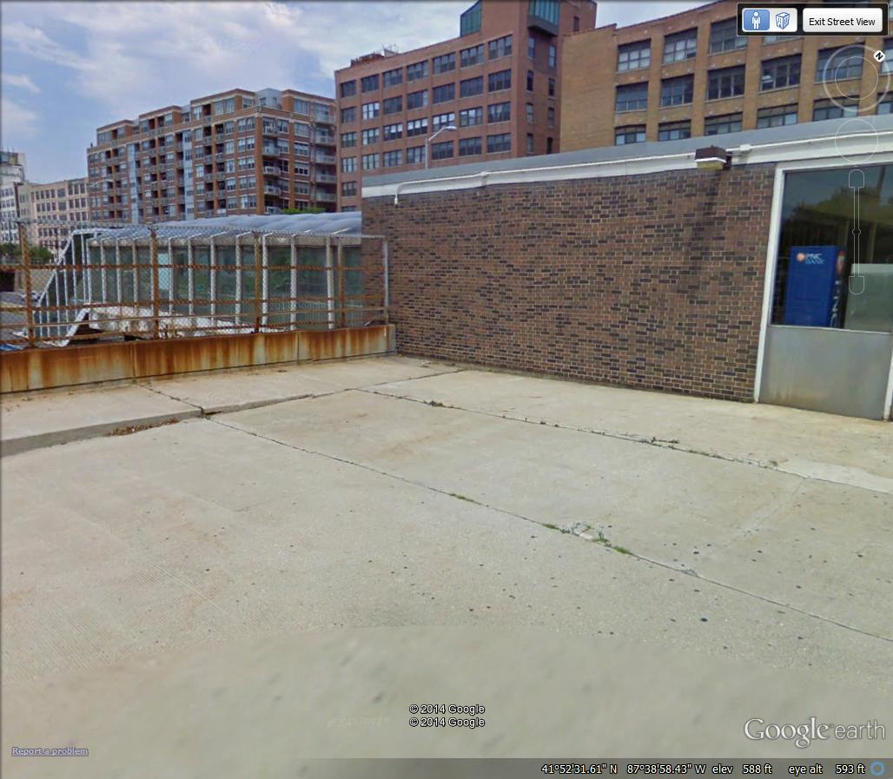

Dear Reviewers

Please find my enclosed proposal of my grant request of continuing research by construction of a living wall at 2S154 Churchill Lane along Illinois Route 53 near Huntington. Although this is private property, during a presentation for IDOT and the Morton Arboretum for living walls, IDOT’s Rick Wanner, landscape architect, recommended that I pursue texture plans on actual wall structures on the resident facing side of sound wall structures. Before such structures can be built, a smaller scale test of materials and builds that can be manufactured near current scales of sound wall panels need to be proven and repeatable.

My plan is to do a case study of ½ scale using various inset materials of textures, porosity and insets, while staying true to a typical structured environment next to a highway/transit area. The goal of this project is to take previous completed research from a hypothetical experimental scale for vertical infrastructure greening in transportation corridors to a the commercial scale. The caveats of success will be
- minimum maintenance with little additional cost after construction.
- better performance and longevity of the structures
- adding climate stabilizing factors,
- noise reducing,
- storm water reclamation and
- air quality enhancement.

More, we have done our research and have concluded that this will significantly add to the ability of land area available for green space, will be more pleasant for those who live or work next to sound walls and can be applied to buildings and transit areas as well.

Because of limited resources, the wall will be hand built out of materials that are basic and inexpensive. However, landscape materials (plants) and labor costs would help complete this next step in a better time frame.

Currently, TAs in the transportation funding is limited and a ½ scale real model is what is needed to complete the research in order to go to full scale industrial modeling. This grant would be very beneficial to us, as it would allow us to proceed with the next steps that usually have a funding gap now and allow us to complete the strategic stage of research before actually working onsite on actual sound walls on project site in 2015-2016.

Unlike other types of landscaping grants, because moss has two bloom period a year, (April-May and October-early November) I can be flexible on grant period timings and interchange fall and spring build and observation deliverable reports.

Thank you for your time and consideration.
Sincerely,
Mary Ann Kaufman, MUPP, principle investigator
makaufman@sbcglobal.net
2s154 Churchill Lane
Glen Ellyn, IL 60137
1-630-793-5064
I. Overview
In 2012, I completed a paper for a masters project for the feasibility of moss and associated flora on vertical infrastructures (retaining walls and sound wall applications). This paper was accepted for a degree. I was encouraged to continue my research in this area by mentors and IDOT staff. The reason for this encouragement is because of the untapped potential of this type of the structure’s landscaping features. With monies in transportation mostly available for maintenance, innovative ideas such as living walls will help with the increase of storm water currently plaguing impermeable surfaces associated with transportation corridors. This addition to sound walls and retaining walls will also keep government infrastructures in better compliance with sustainability mandates, which include a reduction of labor costs, an increase of infrastructure performance than currently exists, while capturing natural services for imperceptible benefits like fine particle reclamation.

III. Community response

Do an online poll showing pictures for feedback on how they like it. Submit by facebook and email to planners, landscapers, neighbor, and public. Poll pool size 1000 people.

IV. Budget

1 year salary | 12,000
Materials | 1000
Software | 500
Plants | 500
Total | 14,000

V. Timeline

Extra time in the beginning has been allotted for the highly changeable weather conditions of spring. Assuming grant is awarded after first hard freeze. Please keep in mind that Spring and Fall are interchangeable.
Date | Tasks | Deliverable
Spring (April, May) | Acquire materials and construct structure  Spray with alge/moss spore solutions  Add plugs where necessary | Record all data
Summer (June, July) | Add Additional plants as nursery guideline appropriate based on night time temperatures  Conduct sound, thermal, air quality steps  Conduct poll | Submit first report
Fall (September, October) | Assess success which includes plant hardiness and weeds, re-apply and algae mixture if needed | Record all data
Winter (November) | Submit second report | Submit second report
2nd Spring (April May) | Assess success, soundness of structure and any re-application of plants/repairs/weeding | Record final data and submit final report

VII. Deliverables
- Initial build report which includes (approximately 16 weeks after start)
  - Labor time and costs
  - Structure materials and costs
  - Plantings (Latin names included)
  - Sound reduction tests
  - Thermal reduction tests
  - Air quality tests
  - Picture records of steps
  - Video documentary
- First growth study report which includes (Delivered at the end of October or May)
  - Success or failure of species, and surface treatments
  - Costs of additional plantings
  - Any repairs needed on the wall structure itself after storms or incidences
  - Actual maintenance hours
  - Re-bloom of moss success or failure
- Final Report (June 1st following previous October report)
    - Success of first annual moss blooming period
    - Succession of native orchids success
    - General successive species
    - Gaps
    - Any damage from winter and spring thaw
    - Documentations of most and least successful plants, infrastructure design.
    - Recommendations for actual industrial processes for manufacture

