CMAQ FY 2016-2020 INPUT MODULE WORKSHEET ☐ Before Improvement
(Complete one worksheet for before conditions and one worksheet for after conditions ☐ After Improvement

General Information |  |  | Site Information
Analysis Time Period: PM Peak  Analysis Year |  |  | Intersection  Area Type CBD Other Jurisdiction
Intersection Geometry (draw or attach)
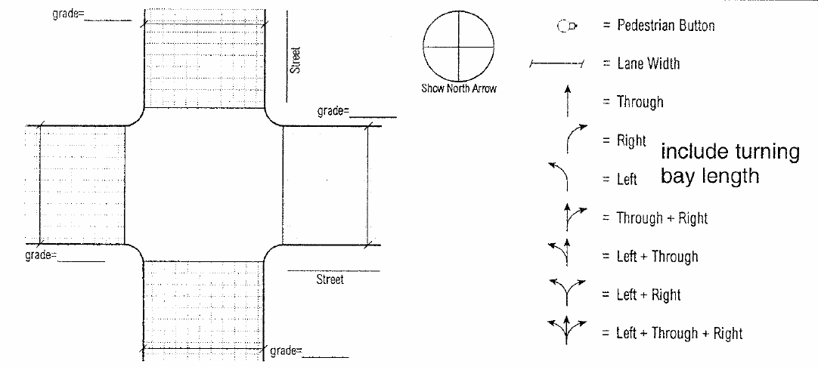

Volume and Timing Input
 |  |  |  |  | EB |  |  |  | WB |  |  |  |  | NB |  |  |  | SB
 |  |  |  |  | LT | TH |  | RT¹ | LT |  | TH | RT¹ |  | LT | TH |  | RT¹ | LT |  | TH | RT¹
Volume, V (veh/h)
% heavy vehicles, % HV
Peak-hour factor, PHF
Pretimed (P) or actuated (A)
Start-up lost time, I₁ (s)
Extension of effective green time, e (s)
Arrival type, AT
Approach pedestrian volume,² v_{ped} (p/h)
Approach bicycle volume,² v_{bic} (bicycles/h)
Parking (Y or N)
Parking maneuvers, N_{m}, (maneuvers/h)
Bus Stopping, N_{B} (buses/h)
Min. timing for pedestrians,³ G_{p} (s)
Signal Phasing Plan
Diagram | 01 | 02 |  | 03 |  |  | 04 |  |  | 05 |  |  | 06 |  |  | 07 |  |  | 08
Timing | G=  Y= | G=  Y= |  | G=  Y= |  |  | G=  Y= |  |  | G=  Y= |  |  | G=  Y= |  |  | G=  Y= |  |  | G=  Y=
Protected turns |  |  |  | Permitted turns  Pedestrian |  |  |  |  |  |  |  |  | Cycle length, C = s
Notes
- RT volumes, as shown, exclude ROR
- Approach pedestrian and bicycle volumes are those that conflict with right turns from the subject approach.
- Refer to Equation 16-2

ACTUATED CONTROLLER PRPOERTIES

Scheme:

Reverse

1 2 3 4

1

5 6 7 8

Reverse

Phase Settings (All times are in seconds)

Phase | 1 | 2 | 3 | 4 | 5 | 6 | 7 | 8
Max Green
Min Green
Amber
All Red
Veh. Ext.
Min Recall
Max Recall

ACTUATED CONTROLLER COORDINATION

Use Coordination Note: All times are in seconds

Phase | 1 | 2 | 3 | 4 | 5 | 6 | 7 | 8
Force-off |  | 0 |  |  |  | 0
Phase can terminate before force-off
Permissive 1
Period 2
Flags

 | Yield Point |  |  | Cycle Length
Extended Side-Street Leading Left-Turn Phases

Phase |  | Duration
Phase |  | Duration

Permissive Periods

Begin Times
1 |  | 2 |  | 3
End Times
1 |  | 2 |  | 3

