Testimony to the Illinois General Assembly
House Transportation Committee on Regulation, Roads, and Bridges

December 19, 2017

Subject Matter: Cost of Maintaining Existing Infrastructure

Submitted by Chicago Metropolitan Agency for Planning
Joseph C. Szabo, Executive Director

I thank the committee for this opportunity to address the core of our region's economic competitiveness and quality of life – the transportation system of metropolitan Chicago, including roads, transit, and freight.

This region first took shape based on its strategic location, with waterways that dictated how settlements and later growth took place over the past two centuries. Metropolitan Chicago is home to a vast multimodal transportation system and these roads, bridges, railroads, transit networks, waterways, and ports are the primary reason Chicago became the global metropolis it is today. The value of our transportation assets cannot be overstated: No economy will grow any faster than its transportation system can carry it. Our system is the nerve center of our economy, carrying $1.3 trillion of goods each year.

And yet this prized economic asset—the historical competitive advantage of our region—is slipping through our fingers. CMAP analysis shows we have reached a crisis in transportation funding that threatens to stunt our economic growth and negatively impact our resident’s quality of life. To simply operate and maintain our aging system in its current condition through 2050—not including any required modernization or expansion—we face a shortfall of $24 billion of reasonably expected revenues. Providing the modern system to sustain and grow our economy will cost much more.

About CMAP
The Chicago Metropolitan Agency for Planning (CMAP) is the federally designated Metropolitan Planning Organization (MPO) for the seven counties of Cook, DuPage, Kane, Kendall, Lake, McHenry, and Will. Its state and federal mandates require CMAP to conduct comprehensive regional planning, prioritize transportation investments, provide technical assistance for communities, and compile data resources that enhance decision-making.

At CMAP we think long-term, and we’re currently developing the ON TO 2050 long-range plan for our region. As part of the ON TO 2050 plan development that is required by law, CMAP must prepare a financial plan, including the anticipated expenditures and revenue sources necessary to carry out the operation, maintenance, and expansion of the region’s surface transportation system over the planning period (2019-50). To be eligible for Federal Highway and Transit Funding, a project must be in our plan. And no transportation project can go in the plan unless it fits within "reasonably expected revenues," the standard applied by CMAP using strict federal guidelines to ensure accountability and fiscal constraint.

Where We Are
The capacity of our system is enormous, which is both a strength for our regional economy and a significant maintenance challenge. On an average weekday, people in the Chicago region travel a cumulative distance of more than 136 million miles. Our transit provides over 2 million rides per day. During peak demand, over 1.2 million people are simultaneously on the move on our roads and rails. And as North America’s freight hub, between a quarter and a third of all of the nation’s freight moves through our region.

But these assets pose tremendous challenges that are not being met. Today nearly one among every four highways in the region are in unacceptable ride condition. Eight percent of our bridges are structurally deficient. More than 30 percent of our transit system is not in a state of good repair. And residents are paying the hidden costs of congestion—more than $7 billion a year in lost time, fuel, and productivity due to excess traffic congestion.

And our infrastructure is old. To cite just one example that some of you probably drove over today, the North Lake Shore Drive Bridge was completed in 1937, and President Franklin Roosevelt attended its dedication. In addition to getting older, our system faces the newer challenge of harsher flooding, freeze-thaw cycles, and extreme heat that damage our infrastructure, pose safety hazards, and cause congestion.

Federal aid has stagnated. Although passage of the "Lockbox" Constitutional amendment brought important attention to infrastructure needs, it did not increase funding. Moreover, state and local revenues are declining or stagnating–-this includes motor vehicle registration and motor fuel tax revenues as trends shift in vehicle ownership and cars become more fuel-efficient. The available revenues have diminished spending power as costs of goods and services throughout our economy continues to grow. The lack of regular capital bills has significantly crippled our ability to address long-term and ongoing needs in a systematic manner.

As a result, IDOT, our region's transit providers, the counties' transportation departments, and municipalities have been under-funded for decades. Finding efficiencies is a central part of how we maintain and invest in our infrastructure, but this is no longer a matter of budget cutting or doing "more with less."

Our transit system is one of the nation’s most efficient, with the lowest cost per passenger mile of any transit system in the country. To maintain safety and efficiency, Metra must entirely rebuild the coaches in their fleet each car, many of which started rolling during the Eisenhower Administration and should be eligible for Medicare. Most of the CTA system opened in the 19th century. These legacy systems require constant renewal to operate in peak condition—and this takes resources.

Municipalities have increased efficiency through joint purchasing and contracting with their neighbors, implemented pavement management plans, and coordinated street repair with water main replacement, all to deal with scarcity of funds. While all helpful, these are simply Band-Aids to the broader challenge: Our roads, bridges, and transit system require major reinvestments to meet the needs of a growing regional economy.

The state MFT has remained at $0.19 per gallon since 1991. As a per-gallon tax, MFT revenues have failed to keep pace with inflation in construction costs over the past quarter-century. State MFT revenues have generally been declining since 2007, when they reached a high of $1.4 billion statewide. This can be partially explained by a decline and stabilization in statewide vehicle miles traveled. After growing steadily throughout the 1990s and early 2000s, miles traveled peaked in 2004 but have held fairly steady with periodic declines since then. Additionally, the consumption of motor fuel has declined more steadily and faster than vehicle miles traveled, primarily a result of rising vehicle fuel economy.
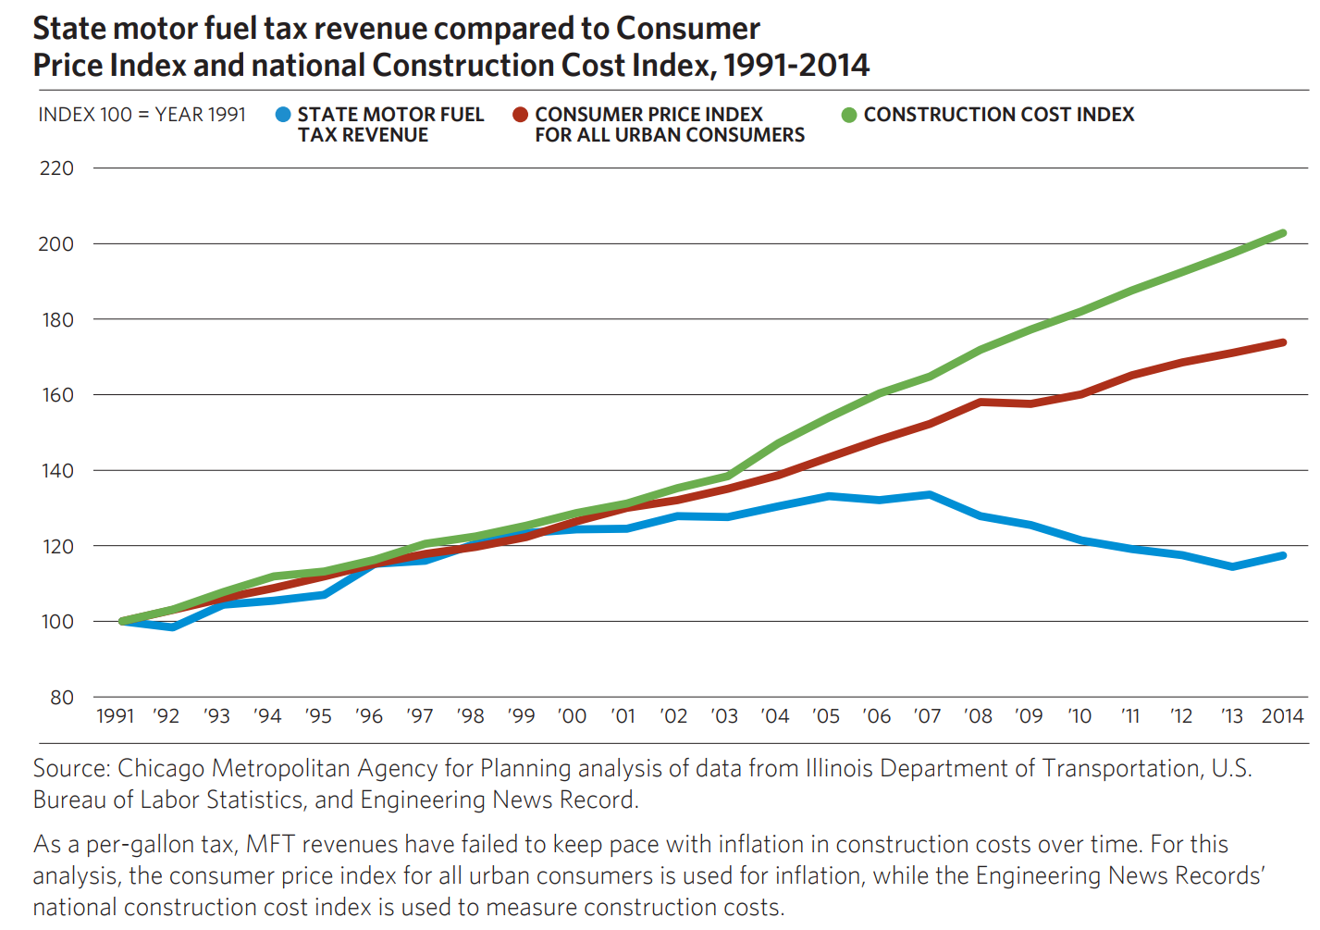

A CMAP issue brief provides a high-level overview of transportation revenues in the region and potential steps to secure adequate funding. To operate and maintain the system in its current condition through 2050—not including modernizing or expanding—we face a shortfall of $24 billion of "reasonably expected revenues."

Where We Need to Be
We must safely, reliably, and efficiently move people and goods through our region if we plan to grow and ensure high quality of life for our residents. To compete in the modern economy requires a modern revenue regime that generates adequate funding for our infrastructure.

Prior CMAP analysis recommended that the state motor fuel tax be increased 8 cents per gallon and indexed to inflation. But with the passage of time this is no longer adequate. Recent analysis indicates that figure must now be in the 10-15 cents per gallon range. And over the longer term, gas taxes will eventually need to be replaced by more efficient user fees, as vehicles switch to alternative energy sources.

CMAP has analyzed potential alternatives to the MFT, including a vehicle miles traveled fee, a motor fuel sales tax, and a vehicle registration fee, against several key criteria.

To provide adequate revenue in the long term, the state MFT needs to be replaced. Vehicles have become increasingly fuel-efficient, and further improvements in fuel economy are expected well into the future. In addition, a flat, per-gallon rate fails to keep pace with inflation over time. In the study, a vehicle miles traveled fee does well against the criteria, and subsequent work on this topic points to implementing a vehicle miles traveled fee as a potential recommendation in ON TO 2050. CMAP has identified the following criteria:

Criteria for Evaluating Potential Motor Fuel Tax Alternatives
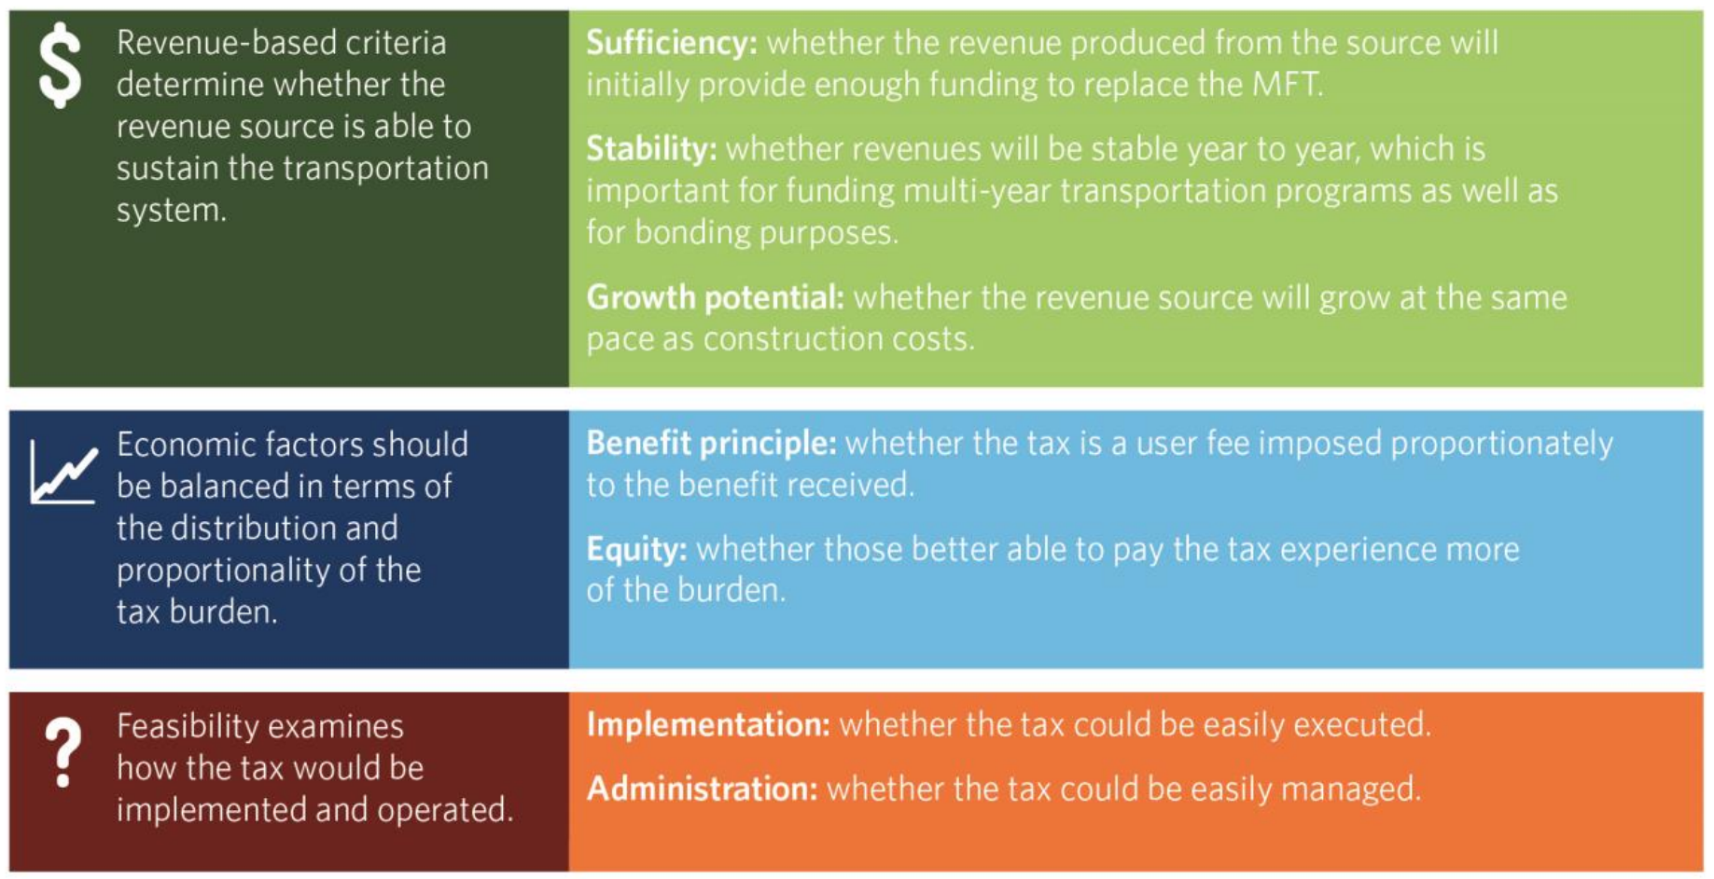

As summarized below, each of the three primary alternatives has advantages and disadvantages that must be weighed.

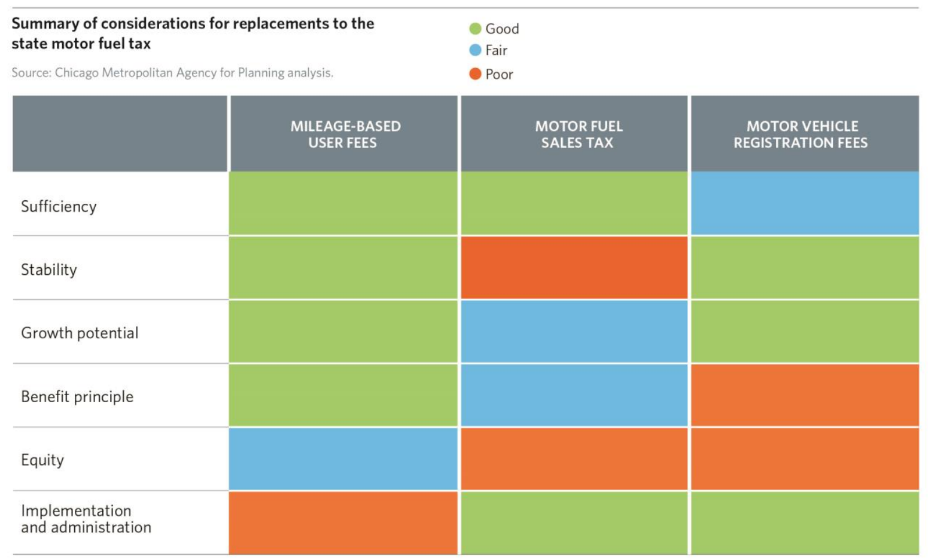

Summing Up
The challenges to our transportation system are vast and growing. Other states—including our neighbors to the east—have taken bold steps to secure their economic future by passing a significant gas tax increase to modernize their infrastructure. Such choices are never easy, but the alternatives—reduced safety, economic stagnation and diminished quality of life—are far worse.

No economy can grow faster than its transportation system will carry it, and the transportation system of Northeastern Illinois has historically been our greatest asset. But CMAP analysis shows it is suffering from inadequate revenues to maintain, modernize and expand it to meet our future needs. I urge the Illinois General Assembly to show the same foresight as your Indiana counterparts by coming together and implementing sustainable revenue for the critical infrastructure needs of our great state and region.

