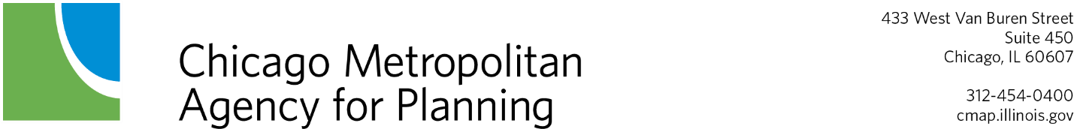

FFY 2022 – 2026 STP – Shared Fund Project Manager Designation Form
According to the Active Program Management policies for the STP Shared Fund, the project sponsor must designate a Technical Project Manager and a Financial Project Manager for each active or contingency project. The project managers are responsible for knowing the project status, and understanding the federally funded project implementation process, and STP Shared Fund program policies throughout the life of a project. Project managers are also responsible for all communications with CMAP regarding projects and for the timely completion of required quarterly status updates.
Project managers must be members of the sponsor agency’s staff. In the event of staff changes, the project sponsor should designate a new manager(s) as soon as possible by completing a new Project Manager Designation Form. The Technical Project Manager and Financial Project Manager generally should not be the same person, unless the Technical Project Manager has a direct role in developing the sponsor’s budget and/or securing local funding. For each project phase utilizing consulting services, a Consultant Project Manager must also be designated from the consulting team.

Project Information
TIP ID: | Click to enter. | Project Sponsor: | Click to enter.
Project Description: |  | Click to enter.

Technical Project Manager
The Technical Project Manager is the person responsible for overseeing the implementation of the project, managing any consultants involved in the project, ensuring that all federal, state, and local requirements are met and, in conjunction with the Financial Project Manager, ensuring that the required agreements between the sponsor agency and IDOT are approved and executed in an appropriate and timely manner.
Name: | Click to enter. |  |  | Title: | Click to enter.
Phone: | Click to enter. | E-mail: | Click to enter.

Financial Project Manager
The Financial Project Manager is the person responsible for ensuring that any required local matching funds are included in the sponsor agency budget in the appropriate fiscal year(s) in which federal obligation and/or project expenditures will occur, and, in conjunction with the Technical Project Manager, that the required agreements between the sponsor agency and IDOT are approved and executed in an appropriate and timely manner.
Name: | Click to enter. |  |  | Title: | Click to enter.
Phone: | Click to enter. | E-mail: | Click to enter.

Consultant Project Manager(s)
For each phase of the project for which a consulting firm will be hired, a Consultant Project Manager must be designated. The Consultant Project Manager is not eligible to complete required quarterly status updates, but may be included in correspondence with CMAP regarding technical details of projects.
Phase 1 Engineering: ☐ N/A – In-house staff ☐ TBD pending selection
Consulting Firm: |  | Click to enter.
Name: | Click to enter. |  |  |  | Title: | Click to enter.
Phone: | Click to enter. |  | E-mail: | Click to enter.

Phase 2 Engineering: ☐ N/A – In -house staff ☐ TBD pending selection
Consulting Firm: |  | Click to enter.
Name: | Click to enter. |  |  |  | Title: | Click to enter.
Phone: | Click to enter. |  | E-mail: | Click to enter.

Phase 3/Construction Engineering: ☐ N/A – In -house staff ☐ TBD pending selection
Consulting Firm: |  | Click to enter.
Name: | Click to enter. |  |  |  | Title: | Click to enter.
Phone: | Click to enter. |  | E-mail: | Click to enter.

Form Submittal
☐ New ☐ Update
Date Completed: | Click to enter.
Completed By (Name and Title): |  | Click to enter.

Please email this completed form to: transportation@cmap.illinois.gov, with a copy to your subregional planning liaison.

