Application form:
Community Planning Program and
Local Technical Assistance Program

DEADLINE: Noon on Thursday, June 26, 2014
This application form is online at www.rtachicago.com/applications. You may submit the form by email to applications@rtachicago.com.
Upon receipt of application, you will receive an e-mail verifying that your application has been received.

1. Name of Applicant: Village of South Holland

2. Main Contact for Application (please include name, phone number and email):
Jason Huisman (Village Administrator)
jhuisman@southholland.org
708-210-2900
3. Type of Applicant (please check any that apply):
__X__ Local government
____ Multijurisdictional group* Please list the members of the group (including
government and nongovernmental organizations):
__________________________________________
__________________________________________
__________________________________________

____ Nongovernmental organization* Name of local government partner(s):
__________________________________________
__________________________________________
__________________________________________

*Applications submitted by multijurisdictional groups and nongovernmental organizations must include a letter indicating support from each relevant local government. See the FAQs for more information. Nongovernmental applicants are strongly encouraged to contact CMAP or the RTA prior to submitting their application to discuss their project and the demonstration of local support.

4. Project Type (please check any that apply):
Please check all statements below that describe characteristics of your project. (This will help us determine whether your project is best handled by CMAP or RTA.)

__X__ My project involves preparation of a plan.
__X__ My project helps to implement a past plan.
__X__ My project links land use, transportation, and housing.
__X__ My project has direct relevance to public transit and supports the use of the existing transit system.
____ My project is not directly related to transportation or land use, but implements GO TO 2040 in other ways.

5. Project Location:
Please provide a brief description of the location of your project. You may include a map if that helps to describe location, but this is not required. If your project helps to implement a past plan, please include a link to that plan.
The Village of South Holland is approximately 19 miles south of downtown Chicago and 4 miles west of the Illinois/Indiana state border.
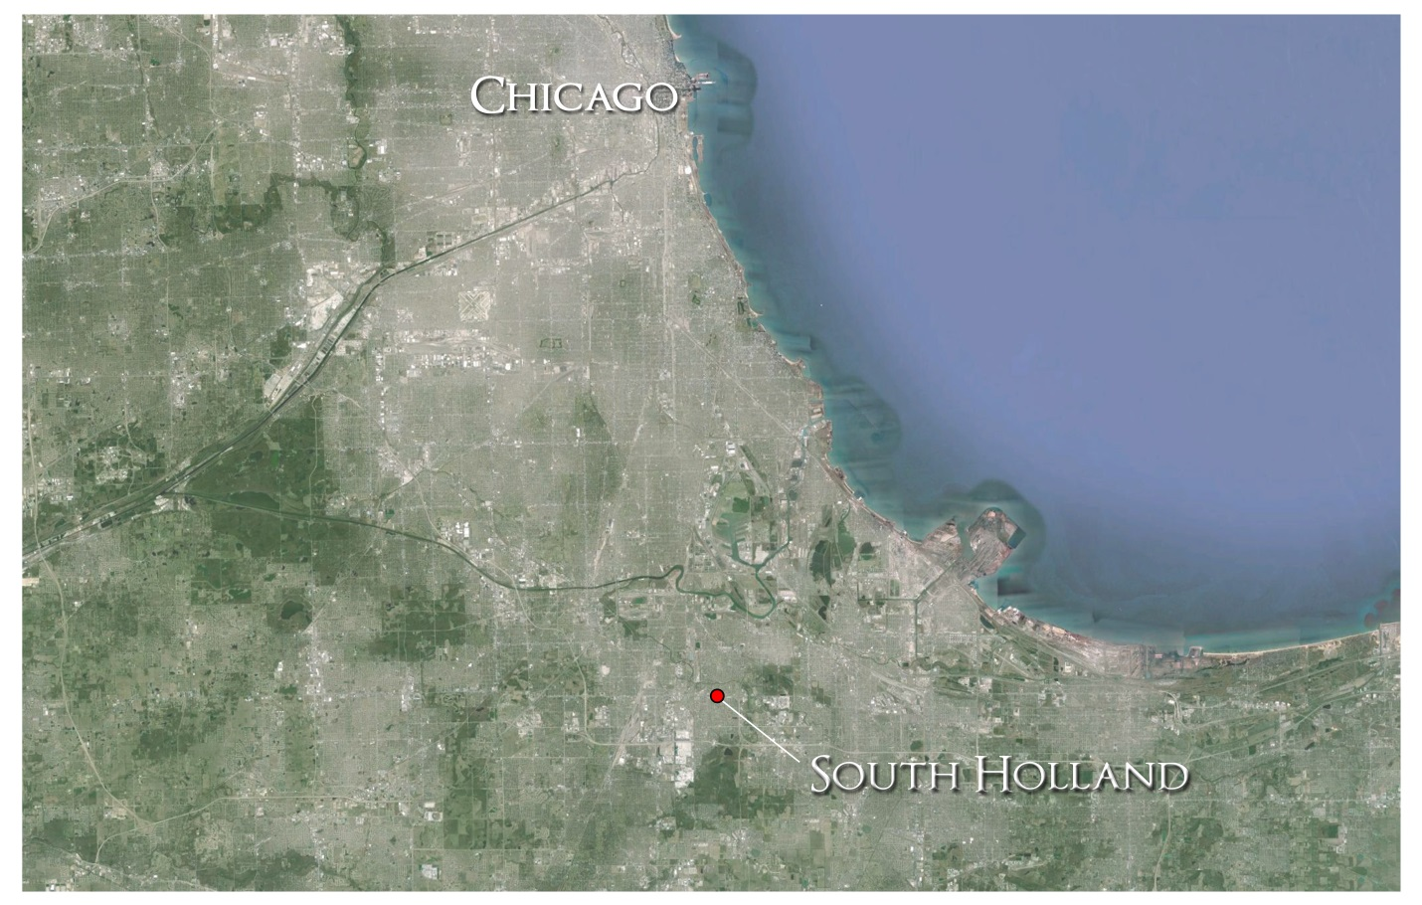

Vision 2022 link:
http://www.southholland.org/index.php?page=Vision2022

6. Project Description:
Please tell us what you would like to do in your community, and what assistance is needed. If you have more than one idea, please submit a separate application for each project. Please be specific, but also brief (less than two pages per project idea)—we simply want to have a basic understanding of what you want to do. CMAP and RTA staff will follow-up with you if we need any additional information to fully understand your proposed project.
(Please include any additional information that is relevant, preferably by providing links to online documents.)

The Village of South Holland is requesting CMAP and RTA participation in evaluating, updating and expanding our strategic plan, which is a long-term vision for the direction of our community. The expanded strategic plan would serve as a comprehensive plan document for the village.

The Village of South Holland began an in-house Strategic Plan that was adopted in 2012. This is a 10 year plan that has been titled “Vision 2022”. It contains policy that is linked to specific actions that can be taken at the municipal level. We feel it is important to continually reassess our established plan and adjust according to changes that our community may experience. For this reason, we feel that the LTA program would be hugely beneficial in moving our community through this reassessment process.

The key elements that this Strategic/Comprehensive Plan would address would be land use, economic development, housing, natural resources, transportation, community facilities, image and identity, and the implementation of this created plan. The staff or consultant selected for the plan would collect and analyze data for each of these elements. This data would be used to evaluate the policy and implementation actions listed in the current plan and suggest additional content. Ultimately, this document would become the policy and legal basis for the revision of the Village’s codes and development of subarea plans.

Specifically, the Village desires to formulate long-term planning objectives associated with, but not limited to, the following elements of our community:

-Transit-oriented development located within our established Town Center, stemming from the new METRA line (South East Service Line) which, as proposed, includes a South Holland station.

-Expand Route 6 shopping opportunities westward from River Oaks Mall, in Calumet City, by attracting major commercial and retail development to the Interstate Zoning District (IZD) and the Gateway East corridors.

-Cargo-oriented development located within our Industrial Park in response to the expansion of the Chicago Intermodal Terminal located in Harvey, IL.

-Continual development of vibrant green spaces to create a community for families through our natural resources.

-Explore how to best market the geographic advantages and ease of access to South Holland to the potential business market.

-Establish an official identity of the Village through branding and marketing.

-Determine how to best utilize existing incentives (TIF Districts, etc.).

-Explore new traditional and non-traditional residential housing opportunities.

-Evaluate the existing transportation network for deficiencies and identify areas for improvement.

The Village of South Holland is eager to continue the process of creating a vision for our future. We believe that the assistance of CMAP and RTA staff would be of great benefit to us and to our future as a community. Your consideration of our proposal is highly appreciated.

