Application form:
Community Planning Program and
Local Technical Assistance Program

DEADLINE: Noon on Thursday, June 26, 2014
This application form is online at www.rtachicago.com/applications. You may submit the form by email to applications@rtachicago.com.
Upon receipt of application, you will receive an e-mail verifying that your application has been received.

1. Name of Applicant: Village of South Holland

2. Main Contact for Application (please include name, phone number and email):
Jason Huisman (Village Administrator)
jhuisman@southholland.org
708-210-2900
3. Type of Applicant (please check any that apply):
__X__ Local government
____ Multijurisdictional group* Please list the members of the group (including
government and nongovernmental organizations):
__________________________________________
__________________________________________
__________________________________________

____ Nongovernmental organization* Name of local government partner(s):
__________________________________________
__________________________________________
__________________________________________

*Applications submitted by multijurisdictional groups and nongovernmental organizations must include a letter indicating support from each relevant local government. See the FAQs for more information. Nongovernmental applicants are strongly encouraged to contact CMAP or the RTA prior to submitting their application to discuss their project and the demonstration of local support.

4. Project Type (please check any that apply):
Please check all statements below that describe characteristics of your project. (This will help us determine whether your project is best handled by CMAP or RTA.)

__X__ My project involves preparation of a plan.
__X__ My project helps to implement a past plan.
__X__ My project links land use, transportation, and housing.
__X__ My project has direct relevance to public transit and supports the use of the existing transit system.
____ My project is not directly related to transportation or land use, but implements GO TO 2040 in other ways.

5. Project Location:
Please provide a brief description of the location of your project. You may include a map if that helps to describe location, but this is not required. If your project helps to implement a past plan, please include a link to that plan.
The Village of South Holland is approximately 19 miles south of downtown Chicago and 4 miles west of the Illinois/Indiana state border.
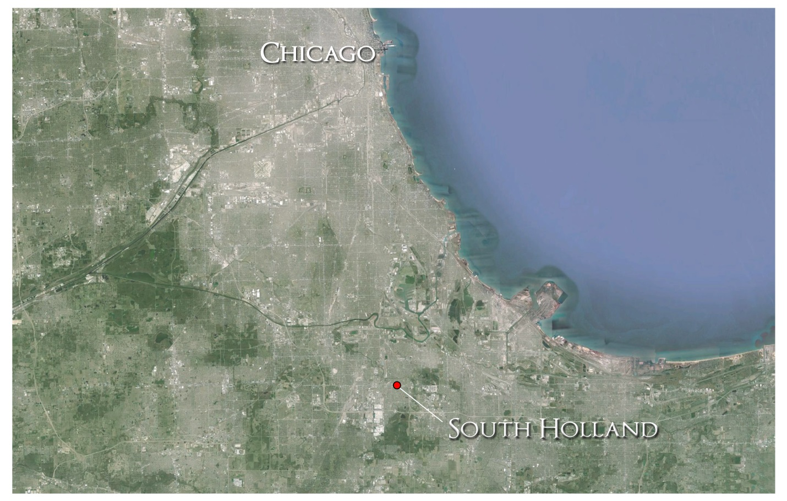

Vision 2022 link:
http://www.southholland.org/index.php?page=Vision2022

6. Project Description:
Please tell us what you would like to do in your community, and what assistance is needed. If you have more than one idea, please submit a separate application for each project. Please be specific, but also brief (less than two pages per project idea)—we simply want to have a basic understanding of what you want to do. CMAP and RTA staff will follow-up with you if we need any additional information to fully understand your proposed project.
(Please include any additional information that is relevant, preferably by providing links to online documents.)

The Village of South Holland is requesting CMAP and RTA participation in creating a Subarea Plan for our Interstate Zoning District. The Interstate Zoning District boundaries are created by Interstate 94 on the west and extend to the village limits to the east. The southern border is created by 170th Street and extends north to the Little Calumet River. An additional zone of the Interstate Zoning District is located in the southwestern portion of South Holland bordered by Interstate 80 and Halsted Street.

The Interstate Zoning District was created for the purpose of developing/redeveloping 187.5 acres of land located adjacent to Interstate 94, which is one of the most highly traveled interstates in the county.

South Holland established five sub-zones within the Interstate Zoning District that are intended to create uses unique to each zone, yet compliment the entire Interstate Zoning District, as a whole.

-Zone A, which is 30 acres, will be used for banquet and conference centers, hotels, restaurants, or new retail and wholesale stores.

-Zone B, which is 36.6 acres can accommodate any of the Zone A uses, as well as automobile or motorcycle dealerships and automobile parts and accessory stores.

-Zone C, comprised of 35.8 acres, is designated for business offices, professional offices, medical and dental clinics, public utilities and government services.

-Zone D, the largest parcel, is 72.6 acres. It has been designated for any uses in Zones A, B and C except automobile service stations, general business, office, warehouse and distribution, schools, business training facilities and light industry and assembly.

-Zone E, which is 12.5 acres, is designated for banquet/conference facilities, hotels/motels, restaurants (not including drive-up establishments), retail business and financial institutions.

The desire is to attract all categories of development through planning, incentives and marketing.

We are requesting assistance in determining how to best establish and promote the Interstate Zoning District through objectives associated with, but not limited to:

-Developing a Subarea Comprehensive Plan for the entire Interstate Zoning District.

-Determining best use of land through a subarea land use plan.

-Identify viable market opportunities of development.

-Evaluate available incentives to encourage growth.

-Developing a marketing plan for available property and the entire Interstate Zoning District.

-Reassessment of established design guidelines.

The Interstate Zoning District offers some of the most attractive property in our region. The appropriate developments can spur immense economic growth. The CMAP and RTA assistance would be helpful in determining how to best approach the future of the Interstate Zoning District. We are hopeful that you will consider this a viable candidate for the Local Technical Assistance Program.

