Table of Contents
Executive Summary 1
Recommendations 1
Introduction to Highway Management and Operations 1
Promoting Management and Operations in the MPO Planning Process 2
Strategies to Address Sources of Congestion 4
Incident Management 4
Traffic Incident Management Process 4
Emergency Responders 5
Traffic Incident Management Training and Quick Clearance 5
Driver Removal and Authority Removal Laws 7
Major Crashes and Investigations 8
PSAP Integration 10
The Need for PSAP-Traffic Operator Communications 10
Challenges and Solutions 11
Improved Detection and Verification 12
Full Function Service Patrols 13
Real Time Crash Information 14
Vehicle Automation & Connected/Automated Vehicles 14
Weather Response 16
Advisory Strategies 16
Control Strategies 17
Treatment Strategies 17
Construction 17
Laws to Promote Work Zone Safety 18
Work Zone Management 18
Traveler Information 19
Work Zone Duration and Active Hours 19
Interagency Coordination 19
Signals 19
Signal Maintenance and Timing 20
Signal Modernization, Coordination and Transit Signal Priority 21
Central Signal Systems 22
Interjurisdictional Coordination 22
Consideration of All Highway Users 23
Traffic Signal Audit 23
Special Events 23
Communications Backbone 24
Existing System 24
Maintenance 25
Expansion and Redundancy 25
Power 26
Traffic Management Centers 26
Regional Traffic Management Center Inventory 27
Integration of Centers 30
Municipal Traffic Management 30
Traveler Information 30
Pricing for Parking 31
Active Traffic Management 31
Active Interstate Management 32
Active Arterial Management – Smart Corridors 33
Integrated Corridor Management 37
Prioritization 41
Implementation Activities 41
Collaboration and Shared Resources 41
Regional Performance Goals and Operations Oriented Objectives 41
Regional Transportation Concept of Operations 41

Executive Summary

Recommendations

Introduction to Highway Management and Operations
(Murtha to add how highways operate, etc.)
National research has shown that an imbalance between demand and capacity accounts for about 40 percent of congestion. Many of the causes of congestion interact with each other, but perhaps 60 percent of congestion nationwide is caused by non-recurring sources – like incidents, construction, and weather -- that are best addressed by operational changes rather than capacity improvements.
Figure 1: Sources of congestion
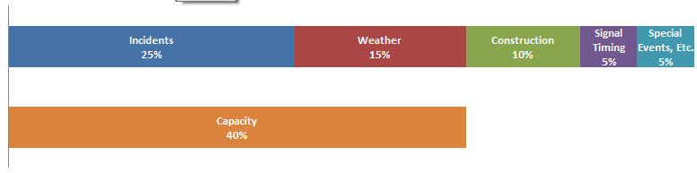
Source: FHWA Office of Operations
http://www.ops.fhwa.dot.gov/congestion_report/executive_summary.htm#overview

The application of improved highway management and operations techniques to address the other sources of congestion results in a system that operates more efficiently, reliably, and safely. The choices made in how to operate highways impact how the highways integrate with the communities they serve. A well-managed highway system works better for all users and reduces congestion, fuel use, and the time people and freight have to spend on the roadways. In fact, M&O strategies can contribute greatly to achieving the Regional Vision for northeastern Illinois’ transportation system. The region’s vision describes a system that is safe, accessible, easy to navigate, affordable, and coordinated with nearby land uses. It is a system that reduces congestion and improves regional mobility, and supports reinvestment in our existing communities.

Promoting Management and Operations in the MPO Planning Process
(Introduction with a discussion of Operation Greenlight)
There are a number of ways Metropolitan Planning Agencies can promote improvements to system management and operations strategies throughout regular MPO activities.

Committees – Many agencies host Intelligent Transportation or Operations committees specifically to work on operations planning. Since ITS and operations are so closely related, agencies sometimes do not differentiate between the two activities. CMAP hosts an Advanced Technology Task Force responsible for the Regional ITS Architecture and a Regional Transportation Operations committee comprising representatives of partner agencies and who can be consulted as needed.

Unified Planning Work Program – MPOs can fund planning for management and operations projects.
Operations Plans ( for example Regional Operations Strategy, Regional Concept for Transportation Operations, Intelligent Transportation System Strategic Plan) – Some regions develop 10 – 15 year operations plans which include goals and objectives for evaluating operations projects and often identify priority corridors or projects. A Regional Concept for Transportation Operations has been developed by only a few regions. This document defines outcomes partnering agencies want to achieve in one or more specific operational areas, formalizes existing collaborative arrangements and defines future ones. The process of developing the document helps the agencies come to agreement on goals, objectives and responsibilities. This document is more focused than general operations plan. There is a close relationship between the goals and objectives of the Congestion Management Process, the Long Range Transportation Plan, and the Operations plan. These plans can provide a basis for TSMO project funding priorities.

Long Range Plan Language - The long range plan is a policy document guiding the selection of projects a region wishes to fund. Inclusion of specific recommendations for management and operations provides a solid basis for funding these activities in the future. Most of the agencies included chapters describing existing management and operations conditions and recommendations for the future.

Set-aside Funding –Some regions dedicate funding for management and operations projects. The funds are generally accumulated from a combination of sources such as CMAQ, STP, Safety, or other state and local funds. Some agencies have developed a pool of funding specifically for traffic signal retiming, or funding highway safety patrols on an ongoing basis. Some regions have implemented local taxes used for transportation improvements and dedicated a portion of them to implementing management and operations projects. The goals and objectives identified in the CMP, LRTP, and operations plans are used to prioritize projects for funding.

The Federal government supports MPO participation in the planning and implementation of system management and operations and requires that the long range transportation plan include “Operational and management strategies to improve the performance of existing transportation facilities to relieve vehicular congestion and maximize the safety and mobility of people and goods.” (23 USC § 134(i)(F))

Table 1 : Examples of MPO Planning for Operations
Agency | Primary City | Population (millions) | Operations Committee | Regional Transportation Operations Plan | M&O Plan Chapter or Section | M&O Funding Set-Aside
Chicago Metropolitan Agency for Planning | Chicago IL | 8.3 | Yes | No | No | No
North Central Texas Council of Governments (NCTCOG) | Dallas-Ft. Worth TX | 6.4 | No | Yes | Yes | Yes
Delaware Valley RPC | Philadelphia PA | 5.6 | Yes | Yes | Yes
Maricopa Association of Governments MAG | Phoenix AZ | 3.8 | Yes | Yes | Yes | Yes
Puget Sound Regional Council PSRC | Seattle WA | 3.7 | Yes | Yes | Yes | No
San Diego Association of Governments SANDAG | San Diego CA | 3.1 | No | Yes | Yes | Yes
Denver Regional Council of Governments (DRCOG) | Denver CO | 2.8 | Yes | Yes | Yes | Yes
Portland Metro | Portland OR | 1.9 | No | Yes | Yes | Yes
MetroPlan Orlando | Orlando FL | 1.8 | Yes | No | Yes | Yes
Source: Programming for Operations: MPO Examples of Prioritizing and Funding Transportation System Management & Operations Strategies (FHWA, 2013), agency websites.

Recommendation

Strategies to Address Sources of Congestion

Incident Management
Incidents are estimated to cause 25% of the region’s roadway congestion. In 2014, there were 207,000 crashes in the CMAP region. In addition to crashes, there were an unknown number of other roadway incidents including broken down or abandoned vehicles, debris on roadways, and damaged or malfunctioning equipment. Each incident presents an opportunity to reduce congestion through earlier detection and verification, faster response, and adherence to quick clearance principles. Reducing the amount of time incidents impact traffic reduces congestion, secondary incidents and incident related delay. The Illinois Tollway has been especially successful with its incident management system, maintaining a 4% rate of secondary crashes while nationwide the rate is 18%.

Traffic Incident Management Process
The traffic incident management process includes a number of steps. With each step, there is the potential to reduce the total amount of time needed to return traffic to normal flows.
Figure 2: Timeline of incident management process
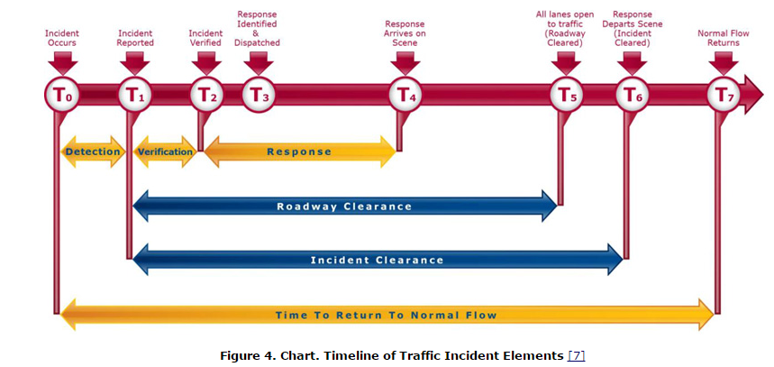

http://www.ops.fhwa.dot.gov/publications/fhwahop15007/chapter1.htm

Emergency Responders
The region is served by a system of 911 call centers, also known as Public Safety Answering Points (PSAPS) that answer emergency calls and dispatch appropriate emergency responders (police, fire, ambulance, vehicle towing and recovery). In January 2016, Public Act 099-0006 requires counties to reduce the number of 911 centers by half, and creates an office of Statewide 911 Administrator within the Illinois State Police to develop, implement and oversee a uniform 911 system, excluding municipalities with more than 500,000 residents (City of Chicago).
The region’s tollway system is patrolled by the Illinois State Police (ISP) District 15. The dispatch for ISP District 15 is housed within the Illinois Tollway Building. ISP District 2 serves the non-tollway interstates in DuPage Kane, Lake and McHenry Counties. ISP District 5 serves non-tollway interstates in Kendall and Will Counties. ISP Chicago District serves Cook County non-tollway interstates. The arterial system is patrolled by county and municipal police departments.
The entire system of interstates and arterials relies on response from fire, rescue and towing/recovery staff from local jurisdictions.

Traffic Incident Management Training and Quick Clearance
When emergency personnel are on the scene of a traffic incident, there is the ever present danger of a responder becoming a crash victim. When a responder is struck by a vehicle, not only is it a tragedy for the individual and family, but it can turn a relatively minor incident into a major disruption. A component of quick clearance laws, called “Scott’s Law,” 625 ILCS 5/11-907(c), was enacted in Illinois and mandates that upon approaching a stationary authorized emergency vehicle, when the authorized emergency vehicle is giving a signal by displaying alternately flashing red, red and white, blue, or red and blue lights or amber or yellow warning lights, a person who drives an approaching vehicle shall: reduce the speed of your vehicle; yield the right-of-way by changing lanes away from an authorized emergency vehicle; and proceed with due regard to safety and traffic conditions. All fifty states have enacted a move over laws.
Table 2: Fatal and Injury Crashes on Illinois Public Roadways
Year | Police | Fire | Ambulance | Towing | Total
2010 | 670 | 51 | 76 | 127 | 924
2011 | 611 | 42 | 64 | 125 | 842
2012 | 533 | 33 | 63 | 90 | 719
2013 | 532 | 52 | 82 | 110 | 776
Total | 2346 | 178 | 285 | 452
Source: IDOT Division of Traffic Safety, Safety Data Mart
Effective traffic incident scene management is one way to improve safety for responders and also to make navigating the area safer for drivers. Interviews with highway system operators indicated that performance in this area was very uneven, and they expressed a desire for CMAP to work with our local agencies towards better performance and standard traffic incident management procedures.
The Illinois Department of Transportation recognized the need and worked with the Illinois Center for Transportation at Southern Illinois University to develop a training program intended for law enforcement, fire departments, emergency medical personnel, tow and recovery operators, highway department staff, and 911 center operators. The training includes incident command system training, response vehicle parking guidelines, the use of high visibility apparel, on-scene emergency lighting procedures, and the use of temporary traffic management devices including queue warnings.
Starting in January 2016, “every person operating a towing or recovery vehicle on behalf of the towing service must have completed a Traffic Incident Management Training Program approved by the Department of Transportation” to be included on a police tow rotation list. This requirement has been effective in training tow truck operators. The same law specifies that Illinois State Police must also receive the training by June 30, 2016.
Figure 3: Illinois Training Recipients as of November 16, 2015
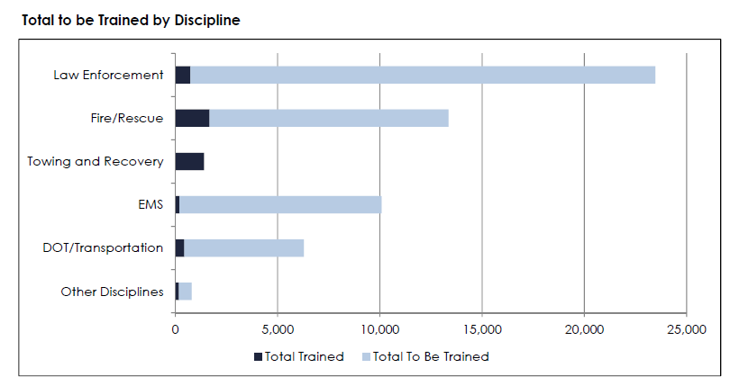
Source: Illinois Training Report, Illinois Department of Transportation (November 2015)
Potential Recommendation: CMAP should work with local governments to promote incident management training for law enforcement and fire/rescue organizations.

Driver Removal and Authority Removal Laws
Removal laws require that disabled vehicles and spilled cargo are moved out of driving lanes as quickly as possible if this can be safely achieved. According to FHWA, Illinois has passed Driver Removal and Authority Removal laws.
Driver Removal of Vehicles
Nearly 80% (160,000) of the crashes reported in northeastern Illinois in 2014 were property damage only crashes. As youngsters, many people were taught that when a crash happens you should keep the vehicles in place and call police. The current Illinois Rules of the Road guide states that “If you are involved in or come upon a traffic crash: Stop your vehicle in a safe, well-lighted public place that does not obstruct traffic, if able to do so...” Driver removal laws encourage or require drivers to move a damaged vehicle or cargo to the shoulder where it does not obstruct traffic and create a hazard. The most effective driver removal laws authorize any licensed driver on-site to move the vehicle. While FHWA reports that Illinois has enacted a driver removal law, anecdotally it seems that drivers involved in crashes often do not remove their vehicles from the traffic lanes.
Authority Removal of Vehicles
Authority Removal laws allow an authority, generally including police, fire, or department of transportation staff to order a driver to remove a vehicle from the roadway if it constitutes a hazard or obstructs traffic. The authority may also call a tow truck or push the vehicle and freight out of the roadway. It is useful to ensure that response vehicles are equipped with push bumpers so they can push disabled vehicles off the travel lanes while waiting for a tow. Illinois statute states that “When an abandoned, unattended, wrecked, burned or partially dismantled vehicle is creating a traffic hazard because of its position in relation to the highway or its physical appearance is causing the impeding of traffic, its immediate removal from the highway or private property adjacent to the highway by a towing service may be authorized by a law enforcement agency having jurisdiction.” The statute allows the removal to be ordered by law enforcement and does not extend to departments of transportation. Unrelated to this statute, departments of transportation have an obligation to maintain safe roadways and may choose to push a vehicle out of traffic to remove the hazard.
In addition to personal vehicles, authority removal laws include authority to remove commercial vehicles and their spilled freight. CMAP estimated that in 2007, there were a total of 1.5 billion truck trips made from, to or through northeastern Illinois. In 2014 commercial trucking crashes (tractor with trailer, tractor without trailer, single unit truck) represented only about 7% of the region’s crashes, but a crash that includes spilled cargo is a major incident. The need to clear the roadway should not be hampered by concerns about liability and damaged cargo.
Liability Protection for Incident Clearance Functions
Having the authority to remove vehicles is ineffective if authorities are hesitant to employ it. Departments of transportation expressed concern that if they tamper with a vehicle, they may be held liable for damages. There are model laws that address these concerns, such as the following suggested by the I-95 Corridor Coalition.
“Governmental agencies responding to incidents, including but not limited to law enforcement, firefighting, emergency medical services, hazardous materials, transportation agencies and other emergency governmental responders are authorized to exercise the incident clearance functions enumerated in this section. If such functions are exercised with reasonable care and at the direction of the incident commander, those governmental agencies and their personnel and other designated representatives are insulated from liability resulting from such actions taken pursuant to incident clearance, including:
- Incident detection and verification;
- Incident area security and protection;
- Rescue of persons from vehicles and hazardous environments;
- Emergency medical transportation and care;
- Hazardous materials response and containment;
- Fire suppression and elimination;
- Transportation of vehicle occupants;
- Traffic direction and management, and establishment and operation of alternate routes, including but not limited to traffic detours and/or diversion;
- Crash investigation;
- Dissemination of traveler information;
- Incident clearance, including removal of debris, coordination of clearance and repair resources, and temporary roadway repair and facilities restoration;
- Removal of vehicles and cargo;
- Any other actions reasonably necessary.”

Potential Recommendation: CMAP should advocate for extending Illinois Driver Removal and Authority Removal laws to include department of transportation staff as an authority, along with protection from damages. CMAP should develop informational materials to disseminate this information to local incident responders including departments of transportation.

Major Crashes and Investigations
A crash requiring an investigation may close a roadway for hours. The police department procedures and the technology used to collect data about the crash both impact the time it takes to complete the investigation and get traffic moving again.
Although the region does not currently track performance in the area of crash clearance, an analysis of detailed crash activity records (2008 – 2011) provided by the Illinois Department of Transportation provides a view into our performance. The dataset includes 16,170 incidents. Those listed as having clearance times of 0 – 12 minutes were excluded, as they were mainly removing debris from the roadways. The remaining 11,402 records were categorized based on identifying text in the activity record describing fire, injury/ambulance/hospital or fatality/coroner. About 10,000 records did not include these terms and are unclassified.
Table 3 Uncategorized Clear Time Percentiles in Hours for 10,146 IDOT Incidents on IDOT arterials and Controlled Access Expressways with a Range of 0.2 hrs. to 48.0 hrs. 2008-2011
25th Percentile | 50th Percentile | 75th Percentile | 95th Percentile | Median
1.55 | 2.93 | 11.16 | 33.96 | 2.93

The median clearance time for uncategorized incidents was 2.93 hours.
Table 4: Categorized Clear Times Percentiles in Hours for 1,256 IDOT Incidents on IDOT Arterials and controlled access expressways with a Range of 0.2 hrs.- 48.0 hrs (2008-2011)
Response Clear Times Categories | 25th Percentile | 50th Percentile | 75th Percentile | 95th Percentile | Median
Fire Department | 1.00 | 2.22 | 7.57 | 29.09 | 2.18
Injury/Ambulance/Hosp | 1.39 | 3.50 | 7.08 | 30.04 | 3.33
Fatal | 2.50 | 4.47 | 7.22 | 25.97 | 4.40

Kansas City Scout, the bi-state (Kansas, Missouri) traffic management system, implemented a traffic incident management program in 2007. Prior to that time, investigators gave no consideration to the implications of a highway shutdown and it was not uncommon for it to take 4 to 6 hours to clear the roadway. The Kansas City Police department typically wouldn’t call a Medical Examiner until the police work was finished and would not call for tow trucks until everything was done. Following a 2007 Traffic Incident Management Summit, vehicle crash squads were established, and a target of 90 minutes maximum closure time was adopted. As a result, secondary incidents were reduced by 47%, and the average time to clear incidents was reduced from 39 minutes to 22 minutes. For level 3 incidents (>90 minutes) average incident duration was reduced by 111 minutes.
Improved technology can also aid in crash investigations. Crash reconstruction requires measuring the locations of items at the crash scene, and has traditionally relied on officers with roll wheel and steel tape rulers. Newer technologies such as total station electronic measuring devices and photogrammetry can reduce the time needed for taking measurements and open the road to traffic more quickly. We do not know how many police departments in our region use roll wheel and tape measurers versus the newer technology.
Potential Recommendations: CMAP should work with municipal, county, and state police to establish a goal of reducing the amount of time roads are closed due to crashes and develop a plan for achieving the goal.

PSAP Integration
Today incidents are most frequently detected through 911 calls or discovery by a patrolling vehicle. Except in the case of the Illinois Tollway, who has automated the exchange of information between the ISP and the Tollway Traffic Incident Management Center, and Lake County DOT who has been successful in establishing the same communication with local 911 centers, departments of transportation may remain unaware of the existence of an incident.
The region’s transportation agencies utilize technologies such as traffic signal timing, ramp metering, dynamic message signs, media notifications, websites, and highway advisory radio (HAR) to manage the transportation network during major incidents. Transportation agencies also have field operations staff to respond to incidents, including IDOT and Tollway service patrols, highway maintenance crews, and contract services to remove spills and debris, repair damaged pavement, communications, signals, regulatory or warning signs, and safety equipment. The timely and accurate availability of crash or other traffic event data is critical to the effective deployment of these resources and timely communication to the motorist.

The Need for PSAP-Traffic Operator Communications
Currently, the regional transportation partners use a variety of mechanisms to detect and verify incidents. These include closed-circuit television (CCTV) on parts of the system, and sensing devices that may detect declining system performance. However, these systems do not fully cover the entire region, so communications with public safety agencies that have timely and accurate information, including PSAPs, is necessary. PSAPs have the timeliest and most accurate information as highway incidents occur, so some transportation agencies are seeking direct communications with computer-aided dispatch (CAD) systems operated by PSAPs.
Current dispatch communications usually work well. However, during the most critical periods, during major incidents when public safety resources are being deployed, transportation communications may be a lower priority. This has resulted in significantly delayed responses to major incidents. As one transportation operations manager put it, “when the system fails, it fails catastrophically.”
PSAP-to-Transportation-Operator Integration efforts have been successfully undertaken at a few key locations in the region. These efforts have been mutually beneficial in several regional examples. PSAP CAD data, provided automatically to traffic management centers, has improved incident detection and response times and incident notifications. Collectively, the region’s transportation operators are certain that additional integration efforts will further enhance the safety and mobility of the region. In addition, beginning in 2014, new federal regulations required the timely and accurate dissemination of traffic incident data.
The benefits to this type of integration include:
- More timely notification and response for the transportation agency.
- Reducing the need for additional phones calls in the midst of major events.
- Ability for emergency response, including dispatchers, to ‘see’ the event often via shared CCTV access.
- Increased coordination between transportation and emergency response in the dispatch of resources.
- Improved safety approaching the scene as transportation operators can quickly use traveler information such as the media and message signs to notify the public, increase awareness, and reduce speeds approaching the event.
- Overall reduction in associated congestion and total clearance time.
- A more consistent and trusted relationship between agencies when addressing traffic event response.

Challenges and Solutions
PSAP-to-transportation operator information exchanges typically require development of formal operational policies and agreements. Before those can occur, participants must understand the information to be shared, when it will be shared, and with whom it will be shared. Once the stakeholders agree on the needs and benefits, answers to the following questions will drive those policies and agreements.
The information exchanged within these systems is private and sensitive. How do we ensure it stays that way? With today’s computer hardware and software systems, the network connections between the transportation and CAD system invariably include firewalls and secure account access. Regularly, these connections utilize agencies’ dedicated communications services. Beyond the connectivity of the hardware, these integration efforts always include a detailed design that addresses exactly which information is to be exchanged and when. Information regarding non-traffic events, names of those involved, license plate information and more sensitive law enforcement data can be readily filtered out of the exchanges. Dispatch centers have a lot of data. What does the transportation agency need? Event type, detailed location including route, direction, cross street, mile post, or street address, and lane blockage patterns are ideal. Access to CAD system notes is also helpful in painting the complete picture of the event, which in turn influences the efficiency of responses.
Once this information is available, the transportation agencies can dispatch their own resources to assist with spills, debris, and roadway infrastructure repairs such as pavement repair, traffic signal repairs, and other required support such as guardrail and bridge repairs or inspections. What does the transportation operations side have to offer to the PSAPs, Police, Fire and EMS? In addition to supporting resources, shared access to CCTV video, including control, is common in these arrangements. The traveler information components can alter and improve driver performance approaching an incident, thus contributing to a safer scene. Traditional congestion data, travel times, and even construction information likely support the efficiency of event responses.
The use of traffic signal timing and ramp metering can be used to formally reroute traffic, reducing traffic congestion at the scene, which reduces incident response times. Often, these efforts spawn more refined relationships between the responding agencies, which, at a minimum, contribute to improved understanding and trust for the next event response.
What information moves to the public as traveler information? Typically, the public gains benefit from knowing the location and severity of the event combined with estimates of impact and clearance times. As events progress, timely updates allow roadway users to adjust routing choices, departure times, and sometimes mode choice (example: diversion to transit). What are the technical hurdles to sharing this data? There are multiple CAD vendors in use in the region, each requiring a different interface to the DOT. Also, where the agencies are sharing video, network bandwidth needs to be considered. In addition, command and control hierarchies for CCTV control are needed. Regionally, these hurdles have already been successfully crossed; the successes are repeatable.
In 2002, Tollway Maintenance, Traffic, Dispatch and Illinois State Police District 15 Staff collaborated to develop and deploy a two-way data exchange between the new Traffic Operations Center- Traffic and Incident Management system (TIMS) and the Tollway Central Dispatch – Computer Aided Dispatch (CAD) system, This innovated approach built upon the unique agency dispatch operation that already handled State Police and Tollway maintenance and operations from a single CAD system. The deployment became recognized in the transportation industry as the first of its kind.
Since that time, Lake County Division of Transportation has established several connections to PSAP operators within the county (as part of Lake County Passage, Figure 1). Some of these have included LCDOT camera and congestion data in return for PSAP highway incident dispatch data. While not all of the Lake County integration efforts include a two-way component, the benefits remain.
Even with some successes, progress on this topic has been difficult. IDOT District 1 has been working for 10 years to get an agreement for integrated communications with the Illinois State Police and the Cook County Sherriff, but that agreement is not yet in place.

Potential Recommendation: CMAP should work with the office of the Statewide 911 Administrator to bring this need to the forefront and advocate for including PSAP integration in the uniform statewide 911 system. CMAP should support PSAP integration projects.

Improved Detection and Verification
Detection is the time an incident becomes known either to public safety officials or road system operators, while verification is the action of confirming the incident details and location to ensure that the correct responders and equipment will be dispatched to the scene. The PSAP Integration section discussed how incident information can flow from 911 centers to the departments of transportation, and how departments of transportation can share camera images or other information with the 911 center as part of the verification process. However, the longer an incident goes undetected, the more it can impact traffic and cause a hazard to other roadway users.
The Illinois Department of Transportation and the Illinois Tollway have traffic management centers (TMC) to help manage the interstate system. These systems use hundreds of closed circuit television cameras, but today the coverage is incomplete. TMC staff can’t watch all the cameras, and if they are watching one there is still the chance for an incident to go unnoticed.
Automated methods of detection can be more effective for early detection than relying on human observation. Analyzing vehicle detection system or probe data can detect potential incidents and generate automated notification to traffic management center operators. Traffic cameras with incident detection capabilities have also been tested on expressways in our region and have been found to accurately identify the existence of most traffic incidents. At the time they were tested, they were expensive compared to the existing closed circuit television cameras. This technology is unlikely to become widespread on the arterial system. There are too many miles of coverage needed, and the stop and go flows make detection by camera difficult. On arterials, it may be possible to use real-time probe data to alert operators to changes in expected flows that can indicate an incident. Cameras would be needed to verify whether there is an incident.
Vehicle technology can also play a role in early incident detection. A number of luxury vehicles include optional automated collision notification systems such as On Star. In fact, On Star is available as an aftermarket product that replaces the original rear view mirror. These systems alert a third party monitoring center, which in turn notifies the appropriate PSAP. This technology can reduce detection time.
Maintaining free flow of traffic in the region’s nascent managed lane system is critical. The goal of the managed lane is to provide reliable travel time. Achieving this level of service requires early incident detection. Managed lanes should be equipped with automated incident detection systems.

Potential Interstate Recommendations: Invest in technology to automate incident detection and reduce detection time. For managed lanes, require automated incident detection systems.
Potential Arterial Recommendations: Install CCTV at critical locations.

Full Function Service Patrols
To keep roadways clear of debris and disabled vehicles, both the Illinois Department of Transportation and the Illinois Tollways employs emergency traffic patrols on the region’s expressways and tollways. Northeastern Illinois developed the first in the nation continuous service freeway service patrol in 1960. The goal of the service patrol is to detect and remove incidents quickly. Patrols perform minor vehicle repairs, provide fuel, change tires, remove debris, and provide assistance to emergency responders at crash scenes. They are integrated within the agency incident management system, and may also be dispatched to a location from the center. IDOT’s patrols, called “Minutemen,” cover the core Cook County IDOT expressway system twenty-four hours a day, every day of the year. The IDOT service patrol provides over 115,000 assists annually – or over 350 per day. This service is also important for keeping the shoulder clear for Pace bus on shoulders on I-55. The Illinois Tollway service patrols, called Highway Emergency Lane Patrol or H.E.L.P, patrol the entire tollway system between 5 am and 8 pm on weekdays. In 2015, H.E.L.P patrol staff assisted 30,000 drivers. Important attributes of service patrols include coverage area, frequency of patrol, hours of operation, and type of patrol vehicles. Agencies desire to extend service patrol coverage, frequency and hours of service.

Maintaining free flow of traffic in the region’s nascent managed lane system is critical. The goal of the managed lane is to provide reliable travel time. Achieving this requires service patrol coverage to keep the managed lanes free of debris and disabled vehicles.

Potential Recommendation: CMAP should support projects that increase the frequency, coverage, and hours of emergency traffic patrols, especially on facilities with managed lanes.

Real Time Crash Information
Providing complete and accurate road condition information to the traveling public is an important part of incident management. When drivers know about an incident they have the opportunity to avoid the area. PSAP integration is needed to collect incident information, and center to center communication between highway operating agencies and traveler information services is needed to disseminate the information. Automating the process ensures that transmission of the information isn’t accidentally neglected. It is important to include private sector traveler information services in the process because they are providing information to large sectors of the traveling public. Once users are familiar with traveler information systems, nearly 80% will use them to adjust their routing and departure times.
Potential Recommendation: Agencies should pursue and CMAP should support center to center communication and PSAP integration projects.

Vehicle Automation & Connected/Automated Vehicles
The best way to manage incidents would be to avoid them. Over 90% of crashes nationwide are attributable to human error. Technological innovations have the potential to greatly reduce crashes and crash severity. Automated vehicles include systems to perform functions that were historically controlled by the driver. The Insurance Institute for Highway Safety reports that vehicles with automatic braking systems, which function as front crash avoidance systems, reduced rear end collisions by 40%. The Institute also found that electronic stability control, standard on 2012 and later models “lowered the risk of a fatal single-vehicle crash by about half, and the risk of a fatal rollover by as much as 80%.” The new systems are proving to be effective and are becoming more widely available. Higher cost auto models offer crash avoidance automation features such as front crash protection, lane departure warning, blind spot detection, adaptive headlights, and parking assist. A number of these technologies are also available for commercial vehicles. As the technology proves its value and the cost of including it on vehicles is reduced, these options will become either standard or required and will permeate the vehicle fleet. These technologies only require auto makers to install them, with no special investment needed from the road operator side.
Connected/Automated vehicles go a step farther in the automation ability. While automated vehicles are equipped with on-board sensors to detect conditions immediately surrounding the vehicle and response equipment to react to detected conditions, connected vehicles can receive information beyond both the immediate vicinity and the types of information that detectors can sense. This technology requires that a vehicles (vehicle to vehicle, V2V) or roadside devices (vehicle to infrastructure, V2I) be transmitting information to detect. Traffic signals may broadcast timing information, preventing red light running and supporting “environmental” driving, with more efficient acceleration and deceleration that reduces fuel consumption. A vehicle in the front of the platoon may broadcast deployment of its brakes, allowing the following vehicles to reduce speed without observing the brake lights. Additionally, roadside equipment may listen for vehicle information and transmit it back to a traffic management center for use – such as detecting the deployment of antilock braking systems that may indicate roadway icing. The region is already deploying V2I in the form of transit signal priority (TSP), with a radio on the bus communicating specific messages to a radio at the traffic signal. Any transmission of dynamic information from the traffic management center to a field radio will require supporting communication infrastructure, as will any collection of intelligence from vehicles for use in managing the system. In addition, traffic management center hardware, software and staffing will be needed to support the system.
This does not mean that significant investment in incident management is unnecessary. Our future includes a fleet of vehicles with crash avoidance technology, but the rate of market penetration into the general fleet is slower than some imagine. For example, in 1985 antilock braking systems became available. Twenty-five years later, by 2010, 88% of registered vehicles had antilock braking systems. As the new features are incorporated into the region’s fleet, we should see the number and severity of crashes decline. However, the region’s fleet will continue to include a large number of vehicles without accident avoidance systems for the foreseeable future.
Full automation represented by driverless vehicles is many years away. Developing the technology, standards, and regulations underpinning the system will likely take decades. It is possible that automated vehicles will require some infrastructure investment, as yet unknown. It is also possible that automated vehicles may eliminate the necessity of other infrastructure investments such as street lights, traffic lights, and message signs. Traffic may become more self-organizing, changing the requirements of the traffic management center. At this time, impacts are purely speculative.
Potential Recommendation CMAP should support efforts to implement and maintain a region wide communication system that can be used to support field equipment, including vehicle to infrastructure technologies.

Weather Response
Inclement weather is estimated to cause 15% of our region’s congestion, increasing the number of crashes and reducing road capacity. During 2014, there were 176 (48%) days with rain, snow or fog reported from the Midway Airport weather station, resulting in 35 inches of precipitation. Illinois ranks eighth in in the country for most lightning strikes, with about 800,000 lightning strikes in Illinois annually. All of these contribute to road closures, traffic slowdowns, crashes, and damage to electronic devices such as traffic lights, message signs, and cameras.
Regional highway system operators are responsible for maintaining safe driving conditions, maintaining road capacity, protecting infrastructure from weather related damage, and repairing damage when it occurs. Northeastern Illinois agencies have a long history of responding to weather conditions. Existing regional strategies include traveler information and alerts, weather advisories, vehicle restrictions such as banning trucks during high winds, road closures, anti-icing/deicing road surface treatments, plowing, and pumping water from flooded locations. In addition, departments of transportation respond to traffic signal malfunctions or outages caused by lightning strikes or voltage slumps (brownouts).
Table 5: Freeway Traffic Flow Reductions due to Weather
Weather Conditions | Freeway Traffic Flow Reductions
 | Average Speed | Free-Flow Speed | Volume | Capacity
Light Rain/Snow | 3% - 13% | 2% - 13% | 5% - 10% | 4% - 11%
Heavy Rain | 3% - 16% | 6% - 17% | 14% | 10% - 30%
Heavy Snow | 5% - 40% | 5% - 64% | 30% - 44% | 12% - 27%
Low Visibility | 10% - 12% |  |  | 12%
Source: How Do Weather Events Impact Roads? FHWA Office of Operations

Advisory Strategies
Advisory strategies are used to keep the public informed about weather related travel conditions. Real time road condition information can keep people safe at home rather than driving under dangerous conditions. The Illinois Department of Transportation, the Illinois Tollway and Lake County Department of Transportation provide road weather condition information for the TravelMidwest and GettingAroundIllinois websites, including winter weather and road closures due to flooding. Lake County also hosts its own Lake County PASSAGE traveler information website. These agencies also provide information using highway advisory radio systems, dynamic message signs, and special alerts that users can subscribe to. Other counties do not have traveler information websites or provide traveler information to TravelMidwest.

Control Strategies
Weather responsive traffic management is not is not used today, except for closing roads to traffic under severe conditions. Agencies have closed roads to truck traffic during periods of high winds and have closed facilities because of drifting snow or flooding. The expansion of ITS devices and traffic management capabilities will ensure that the future will likely include a variety of weather responsive traffic management strategies. Agencies are researching best practices in this area. Collecting and analyzing information about how facilities perform under various weather scenarios can help agencies develop planned responses to weather events. Incident management is an important part of the control strategies and was discussed earlier.

Treatment Strategies
In northeastern Illinois, snow and ice storms are the most frequent high impact weather event. Even light snow and ice under the right conditions can cause widespread traffic slowdowns and crashes. Agencies have developed pre-treatment and snow clearance plans that include clearing a hierarchy of roadways and parking restrictions during snow events where necessary. The City of Chicago has seasonal snow route parking bans that are in effect regardless of the weather. To track of the progress of pre-treating and clearing roadways, automatic vehicle location systems (AVL) are being implemented by the region’s highway operators. These systems also generate information about the progress of clearance that can be provided to the public. Some plows include air and road temperature sensors which report back to operators who use it to plan their response. Agencies also use road weather sensors and cameras to keep abreast of changing road conditions. Road weather stations are especially important on bridges, where pavement can be much colder than the surrounding roadways and unexpected icing can occur. The location information of AVL equipped plows are mapped so agencies can track them. This information is not provided to the public.
Heavy rain events have become more common in recent years, and it is likely that climate change will cause more frequent road flooding in the future. Pavement flooding information hasn’t been collected on a regional basis, and there is no standard pavement flooding reporting system. It is unknown today what the impact of flooding has been on our roadways.
Potential Recommendations: CMAP should undertake an analysis of road performance under severe weather conditions, highlighting critical locations. CMAP should develop a pavement flooding reporting system, because that information is not currently available. CMAP should support agency projects that improve the provision of real time road weather information.

Construction
Work zones are estimated to cause 10% of our region’s congestion. A review of expressway construction reports from TravelMidwest.com on December 31, 2015 shows over 100 construction locations on the expressway system in the CMAP region. There were 4,287 work zone crashes in Illinois in 2014, with 30 fatalities. 90% of the fatalities were road users, not construction workers. Minimizing delay, minimizing congestion, and ensuring driver and worker safety are the operational goals of work zone management. Agencies in our region do not establish performance goals or set targets for this. Collecting performance information for construction zones can help us understand if our work zones are operating safely and efficiently.

Laws to Promote Work Zone Safety
Our state has enacted a number of laws intended to make work zones safer, including increased fines for speeding in work zones, increased penalties for striking a worker, and allowing photo enforcement in work zones.

Work Zone Management
Transportation management plans are developed for construction projects and address operational strategies, temporary traffic control devices, and public information. The management plan for a small project can be quite limited. Planning for a large project is an iterative process involving many more stakeholders.
Both the Illinois Tollway and the Illinois Department of Transportation use technology to manage work zones. Cameras and speed monitoring equipment allow operators to track traffic around the zone. Portable queue detection can be used if needed, with dynamic message signs displaying queue warnings. Camera speed enforcement may be used. Speed feedback signs, which measure vehicle speeds and display a warning if the vehicle is traveling over the posted speed have been effective. These systems are most widely used for interstate construction, but are also useful for large arterial projects. Arterial projects will also include attention to signal plans that accommodate rerouted traffic. Note that rerouted traffic may not travel the way project planners envisioned. For example, recently a major interstate interchange was closed and the traffic did not follow the detour route. Cameras around the work zone were available to observe the emerging pattern, and traffic signals were adjusted to facilitate the actual traffic flows.
Regardless of efforts made to ensure safety during construction, it is important to plan for incident response in and around work zones. A construction project may result in an incident location that has reduced access, narrow lanes, lack of refuge locations, physical barriers, and reduced sight distance. These same characteristics mean even a minor incident can cause much more disruption than it would at another location. For a large project, a specific incident management plan should be developed in cooperation with the project planners, construction staff, and local emergency responders. The incident management plan includes alternate route planning and outlines specific actions to be taken in case of an incident. When everyone knows what is expected, response can take place quickly and without confusion about roles and responsibilities.

Traveler Information
Advising people that a construction zone exists is the first level of traveler information. IDOT has developed an Expressway Construction Closure System that collects data from contractors and sends information to the TravelMidwest website. Development of an Arterial Construction Closure System is underway, which operates in much the same way. The Illinois Tollway also provides construction information for the website. Lake County PASSAGE provides construction information on the PASSAGE website, but does not provide it TravelMidwest. The TravelMidwest operators encourage any agency with construction information to provide it in any format so it can be added to the website.
Providing real time travel information helps reduce the amount of traffic entering a work zone. Often construction disrupts existing data collection systems in the work zone, and temporary monitoring equipment is deployed to collect real time information. The temporary equipment and data must be integrated into existing traffic management center systems, and transmitted to the traveler information system along with the rest of the system information. The Illinois Tollway requires that contractors acquire monitoring equipment and dynamic message signs that are compatible with the Tollway Traffic and Incident Management System.

Work Zone Duration and Active Hours
Reducing the amount of time a location is under construction reduces the disruption it causes. Bonuses or penalties can be included in contracts to encourage timely work completion. Agencies in our region have successfully employed these strategies in our region.
Working during times of day with low traffic volumes, and controlling lane closures by time of day can also reduce construction impacts.

Interagency Coordination
CMAP hosts an annual Construction Coordination Meeting where agencies present overviews of their construction projects in the upcoming season. Agencies put a lot of effort into coordinating on project planning throughout the year, but this is one more event where useful information may come to light.
Potential Recommendations:

Signals
“Traffic signal operations is the active prioritization of objectives and collection of information to efficiently manage traffic signal infrastructure and control devices to maximize safety and throughput while minimizing delays.” Poor signal timing is estimated to cause 5% of our region’s congestion. According to the Institute of Transportation Engineers, 75% of the nation’s traffic signals can be improved by retiming or updating equipment. Comprehensive signal retiming programs can reduce overall travel time 7%-13%, delay 15%-37% and fuel use by 6%-9%. (www.ite.org ) Northeastern Illinois has approximately 8,000 signalized locations.

Signal Maintenance and Timing
The region’s traffic signals require both preventative maintenance and responsive activities to preserve the infrastructure and support the safe and efficient use of surface streets. Traffic signals that are not timed to reflect traffic patterns increase travel delay, crashes, fuel consumption and pollution. How are signals prioritized for timing and maintenance? Regular agency monitoring may reveal problems. Poorly functioning signals are too often addressed when the public submits complaints to the operating agency. ‘"We are largely in a firefighting mode, relying on calls from the public to 311 (the city's nonemergency hotline) and from aldermen," he (Zavattero) said.’ Unfortunately, traffic signals that turn green, yellow, and red are often considered to be functioning well enough, and maintenance may be delayed or canceled even though the signal operation could be improved. With an estimated cost of about $3,000 (2005) dollars per intersection, traffic signal retiming is a cost effective way to improve highway operations, with a cost / benefit ratio of 40:1 or more. “Most agencies obtain the retiming services that they require for $3,700 or less per signal.” At an estimated cost of $3,500 per intersection, it would cost $28 million for simple retiming of the region’s 8,000 signalized intersections. If each signal were retimed every 5 years, the cost would be $5.6 million annually.
Agencies appreciate the value of traffic signal timing. IDOT’s coordinated signal systems were each the subject of a before and after study for conditions and performance. They are re-evaluated every 5-7 years. Lake County DOT retimes traffic signals in coordinated corridors every 5 years, following the IDOT standard. Implementation of the region’s bus transit improvement program, Bus Rapid Transit and Transit Signal Priority (TSP), requires traffic signals to be optimized in the bus corridors. For example, as part of the Loop Link BRT project, traffic signal timings at about 100 locations will be retimed.
The Institute of Transportation Engineers recommends field reviews of signal operations be performed annually for all intersections, and that intersections be systematically retimed every 3 – 5 years.
Potential Recommendation: Northeastern Illinois agencies should establish standards for signal timing field review and timing practices, and commit the resources needed to achieve them.

Signal Modernization, Coordination and Transit Signal Priority
As traffic conditions change around intersections, the traffic control needed to promote safe and efficient use for all users may also change. While established warrants determined whether the traffic signal should be installed in the first place, review of traffic patterns and user needs should guide upgrades to the traffic hardware and software in future years. Not only can outdated hardware and software reduce efficiency, but the costs associated with not modernizing a signal aren’t always appreciated. Old traffic signals and controllers have increased maintenance costs because they tend to break down more frequently, and are more difficult to repair and update. The Institute of Transportation Engineers recommends that traffic signal controllers be replaced every 10 years, at a cost of $10,000 (2005) each.
The region is investing heavily in Transit Signal Priority and Bus Rapid Transit. At many locations, the signal controllers are too old to support modernizing the transit system and must be replaced as part of the bus service improvement project.
Coordinated signal systems are an important strategy for improving traffic flow and increasing facility capacity. Adding signal coordination is relatively inexpensive and less disruptive than adding traffic lanes. In many cases, the use of a coordinated traffic signal system could satisfy the needs of highway users for many years. The benefits of coordinated traffic signals include increased capacity, reduced delay and fuel consumption, and reduced crashes. According to CMAP’s inventory of traffic signal interconnects from 2012, the region hosts 471 traffic signal interconnects, covering 902 centerline miles and including 3,596 signals. Still, there are a large number of additional locations that could benefit from signal coordination.
Adaptive signal control is another technology that can be used at appropriate locations to improve traffic flow. These systems can detect traffic patterns and adjust signal timing in real time. A number of agencies in the region have installed adaptive signal control. Lake County DOT’s experience showed that adaptive signal control increased vehicle throughput by 15%-40%.
Potential Recommendation: System operators should evaluate the age and status of signal hardware and software in context of the local operating environment and prioritize locations for modernization and coordination.

Central Signal Systems
The ultimate goal of all the region’s system operators is to monitor and manage the region’s traffic signals using central signal system. These systems provide the ability to actively monitor traffic signals and highway operations in real time, and communicate desired changes to the traffic signals from a central office. A complete central signal system requires significant investment in communications, hardware, software, and cameras to observe system performance, and trained operators to manage the system. The inclusion of an adequate number of cameras also creates a significant resource for improving incident response, allowing sharing of images with emergency responders.
The Illinois Department of Transportation owns the largest number of traffic signals in the region and has not implemented any central traffic signal control technology. The practice in the region has been for IDOT to enter into agreements with other entities which allow other entities to include IDOT signals within their central system. For example, Lake County DOT has built the most advanced central signal system capabilities, with the largest number of traffic signals and cameras. There are over 700 traffic signals in Lake County. Approximately 550 are connected to the TMC through a combination of wireless and fiber network, even though Lake County DOT only owns 160 of the total. Many of the signals that Lake County monitors are IDOT signals. Lake County can change traffic signal operation on IDOT’s network under emergency circumstances. Regular operational changes have to be completed by IDOT. The agreement between Lake County DOT and IDOT is a template for similar existing or future agreements between IDOT and other counties and municipalities.
In addition to responding to unexpected traffic events, central signal systems improve signal maintenance. The systems monitor equipment and detect malfunctions of the signals, controllers, vehicle detection, and communication, reducing the need for technicians to be in the field observing signal performance.
Potential Recommendation: All agencies, including CMAP, should fund projects which advance the implementation of central signal systems.

Interjurisdictional Coordination
There is a variety of existing signal system coordination agreements between agencies. As central systems become more developed, the potential for coordinating signal operations between jurisdictions will be improved. Center to center integration has been considered the route by which this will happen. However, in DuPage County, testing of a different strategy is being planned. In this instance, DuPage County plans to host the hardware and software for a “virtual” traffic management center. The City of Naperville and the City of Aurora will be the first members of the virtual center, and use the hardware and software to manage their own signals. This should reduce the cost of procuring hardware, software, maintenance and upgrades of the signal management system and eliminate the need for center to center integration.
Potential Recommendations: Opportunities for shared resources that promote coordination and reduce costs should be explored.

Consideration of All Highway Users
Although the discussion so far has focused on traffic signals and vehicle traffic, traffic signal operations by necessity includes consideration of all roadway users. Pedestrian detection, countdown signals, and pedestrian signal timing have all become common in the region. The City of Chicago has installed bicycle directed traffic signals on bike routes, and many agencies have installed beacons where bike trails cross roadways. Some agencies have adopted the standard that “if there is a sidewalk, the location gets a pedestrian signal.” For areas with high pedestrian volumes, the walk sign operates without pedestrian detection.

Traffic Signal Audit
The Institute of Transportation Engineers Traffic Signal Audit Guide provides a list of information needed to evaluate “an agency’s traffic signal system design, management, operations, maintenance and/or safety practices relative to generally recognized best practices and to recommend actions that might be taken by the agency to incorporate these practices into its existing operation.”
Potential Recommendation: Each system operator should undertake a traffic signal audit and use the information to develop an action plan for improved traffic signal practices.

Special Events
Special events are estimated to cause 5% of our region’s congestion. The CMAP region hosts many planned special events each year, including festivals, sports, concerts, parades, and fireworks displays. Holiday traffic can cause high levels of predictable congestion around shopping centers and airports, and can function rather like planned events. Increased traffic congestion and the presence of drivers who are often unfamiliar with the location combine to increase the potential for crashes. In theory, scheduled events should be easy to plan for. In practice, lack of interagency coordination and coordination with event staff can make effective planning for them impossible. Additionally, some useful strategies, such as special signal plans, can be difficult to implement because the signal systems are not centrally controlled.
“A planned special event represents the only type of event that can generate an increase in traffic demand and cause a temporary reduction in roadway capacity because of event staging.” For example, often Chicago’s downtown festivals require the closure of certain streets to accommodate pedestrians. Parades or marathons also require street closures.
The first activity to support operations for special events is having a system to collect special event information. Events sponsored by municipalities are generally known by the local traffic authorities and, for example, the Chicago Office of Emergency Management and Communications provides special event information to the Gateway Traveler Information System. Event information that should be collected is event location, start and end time, and expected attendance. This information should be provided to the Gateway Traveler Information System so it can be distributed as real time information so drivers can choose other paths. Incident management plans and signal timing plans can also be developed. These are discussed in previous sections. Responses to special events will be simplified by central signal systems.
Potential Recommendations: CMAP should work with local governments and events sponsors to systematically report special event information to the Gateway Traveler Information System.

Communications Backbone
Real time monitoring of the system and communication with field equipment requires a robust and redundant communication system. Active traffic management centers requires the ability to monitor and communicate with all field equipment, including traffic signals, cameras, dynamic message signs, other operations centers, and in the future perhaps even vehicles on the roadway. Agencies stated that often the most difficult of implementing intelligent transportation system projects was establishing the communication infrastructure to support them. Most of the agencies used a combination of wireless and fiber communication, but the high volume of data transmission, especially camera images, requires the high capacity linkages provided by fiber optic cables.

Existing System
Individual agencies have been installing fiber communications over time. For a number of reasons, including the recurrent cost of using publicly available communication systems and security concerns, transportation agencies in our region have been building private communication networks to support traffic management activities. The Illinois Tollway has complete coverage of its 286 center mile system and has written agreements to share fiber communication capacity with the Gateway Traveler Information System, and the Lake County Division of Transportation. The Illinois Department of Transportation has an extensive fiber optic network. However, there is need to inventory and review location and condition of the system. Procurement for that inventory is in process now. In the near future, Lake County DOT will share just over 100 miles of fiber of other agencies (ISTHA, IDOT and Cook County), plus will have 38 miles of county-owned fiber. DuPage and Kane Counties are installing fiber links as needed as they develop their central control capabilities. The Chicago Department of Transportation has an inventory of the location of its extensive fiber communication system. Unfortunately, over time much of the CDOT system has been damaged by construction and weather, and an analysis to determine which segments are operational and which segments need repair or replacement is needed. CDOT has lost the ability to communicate with some equipment in the field. In many instances, CDOT relies on the fiber communication system serving the Chicago Police Department for backhaul communications.
There are 902 centerline miles of traffic signal interconnect on the arterial system. These systems are the beginning of communication coverage on the arterial system. Old signal interconnects may communicate with copper wires, but new ones are all installed with fiber communications. When the systems become part of a central signal system, backhaul communication to the traffic management center is added.

Maintenance
Construction activity is the main source of damage to the region communication resources. For the last 7 years the City of Naperville has been protecting its fiber network by having the system included in the Illinois Joint Utility Locating Information for Excavators (JULIE) underground location system. The Naperville technicians review JULIE tickets to see if work is proposed adjacent to Naperville owned infrastructure, then send someone out to locate the cables. There is a cost to agencies per location, so most other agencies have not participated in JULIE. Weather has also damaged underground fiber optic cables. Moisture infiltration combined with freezing temperatures have crushed fibers or caused reliability problems. On rare occasions, aboveground cables have been damaged by traffic incidents. Damage may not be detected, especially on isolated systems. Cable monitoring systems that automate the process of testing the system and notifying agencies of fiber or cable outages are available, and will be important to eliminate degradation of communication system functionality in the future. As central systems become the rule, these systems should become standard.

Expansion and Redundancy
Agencies expressed the desire to plan for system expansion with sharing in mind. A region wide inventory of transportation related fiber-optic cable does not currently exist, making planning for these opportunities more difficult. If agencies agree on the future communication layout, they may be able to incorporate features during normal roadwork that make expansion to build the system easier and cheaper. Retrofitting roadways with fiber optic communication is costly. According to USDOT Intelligent Transportation Systems Joint Program Office, the cost of in-ground fiber optic cable installation might range between $21,000 – $55,000 per mile but “In ground installation would cost significantly less if implemented in conjunction with a construction project.” Even requiring the installation of empty conduit when projects are constructed would decrease the cost of adding communications in the future. Extra capacity can be provided by including extra fiber in an installation, or using larger conduit so more cable can be added later. It might not be sensible to require this for every construction project, but could be practical on roadways that were included in a communications system master plan.
A number of agencies in the region have lost communication with all field equipment because of damage to a critical system link. As the communication system of each of the agencies expands, opportunities for links between agencies and resulting redundant paths will become available. Identifying and supplementing critical links that don’t have alternative routings will be needed to prevent traffic management system failure.
Potential Recommendations: CMAP should work with the region’s agencies to develop a communications plan.

Power
The traffic management center, communications network, and field equipment including pumping stations that keep pavement drained all depend on a good quality, reliable power source.

Traffic Management Centers
Traffic management centers host the hardware, software and staff that monitor and operate the region’s highway systems.
Typical traffic management center functions include:
- Implement dynamic selection of traffic signal timings
- Implement transit signal priority
- Provide coordination among various agencies
- Monitor traffic signal equipment, and dispatch resources to fix malfunctioning equipment
- Provide traffic detection and surveillance
- Modify arterial traffic signal timing when an incident occurs on a freeway
- Manage incidents and special events or emergency evacuations
There are a variety of traffic management center models. Centers in the CMAP region are single jurisdiction, single agency, and publicly staffed and operated.

Table 6: Traffic Management Center Business Models and Configurations
Geographic Area Covered | Number and Type of Agencies Involved | Operating Mechanism
Single jurisdiction  Multiple Jurisdiction  Region wide or district  Statewide | Single agency  Multiple transportation agencies  Multiple agencies and disciplines | Public agency staffed and operated  Private sector staffed and operated
Source: Traffic Management Center Fact Sheet, Texas A&M Transportation Institute
The Texas Transportation Institute has also estimated the annual cost to operate traffic management centers, based on size.
Table 7: TMC Annual Operations Cost Estimates (in 2005 Dollars)
TMC Size in operations hours/days of week | Personnel Costs in $1,000’s | Physical Plant Costs in $1,000’s | Total Annual Operation Costs in $1,000’s
Large Regional TMC  24 hours/7 days | $1,278.1 | $1,838.8 | $3,116.9
Large TMC Weekday  12 hours/5 days | $476.5 | $180.7 | $657.2
Medium TMC Peak Period  8 hours/5 days | $277.9 | $109.4 | $387.3
Small TMC special events only | $53.6 | $46.9 | $100.5
Source: Traffic Management Center Fact Sheet, Texas A&M Transportation Institute

Regional Traffic Management Center Inventory

Illinois Tollway Traffic Operations Unit/ Illinois Tollway Traffic and Incident Management System (TIMS)
The Tollway Traffic Operations unit uses the TIMS system to monitor and control roadway devices such as vehicle detection systems, ramp queue detection, weigh in motion stations, dynamic message signs, portable message signs, road weather stations and closed circuit television. The TIMS also monitors and controls the smart work zones equipment. TIMS automatically reports travel times, incidents, and construction and maintenance information to the Illinois Gateway and to media. TIMS communicates directly with the Illinois State Police using computer aided dispatch.
The base implementation of ISTHA’s Traffic and Incident Management System (TIMS) is complete. The TIMS, located at ISTHA’s headquarters in Downers Grove, provides an Advanced Transportation Management System (ATMS) integrated with Illinois State Police District 15 Computer Aided Dispatch (CAD). The CAD handles District 15 police, maintenance units and HELP (vehicle aid) vehicles, as well as fire and emergency services. The CAD is located on the floor below the TIMS in the Downer’s Grove complex. The TIMS monitors traffic flows via detectors and CCTV cameras and controls ISTHA DMS. It also automatically generates incident response plans and DMS messages for operator review prior to implementation. The Illinois Tollway TMC currently operates 24/5 with Illinois State Police taking over on weekends to the best of their ability. It will be extended to 24/7 operations.
Illinois Department of Transportation ComCenter
The Communications Center acts as the 24-hour incident management and operations center for IDOT District 1 interstates. The ComCenter controls the Highway Advisory Radio system, the Kennedy Expressway reversible lane control (RevLac) system, and operates the roadside Dynamic Message System. The center also provides information to the Gateway Traveler Information system (GTIS) and hosts GTIS staff 24/7/365. The ComCenter also dispatches all maintenance and Emergency Traffic Patrol vehicles
IDOT Transportation System Center (TSC)
The TSC is responsible for monitoring the vehicle detection system on IDOT's District 1 expressway system. The TSC software system is also responsible for distributing congestion information. Staff from the TSC center has recently been moved to the ComCenter.
IDOT does not maintain an arterial traffic management center. Expansion of IDOT’s arterial traffic management activities would require additional physical space and staffing. Arterial traffic management activities could be housed at the currently unutilized TSC.
Cook County Traffic Management Center – Cook County does not maintain a traffic management center and continues to advocate for development of an arterial traffic management center shared by the Illinois Department of Transportation. Especially in northwest Cook County, there are many congested IDOT and Cook County jurisdiction arterials whose management should be coordinated. Maintaining a joint center would facilitate that coordination. Lake-Cook Road is under Cook County Jurisdiction, but there isn’t any communication from equipment on the road directly back to Cook County Department of Transportation and Highways. Lake County Passage communicates with Lake-Cook Road equipment and provides Cook County DOTH communications access.
Chicago Traffic Management Center (CTMC) – Currently major emergency management, which typically involves traffic, operates out of the Office of Emergency Management and Communications 911 Center, located just west of downtown. It is expected that the CTMC and the 911 Center will integrate operations and communications to some degree. It can be noted that at present, CDOT operates a “mini-TMC” out of its Traffic Control Room (30 N. LaSalle Street), which will be expanded as needed until a more permanent facility is built. In late 2016 a contract was signed to begin constructing the Chicago Traffic Management Center. The Chicago Office of Emergency Management and Communications will host the hardware (servers & communications). OEMC manages the police department hardware too.
DuPage County (Virtual) Traffic Management Center - Currently monitoring and management are assigned to a workstation in the DuPage County complex. DuPage County DOT, the City of Naperville and the city of Aurora are use testing the same traffic management software which will likely form the software foundation of the virtual center. DuPage County intends to ultimately host the hardware and software, but provide access to member agencies. The virtual traffic management center streamlines hardware and software purchase and maintenance. In addition, sharing these resources eliminates the need to implement center-to-center communication between traffic management centers that use the system.
Kane County Arterial Operations Center (AOC)– A feasibility study was completed in 2007, and construction was completed in January 2016. Staff is expected to move into the space in late April 2016. The total cost of the center was 1.8 million dollars, with funding assembled from a number of sources including Congestion Mitigation and Air Quality (CMAQ) and Surface Transportation funds.
Kendall County – None existing or planned.
Lake County Passage - Lake County PASSAGE Traffic Management Center (TMC) operates the County roadways. PASSAGE is an Intelligent Transportation System designed to provide motorists real time traffic congestion information due to crashes and construction events. These events are communicated by police department's Computer Aided Dispatch (CAD) systems, sent directly to the Transportation Management Center (TMC), and then communicated back to highway users via www.lakecountypassage.com, PASSAGE Highway Advisory Radio (HAR) 1620 AM, variable message signs, smartphone applications, and a variety of social media outlets.
PASSAGE is currently connected to 470 traffic signals, 300 PTZ traffic monitoring cameras, and nearly 480 video detection cameras. The data from this equipment is brought back to the TMC on over 200 miles of fiber and various wireless data links. Lake County PASSAGE is only staffed on weekdays.
McHenry County – None existing and none planned.
Will County – None existing and none planned.

Integration of Centers
Northeastern Illinois ITS planning and CMAP ITS Architecture envisioned center to center integration to happen using the IDOT Gateway Traveler Information System (GTIS) as a communications hub, eliminating the need for agencies to connect with multiple centers. Each center can connect only with GTIS and share information with multiple agencies. Some operations staff expressed concern about whether the GTIS will be robust enough to support this. In addition, developing and staffing multiple traffic management centers is costly. Cost has been the main impediment developing them. A number of the region’s system operators believe we should evaluate the potential for developing and staffing a region wide, multi jurisdiction center. This could be a virtual TMC or traditional brick and mortar location. A regional center would eliminate the need for integrating multiple TMCs, and share the staffing, hardware and software costs.

Potential Recommendation: CMAP should support expansion of traffic management center capabilities.
CMAP should promote a study of the costs and benefits of implementing a regional, multi-jurisdictional traffic management center, either virtual or traditional.

Municipal Traffic Management
Municipalities can benefit from the strategies already discussed. However, municipalities have an additional responsibility that the county and statewide departments of transportation don’t have - managing parking. Effective management of parking reduces congestion and improves safety. “Sixteen studies conducted between 1927 and 2001 found that, on average, 30 percent of the cars in congested downtowns were cruising for parking.” Most state and county roadways don’t include on-street parking, and state and county system operators don’t provide off-street parking either. Some state highways within municipal boundaries may allow parking, and the municipality is responsible for establishing and enforcing the parking policies.

Traveler Information
One way to reduce the number of people cruising for parking is to provide real-time traveler information about where parking spaces are available. The City of Naperville provides free parking on all downtown streets, in all downtown lots, and downtown parking decks. The city department of transportation has developed a parking navigation system to provide information on parking availability. The system does not provide information regarding the availability of on-street parking.
Traveler information for parking in the city of Chicago is also widely available from private developers rather than the City of Chicago. In addition, there is also a smart phone application allowing the driver to pay for parking using a cell phone application, even to extend the parking time.

Pricing for Parking
Managing the supply of parking through pricing mechanisms is another way to manage capacity and reduce cruising for parking. In many municipalities there is an adequate supply of parking within a reasonable distance from desired destinations, and people just need information about where it is. This calls for parking information systems. In dense locations, there may not be enough parking supply within a reasonable distance from desired destinations so pricing can be used to ensure that there are a number of empty spaces always available. Of course, parking information systems that provide the location of the empty spaces is still useful.
In 2006 the city entered into a 99 year lease of the downtown parking garages for $563 million. This included one City of Chicago garage, and three Chicago Park District garages. “The downtown parking system’s four garages constitute the largest underground parking system in the United States.”
In 2008 the City leased the metered parking system for $1.15 billion to Chicago Parking Meters LLC in a 75 year agreement. The agreement was revised in 2013. “Chicago Parking Meters, LLC (CPM) operates the third-largest metered parking system in the United States and the largest system privately operated under a concession agreement. CPM is responsible for the operation, management, maintenance and rehabilitation of Chicago's on-street parking. Since 2009, CPM has invested over $40 million in system modernization and customer service improvements. With electronic meter boxes serving all of the approximately 36,000 metered spaces in the city’s downtown and neighborhood areas and efficient maintenance processes, it is one of the most sophisticated parking operations in the U.S. and was ranked #1 in the world for on-street parking in IBM’s 2011 Global Parking Survey.” (Chicago Parking Meters)
Rates and hours of operation are established in the lease documents. The documents include conditions relating to competition, and penalties based on changes to street operations caused by construction, special events, and transit service changes. This is an example of how public private partnerships can make operating the system more difficult because the goals of the private partner are not necessarily consistent with the goals of the public partner or the public in general.

Active Traffic Management
Active traffic management is the ability to dynamically manage traffic based on current and expected traffic conditions. It relies on deployment of the intelligent transportation system technology allowing operations staff to identify and address non-recurring and recurring congestion in real time. In addition to deployment of intelligent transportation system technologies in the field, active management requires robust communications systems to support information flows, back-office operations software systems and trained operations staff.
“Several countries in Europe have used ATM for years and reaped the benefits. ATM strategies have been shown to increase overall capacity by up to 22 percent, throughput by up to 7 percent, and reduce crashes and secondary incidents by up to 30 percent and 50 percent, respectively. Onset of traffic congestion is delayed and trip times are more reliable.”
By 2050, the region will enjoy the benefits of active traffic management region and system wide. To support that goal, traffic management, emergency management, traveler information, commercial vehicle operations, and maintenance and construction management systems should be improved, expanded or developed. If public/private partners are involved in operating portions of the region’s highway system, they should share data and operate their facilities in coordination with other highways. The region is moving towards more integration and cooperation, and must protect against fragmentation and competition.

Active Interstate Management
Northeastern Illinois is home to 425 centerline miles of interstates, 18 billion vehicle miles of travel annually. The centerline miles are about evenly split between the Illinois Tollway, 207 miles, and the Illinois Department of Transportation, with 218 miles. Both agencies intend to develop active traffic management programs that include dynamic lane management, shoulder use, pricing, and speed harmonization, supported by a transportation decision support system.
The Illinois Tollway Jane Addams Tollway (I-90) will be the first facility equipped to implement active traffic management. On the IDOT system, I-55 is currently under study, and I-290 will likely be next. Neither roadway has the infrastructure to support active traffic management. Both agencies will need significant expansion of traffic management center capabilities.
Interstate Systems Needed to Support Active Traffic Management
All systems require field equipment, communication, and hardware and software in the traffic management center to operate.
- Network surveillance systems to monitor traffic and road conditions
- Traffic information dissemination to provide drivers with information using roadway equipment
- Dynamic lane management and shoulder use system used to manage and control specific lanes and shoulders.
- Electronic toll collection where needed to implement pricing and process violations
- Traffic incident management system to detect, coordinate and clear incidents especially from priced lanes
- Transportation decision support and demand management to recommends courses of action to traffic operations personnel based on an assessment of current and forecast road network performance
- Speed warning and enforcement to monitor vehicle speeds and warn drivers when their speed is excessive and may also issue citations
- Variable speed limit (speed harmonization) system monitors traffic and environmental conditions along the roadway and sets suitable speed limits.
- Dynamic Roadway Warning to warn drivers of roadway hazards such as road weather driving conditions and queues
- Traffic metering central monitoring and control to support ramp, interchange and mainline traffic metering

Active Arterial Management – Smart Corridors
“Smart Corridor projects are intended to improve travel for all modes (passenger traffic, freight, and transit) through low-cost solutions and Intelligent Transportation Systems (ITS) along a specified roadway facility. (…) There are a broad range of potential Smart Corridor improvements, including signal interconnects, time-of-day parking restrictions and other right-of-way capacity improvements, real-time transit information, Transit Signal Priority (TSP), intersection improvements, information technology, Ethernet based communication systems, crossover improvements, safety improvements, transit service and upgrades including route and stop locations, and policy issues to promote multijurisdictional coordination. These investments are typically focused around a single arterial roadway corridor and are focused on improving corridor performance.” Better management of the region’s arterials is important because arterials carry 64% of the region’s annual vehicle miles traveled on non-local roadways.
Table 8: 2013 District 1 Centerline Mileage and Vehicle Miles of Travel
 | Centerline Miles | Annual Vehicle Miles Traveled
Interstates | 423 | 17,922,000,000
Other Principal Arterials | 1,801 | 15,199,000,000
Minor Arterials | 2,318 | 10,807,000,000
Collectors | 2,832 | 6,085,000,000
Total | 7,374 | 50,013,000,000
Source:Illinois Highway Statistics Sheet 2013. Illinois Department of Transportation

Smart Corridors are not a new concept for the CMAP region. In 2001 the City of Chicago began a project began to implement Smart Corridor technology on Cicero Avenue in the vicinity of Midway Airport. The project includes advanced traffic management capabilities incorporating 19 traffic signals, seven closed circuit televisions, two dynamic message signs and multiple traffic detectors. Future enhancements will include adaptive signal controls and other roadside device enhancements. The advanced traveler information system includes highway advisory radio providing information on the status of at-grade rail crossings in the corridor (gate down/gate up). Dynamic message signs will provide information on travel conditions on nearby I-55.
More recently, the Cook-DuPage Smart Corridor Study was undertaken in the Cook-DuPage corridor, a large swathe of the western suburbs. This project screened and prioritized 45 candidate corridors based on 11 criteria and selected four as pilot projects for implementation. The four selected corridors are Cermak/22nd/Butterfield (Cicero Avenue to Winfield Road), Harlem Avenue (Glenview Road to 95th Street), North Avenue (Cicero Avenue to DuPage/Kane County Line), and Roosevelt Road (Harlem Avenue to DuPage/Kane County Line). Conceptual design plans were developed for the four corridors and included recommendations for specific technologies that should be considered for each segment of the roadways. Work is underway to identify funding and begin implementing these projects.
Figure 4: Cook-DuPage Smart Corridor Plan Pilot Corridors
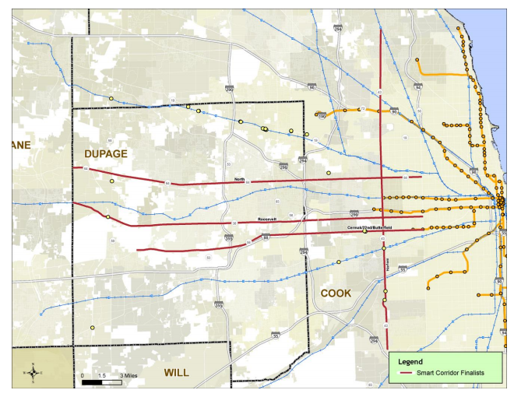
Source: Cook DuPage Smart Corridor Plan and Design Technical Report executive Summary

Implementation
A number of systems must be deployed to support Smart Corridor Operations, in addition to a traffic management center (TMC) to house staff, hardware, and software to support decision making, and backhaul communications to bring data from the field back to the TMC and provide communication back to the field.
Network surveillance systems, either sensor or probe based, are needed to monitor traffic and road conditions, identify and verify incidents, detect faults in indicator operations, and collect census data for traffic strategy development and long range planning. The data can also be made available to users and the traveler information services. While systems to monitor speed and congestion have long been used on the interstate system, it is only recently that the ability to accurately collect the same information for the arterial system has become available. Individual agencies can now deploy detection devices to monitor critical locations. Private vendors collect and transform probe data from cell phones and other devices which can also be used. This data opens the door to understanding arterial system operations in ways that were impossible in the past.
Traffic Signal Control – This system provides the central control and monitoring equipment, communication links, and the signal control equipment that support traffic control at signalized intersections. Central traffic signal control provides the best functionality for managing signal systems.
Signal technology to support various classes of road users. Mixed use systems ensure facility safety and efficiency for transit vehicles, pedestrians, bicyclists, and emergency vehicles that operate on the main roadways, or on pathways which intersect the roadway. Unlike the interstates, the arterials provide transportation for a many classes of users whose needs must be considered when developing Smart Corridors.
The Cook-DuPage Corridor Study estimated the cost for a number of technologies to support Smart Corridors shown in Table 9. They did not estimate the cost for developing the traffic management centers or fiber optic communication needed to operate the system. According to USDOT Intelligent Transportation Systems Joint Program Office, the cost of in-ground fiber optic cable installation might range between $21,000 – $55,000 per mile but “In ground installation would cost significantly less if implemented in conjunction with a construction project.”
Table 9: Cook DuPage Smart Corridor Plan and Design Technical Report (Draft)
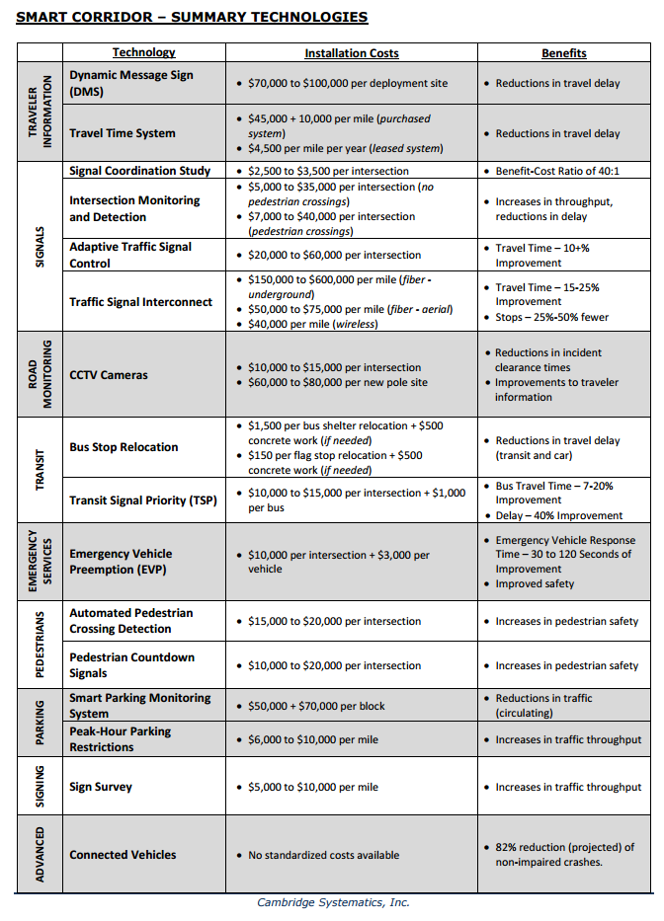

Integrated Corridor Management
Integrated corridor management represents the next step in integrating the region’s ITS systems and cooperatively managing interstate, arterial and transit system operations. It includes operational integration, institutional integration and technical integration, and has been defined as “the operational coordination of multiple transportation networks and cross-network connections comprising a corridor and the coordination of institutions responsible for corridor mobility. The goal of ICM is to improve mobility, safety, and other transportation objectives for travelers and goods. ICM may encompass several activities, for example:
- Cooperative and integrated policy among stakeholders responsible for operations in the corridor.
- Concept of operations for corridor management.
- Improving the efficiency of cross-network junctions and interfaces.
- Mobility opportunities, including shifts to alternate routes and modes.
- Real-time traffic and transit monitoring.
- Real-time information distribution (including alternate networks).
- Congestion management (recurring and non-recurring).
- Incident management.
- Travel demand management.
- Public awareness programs.
- Transportation pricing and payment.”
The United States Department of Transportation partnered with eight transportation agencies, or Pioneer Sites, in large urban areas to research how integrated corridor management can be implemented. Ultimately, the sites in Dallas, Texas, and San Diego California were selected as Pioneer Demonstration Sites where integrated corridor management is being implemented. “These sites began actively deploying their systems in spring 2013.” These efforts are too new to provide observed data on program impacts, but study modeling suggests a number of benefits.
Table 10: Expected Annual ICM Benefits of Piorneer Sites on Corridor Performance
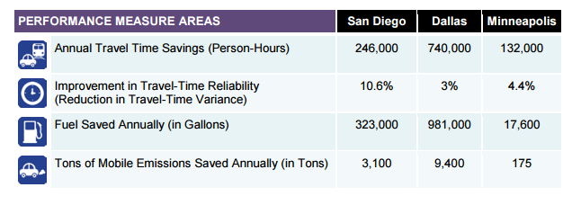
Source: Integrated Corridor Management Modeling Results Report: Dallas, Minneapolis, and San Diego, FHWA, February 2012

Separate efforts in San Francisco on the “I-80 Integrated Corridor Mobility Project” and Virginia “I-95/I-395 Integrated Corridor Management Initiative” are also underway to apply ICM concepts to improve corridor performance.
Interviews with our regional system operators revealed that they were concerned with the interaction between the interstate and arterial systems, and felt that the need for a more holistic approach to system management is clear. They highlighted the impact that deteriorating traffic conditions on one system have on other systems. Some operators were concerned about whether the arterial system could accommodate traffic “routed off” the expressway during an unplanned incident, especially in a congested corridor. The reality is that traffic diversion to arterials already happens. The question is whether unexpected changes in traffic patterns in a corridor that includes interstates, arterials, and transit can be better accommodated if policies and systems are put in place to respond to it. Some comments suggested that the main obstacle to integrated management is agency policy and not technology.
Integrated corridor management is a flexible tool to smooth traffic in corridors, with policies and procedures agreed upon by the stakeholders in the corridor, including emergency responders. Stakeholders will establish locations and conditions under which integrated management would take place, agreed upon procedures for responding to potential conditions, policies to help decide which procedures should be applied, and authority for staff to implement the procedures. Integration can be as limited as establishing responsive signal policies around certain interstate ramps, automated display of other jurisdiction system conditions on dynamic message signs, or a full application including arterials, interstates, and transit services in a corridor. There was agreement that many locations in the region offered the potential for improved operations provided by integrated management. There are even some existing examples of limited integration.

(Bring in local examples, especially construction )
Army Trail Road Queue Backup Protection
There is an interchange of I-355 at Army Trail road in DuPage County, where traffic signal coordination and integration has been implemented. A traffic monitoring system detects significant changes in volumes of traffic on Army Trail Road and locations west of this interchange. Tollway ramp devices initiate an alarm at the DuPage County Division of Transportation (DDOT) office and activate a pre-installed timing programs designed to clear ramps of queued traffic so it doesn’t back up onto the expressway.
An additional device located eastbound on Army Trail Road midway between Meadow Lane and Creekside Drive, will alert the DDOT Traffic Engineer of traffic conditions approaching the interchange. Pan-tilt-zoom cameras situated on Army Trail Road at Glen Ellyn Road, and at I-355, will provide the engineer with on-site capabilities to detect and monitor specific occurrences associated with the alarms. Fiber optic cable will be installed between Meadow Lane and Creekside Drive to complete an essential communications link within the project area.
Traveler Information on DMS Signs
There a number of locations in the region where arterially located dynamic message signs provide traffic information for nearby interstates. There are agreements between the Illinois interstate operators and operators of neighboring states to display requested information on DMS signs, but these are not automated and are subject to the authority of the TMC operator.
Figure 5: Arterial Dynamic Message Signs in DuPage County
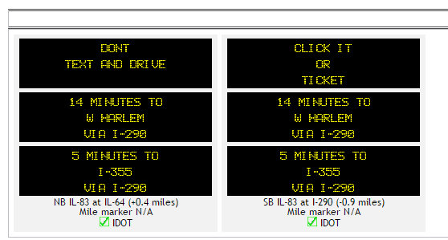
Source: TravelMidwest.com
Figure 6: Arterial Dynamic Message Signs in Suburban Cook County
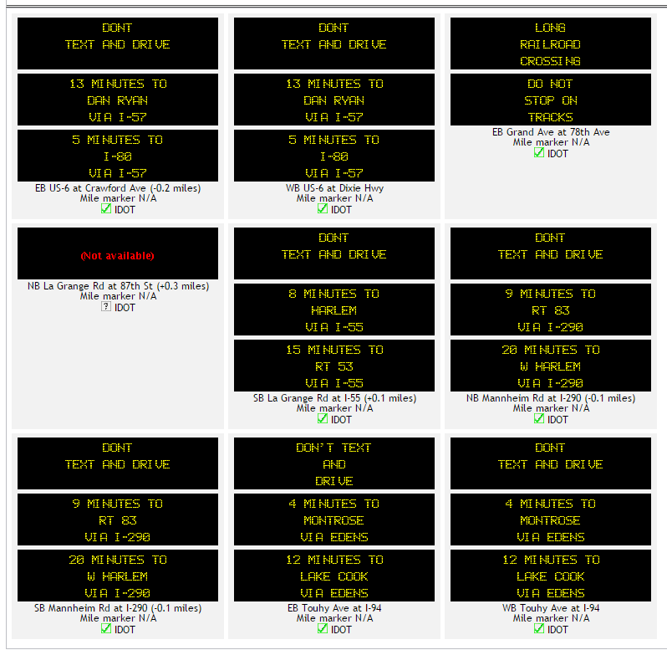
Source: TravelMidwest.com
Implementation needs
Center to center integration will be needed for sharing traffic information and control among traffic management centers. A transportation operations data sharing system will provide real-time transportation operations data to transportation system operators who can manage their individual systems based on an overall view of the corridor transportation system.

Prioritization
Road Performance analysis will go here.

Implementation Activities
Interview notes
Establish a pool of funding to support developing and maintaining the fiber communication system.
Identify and fund “regional” operations projects on local (municipal, township, county) roadways. These locations serve longer distance travel but because of special circumstances they are very costly for an individual operator to resolve.
Scale funding for management and operations staff in relation to the increased staffing needs of active system management.

Collaboration and Shared Resources
- Identify the operations needs of the municipalities and create a vision of future operations for the region. How do municipal operations needs fit into the regional plan?

Regional Performance Goals and Operations Oriented Objectives
Improve performance monitoring process by expanding capabilities and establishing goals.

Regional Transportation Concept of Operations

2014 Illinois Crash Facts and Statistics, Illinois Department of Transportation, 2015
625 ILCS 5/4-203.5
Educational Outreach for Safe, Quick Clearance (SQC) Laws and Policies, FHWA
Freight Volumes for the Trucking System, www.cmap.illinois.gov
Incident Responders’ Safety Model Law, I-95 Corridor Coalition
Major Crash Investigation and Traffic Incident Management Presentation, KC Scout, undated
Federal Highway Administration Service Patrol Handbook, FHWA, November 2008
Traveler Information System Fact Sheet, Texas A&M Transportation Institute
Traffic Safety Facts, National Highway Traffic Safety Administration, February 2015
Insurance Institute for Highway Safety Highway Loss Data Institute Status Report Volume 51 Number 1 ,January 2016
Insurance Institute for Highway Safety Highway Loss Data Institute Bulletin Volume 28, Number 26, April 2012
Weather Underground Custom Summary for Midway Airport
Lightning Safety Awareness Guide, Illinois Emergency Management Agency, June 2014
2014 Illinois Crash Facts and Statistics, Illinois Department of Transportation, 2015
Traffic Incident Management in Construction and Maintenance Work Zones, FHWA Office of Transportation Operations, January 2009
Traffic Signal Operations and Maintenance Staffing Guidelines, FHWA, March 2009
Getting Around, Jon Hilkevitch, Chicago Tribune, July 2012
USDOT Intelligent Transportation Systems Joint Program Office Costs Database
2007 National Traffic Signal Report Card – Executive Summary, Institute of Transportation Engineers, 2007
NCHRP Synthesis 409 Traffic Signal Retiming Practices in the United States, National Cooperative Highway Research Program,2010
Traffic Signal Audit Guide, Institute of Transportation Engineers, 2007
National Traffic Signal Report Card Technical Report, National Transportation Operations Coalition, 2005
Bureau of Design and Environment Manual Chapter Fifty-seven, Illinois Department of Transportation, 2016
Traffic Signal Audit Guide, Institute of Transportation Engineers, 2007
Managing Travel for Planned Special Events, FHWA, September 2003
Intelligent Transportation Systems Joint Program Office Costs Database, in 2014 dollars
Free Parking or Free Markets, Donald Shoup, ACCESS Magazine, University of California Transportation Center, Spring 2011
Chicago Parking Garage Leases, The Civic Federation, December 15, 2010
Active Traffic Management Fact Sheet, Texas A&M Transportation Institute
Illinois Highway Statistics Sheet 2013, Illinois Department of Transportation
Cook-DuPage Smart Corridors Plan and Design Report Technical Report, Cook-DuPage Corridor Planning Group, 2015
Intelligent Transportation Systems Joint Program Office Costs Database, in 2014 dollars
Integrated Corridor Management Concept Development and Foundational Research Phase 1, Task 3.1 Develop Alternative Definitions, USDOT ITS Joint Program Office, April 2006.
Integrated Corridor Management (ICM) Demonstration Sites,

