**Table of Contents**

Executive Summary 1

Recommendations 1

Introduction to Highway Management and Operations 3

Promoting Management and Operations in the MPO Planning Process 5

Strategies to Address Sources of Congestion 8

Incident Management 9

Improved Detection and Verification 10

Public Safety Answering Point (PSAP) Integration 13

Real Time Crash Information Distribution 16

Full Function Service Patrols 19

Emergency Responders 20

Driver Removal and Authority Removal Laws 22

Major Crashes and Investigations 24

Vehicle Automation & Connected/Automated Vehicles 26

Weather Response 28

Advisory Strategies 28

Traffic Control Strategies 29

Pavement Treatment Strategies 30

Construction 31

Traveler Information 32

Work Zone Management 33

Work Zone Duration and Active Hours 34

Utility Coordination 35

Interagency Coordination 39

Signals 39

Signal Maintenance and Timing 39

Signal Modernization, Coordination and Transit Signal Priority 40

Central Signal Systems 42

Interjurisdictional Coordination 50

Consideration of All Highway Users 51

Traffic Signal Audit 51

Special Events 51

Communications Backbone 52

Existing System 53

Maintenance 53

Expansion 54

Power 56

Traffic Management Centers 59

Regional Traffic Management Center Inventory 60

Traffic Management Center Models 62

Integration of Centers 63

Municipal Traffic Management 63

Traveler Information 64

Pricing for Parking 64

Implementation 65

Active Expressway Management 66

Active Arterial Management – Smart Corridors 71

Integrated Corridor Management 75

Identification of Potential ICM Combinations 79

Planning for Operations 81

Regional Performance Goals and Operations Oriented Objectives 82

Investment Prioritization 84

Expressway Results 88

Congestion Pricing 90

Arterial Results 90

Regional Transportation Concept of Operations 93

# Executive Summary

## Recommendations

**Incident Management**

CMAP should support investment in technology to automate incident detection and reduce detection time.

Agencies should install CCTV at critical arterial locations.

Require automated incident detection systems on managed lanes.

CMAP should work with the office of the Statewide 911 Administrator to bring PSAP integration need to the forefront and advocate for including PSAP integration in the uniform statewide 911 system.

CMAP should support PSAP integration projects.

Agencies should pursue and CMAP should support center to center communication and traveler information distribution projects to expand coverage to the entire region.

CMAP should support projects that increase the frequency, coverage, and hours of emergency traffic patrols, especially on facilities with managed lanes.

CMAP should work with local governments to promote incident management training for law enforcement and fire/rescue organizations.

CMAP should advocate for extending Illinois Driver Removal and Authority Removal laws to include department of transportation staff as an authority, along with liability protection from damages.

CMAP should develop informational materials to disseminate information about removal laws to local incident responders including departments of transportation.

CMAP should work with municipal, county, and state police to establish a goal of reducing the amount of time roads are closed due to crash investigations and develop a plan for achieving the goal.

CMAP should support efforts to implement and maintain a region wide communication system that can be used to support field equipment, including vehicle to infrastructure technologies.

**Weather**

CMAP should undertake an analysis of road performance under severe weather conditions, highlighting critical locations.

CMAP should develop a pavement flooding reporting system, because that information is not currently available.

CMAP should support agency projects that improve the provision of real time road weather information.

**Construction**

CMAP should work with counties to measure the impact of utility coordination delays and develop a plan to work with agencies and utilities to improve performance, including reactivating inactive Utility Coordination Councils.

CMAP should explore a cooperative effort to develop a secure database of detailed location information that can serve the region’s system operators.

**Signals**

Northeastern Illinois agencies should establish standards for signal timing field review and timing practices, and commit the resources needed to achieve them.

System operators should evaluate the age and status of signal hardware and software in context of the local operating environment and prioritize locations for modernization and coordination.

Opportunities for shared resources that promote coordination and reduce costs should be explored.

Each system operator should undertake a traffic signal audit and use the information to develop an action plan for improved traffic signal practices. CMAP should support funding for this activity.

**Special Events**

CMAP should work with local governments and events sponsors to systematically report special event information to the Gateway Traveler Information System.

**Communications**

CMAP should work with the region’s agencies to develop a Communications System Master Plan.

**Power**

CMAP should work with agencies to identify and prioritize locations where power is an issue and support the installation of uninterruptable power supply (UPS) and power conditioning systems. This includes review of the need for backup generators at critical locations.

CMAP should support programs and projects which create a resilient highway management system by ensuring a continuous and quality electricity supply.

**Traffic Management Centers**

CMAP should support expansion of traffic management center capabilities.

CMAP should undertake a study of the costs and benefits of implementing a regional, multi-jurisdictional traffic management center, either virtual or traditional.

**Implementation**

CMAP should fund planning activities that work towards implementing active expressway management, active arterial management, and integrated corridor management.

**Planning for Operations**

The planning process for highway operations activities should be fully integrated into the regional transportation planning process.

# Introduction to Highway Management and Operations

Highway management strategies optimize the efficiency, safety, and reliability of the highway system through coordinated operations. Increasingly, highway management involves data, communications, and technologies that help system managers optimize traffic flow and respond to situations as they arise. This increasing reliance on data and communications is expected to facilitate a more modern, performance-driven operations environment for the highway system. Examples of highway management and operations include traffic incident detection and response, providing information for travelers, roadway weather detection and response, managed lanes, traffic signal coordination, work zone management, electronic toll collection, and transportation demand management. From a traveler’s perspective, this may mean radio traffic reports, IDOT Minutemen and Illinois Tollway HELP truck staff, reoptimized traffic signal timing, reversible lanes on the Kennedy Expressway, or engineers working on a plan to maintain traffic through a construction zone. But given new data, technologies, and communications mentioned above, we have the opportunity to ramp these up.

As part of the ON TO 2050 comprehensive regional plan development process, this paper will explore ways to improve highway operations to improve our region’s mobility and accessibility. Highway management and operations are important to regional planning for a number of reasons:

* Some highway congestion and delay cannot be alleviated through capital expenditures (e.g., recovering from a crash or other incident); any reductions in delay must come from the way the highways are managed and operated.
* Even when insufficient capacity is the cause congestion and delay, capacity expansion is not feasible in some locations, so improving system operations is the only practical way to improve travel conditions.
* Many management strategies assure that the benefits of capital expenditures can continue further into the future.
* Many management and operations strategies presuppose an infrastructure investment, e.g., dynamically managing traffic flow after a special event may require an advanced highway traffic signal system with communications infrastructure. Understanding future operations system requirements will result in better capital investment decisions now.

In addition, consideration of traffic management can be part of a staged approach to highway improvements, reflecting a limited funding environment. Efficient operations can increase throughput and sometimes delay capital expenditures for capacity additions, extending tight budgets further. Implementing highway management strategies can often optimize flow to reduce the impact of congestion without additional capacity. Even if congestion cannot be eliminated, the daily onset of congestion may be delayed by smoothing traffic flow and managing incidents. And in recurring oversaturated traffic conditions, effective highway management can move from a focus on optimizing existing traffic to a focus on managing demand through such mechanisms as congestion pricing and travel demand management. In such cases where demand management is not feasible, then the cost-effectiveness and feasibility of capacity additions can be reviewed.

National research has shown that an imbalance between demand and capacity accounts for about 40 percent of congestion. Many of the causes of congestion interact with each other, but perhaps 60 percent of congestion nationwide is caused by non-recurring sources – like incidents, construction, and weather -- that are best addressed by operational changes rather than capacity improvements. Furthermore, non-recurring sources of congestion contribute uniquely to the problem of unreliable travel times, which has becoming a pressing issue for transportation agencies. While day-to-day congestion is bothersome and inefficient, unpredictable delay causes drivers to add buffer time into their plans that may not be needed but which improves the chances of arriving on time. Better incident response, work zone management, and a wide range of other operational improvements could help address reliability. Operational strategies are generally less capital-intensive approaches to managing congestion and could prove to have a bigger “bang for the buck” as well as higher feasibility in a resource-constrained environment.

Figure 1: Sources of congestion

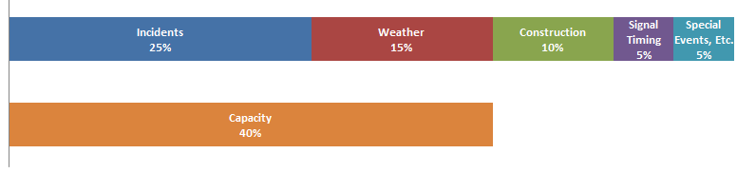

Source: FHWA Office of Operations

<http://www.ops.fhwa.dot.gov/congestion_report/executive_summary.htm#overview>

The application of improved highway management and operations techniques to address the other sources of congestion results in a system that operates more efficiently, reliably, and safely. Underlying all operational decisions is the necessity of balancing the mobility and accessibility needs of all highway users, including pedestrians, bicyclists, transit vehicles, drivers passing through the community, and drivers using the facility to access local destinations. The choices made impact how highways integrate with the communities they serve. A well-managed highway system works better for all users and reduces congestion, fuel use, and travel time for passenger and freight vehicles. In fact, M&O strategies can contribute greatly to achieving the Regional Vision for northeastern Illinois’ transportation system. The region’s vision describes a system that is safe, accessible, easy to navigate, affordable, and coordinated with nearby land uses. It is a system that reduces congestion and improves regional mobility, and supports reinvestment in our existing communities. Investment in the operations of the existing transportation system is an investment that benefits existing communities.

# Promoting Management and Operations in the MPO Planning Process

Chicago area MPO interest in improved highway operations has a long history. In 1988 an eight point plan called “[Operation Green Light: a transportation plan for Northeastern Illinois](https://archive.org/details/operationgreenli00illi)” was developed by the Illinois Department of Transportation in cooperation with the Regional Transportation Authority, the Illinois Tollway, the Chicago Area Transportation Study, and the Northeastern Illinois Planning commission. Two of the eight points were focused on highway operations. The plan recommended **improving freeway traffic management** by expanding surveillance, dynamic message signs, highway advisory radio, ramp metering, implementing electronic toll collection, and expanding the emergency traffic patrol service and **improving arterial traffic management** by developing a region wide incident detection network and an arterial congestion monitoring system. Operation Greenlight resulted in a five-year, one-billion dollar funding program to improve roadway operations.[1] The Chicago area MPO has also supported the use of Congestion Mitigation and Air Quality (CMAQ) funds and Surface Transportation Funds (STP) to implement highway operations projects such as traffic management centers, traffic signal modernization, traffic signal interconnects, intersection improvements, ramp metering, and transit signal priority systems.

Nationwide, there are a number of ways Metropolitan Planning Agencies promote improvements to system management and operations strategies throughout regular MPO activities.

Committees – Many agencies host Intelligent Transportation or Operations committees specifically to work on operations planning. Since ITS and operations are so closely related, agencies sometimes do not differentiate between the two activities. CMAP hosts an Advanced Technology Task Force responsible for the Regional ITS Architecture and a Regional Transportation Operations committee comprising representatives of partner agencies and who can be consulted as needed.

Unified Planning Work Program – MPOs can fund planning for management and operations projects.

Operations Plans ( for example Regional Operations Strategy, Regional Concept for Transportation Operations, Intelligent Transportation System Strategic Plan) – Some regions develop 10 – 15 year operations plans which include goals and objectives for evaluating operations projects and often identify priority corridors or projects. A Regional Concept for Transportation Operations has been developed by only a few regions. This document defines outcomes partnering agencies want to achieve in one or more specific operational areas, formalizes existing collaborative arrangements and defines future ones. The process of developing the document helps the agencies come to agreement on goals, objectives and responsibilities. This document is more focused than general operations plan. There is a close relationship between the goals and objectives of the Congestion Management Process, the Long Range Transportation Plan, and the Operations plan. These plans can provide a basis for TSMO project funding priorities.

Long Range Plan Language - The long range plan is a policy document guiding the selection of projects a region wishes to fund. Inclusion of specific recommendations for management and operations provides a solid basis for funding these activities in the future. Most of the agencies included chapters describing existing management and operations conditions and recommendations for the future.

Set-aside Funding –Some regions dedicate funding for management and operations projects. The funds are generally accumulated from a combination of sources such as CMAQ, STP, Safety, or other state and local funds. Some agencies have developed a pool of funding specifically for traffic signal retiming, or funding highway safety patrols on an ongoing basis. Some regions have implemented local taxes used for transportation improvements and dedicated a portion of them to implementing management and operations projects. The goals and objectives identified in the CMP, LRTP, and operations plans are used to prioritize projects for funding.

The Federal government supports MPO participation in the planning and implementation of system management and operations and requires that the long range transportation plan include “Operational and management strategies to improve the performance of existing transportation facilities to relieve vehicular congestion and maximize the safety and mobility of people and goods.” (23 USC § 134(i)(F))

Table 1 : Examples of MPO Planning for Operations

|  |  |  |  |  |  |  |
| --- | --- | --- | --- | --- | --- | --- |
| Agency | Primary City | Population (millions) | Operations Committee | Regional Transportation Operations Plan | M&O Plan Chapter or Section | M&O Funding Set-Aside |
| Chicago Metropolitan Agency for Planning | Chicago IL | 8.3 | Yes | No | No | No |
| North Central Texas Council of Governments (NCTCOG) | Dallas-Ft. Worth TX | 6.4 | No | Yes | Yes | Yes |
| Delaware Valley RPC | Philadelphia PA | 5.6 | Yes | Yes | Yes | Yes |
| Maricopa Association of Governments MAG | Phoenix AZ | 3.8 | Yes | Yes | Yes | Yes |
| Puget Sound Regional Council PSRC | Seattle WA | 3.7 | Yes | Yes | Yes | No |
| San Diego Association of Governments SANDAG | San Diego CA | 3.1 | No | Yes | Yes | Yes |
| Denver Regional Council of Governments (DRCOG) | Denver CO | 2.8 | Yes | Yes | Yes | Yes |
| Portland Metro | Portland OR | 1.9 | No | Yes | Yes | Yes |
| MetroPlan Orlando | Orlando FL | 1.8 | Yes | No | Yes | Yes |

Source: Programming for Operations: MPO Examples of Prioritizing and Funding Transportation System Management & Operations Strategies (FHWA, 2013), agency websites.

|  |
| --- |
| **Recommendation** |

# Strategies to Address Sources of Congestion

Lake County Department of Transportation maintains a history of the number and types of recorded arterial incidents, producing reports on a monthly and annual basis. Figure 2 presents 2015 performance statistics showing that the preponderance of events (86%) was vehicle crashes or stalls. 39% of recorded events resulted in closed roadways or had high impacts. It is unsurprising that the importance of better response to crashes and disabled vehicles surfaced as a high priority during interviews with agency staff.

Figure 2: Lake County Annual PASSAGE Performance Statistics 2015

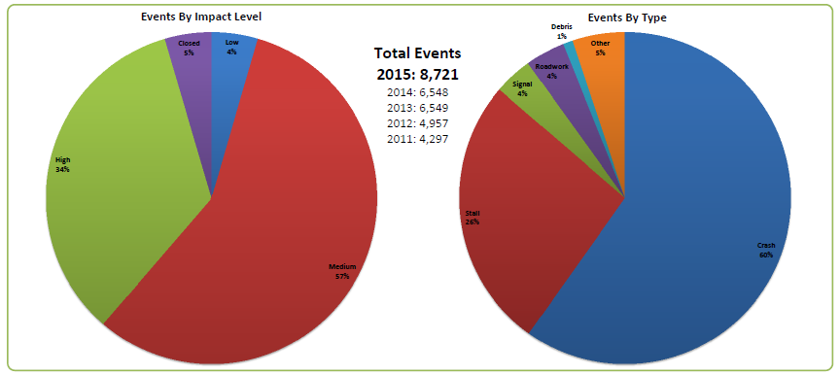

Source: Lake County Department of Transportation, PASSAGE Performance Measures 2015

Therefore, this section includes a long discussion about incident response, and somewhat shorter discussions of strategies to address unreliability caused by weather, construction, signal timing, and special events.

## Incident Management

As described by the United States Department of Transportation, “Traffic Incident Management is a systematic, planned, and coordinated effort to detect, respond to, and remove traffic incidents and restore traffic capacity as safely and quickly as possible.” ([Intelligent Transportation Systems for Traffic Incident Management](http://ntl.bts.gov/lib/jpodocs/brochure/14288_files/14288.pdf), USDOT) Incidents are estimated to cause 25% of the region’s roadway congestion. In 2014, there were 207,000 crashes in the CMAP region. [2] In addition to crashes, there are an unknown number of other roadway incidents including broken down or abandoned vehicles, debris on roadways, and damaged or malfunctioning equipment. In a study of arterial incident management, researchers found that crashes comprised 35% of arterial incidents, stops for traffic violations were 30%, disabled vehicles were 27%, leaving 8% as miscellaneous events, such as traffic signal malfunctions.[3] Each incident presents an opportunity to reduce congestion through earlier detection and verification, faster response, and adherence to quick clearance principles. Reducing incident duration reduces congestion and incident related delay. More important, reducing incident duration reduces the potential for additional incidents caused by congestion resulting from the first incident. Often termed “secondary incidents,” they include “crashes, engine stalls, overheating and running out of fuel. Nationwide, approximately 20% of all incidents are secondary incidents.”[4] The Illinois Tollway has been especially successful with its incident management system, maintaining a 4% rate of secondary crashes[5], far below the national average.

TIM includes a number of steps, each with the potential for reducing the total amount of time needed to return traffic to normal flows. However, unlike other highway operations activities, incident management is largely a public safety agency activity, with the transportation agency playing a supporting role. Therefore, much of the work to improve performance falls upon the public safety agencies.

Figure 3: Timeline of incident management process

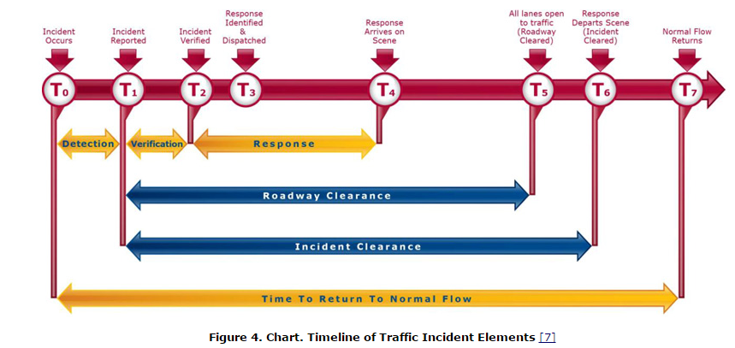

<http://www.ops.fhwa.dot.gov/publications/fhwahop15007/chapter1.htm>

### Improved Detection and Verification

Detection is the time an incident becomes known either to public safety officials or road system operators, while verification is the action of confirming the incident details and location to ensure that the correct responders and equipment will be dispatched to the scene. The longer an incident goes undetected, the more it can impact traffic and cause a hazard to other roadway users. Today incidents are most frequently detected through 911 calls or discovery by a patrolling vehicle.

The Illinois Department of Transportation and the Illinois Tollway have traffic management centers (TMC) to help manage the interstate system. These systems use hundreds of closed circuit television cameras to monitor traffic, detect and verify incidents. TMC staff can’t watch all the cameras, and if they are watching one there is still the chance for an incident to go unnoticed.

Figure 4: IDOT and Illinois Tollway CCTV Camera Locations

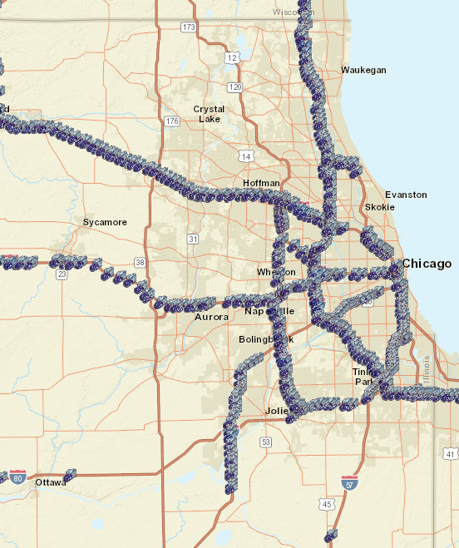

Source: ITS Assets Viewer, <http://www.itsassets.its.dot.gov/> , Oak Ridge National Laboratory for the USDOT ITS Joint Program Office

Counties also use video imaging traffic detection to provide data for the traffic signal. Lake County (Figure 3) has the most advanced system for using and sharing video detection information. Images are transmitted to the Lake County traffic management center and shared with public safety agencies. And, although the camera images are mainly used to support traffic signal operations and are not shared, 2013 ITS deployment statistics ([U.S. DOT ITS Joint Program Office Deployment Information 2013](http://www.itsdeployment.its.dot.gov/Agencies.aspx)) show that DuPage County (50 locations), Kane County (42 location), McHenry County (33 locations) and the City of Naperville (4 locations) have a number of locations where cameras are operating.

Figure 5: Lake County CCTV Traffic Cameras

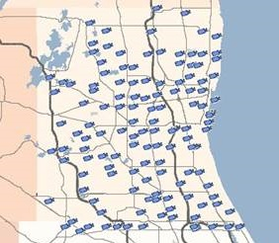

Source: IDOT [TravelMidwest](http://www.travelmidwest.com) Website, [www.TravelMidwest.com](http://www.TravelMidwest.com)

Figure 6: Regional CCTV Camera Locations that Share Images with the Public

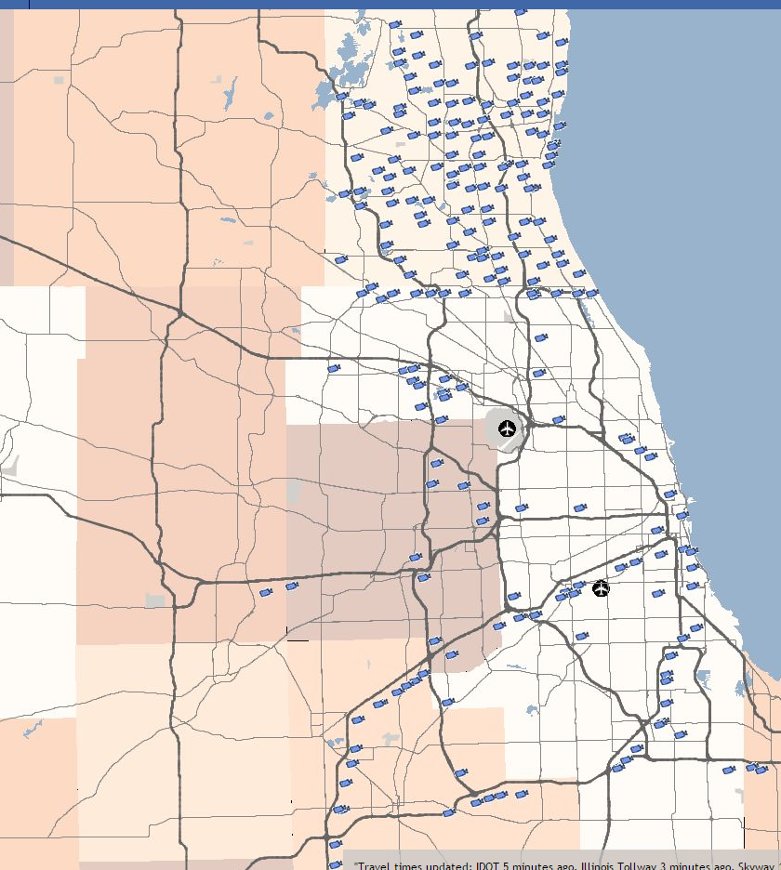

Source: IDOT TravelMidwest website, www.TravelMidwest.com

Automated detection methods can be more effective for early detection than relying on human observation. Analyzing vehicle detection system or probe data can detect potential incidents and generate automated notification to traffic management center operators. Traffic cameras with incident detection capabilities have been tested on expressways in our region and have been found to accurately identify the existence of most traffic incidents. At the time they were tested, they were expensive compared to the existing closed circuit television cameras systems. In a 2007 study that analyzed 5 locations in the state where cameras were used to detect and verify traffic incidents, the South Carolina Department of Transportation determined that the average cost-benefit of using traffic cameras to detect traffic incidents was 12:1. [6]

Using camera technology to detect incidents is unlikely to become widespread on the arterial system, as there are too many miles of coverage needed and the stop and go flows make detection by camera difficult. On arterials, it may be possible to use real-time probe data to alert operators to changes in expected flows that can indicate an incident. Cameras would be needed to verify the existence and characteristics of an incident.

Vehicle technology can also play a role in early incident detection. A number of luxury vehicles include optional automated collision notification systems such as [On Star](https://www.onstar.com/us/en/home.html). In fact, On Star is available as an [aftermarket product](https://www2.onstar.com/web/fmv/home?g=1) that replaces the original rear view mirror. Crowdsource information applications such as [Waze](https://www.waze.com/) are another new source of information. These systems alert a third party monitoring center, which in turn notifies the appropriate PSAP. This technology can reduce detection time.

**Recommendations:** CMAP should support investment in technology to automate incident detection and reduce detection time. Agencies should install CCTV at critical arterial locations. For managed lanes, require automated incident detection systems.

### Public Safety Answering Point (PSAP) Integration

The PSAP is the call center receiving 911 calls and dispatching appropriate emergency responders to the incident. Currently, the regional transportation partners use a variety of mechanisms to detect and verify incidents. These include closed-circuit television (CCTV) on parts of the system, and sensing devices that may detect declining system performance. However, these systems do not fully cover the entire region, so communications with public safety agencies, including PSAPs, is necessary. PSAPs have the most accurate real time information about highway incidents, so transportation agencies are seeking direct automated electronic communications with computer-aided dispatch (CAD) systems operated by PSAPs.

In 2002, Tollway Maintenance, Traffic, Dispatch and Illinois State Police District 15 Staff collaborated to develop and deploy a two-way data exchange between the new Tollway Traffic Operations Center- Traffic and Incident Management system (TIMS) and the Tollway Central Dispatch – Computer Aided Dispatch (CAD) system, This innovated approach built upon the unique agency dispatch operation that already handled State Police and Tollway maintenance and operations from a single CAD system. The deployment became recognized in the transportation industry as the first of its kind.

Since that time, Lake County Division of Transportation has also established connections to many PSAP operators within the county. Some of these agreements have included LCDOT camera and congestion data in return for PSAP highway incident dispatch data. While not all of the Lake County integration efforts include a two-way component, the benefits remain.

Often, the PSAP has a policy for staff to notify departments of transportation about incidents rather than implementing an automated process, and current dispatch communications usually work well. However, during major incidents when public safety resources are being deployed, transportation communications may be a lower priority. This has resulted in significantly delayed responses to major incidents. Unfortunately, departments of transportation may remain unaware of the existence of an incident. As one transportation operations manager put it, **“when the system fails, it fails catastrophically.”**

How can incident information exchange improve incident response? The region’s transportation agencies utilize technologies such as traffic signal timing, ramp metering, dynamic message signs, media notifications, websites, and highway advisory radio (HAR) to manage the transportation network during major incidents. Transportation agencies also have field operations staff to respond to incidents, including IDOT and Tollway service patrols, highway maintenance crews, and contract services to remove spills and debris, repair damaged pavement, communications, signals, regulatory or warning signs, and safety equipment. The timely and accurate availability of crash or other traffic event data is critical to the effective deployment of these supporting resources and timely communication to the motorist.

In addition, the support provided by the DOT can increase safety for emergency responders. Sharing access to CCTV video, including camera control, is common in these arrangements and provides important information to responders who are en-route to the scene. Traveler information distribution can reroute traffic around incidents, and the use of traffic signal timing and ramp metering can be used to formally reroute traffic, further reducing traffic congestion around the location.

The region’s transportation operators are certain that additional integration efforts will further enhance the safety and mobility of the region. In addition, recent federal regulations require departments of transportation to provide timely and accurate dissemination of traffic incident data to the traveling public. ([Real-Time System Management Information Program [1201]](http://www.ops.fhwa.dot.gov/1201/factsheet/factsheet.pdf)) “The timeliness for the availability of information related to roadway or lane blocking traffic incident will be (…) 10 minutes or less from the time that the incident is verified for roadways within Metropolitan areas. (…) Establishment of the real-time information program for traffic and travel conditions on the Interstate system highways shall be completed no later than November 8, 2014. Establishment of the real-time information program for traffic and travel conditions reporting along the State-designated metropolitan area routes of significance shall be completed no later than November 8, 2016.”

Progress on establishing this information exchange has been difficult. PSAP-to-transportation operator information exchanges typically require development of formal operational policies and agreements. Before those can occur, participants must understand the information to be shared, when it will be shared, and with whom it will be shared. In addition, information exchanged between these systems is sensitive, and there are legitimate concerns about maintaining appropriate levels of privacy and software system security. These challenges are not insurmountable, as shown by the Illinois Tollway and Lake County Department of Transportation experiences. The types of information transmitted between the PSAP and DOT can be limited to protect privacy, and secure exchanges of information between computer systems can be developed.

Even with some successes, progress on this topic has been difficult. IDOT District 1 has been working for 10 years to get an agreement for integrated communications with the Illinois State Police and the Cook County Sherriff, but that agreement is not yet in place.

In January 2016, Public Act 099-0006 requires counties to reduce the number of 911 centers by half, and creates an office of [Statewide 911 Administrator](http://www.isp.state.il.us/statewide911/statewide911.cfm) within the Illinois State Police to develop, implement and oversee a uniform 911 system, excluding municipalities with more than 500,000 residents (City of Chicago). This process may provide a good opportunity to advance the goal of PSAP integration as part of the standardization of the statewide system, and to also reduce the number of PSAP communications connections that must be developed to exchange the desired information.

**Recommendation:** CMAP should work with the office of the Statewide 911 Administrator to bring this need to the forefront and advocate for including PSAP integration in the uniform statewide 911 system. CMAP should support PSAP integration projects.

### Real Time Crash Information Distribution

As discussed in the previous section, providing complete and accurate road condition information to the traveling public is an important part of incident management. When drivers know about an incident they have the opportunity to avoid the area. PSAP integration is needed to collect incident information, and center to center communication between highway operating agencies and traveler information services is needed to distribute the information.

Information can be provided to drivers in many ways, including websites, email alerts, text message alerts, navigation applications, dynamic message signs and highway advisory radio. Automating the process ensures that transmission of the information isn’t accidentally neglected. It is important to include private sector traveler information services in the process because they are providing information to large sectors of the traveling public. A travel survey conducted by the Puget Sound Regional Council (Figure 7) shows that most people want information about the cause and length of delay in a trip they are making. [7] Once users are familiar with traveler information systems, nearly 80% will use them to adjust their routing and departure times.[8]

Figure 7: People Want Real Time Information

|  |  |
| --- | --- |
|  |  |

Source: PSRC 2006 Household Travel Survey Analysis Report

In our region, [TravelMidwest](http://www.travelmidwest.com) website provides real time traveler information, including crash data. Incident data is automatically received by the Illinois Tollway TIMS center and Lake County PASSAGE from their respective interfaces with police computer aided dispatch centers and pushed out to the Gateway Traveler Information System (GTIS), which maintains the data for TravelMidwest.com. The IDOT Communication Center also automatically feeds crash information to GTIS, without the benefit of electronic communications with a 911 center. TravelMidwest.com website averages about 5500 users per day, with 4000 subscribers to electronic notification of travel conditions. [9] TravelMidwest can also be downloaded as a smart phone application and those users are in addition to visitors to the website.

[Lake County PASSAGE](https://www.lakecountypassage.com/), the Lake County Division of Transportation real time traveler information system provides services similar to the TravelMidwest website. PASSAGE also has a phone application available and Figure 8 shows the rate of phone application adoption over time, along with subscriptions to electronic notifications twitter followers.

Crash related information is also distributed to dynamic message signs (DMS) and highway advisory radio (HAR) from the Tollway TIMS center and IDOT Communications Center. Figures 9 and 10 show the locations of the DMS and HAR devices.

This information can also be accessed by private developers for use private traveler information systems and navigation systems.

Ultimately, as shown in figure 11, survey respondents believe that traveler information makes their travel time shorter and more predictable and their trips safer.

Figure 8: Lake County PASSAGE Adoption Rate

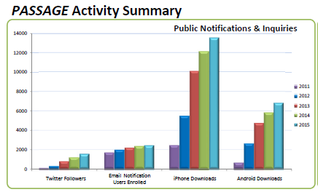

Source: Lake County Department of Transportation 2015 PASSAGE Annual Statistics Report

|  |  |
| --- | --- |
| Figure 9: Dynamic Message Sign Locations | Figure 10: Highway Advisory Radio Locations |

Source: ITS Assets Viewer, <http://www.itsassets.its.dot.gov/> , Oak Ridge National Laboratory for the USDOT ITS Joint Program Office

Figure 11: Traveler Information Impacts, Seattle Travel Survey

|  |
| --- |
|  |

Source: [Managing Demand through Travel Information Services](http://www.ops.fhwa.dot.gov/publications/manag_demand_tis/travelinfo.htm), Federal Highway Administration

|  |
| --- |
| **Recommendation**: Agencies should pursue and CMAP should support center to center communication and traveler information distribution projects to expand coverage to the entire region. |

### Full Function Service Patrols

To keep roadways clear of debris and disabled vehicles, both the Illinois Department of Transportation and the Illinois Tollways employs emergency traffic patrols on the region’s expressways and tollways. Northeastern Illinois developed the first in the nation continuous service freeway service patrol in 1960. [10] The goal of the service patrol is to detect and remove incidents quickly. Patrols perform minor vehicle repairs, provide fuel, change tires, remove debris, and provide assistance to emergency responders at crash scenes. They are integrated within the agency incident management system, and may also be dispatched to a location from the traffic management center. [IDOT’s patrols](http://www.idot.illinois.gov/travel-information/roadway-information/driver-information/emergency-traffic-patrol/index), called “Minutemen,” cover the core Cook County IDOT expressway system twenty-four hours a day, every day of the year. The IDOT service patrol provides over 115,000 assists annually – or over 315 per day. This service is also important for keeping the shoulder clear for Pace bus on shoulders on I-55. The [Illinois Tollway service patrols](http://www.illinoistollway.com/roadway-information/roadway-services/help-trucks), called Highway Emergency Lane Patrol or H.E.L.P, patrol the entire tollway system between 5 am and 8 pm on weekdays. In 2015, H.E.L.P patrol staff assisted 30,000 drivers. Important attributes of service patrols include coverage area, frequency of patrol, hours of operation, and type of patrol vehicles. Agencies desire to extend service patrol coverage, frequency and hours of service. In a study completed in 2009, the Missouri Department of Transportation estimated that the Motorist Assist (MA) program provides an annual benefit cost ratio of 38:1.[11] This high ratio is based in part on the relatively low operational cost of service patrols, and the fact that the researchers included the costs of secondary incidents, which have not always been reflected in analyses of these programs. The researchers estimated that the service patrols reduced secondary crashes by over 1,000 per year.

Maintaining free flow of traffic in the region’s nascent managed lane system is critical. The goal of the managed lane is to provide reliable travel time. Achieving this requires service patrol coverage to keep the managed lanes free of debris and disabled vehicles. Emergency service patrols should be provided for all managed lanes.

|  |
| --- |
| **Recommendation**: CMAP should support projects that increase the frequency, coverage, and hours of emergency traffic patrols, especially on facilities with managed lanes. |

### Emergency Responders

Emergency responders include police, fire, ambulance, and vehicle towing and recovery. The region’s tollway system is patrolled by the Illinois State Police (ISP) District 15. The dispatch for ISP District 15 is housed within the Illinois Tollway Building. ISP District 2 serves the non-tollway interstates in DuPage Kane, Lake and McHenry Counties. ISP District 5 serves non-tollway interstates in Kendall and Will Counties. ISP Chicago District serves Cook County non-tollway interstates. The arterial system is patrolled by county and municipal police departments. Incident response for the entire system of interstates and arterials relies on local fire, rescue and towing/recovery staff.

When emergency personnel are on the scene of a traffic incident, there is the ever present danger of a responder becoming a crash victim. As shown in Table 2, many emergency responders are harmed in the line of duty. When a responder is struck by a vehicle, not only is it a tragedy for the individual and family, but it can turn a relatively minor incident into a major disruption. A component of quick clearance laws, called “[Scott’s Law](https://www.isp.state.il.us/docs/1-163.pdf),” 625 ILCS 5/11-907(c), was enacted in Illinois and mandates that upon approaching a stationary authorized emergency vehicle, when the authorized emergency vehicle is giving a signal by displaying alternately flashing red, red and white, blue, or red and blue lights or amber or yellow warning lights, a person who drives an approaching vehicle shall: reduce the speed of your vehicle; yield the right-of-way by changing lanes away from an authorized emergency vehicle; and proceed with due regard to safety and traffic conditions. All fifty states have enacted a move over laws.

Table 2: Fatal and Injury Crashes on Illinois Public Roadways

|  |  |  |  |  |  |
| --- | --- | --- | --- | --- | --- |
| Year | Police | Fire | Ambulance | Towing | Total |
| 2010 | 670 | 51 | 76 | 127 | 924 |
| 2011 | 611 | 42 | 64 | 125 | 842 |
| 2012 | 533 | 33 | 63 | 90 | 719 |
| 2013 | 532 | 52 | 82 | 110 | 776 |
| Total | 2346 | 178 | 285 | 452 |  |

Source: IDOT Division of Traffic Safety, Safety Data Mart

Effective traffic incident scene management is one way to improve safety for responders and also to make navigating the area safer for drivers. Interviews with highway system operators indicated that performance in this area was very uneven, and they expressed a desire for CMAP to work with local agencies towards better performance and standard traffic incident management procedures. In a 1997 study of urban arterial incident management, researchers found that “a problem common to incident management in most roadway environments but particularly on arterial streets: protection and maintenance of traffic operations during incidents and rapid clearance of obstacles and visual distractions are not high priority objectives for emergency responders. In fact, most responders appear to be unconcerned about how their actions affect traffic, although in many cases their actions were observed to exacerbate congestion.”[12] Although this is a relatively old study (1997) agency interviews revealed this situation continues today.

The Illinois Department of Transportation recognized the need and worked with the Illinois Center for Transportation at Southern Illinois University to develop a [training program](http://www.idot.illinois.gov/transportation-system/safety/roadway/traffic-incident-management) intended for law enforcement, fire departments, emergency medical personnel, tow and recovery operators, highway department staff, and 911 center operators. The training includes incident command system training, response vehicle parking guidelines, the use of high visibility apparel, on-scene emergency lighting procedures, and the use of temporary traffic management devices including queue warnings.

Starting in January 2016, “every person operating a towing or recovery vehicle on behalf of the towing service must have completed a Traffic Incident Management Training Program approved by the Department of Transportation”[13] to be included on a police tow rotation list. This requirement has been effective in training tow truck operators. The same law specifies that Illinois State Police must also receive the training by June 30, 2016.

Figure 12: Illinois Training Recipients as of November 16, 2015

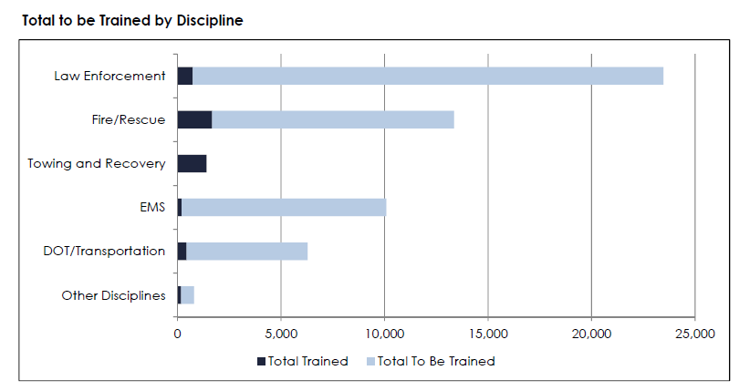

Source: Illinois Training Report, Illinois Department of Transportation (November 2015)

**Recommendation:** CMAP should work with local governments to promote incident management training for law enforcement and fire/rescue organizations.

### Driver Removal and Authority Removal Laws

A key component of quick clearance programs are the enactment of removal laws. Removal laws require that disabled vehicles and spilled cargo are moved out of driving lanes as quickly as possible if this can be safely achieved. According to FHWA, Illinois has passed Driver Removal and Authority Removal laws.[14]

**Driver Removal of Vehicles**

Nearly 80% (160,000) of the crashes reported in northeastern Illinois in 2014 were property damage only crashes. As youngsters, many people were taught that when a crash happens you should keep the vehicles in place and call police. The current [Illinois Rules of the Road](http://www.cyberdriveillinois.com/publications/pdf_publications/dsd_a112.pdf) guide states that “If you are involved in or come upon a traffic crash: Stop your vehicle in a safe, well-lighted public place that does not obstruct traffic, if able to do so...” Driver removal laws encourage or require drivers to move a damaged vehicle or cargo to the shoulder where it does not obstruct traffic and create a hazard. The most effective driver removal laws authorize any licensed driver on-site to move the vehicle. While FHWA reports that Illinois has enacted a driver removal law, anecdotally it seems that drivers involved in crashes often do not remove their vehicles from the traffic lanes. Removal laws are not useful if drivers or law enforcement are unaware of their existence.

**Authority Removal of Vehicles**

Authority Removal laws allow an authority, generally including police, fire, or department of transportation staff to order a driver to remove a vehicle from the roadway if it constitutes a hazard or obstructs traffic. The authority may also call a tow truck or push the vehicle and freight out of the roadway. It is useful to ensure that response vehicles are equipped with push bumpers so they can push disabled vehicles off the travel lanes while waiting for a tow. The Illinois [statute](http://www.ilga.gov/legislation/ilcs/fulltext.asp?DocName=062500050K4-203) only allows for towing a vehicle when ordered by a law enforcement official, stating that “When an abandoned, unattended, wrecked, burned or partially dismantled vehicle is creating a traffic hazard because of its position in relation to the highway or its physical appearance is causing the impeding of traffic, its immediate removal from the highway or private property adjacent to the highway by a towing service may be authorized by a law enforcement agency having jurisdiction.” The statute does not address moving the vehicle out of driving lanes by departments of transportation.

In addition to personal vehicles, authority removal laws include authority to remove commercial vehicles and their spilled freight. CMAP estimated [15] that in 2007, there were a total of 1.5 billion truck trips made from, to or through northeastern Illinois. In 2014 commercial trucking crashes (tractor with trailer, tractor without trailer, single unit truck) represented only about 7% of the region’s crashes, but a crash that includes spilled cargo is a major incident. The Illinois authority removal law does not address relocation of spilled cargo off the roadway.

**Liability Protection for Incident Clearance Functions – Hold Harmless Law**

The need to clear the roadway should not be hampered by concerns about liability and damaged cargo. Departments of transportation expressed concern that if they tamper with a vehicle, they may be held liable for damages. States have enacted laws to protect responders from being responsible for damages to vehicles and cargo caused by responsible incident clearance procedures. For example I-95 Corridor Coalition produced the following model.

“Governmental agencies responding to incidents, including but not limited to law enforcement, firefighting, emergency medical services, hazardous materials, transportation agencies and other emergency governmental responders are authorized to exercise the incident clearance functions enumerated in this section. If such functions are exercised with reasonable care and at the direction of the incident commander, those governmental agencies and their personnel and other designated representatives are insulated from liability resulting from such actions taken pursuant to incident clearance (…)” [16]

**Recommendation:** CMAP should advocate for extending Illinois Driver Removal and Authority Removal laws to include department of transportation staff as an authority, along with liability protection from damages. CMAP should develop informational materials to disseminate information about removal laws to local incident responders including departments of transportation.

### Major Crashes and Investigations

A crash requiring an investigation may close a roadway for hours. The police department procedures and the technology used to collect data about the crash both impact the time it takes to complete the investigation and get traffic moving again.

Although the region does not currently track performance in the area of crash clearance, an analysis of detailed crash activity records (2008 – 2011) provided by the Illinois Department of Transportation provides a view into our performance. The dataset includes 16,170 incidents. Those listed as having clearance times of 0 – 12 minutes were excluded, as they were mainly removing debris from the roadways. The remaining 11,402 records were categorized based on identifying text in the activity record describing fire, injury/ambulance/hospital or fatality/coroner. About 10,000 records did not include these terms and are unclassified.

Table 3 Uncategorized Clear Time Percentiles in Hours for 10,146 IDOT Incidents on IDOT arterials and Controlled Access Expressways with a Range of 0.2 hrs. to 48.0 hrs. 2008-2011

|  |  |  |  |  |
| --- | --- | --- | --- | --- |
| 25th Percentile | 50th Percentile | 75th Percentile | 95th Percentile | Median |
| 1.55 | **2.93** | **11.16** | **33.96** | **2.93** |

The median clearance time for uncategorized incidents was 2.93 hours.

Table 4: Categorized Clear Times Percentiles in Hours for 1,256 IDOT Incidents on IDOT Arterials and controlled access expressways with a Range of 0.2 hrs.- 48.0 hrs (2008-2011)

|  |  |  |  |  |  |
| --- | --- | --- | --- | --- | --- |
| Response Clear Times Categories | 25th Percentile | 50th Percentile | 75th Percentile | 95th Percentile | Median |
| Fire Department | **1.00** | **2.22** | **7.57** | **29.09** | **2.18** |
| Injury/Ambulance/Hosp | **1.39** | **3.50** | **7.08** | **30.04** | **3.33** |
| Fatal | **2.50** | **4.47** | **7.22** | **25.97** | **4.40** |

When a crash results in a fatality, the duration of an incident can be especially lengthy. As table 4 shows, the median clearance time if fatal accidents is over four hours. In a survey conducted of jurisdictions in 21 states, 73% require medical examiners or coroners to respond to the crash site before the deceased can be removed.[17] Illinois is a state with this requirement. A number of states have instituted policies such as allowing responding emergency medical staff to certify the death, allowing on-scene responders to electronically transmit vital signs to a remotely located coroner for verification, allowing on-scene responders to move the body to a safer location to protect public safety (Pennsylvania Turnpike Commission), or to do move the body with the permission of the coroner by telephone or other mode (Rhode Island DOT).12

As a way to ensure that reducing the duration of incidents is a priority for all agencies involved, a number of states have enacted **Open Roads Policies** (for example [Florida](http://www.dot.state.fl.us/trafficoperations/Traf_Incident/pdf/Open_Roads_Policy_FDOT_FHP.pdf), [Georgia](http://www.timetaskforce.com/documents/FINAL%20GA%20Open%20Roads%20Policy_fully%20signed%20governor%20endorsed.pdf), [Minnesota](http://www.dot.state.mn.us/environment/regulatedmaterials/pdf/mndotopenroadspolicy.pdf), Maryland, Tennessee, [Washington](http://www.dot.state.fl.us/trafficoperations/Traf_Incident/pdf/Open_Roads_Policy_FDOT_FHP.pdf)). “Open Roads policies formally state the agencies’ goals in partnership to remove vehicles, cargo, and debris from roadways with the intention of restoring safe, orderly traffic flow after motor vehicle crashes and other roadway incidents.”[18] Open roads policies define agency responsibilities for incident response. For example, law enforcement agencies commit to performing investigations as quickly as possible and may require non-critical portions of the investigation to occur when lighter traffic conditions prevail. They agree to close only the travel lanes necessary to deal with the incident, and they work with transportation agencies to set up appropriate traffic control, establish alternate routes, and expedite traffic movement at the incident scene. Law enforcement may allow damaged vehicles to be relocated to accident investigation sites or other locations for safe completion of investigations. Departments of transportation in turn commit to responding with appropriate resources for traffic control and incident clean-up within specified time frames, ensuring safe work zones for responders and the motoring public. Transportation agencies may agree to have additional heavy equipment at their disposal to assist tow operators in quicker clearing of blocked lanes. Most importantly, these incident response partners commit to work together to ensure all motorist needs are being met in a safe, professional, and efficient manner.

[Kansas City Scout](http://www.kcscout.net/Default.aspx), the bi-state (Kansas, Missouri) traffic management system, implemented a traffic incident management program in 2007. Prior to that time, investigators gave no consideration to the implications of a highway shutdown and it was not uncommon for it to take 4 to 6 hours to clear the roadway. The Kansas City Police department typically wouldn’t call a Medical Examiner until the police work was finished and would not call for tow trucks until everything was done. Following a 2007 Traffic Incident Management Summit, vehicle crash squads were established, and a target of 90 minutes maximum closure time was adopted. As a result, secondary incidents were reduced by 47%, and the average time to clear incidents was reduced from 39 minutes to 22 minutes. For level 3 incidents (>90 minutes) average incident duration was **reduced by 111 minutes**.[19]

Improved technology can also aid in crash investigations. Crash reconstruction requires measuring the locations of items at the crash scene, and has traditionally relied on officers with roll wheel and steel tape rulers. Newer technologies such as total station electronic measuring devices and photogrammetry can reduce the time needed for taking measurements and open the road to traffic more quickly. We do not know how many police departments in our region use roll wheel and tape measurers versus the newer technology.

|  |
| --- |
| **Recommendations**: CMAP should work with municipal, county, and state police to establish a goal of reducing the amount of time roads are closed due to crash investigations and develop a plan for achieving the goal. |

### Vehicle Automation & Connected/Automated Vehicles

The best way to manage incidents would be to avoid them. Over 90% of crashes nationwide are attributable to human error. [20] Technological innovations have the potential to greatly reduce crashes and crash severity. Automated vehicles include systems to perform functions that were historically controlled by the driver. The Insurance Institute for Highway Safety reports that vehicles with automatic braking systems, which function as front crash avoidance systems, reduced rear end collisions by 40%.[21] The Institute also found that electronic stability control, standard on 2012 and later models “lowered the risk of a fatal single-vehicle crash by about half, and the risk of a fatal rollover by as much as 80%.” The new systems are proving to be effective and are becoming more widely available. Higher cost auto models offer crash avoidance automation features such as front crash protection, lane departure warning, blind spot detection, adaptive headlights, and parking assist. A number of these technologies are also available for commercial vehicles. As the technology proves its value and the cost of including it on vehicles is reduced, these options will become either standard or required and will permeate the vehicle fleet. These technologies only require auto makers to install them, with no special investment needed from the road operator side.

Connected/Automated vehicles go a step farther in the automation ability. While automated vehicles are equipped with on-board sensors to detect conditions immediately surrounding the vehicle and response equipment to react to detected conditions, connected vehicles can receive information beyond both the immediate vicinity and the types of information that detectors can sense. This technology requires that a vehicles (vehicle to vehicle, V2V) or roadside devices (vehicle to infrastructure, V2I) be transmitting information to detect. Traffic signals may broadcast timing information, preventing red light running and supporting “environmental” driving, with more efficient acceleration and deceleration that reduces fuel consumption. A vehicle in the front of the platoon may broadcast deployment of its brakes, allowing the following vehicles to reduce speed without observing the brake lights. Additionally, roadside equipment may listen for vehicle information and transmit it back to a traffic management center for use – such as detecting the deployment of antilock braking systems that may indicate roadway icing. The region is already deploying V2I in the form of transit signal priority (TSP), with a radio on the bus communicating specific messages to a radio at the traffic signal. Any transmission of dynamic information from the traffic management center to a field radio will require supporting communication infrastructure, as will any collection of intelligence from vehicles for use in managing the system. In addition, traffic management center hardware, software and staffing will be needed to support the system.

This does not mean that significant investment in incident management is unnecessary. Our future includes a fleet of vehicles with crash avoidance technology, but the rate of market penetration into the general fleet is slower than some imagine. For example, in 1985 antilock braking systems became available. Twenty-five years later, by 2010, 88% of registered vehicles had antilock braking systems. [22] As the new features are incorporated into the region’s fleet, we should see the number and severity of crashes decline. However, the region’s fleet will continue to include a large number of vehicles without accident avoidance systems for the foreseeable future.

Full automation represented by driverless vehicles is many years away. Developing the technology, standards, and regulations underpinning the system will likely take decades. It is possible that automated vehicles will require some infrastructure investment, as yet unknown. It is also possible that automated vehicles may eliminate the necessity of other infrastructure investments such as street lights, traffic lights, and message signs. Traffic may become more self-organizing, changing the requirements of the traffic management center. At this time, impacts are purely speculative.

|  |
| --- |
| **Recommendation** CMAP should support efforts to implement and maintain a region wide communication system that can be used to support field equipment, including vehicle to infrastructure technologies. |

## Weather Response

Inclement weather is estimated to cause 15% of our region’s congestion, increasing the number of crashes and reducing road capacity (see table 5). During 2014, there were 176 (48%) days with rain, snow or fog reported from the Midway Airport weather station, resulting in 35 inches of precipitation.[23] Illinois ranks eighth in in the country for most lightning strikes, with about 800,000 lightning strikes in Illinois annually. [24] All of these contribute to road closures, traffic slowdowns, crashes, and damage to electronic devices such as traffic lights, message signs, and cameras.

Regional highway system operators are responsible for maintaining safe driving conditions, maintaining road capacity, protecting infrastructure from weather related damage, and repairing damage when it occurs. Northeastern Illinois agencies have a long history of responding to weather conditions. Existing regional strategies include traveler information and alerts, weather advisories, vehicle restrictions such as banning trucks during high winds, road closures, anti-icing/deicing road surface treatments, plowing, and pumping water from flooded locations. In addition, departments of transportation respond to traffic signal malfunctions or outages caused by lightning strikes or voltage slumps (brownouts).

Table 5: Freeway Traffic Flow Reductions due to Weather

|  |  |  |  |  |
| --- | --- | --- | --- | --- |
| Weather Conditions | Freeway Traffic Flow Reductions | | | |
| **Average Speed** | **Free-Flow Speed** | **Volume** | **Capacity** |
| Light Rain/Snow | 3% - 13% | 2% - 13% | 5% - 10% | 4% - 11% |
| Heavy Rain | 3% - 16% | 6% - 17% | 14% | 10% - 30% |
| Heavy Snow | 5% - 40% | 5% - 64% | 30% - 44% | 12% - 27% |
| Low Visibility | 10% - 12% | Empty Cell | Empty Cell | 12% |

Source: [How Do Weather Events Impact Road](http://www.ops.fhwa.dot.gov/weather/q1_roadimpact.htm)s? FHWA Office of Operations

### Advisory Strategies

Advisory strategies are used to keep the public informed about weather related travel conditions. Real time road condition information can keep people safe at home rather than driving under dangerous conditions. The Illinois Department of Transportation, the Illinois Tollway and Lake County Department of Transportation provide road weather condition information for the [TravelMidwest](http://travelmidwest.com/lmiga/home.jsp) and [GettingAroundIllinois](http://apps.dot.illinois.gov/winterroadconditions/pages/wrc.htm)  websites, including winter weather and road closures due to flooding. Lake County also hosts its own [Lake County PASSAGE](https://www.lakecountypassage.com/index.jsp) traveler information website. These agencies also provide information using highway advisory radio systems, dynamic message signs, and special alerts that users can subscribe to. Other counties do not have traveler information websites or provide traveler information to [TravelMidwest](http://www.TravelMidwest.com).

Figure 13: Lake County PASSAGE Annual Performance Statistics 2015

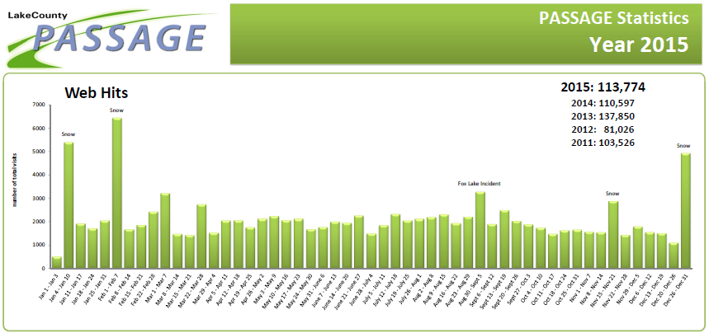

When people know information is available, they use the service. Note the high number of page visits to Lake County PASSAGE during winter storms. During a snow storm on February 24, 2016, 1876 incidents were entered into the Gateway Traveler Information System and displayed on the [TravelMidwest](http://www.travelmidwest.com) website.

### Traffic Control Strategies

Weather responsive traffic management is not widely used today, except for closing roads to traffic under severe conditions. Agencies have closed roads to truck traffic during periods of high winds and have closed facilities because of drifting snow or flooding. The expansion of ITS devices and traffic management capabilities will ensure that the future will likely include a variety of weather responsive traffic management strategies. Agencies are researching best practices in this area. Some potential control strategies include using variable speed limit systems to reduce speeds during inclement weather, implementing coordinated traffic signal timing that reflects the slower speed of travel in corridors during bad weather, and increasing the coverage of emergency vehicle patrols to remove disabled vehicles more quickly. Focusing incident management resources on locations which are known to be especially impacted by rain or snow can reduce congestion and secondary incidents. It will be important to collect and analyze information about how facilities perform under various weather scenarios so agencies can develop planned responses to weather events.

### Pavement Treatment Strategies

In northeastern Illinois, snow and ice storms are the most frequent high impact weather event. Even light snow and ice under the right conditions can cause widespread traffic slowdowns and crashes. Agencies have developed pre-treatment and snow clearance plans that include clearing a hierarchy of roadways and parking restrictions during snow events where necessary. The City of Chicago has seasonal snow route parking bans that are in effect regardless of the weather. To track of the progress of pre-treating and clearing roadways, automatic vehicle location systems (AVL) are being implemented by the region’s highway operators. Some plows include air and road temperature sensors which report back to operators who use it to plan their response. The location information of AVL equipped plows are mapped so agencies can track them, leading to more efficient use of equipment and reduced fuel consumption. This information is sometimes provided to the public ([City of Chicago Plow Tracker](http://www.cityofchicago.org/city/en/depts/mayor/iframe/plow_tracker.html), [Naperville Snow Route Status Map](http://gis.naperville.il.us/mashups/snowroutes/)). Agencies also use road weather stations (see figure 11) and cameras to keep abreast of changing road conditions. Road weather stations are especially important on bridges, where pavement can be much colder than the surrounding roadways and unexpected icing can occur.

Heavy rain events have become more common in recent years, and it is likely that climate change will cause more frequent road flooding in the future. Pavement flooding information hasn’t been collected on a regional basis, and there is no standard pavement flooding reporting system. It is unknown today what the impact of flooding has been on our roadway operations.

Figure 14: Northeastern Illinois Road Weather Stations

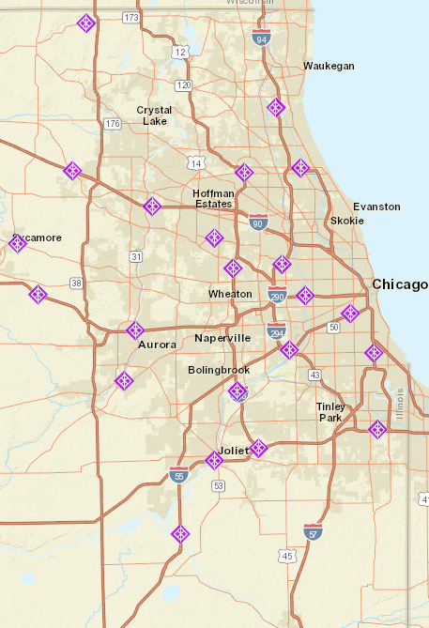

Source: ITS Assets Viewer, <http://www.itsassets.its.dot.gov/> , Oak Ridge National Laboratory for the USDOT ITS Joint Program Office

|  |
| --- |
| **Recommendations:** CMAP should undertake an analysis of road performance under severe weather conditions, highlighting critical locations. CMAP should develop a pavement flooding reporting system, because that information is not currently available. CMAP should support agency projects that improve the provision of real time road weather information. |

## Construction

Work zones are estimated to cause 10% of our region’s congestion. A review of expressway construction reports from TravelMidwest.com on December 31, 2015 shows over 100 construction locations on the expressway system in the CMAP region. There were 4,287 work zone crashes in Illinois in 2014, with 30 fatalities. [25] 90% of the fatalities were road users, not construction workers. Work zone management are strategies used to minimize delay, minimize congestion, and ensure driver and worker safety. Each road construction project includes a transportation management plan that address operational strategies, temporary traffic control devices, and public information. The management plan for a small project can be quite limited. Planning for a large project is an iterative process involving many more stakeholders. There are many specific strategies available to planners, engineers, and contractors to meet the goals, and they are selected based on an evaluation of the tradeoffs between traffic flow and construction efficiency. Providing traveler information, including good traffic management, and limiting the duration of construction

### Traveler Information

Advising people that a construction zone exists allows them to plan their travel accordingly. IDOT has developed an [Expressway Construction Closure System](http://data.cmap.illinois.gov/its_arch_v30/html/proj/pr43.htm) that collects data from contractors and sends information to the TravelMidwest website. Development of an [Arterial Construction Closure System](http://data.cmap.illinois.gov/its_arch_v30/html/proj/pr155.htm) is underway, which operates in much the same way. The Illinois Tollway also provides construction information for the website. Lake County PASSAGE provides construction information on the PASSAGE website, but does not provide it TravelMidwest. The TravelMidwest operators encourage any agency with construction information to provide it in any format so it can be added to the website. During the peak construction season in 2015, nearly 600 daily entries were entered into the Gateway Traveler Information System for display on the [TravelMidwest](http://www.travelmidwest.com) website. [26] Information is also displayed on roadside dynamic message signs and broadcast on highway advisory radio.

Figure 15: Lake County PASSAGE Construction Information 4-22-2016

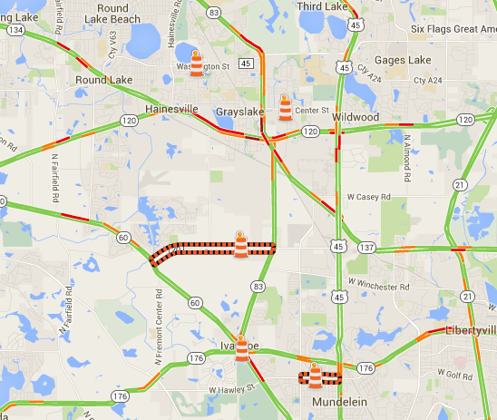

Source: Screenshot of Lake County PASSAGE [website](https://www.lakecountypassage.com/)

Providing real time travel information helps reduce the amount of traffic entering a work zone. Often construction disrupts existing data collection systems in the work zone, and temporary monitoring equipment is deployed to collect real time information. The temporary equipment and data must be integrated into existing traffic management center systems, and transmitted to the traveler information system along with the rest of the system information. The Illinois Tollway requires that contractors acquire monitoring equipment and dynamic message signs that are compatible with the Tollway Traffic and Incident Management System.

### Work Zone Management

Both the Illinois Tollway and the Illinois Department of Transportation use technology to manage work zones. Cameras and speed monitoring equipment allow operators to track traffic around the zone. Portable queue detection can be used if needed, with dynamic message signs displaying queue warnings. Camera speed enforcement may be used. Speed feedback signs, which measure vehicle speeds and display a warning if the vehicle is traveling over the posted speed have been effective. These systems are most widely used for interstate construction, but are also useful for large arterial projects. Arterial projects also include attention to signal plans that accommodate rerouted traffic. Note that rerouted traffic may not travel the routes project planners envisioned. For example, recently the IL 59 / I-55 interchange was [closed](http://www.naperville.il.us/route59expansion.aspx) for construction of a diverging diamond interchange. A detour route was established, but cameras in the vicinity allowed DuPage Department of Transportation staff to observe that the traffic did not follow the detour route. Responding to the emerging traffic pattern, engineers adjusted traffic signals to facilitate the actual traffic flows, which seemed to be maintained without the unreasonable congestion impacts. A central signal system and cameras for observation makes this much easier to do.

Our state has enacted a number of laws intended to make work zones safer, including increased fines for speeding in work zones, increased penalties for striking a worker, and allowing photo enforcement in work zones. Regardless of efforts made to ensure safety during construction, it is important to plan for incident response in and around work zones. A construction project may result in an incident location that has reduced access, narrow lanes, lack of refuge locations, physical barriers, and reduced sight distance.[27] These same characteristics mean even a minor incident can cause much more disruption than it would at another location. For a large project, a specific incident management plan are developed in cooperation with the project planners, construction staff, and local emergency responders. The incident management plan includes alternate route planning and outlines specific actions to be taken in case of an incident. When everyone knows what is expected, response can take place quickly and without confusion about roles and responsibilities.

### Work Zone Duration and Active Hours

Reducing the amount of time a location is under construction reduces the disruption it causes. Bonuses or penalties can be included in contracts to encourage timely work completion. Working during times of day with low traffic volumes, and controlling lane closures by time of day can also reduce construction impacts on highway users. Agencies in our region have successfully employed these strategies.

Many exciting new construction techniques and materials are also becoming available that will reduce project completion time or extend the time between maintenance and rehabilitation treatments.

* Mapping applications and databases can help coordinate work. The Chicago Department of Transportation developed a system that “helped the CDOT’s PCO (Project Coordination Office) partner with public and private entities to coordinate their work more efficiently, resulting in additional savings from duplicative work in 2014 of more than $24 million.”[28] Reducing duplicative work means reducing the number of times a construction zone is established.
* E-Construction provides digital management of all construction documentation, document routing and digital signatures, and provides the documents to people working on the project in the office and in the field. “The Michigan DOT, a leader in e-Construction, estimates that the agency saves approximately $12 million in added efficiencies and 6,000,000 pieces of paper annually by using electronic document storage for its $1 billion construction program, while reducing its average contract modification processing time from 30 days to three days. “ [29]
* New survey 3-D survey technology speeds up and improves survey data, and can be used as inputs to the files needed by 3-D construction equipment. For example, [stringless pavers](http://www.ctre.iastate.edu/pubs/t2summaries/stringless_paving.pdf) operate using Global Positioning System (GPS) and three-dimensional design computer files. This technology was used to construct new runways at O’Hare airport, and increases “paving production by saving time and money on surveying, stake driving and string set-up. It is allowing the contractor to be more efficient and to save time on the job.”[30] A [presentation](http://www.wisconcrete.org/wp-content/uploads/2015/02/9-Pope-Stringless-Concrete-Pavement.pdf) given by [Gomaco Corporation](http://www.gomaco.com/index.html) at the [Wisconsin Concrete Pavement Association](http://www.wisconcrete.org/) 2015 Annual Concrete Pavement Workshop estimated a savings of 50% in survey costs and a 20% - 50% productivity increase. The high end was in complex areas.
* Accelerated bridge construction using pre-cast components or slide-in construction methods reduces construction time and produces bridges with longer service lives than conventional construction. [31]

The market will play the largest part in determining how quickly most of these are adopted as standard practices, responding to a combination of agency demand for these techniques and materials, and contractor ability to invest in developing and providing them. Increased the value placed on operational impacts and mobility may increase the speed of adoption.

### Utility Coordination

A construction project often necessarily includes organizations other than transportation agencies and their contractors. Often, project construction locations also include utility infrastructure which must be relocated or removed because it can’t be avoided during construction. Utilities are defined as “A privately, publicly, or cooperatively owned line, facility, or system for producing, transmitting, or distributing communications, cable television, power, electricity, light, heat, gas, oil, crude products, water, steam, waste, storm water not connected with highway drainage, or any other similar commodity, including any fire or police signal system or street lighting system, which directly or indirectly serves the public.”[32] Any number of these organizations may be involved, and they may be both underground and overhead. Figure 16 shows an image of multiple utilities at a Chicago construction location. Utilities at the project site included Commonwealth Edison electric cables, AT&T fiber optic cables, water mains, sewers, and gas lines.[33]

Figure 16: Wacker Drive / Congress Interchange Advanced Utility

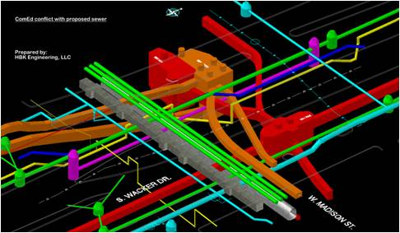

Source: HBK Engineering [Website](http://hbkengineering.com/projects/wacker-drive-congress-interchange-advanced-utility-relocation/)

Coordination with utility operators is a complex process which involves each utility agency and includes multiple reviews of construction plans at various stages of project development, signing agreements, and completing the work. If the utilities can be adjusted before road construction takes place, then delays may impact only the project start date and not project duration. Unfortunately, utility work must often occur during project construction. If there are delays in completing the work while the project is under construction, the construction schedule, traffic, and budget impacts are significant. Departments of transportation expressed frustration that the coordination process often seems to be failing. According to an IDOT Utilities Coordinator, lack of coordination by all parties contributes to utility adjustment delays. “Sometimes, utilities get moved within 90 days and sometimes (it) can take 300 days.”

This is not a new problem. In August of 2001, Governor George Ryan signed [Public Act 92-0470](http://www.ilga.gov/legislation/publicacts/pubact92/acts/92-0470.html) addressing questions of utilities located in the public right of way. This became Statute [(605 ILCS 5/9-113) (from Ch. 121, par. 9-113)](http://www.ilga.gov/legislation/ilcs/fulltext.asp?DocName=060500050K9-113) which **required** the Illinois Department of Transportation and allowed county departments of transportation to establish “coordination strategies and practices designed and intended to establish and implement effective communication respecting planned highway projects that the state or county highway authority believes may require removal, relocation or modification…”

The law listed two specific strategies that must be adopted as part of the strategies and practices: delivery of 5-year and annual programs, and establishment of utility coordination councils. “In addition, each utility shall designate in writing to the Secretary of Transportation or his or her designee and agent for notice and delivery of programs.” “Should a county highway authority decide not to establish coordination councils, the 90 day deadline for removal, relocation, or modification of the ditches, drains, track, rails, poles, wires, pipe line, or other equipment in subsection (f) of this section shall be waived for those highways.”

Lake County developed a Utility Coordination Council, and hosts an annual coordination meeting where the county 5-year highway improvement program is discussed. Figure 17 is from a presentation given by the Division of Transportation at the 2016 annual meeting and presents the number and types of permits issued by the highway department in 2015. The presentation also highlighted that “Under the County’s recently implemented Project Manager System, utility location requests will be transmitted to utility companies in the initial Phase I stage to identify conflicts before design work starts.” Our inquiries suggest that originally all the counties developed utility coordination councils, but only Cook County and Lake County continue the process today. [34]

Figure 17: Lake County Number and Type of Utility Permits (2015)

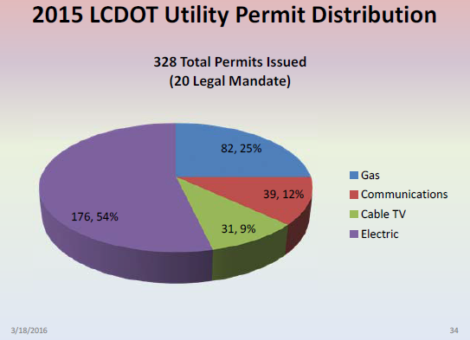

Source: Lake County Division of Transportation Presentation to 2016 Annual Utility Coordination Council Meeting

In addition to the highway operations impacts, this issue was mentioned by CMAP’s transportation partners numerous times in different settings a significant problem impacting our region’s ability to deliver of transportation improvements on schedule.

“The inability to obtain reliable underground utility information has long been a troublesome problem for highway designers in the United States.”[35] Discovering and possibly damaging unexpected utilities underground during project excavation is another event that can cause significant delays. Subsurface Utility Engineering (SUE) is a process of collecting accurate information about underground utilities that FHWA has encouraged since 1991. The one-call systems are useful but inadequate for preventing damage to utilities. “The one-call system just deals with the information on buried utilities that the members of the system provide. In other words, information on existing utilities of many non-members is not available in the one-call system. In addition, sometimes existing facility owners/operators are notified by the one-call center incorrectly or even fail to mark their utility location. Old utilities that remain active may not be discovered under the one-call system, and timing of locations relative to actual construction also can be a problem of the system.” [36] To ensure reliable utility information, IDOT adopted the use of SEU services for most widening, add-lanes, and intersection relocation projects, and uses the [American Society of Civil Engineers (ASCE) National Standard CI/ASCE 38-02](http://www.dot.ga.gov/PartnerSmart/utilities/Documents/ASCE%2038-02.pdf) (2002) standards. There are many benefits of the process during project planning and contracting, but in terms of highway operations the process can reduce project delay by preventing damage that requires repair time, and reducing redesign time. [37] Lake County ordinance requires utility companies to provide horizontal and vertical data on the location of their lines within the limits of a County project, which is consistent with SUE procedures. Accurate utility location data collected before and during construction projects is useful for future project planning, contracting, design and construction. This data should be retained in an asset database in a format that makes it an accessible resource for the region’s agencies. In [Engineering Automation Key Concepts for a 25 Year Time Horizon (March 2009)](http://www.oregon.gov/ODOT/HWY/GEOMETRONICS/docs/dozer/Engineering_Automation-Key_Concepts-8Mar2009.pdf), the Oregon Department of Transportation Highway Division recommends that “all new, or relocated, underground installations within ODOT right-of-way must provide 3D as built data for inclusion into the asset database. Future design projects should also strive to utilize emerging technologies to 3 dimensionally locate underground utilities to produce more reliable designs, and to add to the utility asset database.” Northeastern Illinois agencies should explore cooperatively building a regionwide system to house this information.

### Interagency Coordination

CMAP hosts an annual [Construction Coordination Meeting](http://www.cmap.illinois.gov/mobility/strategic-investment/construction-planning) where agencies present overviews of their construction projects in the upcoming season. Agencies put a lot of effort into coordinating on project planning throughout the year, but this is one more event where useful information may come to light.

|  |
| --- |
| **Recommendations**: CMAP should work with counties to measure the impact of utility coordination delays and develop a plan to work with agencies and utilities to improve performance, including reactivating inactive Utility Coordination Councils. CMAP should explore a cooperative effort to develop a secure database of detailed location information that can serve the region’s system operators. |

## Signals

“Traffic signal operations is the active prioritization of objectives and collection of information to efficiently manage traffic signal infrastructure and control devices to maximize safety and throughput while minimizing delays.”[38] Poor signal timing is estimated to cause 5% of our region’s congestion. According to the Institute of Transportation Engineers, 75% of the nation’s traffic signals can be improved by retiming or updating equipment. Comprehensive signal retiming programs can reduce overall travel time 7%-13%, delay 15%-37% and fuel use by 6%-9%. ([www.ite.org](http://www.ite.org/signal/index.asp) ) Northeastern Illinois has approximately 8,000 signalized locations.

### Signal Maintenance and Timing

The region’s traffic signals require both preventative maintenance and responsive activities to preserve the infrastructure and support the safe and efficient use of surface streets. Traffic signals that are not timed to reflect traffic patterns increase travel delay, crashes, fuel consumption and pollution. The Institute of Transportation Engineers recommends field reviews of signal operations be performed annually for all intersections, and that intersections be systematically retimed every 3 – 5 years. [39]

How are signals prioritized for timing and maintenance? Regular agency monitoring may reveal problems, but poorly functioning signals are too often addressed when the public submits complaints to the operating agency. ‘"We are largely in a firefighting mode, relying on calls from the public to 311 (the city's nonemergency hotline) and from aldermen," he (Zavattero) said.’[40] Unfortunately, traffic signals that turn green, yellow, and red are often considered to be functioning well enough, and maintenance may be delayed or canceled even though the signal operation could be improved. Traffic signal retiming is a cost effective way to improve highway operations, with a cost / benefit ratio of 40:1 or more.[41] Retiming a single intersection costs about $6000, but the cost is reduced to about $4,000 per intersection if multiple intersections are being retimed[42] including traffic counts, modeling, and field observation. At $4000 per intersection, it would cost $32 million to retime the region’s 8,000 signalized intersections. If each signal were retimed every 5 years the cost would be $6.4 million annually ($32 million / 5).

Agencies appreciate the value of traffic signal timing. According to statements made by operations staff, IDOT’s coordinated signal systems were each the subject of a before and after study for conditions and performance. They are re-evaluated every 5-7 years. Lake County DOT retimes traffic signals in coordinated corridors every 5 years, following the IDOT standard. Implementation of the region’s bus transit improvement program, Bus Rapid Transit and Transit Signal Priority (TSP), requires traffic signals to be optimized in the bus corridors. For example, as part of the Loop Link BRT project, traffic signal timings at about 100 locations will be retimed. During 2005/2006 the City of Naperville re-optimized three traffic signal systems, reducing peak directional travel time 32%.37

|  |
| --- |
| **Recommendation**: Northeastern Illinois agencies should establish standards for signal timing field review and timing practices, and commit the resources needed to achieve them. |

### Signal Modernization, Coordination and Transit Signal Priority

As traffic conditions change around intersections, the traffic control needed to promote safe and efficient use for all users may also change. While established warrants , or condition thresholds that indicate a signal is needed, determined whether the traffic signal should be installed in the first place, review of traffic patterns and user needs should guide upgrades to the traffic hardware and software in future years. Not only can outdated hardware and software reduce efficiency, but the costs associated with not modernizing a signal aren’t always appreciated. Old traffic signals and controllers have increased maintenance costs because they tend to break down more frequently, and are more difficult to repair and update. The Institute of Transportation Engineers recommends that traffic signal controllers be replaced every 10 years[43], at a cost of $4,000 each[44].

The region is investing heavily in Transit Signal Priority and Bus Rapid Transit. At many locations, the signal controllers are too old to support modernizing the transit system and must be replaced as part of the bus service improvement project.

Coordinated signal systems are an important strategy for improving traffic flow and increasing facility capacity. Signal coordination can be accomplished by timing the signal activity based on elapsed time without actual communication between signals, adding communications between signals (signal interconnect), or allowing a central signal management software to coordinate the signals from a traffic management center. Adding signal coordination is relatively inexpensive and less disruptive than adding traffic lanes and is usually accomplished by installing a traffic signal interconnect. In many cases, the use of a coordinated traffic signal system could satisfy the needs of highway users for many years. [45] The benefits of coordinated traffic signals include increased capacity, reduced delay and fuel consumption, and reduced crashes. According to CMAP’s inventory of traffic signal interconnects from 2012 (see figure 17), the region hosts 471 traffic signal interconnects, covering 902 centerline miles and including 3,596 signals. Still, there are a large number of additional locations remaining that could benefit from signal coordination, as discussed in the implementation section.

Figure 18: Traffic Signal Interconnects for Signal Coordination

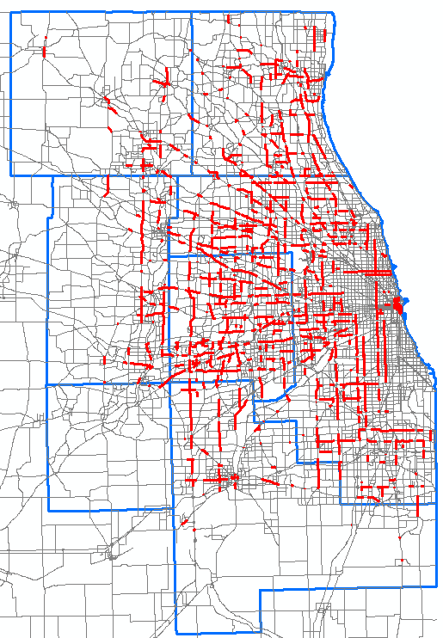

Source: CMAP Traffic Signal Interconnect Inventory, 2012 update

[Adaptive signal control](https://www.fhwa.dot.gov/innovation/everydaycounts/edc-1/asct.cfm) is another technology that can be used at appropriate locations to improve traffic flow. These systems can detect traffic patterns and adjust signal timing in real time. A number of agencies in the region have installed adaptive signal control. Lake County DOT’s experience showed that adaptive signal control increased vehicle throughput by 15%-40%.

Recommendation: System operators should evaluate the age and status of signal hardware and software in context of the local operating environment and prioritize locations for modernization and coordination.

### Central Signal Systems

The ultimate goal of all the region’s system operators is to monitor and manage the region’s traffic signals using central signal systems. These systems provide the ability to actively monitor traffic signals and highway operations in real time, and communicate desired changes to the traffic signals from a central office. For example, if a road were blocked by an incident, traffic management staff could observe traffic patterns at traffic lights in the vicinity using cameras and transmit new instructions to an ad hoc group of signals to accommodate the new traffic pattern. The results can be observed from the central office to confirm that the changes had the desired effect, and further adjustments can be made as needed. In a situation where central control is not available, an engineer must fight the same traffic as road users and visit each traffic signal to provide new instructions. The engineer then must revisit the signals to observe the impacts. When the incident is cleared, the engineer must visit the signals again to return them to their pre-incident state. The cost in time and difficulty of this process reduces the likelihood that an agency will consider it. Interviews with operations staff indicated that the difficulty of the process without central signal systems severely limits the extent to which they can respond to special events. In addition to managing unexpected traffic events, central signal systems improve signal maintenance. The systems monitor equipment and detect malfunctions of the signals, controllers, vehicle detection, and communication, reducing the need for technicians to be in the field observing signal performance, which can also be neglected due to costs and staffing shortages.

A complete central signal system requires significant investment in communications, hardware, software, and cameras to observe system performance, and trained operators to manage the system. The inclusion of an adequate number of cameras also creates a significant resource for improving incident response, allowing sharing of images with emergency responders.

To clarify how the users, traffic management center, and roadway located systems interact in a central traffic signal deployment, Figure 18 presents a diagram from the U.S. DOT Intelligent Transportation Systems Joint Program Office [National ITS Architecture](http://www.iteris.com/itsarch/) of [ATMS03-Traffic Signal Control](http://www.iteris.com/itsarch/html/mp/mpatms03.htm#tab-1). The yellow boxes are people and vehicles. The white boxes are hardware and software equipment packages operating at the traffic management center or on the road (shown in purple). The arrows show the direction of information flowing between them.

In the diagram, traffic operations personnel monitor data and provide control inputs to the traffic management center equipment packages. The traffic management equipment packages exchange information with roadway equipment packages. In this example, the roadway field equipment transmits right of way request notifications, signal control status, traffic flow and images data, and signal fault data. In the other direction, traffic management center service packages send signal control commands, signal control device configurations, signal control plans, surveillance equipment control instructions, and signal system configurations. The roadway systems are also communicating with “other roadway” people and vehicles in the field, such as buses requesting and receiving transit signal priority requests, emergency vehicles requesting traffic light pre-emption, drivers viewing instruction from the traffic lights, and pedestrians requesting and receiving a walk signal. With reliable communications, the traffic management center receives information continuously and can act on it when needed. If communications are interrupted, the roadway equipment packages will continue operating independent of the traffic management center. In the best deployment, communication redundancy ensures high system reliability.

Figure 19: Advanced Traffic Management System (ATMS)

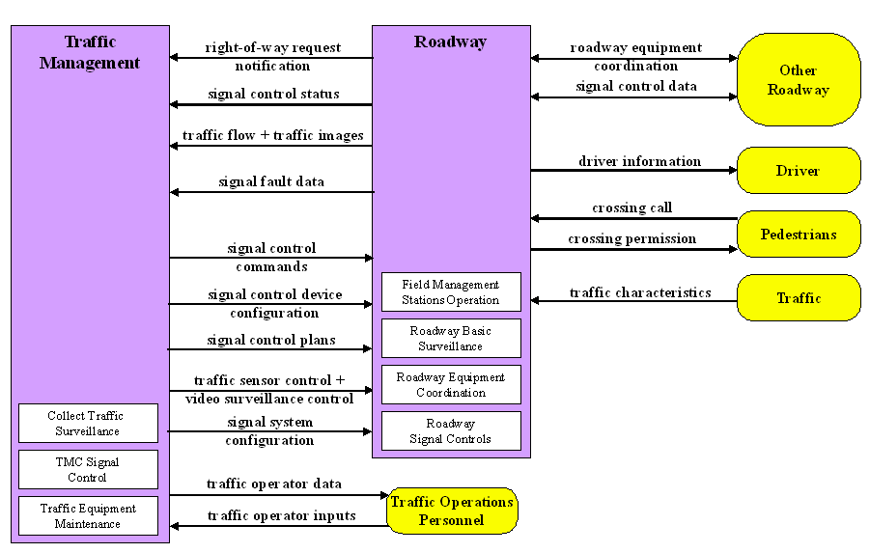

Source: U.S. DOT Intelligent Transportation Systems Joint Program Office National ITS Architecture [web page](http://www.iteris.com/itsarch/html/mp/mpatms03.htm#tab-2).

The Illinois Department of Transportation owns the largest number of traffic signals in the region and has not implemented any central traffic signal control technology. The practice in the region has been for IDOT to enter into agreements with other entities, allowing other entities to include IDOT signals within their central systems.

For example, Lake County DOT has built the most advanced central signal system capabilities, with the largest number of traffic signals and cameras. There are over 700 traffic signals in Lake County. Approximately 550 are connected to the traffic management center, even though Lake County DOT only owns 160 of the total. Many of the signals that Lake County monitors are IDOT signals. Lake County can change traffic signal operation on IDOT’s network under emergency circumstances. Regular operational changes have to be completed by IDOT. The agreement between Lake County DOT and IDOT is a template for similar existing or future agreements between IDOT and other counties and municipalities. Communication between the traffic management center and the field equipment (signals and cameras) is provided by a system comprising fiber and wireless communication. To support the transmission of video images, line-haul communication from the field to the TMC uses fiber optic cable.

Figure 20: Lake County Traffic Signals April 2016

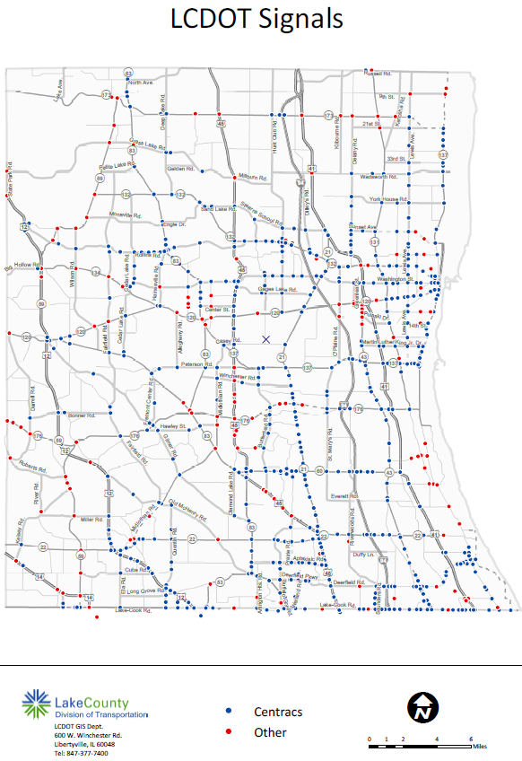

Blue dots indicate signals that are connected to the central system, red are not. The system is expanded every year.

DuPage County is developing a central traffic signal system. Phase 1 construction is underway, and completion is expected by June 2016.

Figure 21: DuPage County Central Signal System Project

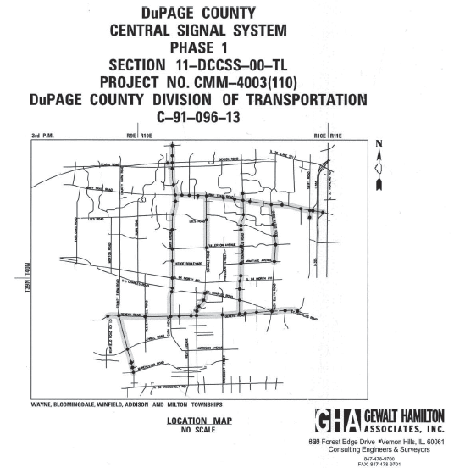

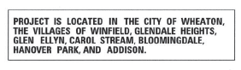

Kane County is also developing a central signal system. Note the number of IDOT signals (blue) included in the system.

|  |  |
| --- | --- |
| Figure 22: Kane County Signals in Central Signal System 2016 | This is a map of traffic signals in Kane County.  Signals with numbers adjacent to them are connected to the KCDOT central signal system.  The dot colors represent maintenance responsibility.  Green: Kane DOT  Blue: IDOT  Magenta: Municipal |

Source: Kane County Division of Transportation

The City of Chicago Department of Transportation also has some traffic signals under central control. In this case, they only include signals coordinated by interconnects. CDOT currently operates signals using three central signal software packages: MIST, CLS-DOS, and CLMATS. CLMATS and CLS-DOS are old systems which will be phased out when the opportunity arises. Communication for these systems is also provided using a combination of wireless and fiber optic cable.

Figure 23: City of Chicago Signals Included in Central System

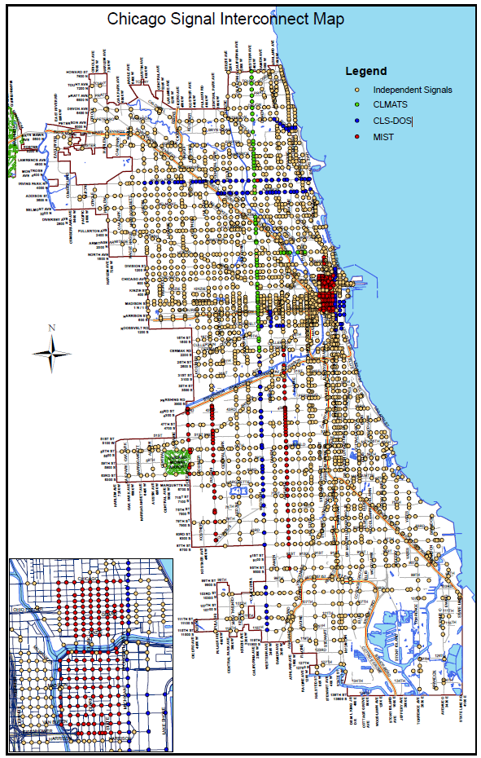

Source: City of Chicago Department of Transportation.

Figure 24: City of Naperville Central Signal System (2016)

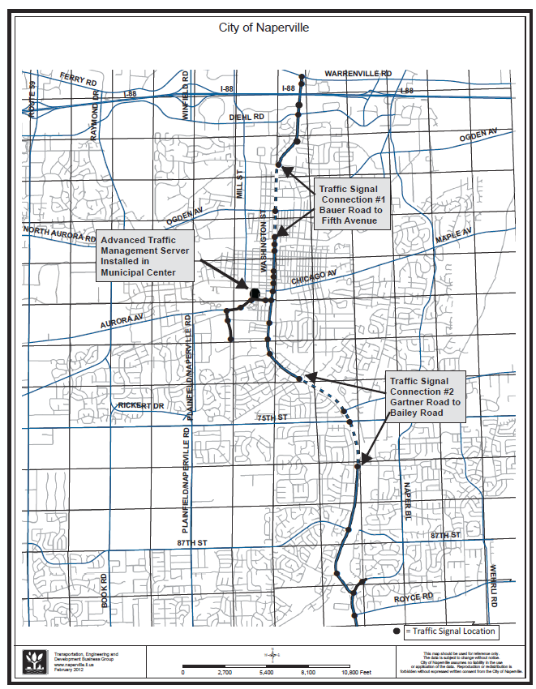

Source: City of Naperville, Transportation, Engineering & Development Business Group

Recommendation: All agencies, including CMAP, should fund projects which advance the implementation of central signal systems.

### Interjurisdictional Coordination

There is a variety of existing signal system coordination agreements between agencies. As central systems become more developed, the potential for coordinating signal operations between jurisdictions will be improved. Center to center integration has been considered the route by which this will happen. However, in DuPage County, testing of a different strategy is being planned. In this instance, DuPage County plans to host the hardware and software for a “virtual” traffic management center. The City of Naperville and the City of Aurora will be the first members of the virtual center, and use the hardware and software to manage their own signals. This should reduce the cost of procuring hardware, software, maintenance and upgrades of the signal management system and eliminate the need for center to center integration.

Recommendations: Opportunities for shared resources that promote coordination and reduce costs should be explored.

### Consideration of All Highway Users

Although the discussion so far has focused on traffic signals and vehicle traffic, traffic signal operations by necessity includes consideration of all roadway users. Pedestrian detection, countdown signals, and pedestrian signal timing have all become common in the region. The City of Chicago has installed bicycle directed traffic signals on bike routes, and many agencies have installed beacons where bike trails cross roadways. Some agencies have adopted the standard that “if there is a sidewalk, the location gets a pedestrian signal.” For areas with high pedestrian volumes, the walk sign operates without pedestrian detection.

### Traffic Signal Audit

The Institute of Transportation Engineers [Traffic Signal Audit Guide](http://library.ite.org/pub/e2654d52-2354-d714-5126-ca1779c02831) provides a list of information needed to evaluate “an agency’s traffic signal system design, management, operations, maintenance and/or safety practices relative to generally recognized best practices and to recommend actions that might be taken by the agency to incorporate these practices into its existing operation.”

**Recommendation**: Each system operator should undertake a traffic signal audit and use the information to develop an action plan for improved traffic signal practices. [46] CMAP should support funding for this activity.

## Special Events

Special events are estimated to cause 5% of our region’s congestion. The CMAP region hosts many planned special events each year, including festivals, sports, concerts, parades, and fireworks displays. Holiday traffic can cause high levels of predictable congestion around shopping centers and airports, and can function rather like planned events. Increased traffic congestion and the presence of drivers who are often unfamiliar with the location combine to increase the potential for crashes. In theory, scheduled events should be easy to plan for. In practice, lack of interagency coordination and coordination with event staff can make effective planning for them impossible. Additionally, some useful strategies, such as special signal plans, can be difficult to implement because the signal systems are not centrally controlled.

“A planned special event represents the only type of event that can generate an increase in traffic demand and cause a temporary reduction in roadway capacity because of event staging.”[47] For example, often Chicago’s downtown festivals require the closure of certain streets to accommodate pedestrians. Parades or marathons also require street closures.

The first activity to support operations for special events is having a system to collect special event information. Events sponsored by municipalities are generally known by the local traffic authorities and, for example, the Chicago Office of Emergency Management and Communications provides special event information to the Gateway Traveler Information System. Event information that should be collected is event location, start and end time, and expected attendance. This information should be provided to the Gateway Traveler Information System so it can be distributed as real time information so drivers can choose other paths. Incident management plans and signal timing plans can also be developed. These are discussed in previous sections. Responses to special events will be simplified by central signal systems.

|  |
| --- |
| **Recommendations**: CMAP should work with local governments and events sponsors to systematically report special event information to the Gateway Traveler Information System. |

# Communications Backbone

Real time monitoring of the system and communication with field equipment requires a robust and redundant communication system. Active traffic management centers requires the ability to monitor and communicate with all field equipment, including traffic signals, cameras, dynamic message signs, other operations centers, and in the future perhaps even vehicles on the roadway. Agencies stated that often the most difficult part of implementing intelligent transportation system projects was establishing the communication infrastructure to support them. Most of the agencies used a combination of wireless and fiber communication, but the high volume of data transmission, especially camera images, requires the high capacity linkages most often provided by fiber optic cables.

### Existing System

Individual agencies have been installing fiber communications over time. For a number of reasons, including the recurrent cost of using publicly available communication systems and security concerns, transportation agencies in our region have been building private communication networks to support traffic management activities. The Illinois Tollway has complete coverage of its 286 center mile system and has written agreements to share fiber communication capacity with the Gateway Traveler Information System, and the Lake County Division of Transportation. The Illinois Department of Transportation has an extensive fiber optic network. However, there is a need to inventory and review location and condition of the IDOT system. Procurement for that inventory is in process now. In the near future, Lake County DOT will share just over 100 miles of fiber of other agencies (ISTHA, IDOT and Cook County), plus will have 38 miles of county-owned fiber. DuPage and Kane Counties are installing fiber links as needed as they develop their central control capabilities. The Chicago Department of Transportation has an inventory of the location of its extensive fiber communication system. There are also 902 centerline miles of traffic signal interconnect on the arterial system, which can be counted as segments of communication infrastructure serving individual systems in the field.

These systems form the beginning of communication coverage on the arterial system. Old signal interconnects may communicate with copper wires, but new ones are all installed with fiber communications. When the systems become part of a central signal system, communication to the traffic management center is added.

### Maintenance

Construction activity is the main source of damage to the region’s communication resources. For example, over time much of the CDOT system has been damaged by construction (and less often weather), and an analysis to determine which segments are operational and which segments need repair or replacement is needed. CDOT has lost the ability to communicate with some equipment in the field. In many instances, CDOT relies on the fiber communication system serving the Chicago Police Department for transmitting large amounts of data from the field back to the traffic management center.

Moisture infiltration combined with freezing temperatures have also crushed fibers or caused reliability problems. The impacts of climate change combined with the expanding size of the communications system may make this more frequent. On rare occasions, aboveground cables have been damaged by traffic incidents.

For the last 7 years the City of Naperville has been protecting its fiber network by having the system included in the Illinois Joint Utility Locating Information for Excavators ([JULIE](http://www.illinois1call.com/)) underground location system. The Naperville technicians review JULIE tickets to see if work is proposed adjacent to Naperville owned infrastructure, then send someone out to locate the cables. There is a cost to agencies per location, so most other agencies have not participated in JULIE. As mentioned earlier in the section discussing utility coordination, JULIE does not protect infrastructure of agencies who are not members. It could be useful to evaluate the cost to transportation agencies for joining the system compared to the cost to agencies of system damage.

Ultimately, damage may not be detected, especially on isolated systems. Cable/communications monitoring systems that automate the process of testing the system and notifying agencies of fiber or other communication interruptions are available, and will be important to eliminate degradation of communication system functionality in the future. As central traffic management systems become the rule, these systems should become standard.

### Expansion

Agencies expressed the desire to plan for system expansion with sharing in mind. A region wide inventory of transportation related fiber-optic cable does not currently exist, which makes planning for these opportunities more difficult. If agencies agree on the future communication layout, they may be able to incorporate features during normal roadwork that make expansion to build the system easier and cheaper. Retrofitting roadways with fiber optic communication is costly. According to USDOT Intelligent Transportation Systems Joint Program Office, the cost of in-ground fiber optic cable installation might range between $21,000 – $55,000 per mile but “In ground installation would cost significantly less if implemented in conjunction with a construction project.” [48] According to a Chicago Department of Transportation staff member, locations with very complex underground utility systems like the City of Chicago can incur costs between ½ to one million dollars per mile for design and construction of fiber optic communication.

Even requiring the installation of empty conduit when projects are constructed would decrease the cost of adding communications in the future. Extra capacity can be provided by including extra fiber in an installation, or using larger conduit so more cable can be added later. It might not be sensible to require this for every construction project, but could be practical on roadways that were included in a communications system master plan.

A number of agencies in the region have lost communication with all field equipment because of damage to a critical system link. As the communication system of each of the agencies expands, opportunities for links between agencies and resulting redundant paths will become available. Identifying and supplementing critical links that don’t have alternative routings will be needed to prevent traffic management system failure.

Expanding the system and creating the necessary redundancy may proceed in a smoother and more predictable way if the region has an understanding of how the system should or will be developed. The region’s agencies expressed a desire to work together to develop a Communications Master Plan. In addition to the basic question of what is existing, and where there are gaps, a master plan should also consider these questions:

* Can agencies use existing fiber network owned by non-transportation government agencies (e.g. State of Illinois, emergency management, transit agencies) to provide additional connectivity?
* Should agencies increase the use of wireless communications for short distances? Most agencies are already using combined wireless/fiber systems.
* Would it be advantageous in the long run to use of Public-Private partnerships which offer communications capacity in return for access to public infrastructure as locations for private party equipment?
* Are there alternative ways of achieving system wide reliable and redundant communications? Some cities have implemented their own [mesh networks](http://www.motorola.com/innovators/pdfs/mesh-ntwks-wp-7.24.06.pdf). Scottsdale Arizona, with an area of 185 square miles and population of 225,000 residents did this and saved the city approximately $250,000 annually in communication lease fees.[49] The City of Chicago is currently replacing about 300,000 street lights with new light poles and LED lamps, providing a huge savings in energy and maintenance. The plan may also include the development of a wireless mesh network by installing an antenna on each of the new poles. This is only at a conceptual stage right now, but would provide citywide connectivity.
* What impact will new technologies have? New technologies may reduce or eliminate the need for fiber communications. For example, 5G communication may begin to be rolled out in 2017[50]. This technology isn’t just a faster version of current communication; it provides for different system operations such as device to device communication, ad-hoc networks and supports the internet of things.

|  |
| --- |
| **Recommendations**: CMAP should work with the region’s agencies to develop a Communications System Master Plan. |

# Power

*The largest power outage in U.S. history rolled across much of the Northeast from Detroit to New York City on a hot and humid Thursday in August 2003. The massive power outage left a swath 6,000 kilometers (3,700 miles) long–including portions of Michigan, Ohio, Pennsylvania, New Jersey, New York, Connecticut, Vermont, and Canada–in the dark. In New York City, workers poured out of the highrises only to find the streets gridlocked, because traffic signals at all of the city's 11,600 signalized intersections had ceased to operate. The New York subway system ground to a halt, stranding more than 400,000 passengers in tunnels. The city's extensive commuter rail network also closed down, leaving few options for routing stranded customers back to their homes in New Jersey and Connecticut since approximately three-fourths of work trips into Manhattan are made using transit.*

*Traffic signals and public transit are only part of the transportation facilities that depend on electricity. Other systems include tunnel lights and ventilation; intelligent transportation systems (ITS) equipment such as cameras, loop detectors, variable message signs, and electronic toll collection equipment; and pumps to control flooding in depressed roadways.*

*In Detroit, MI, the August 14, 2003, power outage hit just at the beginning of rush hour, leading to heavy congestion on miles of freeways. By the next day, a heavy rain had flooded several sections of depressed freeway because the sump pumps used to remove water from these sections had no power, and backup generators were unavailable. Cameras and variable message signs were not operational as well, making it difficult for managers to gather and communicate information to the public--except through the lenses of cameras on news helicopters.*

*Restoring transportation operations is vital to safety, freight movement, and national security. "Historically, transportation has been viewed as an important support function during disasters," says the Federal Highway Administration's (FHWA) Emergency Transportation Operations Team Leader Vince Pearce. "But the more we look at large-scale situations, the more we see that if transportation doesn't work right, it's too hard for other responders to do their jobs. If we can't get the fire trucks and ambulances to the scene, we can't put the fires out or help the injured. Transportation must work at its absolute best in these kinds of situations, and our objective is to help the transportation community bring their resources to bear at the most important time." (*[*Learning from the 2003 Blackout, Public Roads Magazines*](https://www.fhwa.dot.gov/publications/publicroads/04sep/04.cfm)*, FHWA October 2004)*

The importance of the availability, condition, and reliability of electricity powering highway operations systems can’t be overstated. The traffic management center, communications network, and field equipment depend on a reliable, good quality power. Under normal conditions, a power failure is a time consuming inconvenience. In an emergency situation, the same power failure can cripple our ability to respond to emergencies, to warn travelers of danger ahead, or move people to safer locations.

An aging electrical grid, increased demands for electricity and increases in severe weather all contribute to power outages. Over time, the number of outages has been increasing (see figure 25, which presents major outages, excluding smaller local outages). Illinois had the 9th highest number of major weather related outages of all states in the years 2003 through 2012[51]. Nationwide, “147 million customers lost power, for at least an hour and often far longer, from weather-related outages since 2003, an average of 15 million customers affected each year (…) A customer is a home or a business, or anyone who receives a bill from a utility””50 Highway operators are among the customers included this number.

Figure 25: Trends in Power Outages

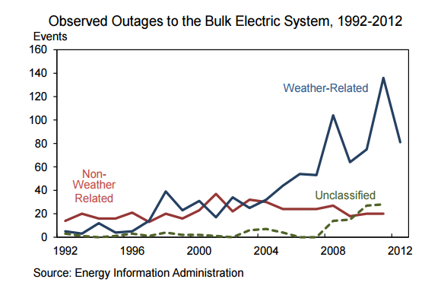

Source: [Economic Benefits of Increasing Electric Grid Resilience to Weather Outages](http://energy.gov/sites/prod/files/2013/08/f2/Grid%20Resiliency%20Report_FINAL.pdf), President’s Council of Economic Advisors and The U.S. Department of Energy’s Office of Electricity Delivery and Energy Reliability, August 2013

Not only can our highway operation equipment *lose* power, but the quality of electricity supplied can vary in ways that disrupt the operation of electronic components. In this case, quality refers to how consistent the flow of electricity is. Consider the surge protectors we plug our computers in to protect them from damage by inconsistent electrical flows in the form of power surges. Similarly, the electronics and operation of roadway equipment can be damaged by surges or sags in voltage, and spikes caused by events such as lightning strikes or restoration of power after a blackout.

“Many of the mysteries of equipment failure, downtime, software and data corruption, are the result of a problematic supply of power.”[52] The impacts of power service disruptions and variability can be reduced by investing in equipment that monitors and responds to power flow changes. Uninterruptable power supplies (UPS) for traffic signals have become more common, and power conditioners can be included as part of the UPS. Power conditioning is important because even a momentary sag in electricity can cause a traffic signal to malfunction and go into red flashing mode. “A traffic signal that is dark or flashing contributes to traffic congestion and jeopardizes safety for vehicles and pedestrians. Emergency vehicles are unable to preempt the operation of the nonfunctional traffic signal, experiencing unwanted delays. In addition, power interruptions render useless the signals that are interconnected with railroad crossings, which keep the tracks clear of vehicles before the arrival of a train. A power interruption lasting only a fraction of a second may send the signals into the flash mode, and the signals may continue flashing until manually reset.”[53] Power conditioning senses the sag or surge, switches to backup power, then switches back when the disturbance is over, eliminating the red flash mode and technician response. If power is interrupted for a period of time, backup power can run the traffic signal until it is restored. Anyone who has experienced the performance of a busy intersection when the traffic light is in red flash mode will attest to the resulting bottleneck. Often power interruptions impact many nearby intersections, creating a traffic operations failure that can spill over a large area.

The Texas Department of Transportation suggests that “Locations where UPS systems are most beneficial include intersections with:

* unique geometry such as wide medians, conflicting left turns that require lead-lag operation, protected only left turn operation, or split phasing where right-of-way assignment is difficult for a four-way stop operation;
* intersections over capacity with heavy directional traffic flow;
* a history of signal malfunction due to power quality or reliability issues;
* high volume roads (total volume of all approaches in excess of 20,000 ADT);
* rail preemption;
* emergency preemption, or intersections near fire stations (within 1200 ft.);
* signal repair response time in excess of 30 minutes;
* 1320 ft. proximity to another intersection with UPS;
* a coordinated system, or is part of a corridor that functions as a major arterial in an urbanized area;
* high speed approaches.”[54]

Other critical equipment such as pumping stations, message signs, cameras, and sensors can benefit from UPS, and should be reviewed to determine priorities for developing a more resilient highway management electrical system. The need is heightened as we become more reliant on these systems for day to day highway operations, and weather and infrastructure condition threatens to make them malfunction more frequently.

Communications systems also rely on power to operate. Including UPS to control an individual signal is helpful, but if the signal is designed to coordinate with other signals, or communicate with a traffic management center, it is important to ensure that the power needed to serve that purpose is also maintained. Other roadside equipment also uses the communication system, and the future seems to include even our vehicles communicating with the highway infrastructure. Including UPS in communications hubs shouldn’t be overlooked in system design.

UPS systems can also be centrally monitored and managed from the traffic management center if the communications is available to support this. The systems also require field maintenance. “In order to ensure that UPS operates properly when needed, units should be checked periodically. Batteries should be inspected and replaced when needed. Additionally, all ancillary equipment in the cabinet (i.e. fans, lights, circuit breakers, charging circuits, temperature sensors) should also be checked periodically for proper operation.”53

Recommendation: CMAP should work with agencies to identify and prioritize locations where power is an issue and support the installation of UPS and power conditioning systems. This includes review of the need for backup generators at critical locations. CMAP should support programs and projects which create a resilient highway management system by ensuring a continuous and quality electricity supply.

# Traffic Management Centers

The hub for all the activities and systems we have described is the traffic management center (TMC). TMC’s host the hardware, software and staff that monitor and operate all the region’s highway systems.

Typical traffic management center functions include:

* Implement dynamic selection of traffic signal timings
* Implement transit signal priority
* Provide coordination among various agencies
* Monitor traffic signal equipment, and dispatch resources to fix malfunctioning equipment
* Provide traffic detection and surveillance
* Modify arterial traffic signal timing when an incident occurs on a freeway
* Manage incidents and special events or emergency evacuations

## Regional Traffic Management Center Inventory

**Illinois Tollway Traffic Operations Unit/ Illinois Tollway Traffic and Incident Management System (TIMS)**

The Tollway Traffic Operations unit uses the TIMS system to monitor and control roadway devices such as vehicle detection systems, ramp queue detection, weigh in motion stations, dynamic message signs, portable message signs, road weather stations and closed circuit television. The TIMS also monitors and controls the smart work zones equipment. TIMS automatically reports travel times, incidents, and construction and maintenance information to the Illinois Gateway and to media. TIMS communicates directly with the Illinois State Police using computer aided dispatch.

The base implementation of ISTHA’s Traffic and Incident Management System (TIMS) is complete. The TIMS, located at ISTHA’s headquarters in Downers Grove, provides an Advanced Transportation Management System (ATMS) integrated with Illinois State Police District 15 Computer Aided Dispatch (CAD). The CAD handles District 15 police, maintenance units and HELP (vehicle aid) vehicles, as well as fire and emergency services. The CAD is located on the floor below the TIMS in the Downer’s Grove complex. The TIMS monitors traffic flows via detectors and CCTV cameras and controls ISTHA DMS. It also automatically generates incident response plans and DMS messages for operator review prior to implementation. The Illinois Tollway TMC currently operates 24/5 with Illinois State Police taking over on weekends to the best of their ability. It will be extended to 24/7 operations.

**Illinois Department of Transportation ComCenter**

The Communications Center acts as the 24-hour incident management and operations center for IDOT District 1 interstates. The ComCenter controls the Highway Advisory Radio system, the Kennedy Expressway reversible lane control (RevLac) system, and operates the roadside Dynamic Message System. The center also provides information to the Gateway Traveler Information system (GTIS) and hosts GTIS staff 24/7/365. The ComCenter also dispatches all maintenance and Emergency Traffic Patrol vehicles

**IDOT Transportation System Center (TSC)**

The TSC is responsible for monitoring the vehicle detection system on IDOT's District 1 expressway system. The TSC software system is also responsible for distributing congestion information. Staff from the TSC center has recently been moved to the ComCenter.

IDOT does not maintain an arterial traffic management center. Expansion of IDOT’s arterial traffic management activities would require additional physical space and staffing. Arterial traffic management activities could be housed at the currently unutilized TSC.

**Cook County Traffic Management Center** – Cook County does not maintain a traffic management center and continues to advocate for development of an arterial traffic management center shared by the Illinois Department of Transportation. Especially in northwest Cook County, there are many congested IDOT and Cook County jurisdiction arterials whose management should be coordinated. Maintaining a joint center would facilitate that coordination. Lake-Cook Road is under Cook County Jurisdiction, but there isn’t any communication from equipment on the road directly back to Cook County Department of Transportation and Highways. Lake County Passage communicates with Lake-Cook Road equipment and provides Cook County DOTH communications access.

**Chicago Traffic Management Center (CTMC)** – Currently major emergency management, which typically involves traffic, operates out of the Office of Emergency Management and Communications 911 Center, located just west of downtown. It is expected that the CTMC and the 911 Center will integrate operations and communications to some degree. It can be noted that at present, CDOT operates a “mini-TMC” out of its Traffic Control Room (30 N. LaSalle Street), which will be expanded as needed until a more permanent facility is built. In late 2016 a contract was signed to begin constructing the Chicago Traffic Management Center. The Chicago Office of Emergency Management and Communications will host the hardware (servers & communications). OEMC manages the police department hardware too.

**DuPage County (Virtual) Traffic Management Center** - Currently monitoring and management are assigned to a workstation in the DuPage County complex. DuPage County DOT, the City of Naperville and the city of Aurora are use testing the same traffic management software which will likely form the software foundation of the virtual center. DuPage County intends to ultimately host the hardware and software, but provide access to member agencies. The [virtual traffic management center](http://www.ops.fhwa.dot.gov/publications/fhwahop14016/fhwahop14016.pdf) streamlines hardware and software purchase and maintenance. In addition, sharing these resources eliminates the need to implement center-to-center communication between traffic management centers that use the system.

**Kane County TMC** – A [feasibility study](http://kdot.countyofkane.org/Publications/ITSFinalReport.pdf) was completed in 2007, and the TMC was constructed in 2015 and should become operational in 2016.

**Kendall County** – None existing or planned.

**Lake County Passage** - Lake County PASSAGE Traffic Management Center (TMC) operates the County roadways. PASSAGE is an Intelligent Transportation System designed to provide motorists real time traffic congestion information due to crashes and construction events. These events are communicated by police department's Computer Aided Dispatch (CAD) systems, sent directly to the Transportation Management Center (TMC), and then communicated back to highway users via www.lakecountypassage.com, PASSAGE Highway Advisory Radio (HAR) 1620 AM, variable message signs, smartphone applications, and a variety of social media outlets.

PASSAGE is currently connected to 470 traffic signals, 300 PTZ traffic monitoring cameras, and nearly 480 video detection cameras. The data from this equipment is brought back to the TMC on over 200 miles of fiber and various wireless data links. Lake County PASSAGE is only staffed on weekdays.

**McHenry County –** None existing and none planned**.**

**Will County –** None existing and none planned**.**

## Traffic Management Center Models

As shown in Table 6, there are a variety of traffic management center models. Centers in the CMAP region are single jurisdiction and publicly staffed and operated. However, not all system operators have implemented a TMC and most centers do not operate 24/7. This is mainly due to the cost. Some agencies support evaluating shared TMC models which could reduce the cost to individual agencies and expand the hours of operation for the traveling public.

Table 6: Traffic Management Center Business Models and Configurations

|  |  |  |
| --- | --- | --- |
| Geographic Area Covered | Number and Type of Agencies Involved | Operating Mechanism |
| Single jurisdiction  Multiple Jurisdiction  Region wide or district  Statewide | Single agency  Multiple transportation agencies  Multiple agencies and disciplines | Public agency staffed and operated  Private sector staffed and operated |

Source: [Traffic Management Center Fact Sheet, Texas A&M Transportation Institute](http://mobility.tamu.edu/mip/strategies-pdfs/traffic-management/technical-summary/traffic-management-centers-4-pg.pdf)

The Texas Transportation Institute has also estimated the annual cost to operate traffic management centers based on size and hours of operation (table 7). The costs are out of date, but the relative amounts provide some insight into potential savings associated sharing TMC resources. Much of what the TMC does is not dependent on TMC location, and some regions have combined resources to develop a single TMC. In 2005, the Florida Department of transportation, two counties and two cities entered into such an [agreement](https://www.mymanatee.org/home/government/departments/public-works/traffic-management/traffic-engineering/advanced-traffic-management-system.html).

Table 7: TMC Annual Operations Cost Estimates (in 2005 Dollars)

|  |  |  |  |
| --- | --- | --- | --- |
| TMC Size in operations hours/days of week | Personnel Costs in $1,000’s | Physical Plant Costs in $1,000’s | Total Annual Operation Costs in $1,000’s |
| Large Regional TMC  24 hours/7 days | $1,278.1 | $1,838.8 | $3,116.9 |
| Large TMC Weekday  12 hours/5 days | $476.5 | $180.7 | $657.2 |
| Medium TMC Peak Period  8 hours/5 days | $277.9 | $109.4 | $387.3 |
| Small TMC special events only | $53.6 | $46.9 | $100.5 |

Source: [Traffic Management Center Fact Sheet, Texas A&M Transportation Institute](http://mobility.tamu.edu/mip/strategies-pdfs/traffic-management/technical-summary/traffic-management-centers-4-pg.pdf)

## Integration of Centers

Northeastern Illinois ITS planning and [CMAP ITS Architecture](http://data.cmap.illinois.gov/its_arch_v30/index.htm) envisioned center to center integration to happen using the [IDOT Gateway Traveler Information System](http://data.cmap.illinois.gov/its_arch_v30/html/inv/el56.htm) (GTIS) as a communications hub, eliminating the need for agencies to connect with multiple centers. Each center can connect only with GTIS and share information with multiple agencies. Some operations staff expressed concern about whether the GTIS will be robust enough to support this. In addition, developing and staffing multiple traffic management centers is costly. Cost has been the main impediment to developing them. A number of the region’s system operators believe we should evaluate the potential for developing and staffing a region wide, multi jurisdiction center. This could be a virtual TMC or traditional brick and mortar location. A regional center would eliminate the need for integrating multiple TMCs, and share the staffing, hardware and software costs.

|  |
| --- |
| **Recommendation**: CMAP should support expansion of traffic management center capabilities.  CMAP should undertake a study of the costs and benefits of implementing a regional, multi-jurisdictional traffic management center, either virtual or traditional. |

# Municipal Traffic Management

Municipalities can benefit from the strategies already discussed. However, municipalities have an additional responsibility that the county and statewide departments of transportation don’t have - managing parking. Effective management of parking reduces congestion and improves safety. “Sixteen studies conducted between 1927 and 2001 found that, on average, 30 percent of the cars in congested downtowns were cruising for parking.” [55] Most state and county roadways don’t include on-street parking, and state and county system operators don’t provide off-street parking either. Some state highways within municipal boundaries may allow parking, and the municipality is responsible for establishing and enforcing the parking policies.

## Traveler Information

One way to reduce the number of people cruising for parking is to provide real-time traveler information about where parking spaces are available. The City of Naperville provides free parking on all downtown streets, in all downtown lots, and downtown parking decks. The city department of transportation has developed a [parking navigation system](http://www.naperville.il.us/downtownparking.aspx) to provide information on parking availability. The system does not provide information regarding the availability of on-street parking.

[Traveler information](https://play.google.com/store/apps/details?id=com.passportparking.mobile.parkchicago&hl=en) for parking in the city of Chicago is also widely available from private developers rather than the City of Chicago. In addition, there is also a [smart phone application](http://parkchicago.com/) allowing the driver to pay for parking using a cell phone application, even to extend the parking time.

## Pricing for Parking

Managing the supply of parking through pricing mechanisms is another way to manage capacity and reduce cruising for parking. In many municipalities there is an adequate supply of parking within a reasonable distance from desired destinations, and people just need information about where it is. This calls for parking information systems. In dense locations, there may not be enough parking supply within a reasonable distance from desired destinations so pricing can be used to ensure that there are a number of empty spaces always available. Of course, parking information systems that provide the location of the empty spaces is still useful.

In 2006 the city entered into a 99 year lease of the downtown parking garages for $563 million. This included one City of Chicago garage, and three Chicago Park District garages. “The downtown parking system’s four garages constitute the largest underground parking system in the United States.”[56]

In 2008 the City leased the metered parking system for $1.15 billion to Chicago Parking Meters LLC in a 75 year agreement. The agreement was revised in 2013. “Chicago Parking Meters, LLC (CPM) operates the third-largest metered parking system in the United States and the largest system privately operated under a concession agreement. CPM is responsible for the operation, management, maintenance and rehabilitation of Chicago's on-street parking. Since 2009, CPM has invested over $40 million in system modernization and customer service improvements. With electronic meter boxes serving all of the approximately 36,000 metered spaces in the city’s downtown and neighborhood areas and efficient maintenance processes, it is one of the most sophisticated parking operations in the U.S. and was ranked #1 in the world for on-street parking in IBM’s 2011 Global Parking Survey.” ([Chicago Parking Meters](http://chicagometers.com/))

Rates and hours of operation are established in the lease documents. The documents include conditions relating to competition, and penalties based on changes to street operations caused by construction, special events, and transit service changes. This is an example of how public private partnerships can make operating the system more difficult because the goals of the private partner are not necessarily consistent with the goals of the public partner or the public in general.

# Implementation

So far this paper has explored and made recommendations for a number of general ways the region can improve its management and response to incidents, weather, construction, traffic signals and special events on the highway system. We’ve discussed how maintenance and expansion of the communication system, and attention to maintaining the power needed to run the system help ensure that the strategies can be applied reliably when and where needed. And, we’ve highlighted the region’s traffic management centers, the heart of the system, where professionals and software systems monitor and manage information flows and take decisions about appropriate responses to system conditions in real time. How can these ideas be applied to individual northeastern Illinois roadways between now and 2050 to improve system operations? The future of congestion management is the application of selected real-time strategies in a coordinated fashion on individual roadways, which is often called **Active Traffic Management**.

Active traffic management is the ability to dynamically manage traffic based on current and expected traffic conditions. It relies on deployment of intelligent transportation system technology allowing operations staff to identify and address non-recurring and recurring congestion in real time. In addition to deployment of intelligent transportation system technologies in the field, active management requires robust communications systems to support information flows, back-office operations software systems and trained operations staff. Since interstates and arterial operate quite differently, the suite of strategies used for each also differs.

“Several countries in Europe have used ATM for years and reaped the benefits. ATM strategies have been shown to increase overall capacity by up to 22 percent, throughput by up to 7 percent, and reduce crashes and secondary incidents by up to 30 percent and 50 percent, respectively. Onset of traffic congestion is delayed and trip times are more reliable.”[57]

While northeastern Illinois implemented reversible lanes and ramp metering decades ago, other active traffic management strategies have not been used in the region. However, they have been widely used across the United States (see figure 26). Nationwide, active traffic management applications are more widely found on expressways than on arterials.

Figure 26: Active Traffic Management Locations

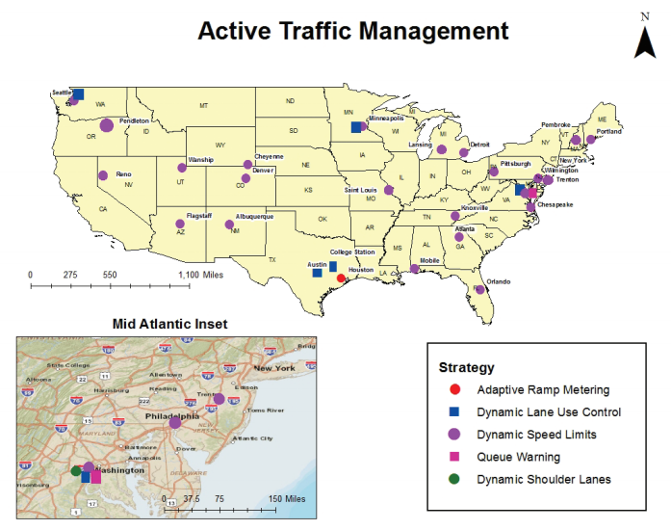

Source: [Active Transportation Demand Management Program Brief: Active Traffic Management](http://www.ops.fhwa.dot.gov/publications/fhwahop13003/fhwahop13003.pdf), FHWA Office of Operations, October 2012

## Active Expressway Management

Northeastern Illinois is home to 425 centerline miles of interstates, carrying 18 billion vehicle miles of travel annually[58]. The centerline miles are about evenly split between the Illinois Tollway, 207 miles, and the Illinois Department of Transportation, with 218 miles. Moving into the future, both agencies intend to develop active traffic management programs for the interstate facilities as opportunities to do it arise. Strategies will likely include:

* **dynamic lane management**, which opens and closes travel lanes based on travel conditions such as downstream incidents. Dynamic lane management was implemented by CalTrans on northbound SR-110 , an 8.2 mile section of freeway that had an accident rate of 3.36 accidents per million vehicle miles when the expected rate was 0.73. Peak hour average vehicle delay was over 20 minutes. Restriping provided an optional dynamically managed lane and the result was delay reduced to under 5 minutes and a 30% reduction in accidents from the previous year.[59]
* **dynamic shoulder use**, which allows the road shoulder to be opened and closed to all or selected traffic based on travel conditions. This strategy provides extra capacity at critical times. In figure 27, the blue line shows speed and flows without the shoulder lane and speed harmonization, and the red line shows the new flow and speed using the shoulder and speed harmonization.

Figure 27: Speed Flow Curves in German Use of Dynamic Shoulder Use and Speed Harmonization

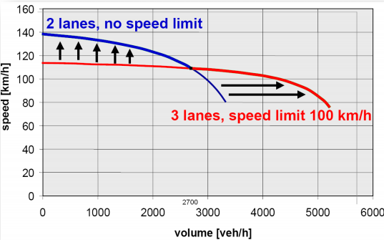

Source[: General Guidelines for Active Traffic Management Deployment](http://utcm.tamu.edu/publications/final_reports/kuhn_10-01-54_interim.pdf), Levecq, Kuhn and Jasek, Texas Transportation Institute October 2011

* **dynamic speed limits** modified speed limits based on traffic and weather conditions. Dynamic speed limits can reduce crashes and delay the onset of congestion. With a goal of improving safety, the Wyoming Department of Transportation implemented dynamic speed limits on I-80 between Laramie and Rawlins. During the following year the number of crashes was significantly lower than any of the previous 10 years. More years of data are needed to confirm this result. However, this success resulted in WYDOT applying dynamic speed limits to four more corridors (three on other parts of I-80) and avoiding an estimated 50 crashes per year on I-80.[60] The system also helped them reduce road closures due to weather.
* **Congestion pricing**, which manages demand and congestion using tolling, increasing vehicle throughput and providing drivers with reliable travel times.

Figure 28: Peak Period Road Performance During Congested Times Priced vs. Free Lanes

|  |  |
| --- | --- |
|  |  |

Source: [Congestion Pricing a Primer](http://ops.fhwa.dot.gov/publications/congestionpricing/congestionpricing.pdf), FHWA Office of Transportation Management, 2006

Active traffic management on the expressways will be most effective when multiple strategies are used in combination. In England, the Highways Agency implemented a pilot project for multiple traffic management measures on the M42 including speed harmonization with camera enforcement, incident detection with queue warning, traveler information and peak hour shoulder use. “**The results of the M42 pilot project included a travel time decrease of 26 percent in the northbound direction and 9 percent in the southbound direction. Also, travel time reliability increased by 27 percent in the northbound direction and 34 percent in the southbound direction**.”[61]

Implementing these capabilities requires development or expansion of field equipment deployment, communication infrastructure, backup power systems, and traffic management center hardware and software to operate. Some potential investments include:

* Network surveillance systems to monitor traffic and road conditions
* Traffic information dissemination to provide drivers with information using roadway equipment
* Dynamic lane management and shoulder use system used to manage and control field equipment specific lanes and shoulders.
* Electronic toll collection where needed to implement pricing and process violations
* Traffic incident management system including expansion of emergency traffic patrols to detect, coordinate and clear incidents and debris especially from priced lanes
* Speed warning and enforcement to monitor vehicle speeds and warn drivers when their speed is excessive and may also issue citations
* Variable speed limit system monitors traffic and environmental conditions along the roadway and sets suitable speed limits.
* Dynamic Roadway Warning to warn drivers of roadway hazards such as crashes, road weather driving conditions, and queues ahead
* Traffic metering central monitoring and control to support ramp, interchange and mainline traffic metering
* Transportation decision support system to recommend courses of action to traffic operations personnel based on an assessment of current and forecast road network performance

The Illinois Tollway Jane Addams Tollway (I-90) will be the first facility equipped to implement active traffic management, starting on the eastern side. The Illinois Tollway is currently rebuilding and widening the Jane Addams Memorial Tollway (I-90) as a 21st century, state-of-the-art corridor linking Rockford to O'Hare International Airport. The [project](http://www.illinoistollway.com/documents/10157/2ef67398-39cc-4add-a47f-f398debcacc8) includes reliable power and communications, and ATM system related equipment and systems (cameras, wireless traffic sensors, dynamic message signs, road weather stations) to support lane management. The technology is flexible enough to accommodate changes in future lane management such as implementing congestion pricing and the use of Vehicle to Infrastructure (V2I) communication. The project is currently underway, but will take a number of years to complete. Notably, the Tollway has entered into an agreement with FHWA to be a pilot Connected Vehicle Affiliated Test bed corridor.

Figure 29: I-90/Jane Addams Corridor

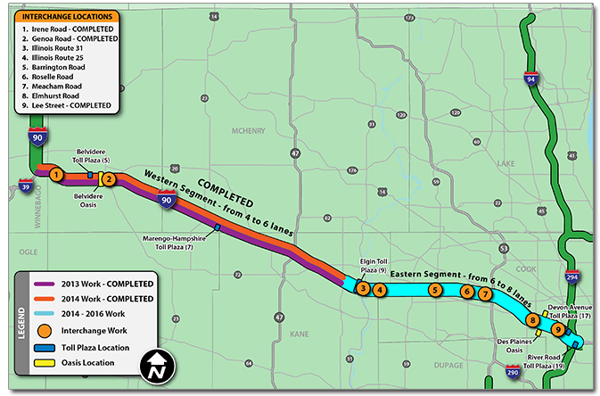

Source: [Illinois Tollway Memorial Tollway Overview](http://www.illinoistollway.com/documents/10157/01c1b486-380c-43d1-9c62-08318d011c70), Illinois Tollway, March 2016

Neither IDOT roadway currently has all the infrastructure to support active traffic management. Both agencies will require significant expansion of traffic management center capabilities.

On the IDOT system, I-55 is currently under study as the first price managed lane project in the region. The I-55 study focused on converting a shoulder to a managed traffic lane with the understanding that the existing lanes will be actively managed but not priced. Except for electronic tolling capabilities, the underlying infrastructure needed for ATM and ETL are the same. The I-55 study analysis compared managing the lane as a High Occupancy Vehicle (HOV), a High Occupancy Toll (HOT) lane where single occupant vehicles can travel if they pay a toll, or an express Toll Lane (ETL) where every vehicle pays a toll. Those types of managed lanes are in operation in many locations throughout the United States (see figure 27). The I-55 Draft [Environmental Assessment](http://www.i55managedlaneproject.org/pdfs/ea.pdf) was released in April 2016 and recommends implementing the I-55 managed lane as an Express Toll Lane.

Figure 30: I-55 Managed Lane Project Location

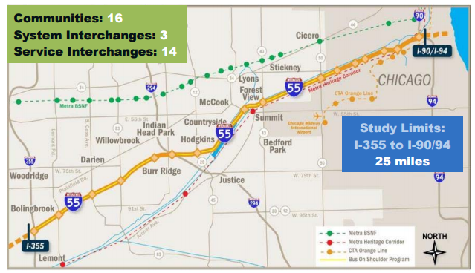

Source: [Draft Environmental Assessment Interstate 55, Interstate 355 to Interstate 90/94 Managed Lane Project Will, DuPage and Cook Counties](http://www.i55managedlaneproject.org/pdfs/ea.pdf), Illinois Department of Transportation, April 2016

I-290 will likely follow as the second price - managed lane corridor. In this case the preliminary preferred alternative is the HOT3+. High occupancy vehicles with 3 or more people can drove in the lane at no cost, and other drivers can use the lane if they pay a toll. Again, the other existing lanes will include active traffic management but without the price component.

**If public/private partners are involved in operating portions of the region’s highway system, they should share data and operate their facilities in coordination with other highways. The region is moving towards more integration and cooperation, and must protect against fragmentation and competition.**

## Active Arterial Management – Smart Corridors

Smart Arterial Corridors are created when we implement technologies that can monitor and respond to arterial traffic conditions in real time. Potential technologies include traffic surveillance systems to monitor traffic conditions. Real time arterial traveler information about congestion and crashes can be distributed. Real time system performance can be used to help operate traffic signals and detect incidents. Automated speed and traffic signal enforcement can reduce the number of crashes. Cameras can provide information about incident impacts to traffic operations staff. Parking systems can reduce the number of drivers cruising to find a parking space and improve enforcement of time of day parking restrictions. The technology and systems needed to actively manage the arterial system has only recently reached maturity. Managing the region’s arterials is important because arterials carry 64% of the region’s annual vehicle miles traveled on non-local roadways.

Smart Corridors are not a new concept for the CMAP region. In 2001 the City of Chicago began a project to implement Smart Corridor technology on Cicero Avenue in the vicinity of Midway Airport. The project includes advanced traffic management capabilities incorporating 19 traffic signals, seven closed circuit televisions, two dynamic message signs and multiple traffic detectors. Future enhancements will include adaptive signal controls and other roadside device enhancements. The advanced traveler information system includes highway advisory radio providing information on the status of at-grade rail crossings in the corridor (gate down/gate up). Dynamic message signs will provide information on travel conditions on nearby I-55.

More recently, the [Cook-DuPage Smart Corridor Study](http://www.cmap.illinois.gov/documents/10180/205364/CDP_Smart_Corridors_PhaseI_Results.pdf/9a52e954-835a-4ea0-87cd-415ceb4cd649) was undertaken in the Cook-DuPage corridor, a large swathe of the western suburbs. This project screened and prioritized 45 candidate corridors based on 11 criteria and selected four as pilot projects for implementation. The four selected corridors are Cermak/22nd/Butterfield (Cicero Avenue to Winfield Road), Harlem Avenue (Glenview Road to 95th Street), North Avenue (Cicero Avenue to DuPage/Kane County Line), and Roosevelt Road (Harlem Avenue to DuPage/Kane County Line). Conceptual design plans were developed for the four corridors and included recommendations for specific technologies that should be considered for each segment of the roadways. Work is underway to identify funding and begin implementing these projects.

Figure 31: Cook-DuPage Smart Corridor Plan Pilot Corridors

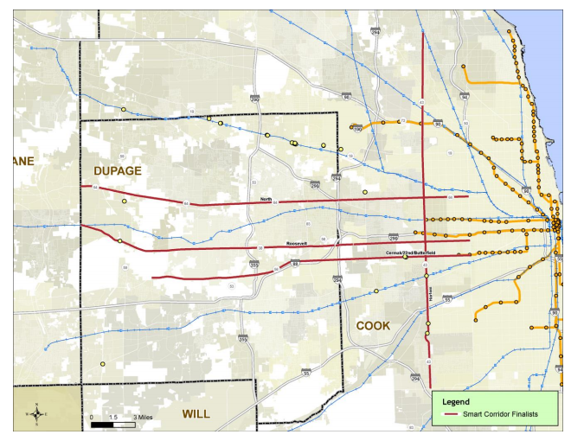

Source: Cook DuPage Smart Corridor Plan and Design Technical Report executive Summary

The Cook-DuPage Corridor Study estimated the cost for a number of technologies to support Smart Corridors shown in Table 9. They did not estimate the cost for developing the traffic management centers or fiber optic communication needed to operate the system.

Table 8: [Cook DuPage Smart Corridor Plan and Design Technical Report (Draft)](http://www.cmap.illinois.gov/documents/10180/433198/CDP_SmrtCor_TechMemoSummary_2015-06-01_DRAFTv1.pdf/9f76d827-79bd-4427-b6c3-1bc03f6b5b18)

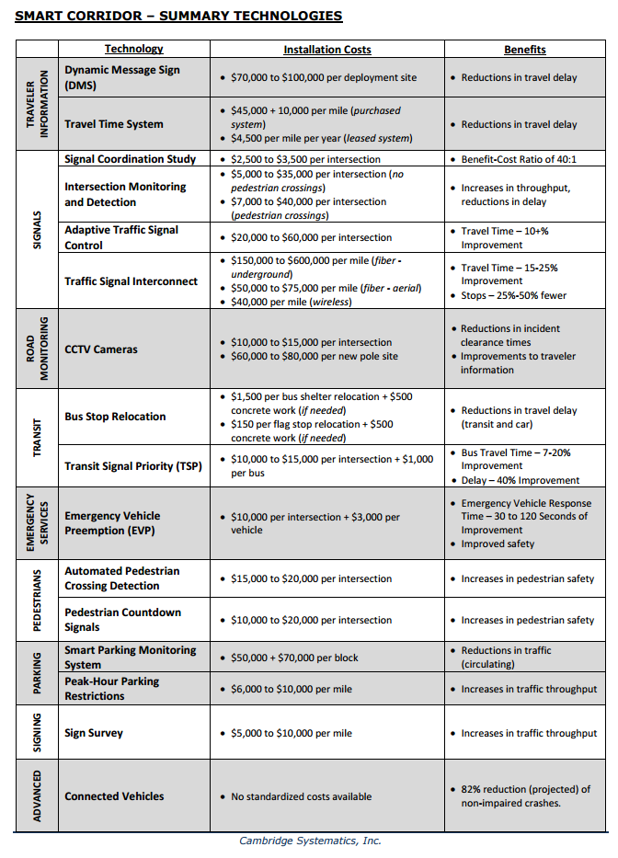

## Integrated Corridor Management

Integrated corridor management represents the next step in integrating the region’s ITS systems and cooperatively managing interstate, arterial and transit system operations. It includes operational integration, institutional integration and technical integration, and has been defined as “the operational coordination of multiple transportation networks and cross-network connections comprising a corridor and the coordination of institutions responsible for corridor mobility. The goal of ICM is to improve mobility, safety, and other transportation objectives for travelers and goods. ICM may encompass a number of activities, for example:

* Cooperative and integrated policy among stakeholders responsible for operations in the corridor.
* Concept of operations for corridor management.
* Improving the efficiency of cross-network junctions and interfaces.
* Mobility opportunities, including shifts to alternate routes and modes.
* Real-time traffic and transit monitoring.
* Real-time information distribution (including alternate networks).
* Congestion management (recurring and non-recurring).
* Incident management.
* Travel demand management.
* Public awareness programs.
* Transportation pricing and payment.”[62]

The United States Department of Transportation partnered with eight transportation agencies, or Pioneer Sites, in large urban areas to research how integrated corridor management can be implemented. Ultimately, the sites in Dallas, Texas, and San Diego California were selected as [Pioneer Demonstration Sites](http://www.its.dot.gov/factsheets/pdf/ICM_DemoSites_V7.pdf) where integrated corridor management is being implemented. “These sites began actively deploying their systems in spring 2013.”[63] These efforts are too new to provide observed data on program impacts, but study modeling suggests a number of benefits.

Table 9: Expected Annual ICM Benefits of Pioneer Sites on Corridor Performance

|  |  |  |  |
| --- | --- | --- | --- |
|  | San Diego | Dallas | Minneapolis |
| Person Hours Saved | 246,000 | 740,000 | 132,000 |
| Reduction in Travel Time Variance | 10.6% | 3% | 4.4% |
| Gallons of Fuel Saved | 323,000 | 981,000 | 17,600 |
| Tons of Mobile Emissions Saved | 3,100 | 9,400 | 175 |

Source: [Integrated Corridor Management Modeling Results Report: Dallas, Minneapolis, and San Diego, FHWA, February 2012](http://ntl.bts.gov/lib/54000/54300/54346/ICM_Modeling_Results_Report__FHWA-JPO-12-037_.pdf)

Table 10: ICM Demonstration Sites Partners and Strategies

|  |  |  |
| --- | --- | --- |
|  | Partners | Decision Support System Response Plan Strategies |
| Dallas | Dallas Area Rapid Transit  City of Dallas  Town of Highland Park  North Central Texas Council of  Governments  North Texas Tollway Authority  City of Plano  City of Richardson  Texas Department of Transportation  City of University Park | Divert onto frontage roads, arterials, and/or light rail, depending on severity of event on freeway  Implement dynamic signal timing to maximize throughput on diversion routes  Provide real-time information on traffic conditions (including speeds), public transit, and parking availability through 511 system  Provide diversion recommendations  (including mode shift to light rail) on dynamic message signs, under certain conditions |
| San Diego | San Diego Association of  Governments (SANDAG)  California Department of  Transportation  City of Escondido  Metropolitan Transit System  North County Transit District  City of Poway  City of San Diego | Provide en-route and pre-trip traveler information and enhanced transit network information through a new 511 smartphone app for trip decision-making  Coordinate signal timing with ramp meters to optimize mode shifts between the freeway and arterials  Deploy dynamic wayfinding signs on arterials to re-direct diverted traffic back to freeways |

Source: [Integrated Corridor Management (ICM) Demonstration Sites](http://www.its.dot.gov/factsheets/pdf/ICM_DemoSites_V7.pdf), FHWA ITS Joint Program Office,

Separate efforts in San Francisco on the “[I-80 Integrated Corridor Mobility Project](http://80smartcorridor.org/wp-content/uploads/2014/09/I-80_SMART_Corridor_FactSheet.pdf)” and Virginia “[I-95/I-395 Integrated Corridor Management Initiative](http://www.itsa.wikispaces.net/file/view/ITSA_ICM+Workshop_Hari+Sripathi_VDOT.pdf)” are also underway to apply ICM concepts to improve corridor performance.

Interviews with our regional system operators revealed that they were concerned with the interaction between the interstate and arterial systems, and felt that the need for a more holistic approach to system management is clear. They highlighted the impact that deteriorating traffic conditions on one system have on other systems. Some operators were concerned about whether the arterial system could accommodate traffic “routed off” the expressway during an unplanned incident, especially in a congested corridor. The reality is that traffic diversion to arterials already happens. The question is whether unexpected changes in traffic patterns in a corridor that includes interstates, arterials, and transit can be better accommodated if policies and systems are put in place to respond to it. Some comments suggested that the main obstacle to integrated management is agency policy and not technology.

Integrated corridor management is a flexible tool to smooth traffic in corridors, with policies and procedures agreed upon by the stakeholders in the corridor, including emergency responders. Stakeholders will establish locations and conditions under which integrated management would take place, agreed upon procedures for responding to potential conditions, policies to help decide which procedures should be applied, and authority for staff to implement the procedures. Integration can be as limited as establishing responsive signal policies around certain interstate ramps, automated display of other jurisdiction system conditions on dynamic message signs, or a full application including arterials, interstates, and transit services in a corridor. There was agreement that many locations in the region offered the potential for improved operations provided by integrated management. There are even some existing examples of limited integration where arterial traffic signals are managed to improve ramp and mainline expressway safety, and where different system operators post messages about conditions on other corridor roadways. These locations are described below.

[**Army Trail Road Queue Backup Protection**](https://www.dupageco.org/DOT/1573/)

There is an interchange of I-355 at Army Trail road in DuPage County, where traffic signal coordination and integration has been implemented. A traffic monitoring system detects significant changes in volumes of traffic on Army Trail Road and locations west of this interchange. Tollway ramp devices initiate an alarm at the DuPage County Division of Transportation (DDOT) office and activate a pre-installed timing programs designed to clear ramps of queued traffic so it doesn’t back up onto the expressway.

An additional device located eastbound on Army Trail Road midway between Meadow Lane and Creekside Drive, will alert the DDOT Traffic Engineer of traffic conditions approaching the interchange. Pan-tilt-zoom cameras situated on Army Trail Road at Glen Ellyn Road, and at I-355, will provide the engineer with on-site capabilities to detect and monitor specific occurrences associated with the alarms. Fiber optic cable will be installed between Meadow Lane and Creekside Drive to complete an essential communications link within the project area.

[**Traveler Information on DMS Signs**](http://travelmidwest.com/lmiga/dms.jsp)

There a number of locations in the region where arterially located dynamic message signs provide traffic information for nearby interstates. There are agreements between the Illinois interstate operators and operators of neighboring states to display requested information on DMS signs, but these are not automated and are subject to the authority of the TMC operator.

Figure 32: Arterial Dynamic Message Signs in DuPage County

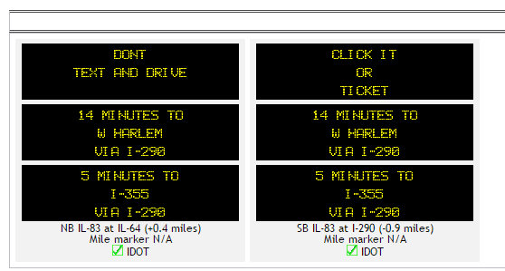

Source: [TravelMidwest.com](http://travelmidwest.com/lmiga/dms.jsp?location=GATEWAY.IL.ARTERIALS.DUPAGE)

Figure 33: Arterial Dynamic Message Signs in Suburban Cook County

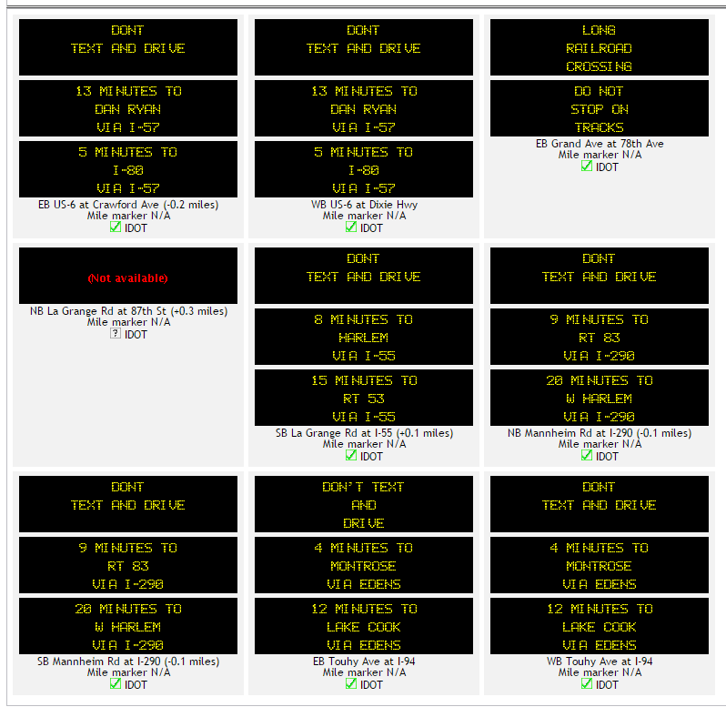

Source: [TravelMidwest.com](http://travelmidwest.com/lmiga/dms.jsp?location=GATEWAY.IL.ARTERIALS.COOK)

### Identification of Potential ICM Combinations

A few candidate integrated corridors readily come to mind. For example, the Kennedy Expressway currently operates two reversible lanes between the Edens Expressway and Ohio Street. In the past, traffic flow was more directional and providing extra capacity in the prevailing direction reduced congestion in that direction. As time passed and total traffic grew, traffic became heavy in both directions during the morning and evening peak, reducing the benefit of the reversible lanes. "The decision is absolutely getting harder to make," said Steve Travia, chief of traffic operations for IDOT's Chicago region. "There simply is not much benefit to be gained by making the switch when there is equity in the volume of inbound and outbound traffic." [64] In this corridor, we also have the CTA Blue Line train with 798 parking spaces at the Rosemont station, and 1633 spaces at the Cumberland stop. Metra’s Union Pacific Northwest line parallels the roadway and from Cumberland to Clybourn has 1884 parking spaces. (RTAMS.org). The Pace bus Pulse Milwaukee Line will travel on Milwaukee Avenue between Golf Road and Jefferson Park transportation station. Jefferson park station links the Blue Line O’Hare branch, the Metra UP Northwest line and multiple bus routes. Elston Avenue and Milwaukee Avenue both parallel the Kennedy Expressway.

|  |  |
| --- | --- |
|  |  |

Integrated corridor management in this location could include:

* Conversion of the reversible lanes to bi-directional express toll lanes
* Active traffic management on the general purpose lanes
* Pre-trip information about travel times and costs on the express toll lanes, general purpose lanes, public transportation and arterials to downtown
* Real time parking availability information and parking reservation capabilities
* En-route information allowing people to change route or mode
* Active traffic management on the expressway
* Arterial traffic signal timing plans to support detouring traffic during interstate incidents

An evaluation of other candidate locations for integrated corridor management can be undertaken using performance data. Traffic signal policies around interstate interchanges can be reviewed to identify places where changes can improve performance. A key indicator of whether roadways and transit services operate as a system is what happens to traffic on one roadway or transit service in the corridor when there is a disruption of traffic on another. Performance data showing roadway travel times on an average day compared to travel times during an incident should provide a picture of performance linkages between roadways. Transit ridership on an average day and on the disrupted day can also be analyzed.

|  |
| --- |
| Recommendation: A planning study to identify locations where integrated corridor management can improve corridor operations should be undertaken. CMAP should fund planning activities that work towards implementing active expressway management, active arterial management, and integrated corridor management. |

# Planning for Operations

Long range transportation planning has traditionally focused on capital spending – building new transportation facilities to improve mobility and reduce congestion. However, building new roads or lanes is costly, takes a long time, and in some locations isn’t a practical solution. Highway operations projects can delay the need for additional capacity and maximize capacity in locations where it isn’t practical to add capacity. An analysis comparing the number of through-lanes (assumed to be twelve feet wide) to the CMAP 2010 parcel-based land use inventory reveals that adding twelve foot lanes to most of the NHS system is likely to be difficult. Figure 33 presents the results. One lane means there is an estimated twelve feet available for one additional lane, converting a two lane roadway to three or four lane roadway to five. Two lanes indicate an estimated twenty-four feet available to add a single lane in each direction. This is an imperfect estimate but seems to show that in the most congested locations, operations projects will often be the main practical path to improving traffic flow and safety, and reducing congestion.

Figure 34: Locations with Right of Way Available (estimated)

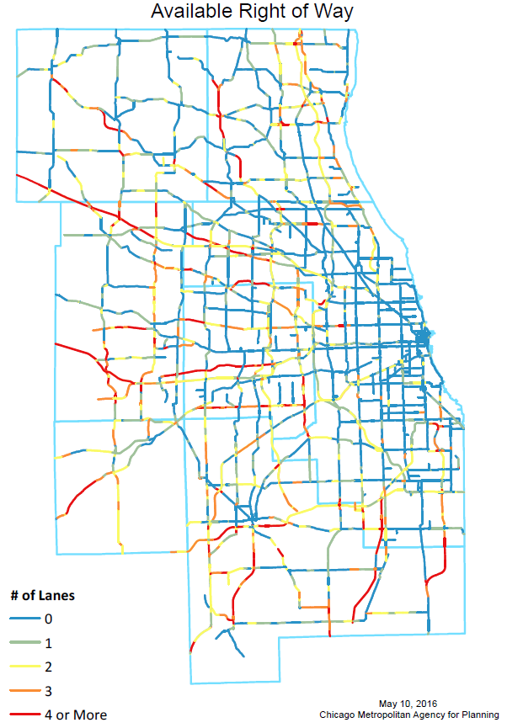

## Regional Performance Goals and Operations Oriented Objectives

CMAP supports performance based programming as a way to ensure that transportation funds are spent effectively to meet desired performance goals. After all, the purpose of investing in the transportation system is to improve how it serves the region. Performance based programming begins with performance based planning. The planning process provides the venue where a region can discuss current system performance and identify desired performance goals. The goals can relate to a wide variety of performance areas such as equity, transit ridership, system condition, economic development, environmental impacts, safety, congestion or reliability, among many others. Goals are established during the planning process to help guide selection of programs and projects that make progress towards achieving them. Many of the goals that underlie long range capital project selection are also goals that can be furthered in the shorter run using operations strategies. Once the regional transportation planning goals are established, the goals that can be addressed using operations strategies should be identified. Operations objectives for these goals can then be developed which further guide the selection of operations strategies. Operations objectives should be specific, quantifiable, realistic, have a reasonable timeframe and be consensus based. Figure 35 presents a flow chart describing the systematic process to develop operations strategies to meet the operations performance objectives.

Figure 35: Performance Based Planning for Operations Process

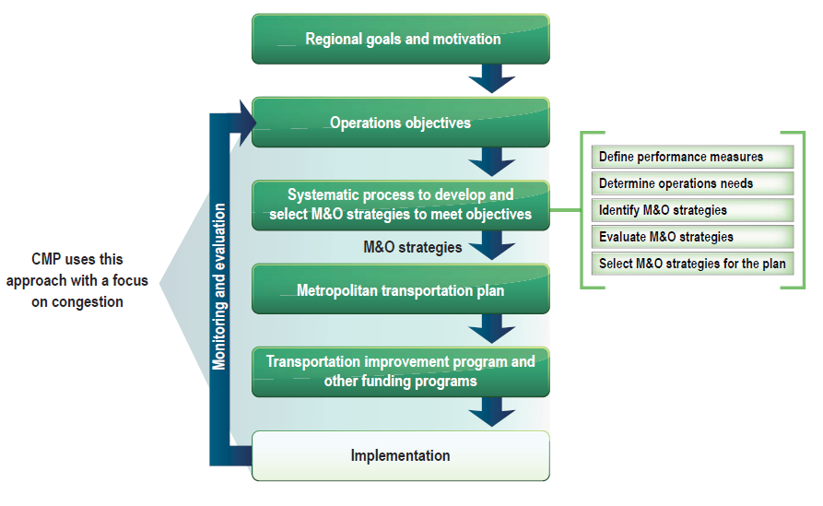

Source: [Advancing Metropolitan Planning for Operations an Objectives-Driven Performance-Based Approach](http://www.ops.fhwa.dot.gov/publications/fhwahop10026/fhwa_hop_10_026.pdf), Federal Highway Administration, 2010

When the selected operations strategies are implemented, it is important to track system performance (monitoring and evaluation) to identify necessary changes or new strategies.

Some example objectives are:

* Reduce clearance time of traffic incidents on expressway 25% by 2020.
* Reduce the planning time index on roadways to no more than 1.5 by 2020.

These operations objectives are measureable and address results, not inputs. Strategies to address these might be to add automatic incident detection and communication with emergency responders to our traffic management centers. There is a very long list of goals, objectives, strategies and ways to measure performance available.

|  |
| --- |
| **Recommendation**: The planning process for highway operations activities should be fully integrated into the regional transportation planning process. |

## Investment Prioritization

Since this paper is being written as input to the planning process that will develop the next plan, regional performance goals have not been set. However, over the last five years CMAP has been developing databases of performance information intended to help prioritize investments by helping us understand which locations seem most in need of investment based on performance. Observed performance both shows us where we might consider ways to improve system performance and establishes a baseline for system performance evaluation when improvements are made.

As an example of how the region might use performance based selection, existing performance data was applied to the National Highway System (NHS) expressways and arterials (figure 33). The NHS system “consists of roadways important to the nation’s economy, defense and mobility” and includes interstates, other principal arterials, strategic highway network roads, major strategic highway network connectors, and intermodal connectors. [65] Because if the importance of these roadways, performance standards are under development by FHWA and relatively complete performance data is available. This prioritization addresses existing facilities and their existing performance.

Figure 36: National Highway System in Northeastern Illinois

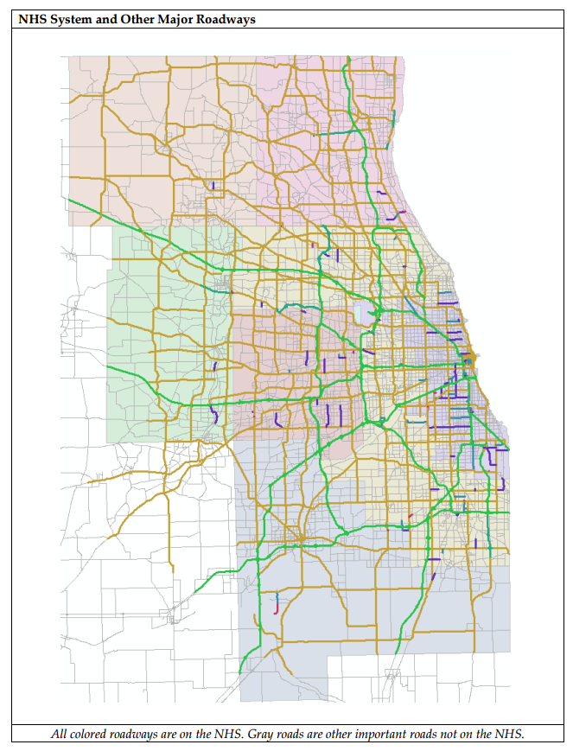

Figure 37: National Highway System

A number of performance datasets were used to score and prioritize the system.

**Importance to regional travel** was measured using the annual average daily traffic included in the 2014 Illinois Roadway Information System (IRIS) from the Illinois Department of Transportation (IDOT). This was used for expressways and arterials.

**Importance to freight movement** was measured using heavy commercial vehicle volumes included in the 2014 Illinois Roadway Information System (IRIS) file from IDOT. This was used for expressways and arterials. We are aware that the data included for arterials may be of poor quality but better data is not available at this time. This was used for expressways and arterials.

**Congestion** was measured using the travel time index calculated using 2012 highway probe data. The travel time index is the ratio of average peak hour travel time to free flow travel time. A higher number shows that there is a lot more traffic on average in the peak than during free flow times, a number closer to one shows that there isn’t much more traffic in the peak than during free flow times. This was used for expressways and arterials.

**Reliability** was measured using the planning time index calculated using 2012 highway probe data. The planning time index is the ratio of the 95th percentile time (travel time on a particularly bad day) to free flow time. An index close to one indicates that on a bad day the travel time isn’t much worse than free flow travel time, and high numbers show that a bad day is much worse than free flow travel time. These indices are larger than the travel time index.

**Safety** was measured using the rate of K (fatal) and A (disabling) crashes per vehicle miles traveled over a 5 year period. The crash data was provided by IDOT’s safety data mart, and the vehicle miles traveled was calculated using the 2012 IDOT IRIS file. This was used for expressways and arterials.

**Availability of existing ITS infrastructure** was measured by the percent of the segment included in a traffic signal interconnect. This indicates that there is communication infrastructure available and came from the CMAP traffic signal interconnect inventory, updated in 2012. This was only used for arterials because expressways do not use traffic signals.

If an arterial **serves an expressway interchange** it is the point of integration between the arterial system and the expressway system. This was determined through a visual inspection of the NHS system. This was only used for arterials.

If the Regional Transportation Authority (RTA), the Chicago Transit Authority (CTA) and Pace suburban bus plan to include the road as part of the **transit signal priority** system, prioritization should reflect its increased importance. An analysis determined whether any part of road segment was a TSP route using a [shapefile](http://rtagis.maps.arcgis.com/apps/Viewer/index.html?appid=0ba608d033ff4f7791bf2fcff6a48100) from the RTA. This was only used for arterials.

Segments

Development of NHS segments started with the 2014 IRIS file. The NHS system was aggregated into longer segments to allow scoring of “project length” segments rather than the many tiny segments comprising IRIS. The process to do this relied on simply identifying where NHS roadways crossed, which became the endpoints of the segments. The results system included 1039 segments, 170 on the expressway and 869 on the arterial system.

As shown, the segments could be long (see table 12) and include a range of performance by location, direction and time of day, the scores were based on the segment’s worst point.

Table 11: Segment Lengths

|  |  |
| --- | --- |
|  |  |

Averaging or aggregating would tend to wash out locations of most need, and we hope that the application of operations improvements would focus on improving performance at the worst locations. A segment traffic volume score was assigned by the highest traffic location. The freight volume score as assigned by the highest segment freight volume. The safety score was also assigned based on the worst location. The travel time index and planning time index are directional and differ by time of day. The worst segment direction during the worst time of day was used to assign those scores. In all of these cases, the segments were sorted from worst to best and assigned divided into 5 quantiles. The worst quantile received a score of five; the best received a score of one.

On the arterials, a segment received a score of five if it served an interstate interchange, and zero if it did not. It received a five if it included any transit signal priority locations and zero if it did not. The signal interconnect score was assigned based on the percent of segment served by a signal interconnect. No signal interconnect received zero. Up to twenty percent received one point, twenty to forty percent received two points, forty to sixty percent received three points, sixty to eighty percent received four points and eighty to 100 percent received 5 points.

All of the scores were added for total “need points.” The need points were again ranked highest to lowest. These were used to generate priority recommendations of one to 5. Expressways and arterials were scored and prioritized separately.

### Expressway Results

Table 13 presents the distribution of need scores by category. Note that since the segments were not created based on achieving similar length, the centerline miles varies more than the number of segments with the score. An attempt was made to include an equal number of segments in each category, but at times the data did not lend itself to being divided that way.

Table 12: Need Score Summary by Category

|  |  |  |  |  |  |  |  |
| --- | --- | --- | --- | --- | --- | --- | --- |
|  |  | Least Need | | **Score** | Most Need | |  |
|  |  | 1 | 2 | 3 | 4 | 5 | Total |
| Users | # | 34 | 34 | 34 | 34 | 34 | 170 |
| *Annual Average Daily Traffic AADT* | Miles | 135 | 96 | 85 | 87 | 53 | 455 |
| Freight | # | 34 | 34 | 34 | 34 | 34 | 170 |
| *Heavy Commercial Vehicle Volume HCV* | Miles | 103 | 97 | 90 | 80 | 84 | 455 |
| Congestion | # | 30 | 26 | 27 | 21 | 66 | 170 |
| *Travel Time Index* | Miles | 119 | 84 | 80 | 50 | 121 | 455 |
| Reliability | # | 33 | 31 | 33 | 35 | 38 | 170 |
| *Planning Time Index* | Miles | 127 | 102 | 90 | 69 | 65 | 455 |
| Safety | # | 37 | 35 | 34 | 32 | 32 | 170 |
| *K and A Crash Rate* | Miles | 92 | 92 | 98 | 79 | 94 | 455 |

Figure 35 presents the distribution of need scores by segment. The maximum possible segment score is twenty-five, and only one segment achieved that. The scores range from five to twenty-five.

Figure 38: Distribution of Expressway Need Scores

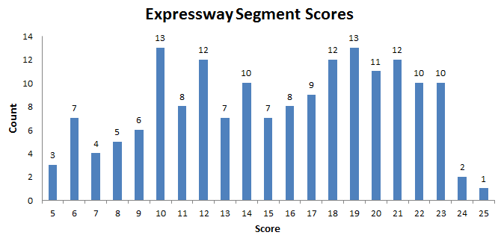

The segments were assigned priorities of one to five based on the need scores. The highest need score was priority 1, the lowest was priority 5.

Table 13: Expressway Priority

|  |  |  |
| --- | --- | --- |
| Expressway Priority | # | Miles |
| Highest (early year) - 1 | 35 | 63 |
| 2 | 36 | 79 |
| 3 | 34 | 84 |
| 4 | 34 | 116 |
| Lowest (later year) - 5 | 31 | 113 |
| Total | 170 | 455 |

Figure 39: Expressway Priority Segments

|  |  |
| --- | --- |
|  |  |

### Congestion Pricing

In addition to the prioritization of existing facilities already described, the region has adopted the GO TO 2040 recommendation to implementing congestion pricing on all new expressway capacity (entire new facilities and additional lanes on existing facilities).

Figure 40: GO TO 2040 Locations Recommended for Congestion Pricing

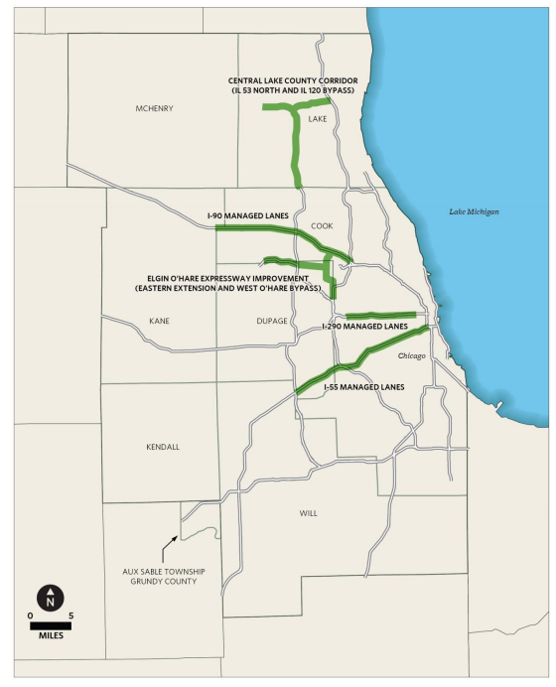

Source: [Congestion Pricing an Analysis of the GO TO 2040 Major Capital Projects](http://www.cmap.illinois.gov/documents/10180/24896/FY13-0028+CONGESTION+PRICING+STUDY.pdf/ca284fd8-43ba-479a-b328-15d3a541e3fd), Chicago Metropolitan Agency for Planning, October 2012

### Arterial Results

The same process was followed for the arterial system, with the addition of scores for integration, future transit and existing communications. Table 15 presents the summary of segment scores.

Table 14: Segment Score Summary

|  |  |  |  |  |  |  |  |  |
| --- | --- | --- | --- | --- | --- | --- | --- | --- |
|  |  | Low Need | |  |  | High Need | |  |
|  |  | 0 | 1 | 2 | 3 | 4 | 5 | Sum |
| Users Served | # | 1 | 174 | 173 | 173 | 174 | 174 | 869 |
| *(Daily Volume Score)* | mi. | 0 | 448 | 355 | 386 | 362 | 393 | 1,944 |
| Freight Importance | # | 321 | 109 | 109 | 110 | 110 | 110 | 869 |
| *(Truck Volume Score)* | mi. | 545 | 229 | 266 | 337 | 291 | 275 | 1,944 |
| Congestion | # | 63 | 144 | 174 | 153 | 172 | 163 | 869 |
| *(Travel Time Index)* | mi. | 96 | 372 | 391 | 373 | 390 | 321 | 1,944 |
| Reliability | # | 64 | 139 | 167 | 160 | 174 | 165 | 869 |
| *(Planning Time Index)* | mi. | 98 | 384 | 379 | 365 | 392 | 326 | 1,944 |
| Safety | # | 0 | 174 | 180 | 176 | 171 | 168 | 869 |
| *(K A Crash Rate Score)* | mi. | 0 | 192 | 380 | 371 | 479 | 521 | 1,944 |
| Integration | # | 646 | 0 | 0 | 0 | 0 | 223 | 869 |
| *(Serves Interstate)* | mi. | 1,485 | 0 | 0 | 0 | 0 | 459 | 1,944 |
| Future Transit | # | 689 | 0 | 0 | 0 | 0 | 180 | 869 |
| *(Existing or Planned TSP)* | mi. | 1,632 | 0 | 0 | 0 | 0 | 312 | 1,944 |
| Existing Communications | # | 225 | 191 | 91 | 73 | 97 | 192 | 869 |
| *(Signal Interconnect)* | mi. | 563 | 458 | 224 | 181 | 228 | 290 | 1,944 |

Figure 37 presents the distribution of segment need scores that were used to generate the priority assignments. The arterial need scores range from two to thirty-seven of a possible forty points.

Figure 41: Segment Score Distribution

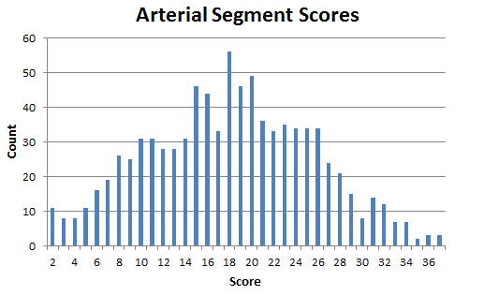

Table 16 presents the summary of arterial priorities. The priority list shows about 400 centerline miles of operations projects for each priority period.

Table 15: Arterial Priority Summary

|  |  |  |
| --- | --- | --- |
| Arterial Priority | # | Miles |
| Highest (early year) -1 | 184 | 395 |
| 2 | 187 | 395 |
| 3 | 179 | 432 |
| 4 | 164 | 400 |
| Lowest (later year) - 5 | 155 | 322 |
| Total | 869 | 1,944 |

Figure 42: Arterial Priority Locations

|  |  |
| --- | --- |
|  |  |

## Regional Transportation Concept of Operations

1. [Cure for Gridlock](http://articles.chicagotribune.com/1990-02-23/news/9001160178_1_traffic-congestion-air-pollution/2), Chicago Tribune Blair Kamin and David Ibata, February 1990
2. [2014 Illinois Crash Facts and Statistics](http://www.idot.illinois.gov/Assets/uploads/files/Transportation-System/Resources/Safety/Crash-Reports/crash-facts/2014%20CF.pdf), Illinois Department of Transportation, 2015
3. [Managing Incidents on Urban Arterial Roadways](http://ntl.bts.gov/lib/jpodocs/rept_mis/10667.pdf), Richard A. Raub and Joseph L. Shofer, Transportation Research Record volume 1603, 1997
4. [FHWA Office of Operations Traffic Incident Management Webpage](http://ops.fhwa.dot.gov/aboutus/one_pagers/tim.htm). http://ops.fhwa.dot.gov/aboutus/one_pagers/tim.htm
5. Illinois Tollway Staff Interview, November, 2015
6. [Benefit Cost Analysis of Accelerated Incident Clearance Final Report](http://www.clemson.edu/t3s/scdot/pdf/projects/SPR%20659.pdf), Clemson University Transportation Systems Research and Education prepared for South Carolina Department of Transportation, 2007
7. [PSRC 2006 Household Activity Survey Analysis Report](http://www.psrc.org/assets/1474/analysisonly_2006.pdf?processed=true), Cambridge Systematics, Inc. , 2007
8. [Traveler Information System Fact Sheet](http://mobility.tamu.edu/mip/strategies-pdfs/traffic-management/executive-summary/traveler-information-systems-1-pg.pdf), Texas A&M Transportation Institute
9. Gateway Project Status Report, prepared for the Lake Michigan Interstate Gateway Alliance by University of Illinois at Chicago and Illinois Department of Transportation, March 2016
10. [Federal Highway Administration Service Patrol Handbook](http://www.ops.fhwa.dot.gov/publications/fhwahop08031/ffsp_handbook.pdf), FHWA, November 2008
11. [Evaluation of Freeway Motorist Assist Program Final Report](http://ntl.bts.gov/lib/33000/33000/33049/or10018.pdf), University of Missouri, HDR Engineering and Missouri Department of Transportation, 2010
12. [Managing Incidents on Urban Arterial Roadways](http://ntl.bts.gov/lib/jpodocs/rept_mis/10667.pdf), Richard A. Raub and Joseph L. Shofer, Transportation Research Record volume 1603, 1997
13. 625 ILCS 5/4-203.5
14. Educational Outreach for Safe, Quick Clearance (SQC) Laws and Policies, FHWA
15. [Freight Volumes for the Trucking System](http://www.cmap.illinois.gov/mobility/freight/freight-data-resources/trucking-system), [www.cmap.illinois.gov](http://www.cmap.illinois.gov)
16. [Incident Responders’ Safety Model Law](http://i95coalition.org/wp-content/uploads/2015/03/Law_TIM_-NCUTLO.pdf?dd650d), I-95 Corridor Coalition
17. [NCHRP Synthesis 318 Safe and Quick Clearance of Traffic Incidents, A Synthesis of Highway Practice](http://onlinepubs.trb.org/onlinepubs/nchrp/nchrp_syn_318.pdf), Transportation Research Board , 2003
18. [Traffic Control Concepts for Incident Clearance](http://ops.fhwa.dot.gov/publications/fhwahop08057/fhwahop08057.pdf), FHWA, 2009
19. [Major Crash Investigation and Traffic Incident Management Presentation](http://www.kcscout.com/downloads/ITSSymposium/TIM%20Patrol%20Bureau.ppt), KC Scout, undated
20. [Traffic Safety Facts](http://www-nrd.nhtsa.dot.gov/pubs/812115.pdf), National Highway Traffic Safety Administration, February 2015
21. Insurance Institute for Highway Safety Highway Loss Data Institute [Status Report Volume 51 Number 1](http://www.iihs.org/iihs/sr/statusreport/article/51/1/1) ,January 2016
22. Insurance Institute for Highway Safety Highway Loss Data Institute [Bulletin Volume 28, Number 26](http://www.iihs.org/media/31d3dcc6-79d5-48a8-bafb-1e93df1fb16f/324452632/HLDI%20Research/Bulletins/hldi_bulletin_31_15.pdf), April 2012
23. [Weather Underground Custom Summary for Midway Airport](http://www.wunderground.com/history/airport/KMDW/2014/12/31/CustomHistory.html?dayend=31&monthend=12&yearend=2015&req_city=&req_state=&req_statename=&reqdb.zip=&reqdb.magic=&reqdb.wmo=)
24. [Lightning Safety Awareness Guide](https://www.illinois.gov/iema/Preparedness/Documents/Lightning_Safety_Awareness_Guidebook.pdf), Illinois Emergency Management Agency, June 2014
25. [2014 Illinois Crash Facts and Statistics](http://www.idot.illinois.gov/Assets/uploads/files/Transportation-System/Resources/Safety/Crash-Reports/crash-facts/2014%20CF.pdf), Illinois Department of Transportation, 2015
26. Gateway Project Status Report, prepared for the Lake Michigan Interstate Gateway Alliance by the University of Illinois at Chicago and the Illinois Department of Transportation, March 2016
27. [Traffic Incident Management in Construction and Maintenance Work Zones](http://ops.fhwa.dot.gov/publications/fhwahop08056/fhwahop08056.pdf), FHWA Office of Transportation Operations, January 2009
28. [Google Geo Developers Blog](http://googlegeodevelopers.blogspot.com/2015/07/chicago-department-of-transportation.html), Lawrence Olzsak, IT Director and William Cheaks Jr., Deputy Commissioner of Infrastructure Management at Chicago Department of Transportation, July 2015
29. [E-Construction Fact Sheet](https://www.fhwa.dot.gov/innovation/everydaycounts/edc-3/factsheets/edc_3_factsheet_e-construction_508.pdf), Every Day Counts Program, FHWA, 2014
30. [Major Upgrade for Chicago O’Hare Airport](http://www.worldhighways.com/categories/concrete-paving-compaction-testing/features/major-upgrade-for-chicago-ohare-airport/), World Highways, July/August 2015
31. [Accelerated Bridge Construction Factsheet](http://www.fhwa.dot.gov/innovation/everydaycounts/edc-2/pdfs/edc_abc.pdf), Every Day Counts Program, FHWA
32. [IDOT Bureau of Design and Environment Manual, Chapter 6 Utility Coordination](http://www.idot.illinois.gov/doing-business/procurements/engineering-architectural-professional-services/Consultants-Resources/index), Illinois Department of Transportation, July 2015
33. HBK Engineering Wacker Drive/Congress Interchange Advanced Utility [website](http://hbkengineering.com/projects/wacker-drive-congress-interchange-advanced-utility-relocation/)
34. Conversation with Damage Prevention Manager, Northern Illinois region of JULIE Inc., May 2016
35. [Subsurface Utility Engineering](https://www.fhwa.dot.gov/programadmin/sueindex.cfm), U.S. DOT Federal Highway Administration Office of Program Administration website
36. [Subsurface Utility Engineering Manual](http://www.penndot.gov/Migration/Documents/PTI%202008-02%20Final%20Report%2024Oct07_s.pdf), Pennsylvania Transportation Institute of Pennsylvania State University for Pennsylvania Department of Transportation, August 2007
37. [Survey Manual](http://www.idot.illinois.gov/assets/uploads/files/doing-business/manuals-guides-&-handbooks/highways/design-and-environment/survey%20manual.pdf), Illinois Department of Transportation Bureau of Design and Environment, revised May 2015
38. [Traffic Signal Operations and Maintenance Staffing Guidelines](http://ops.fhwa.dot.gov/publications/fhwahop09006/fhwahop09006.pdf), FHWA, March 2009
39. [Traffic Signal Audit Guide](http://library.ite.org/pub/e2654d52-2354-d714-5126-ca1779c02831), Institute of Transportation Engineers, 2007
40. [Getting Around](http://articles.chicagotribune.com/2012-07-16/classified/ct-met-getting-around-0716-20120716_1_traffic-signals-traffic-lights-traffic-management-system/2), Jon Hilkevitch, Chicago Tribune, July 2012
41. [2007 National Traffic Signal Report Card – Executive Summary](http://library.ite.org/pub/e265c148-2354-d714-515a-eb251643bd2a), Institute of Transportation Engineers, 2007
42. Lake County DOT estimate, April 2016
43. [National Traffic Signal Report Card Technical Report](http://library.ite.org/pub/e2656526-2354-d714-51ef-1767fbf279ff), National Transportation Operations Coalition, 2005
44. Lake County DOT estimate, April 2016
45. [Bureau of Design and Environment Manual Chapter Fifty-seven](http://www.idot.illinois.gov/doing-business/procurements/engineering-architectural-professional-services/Consultants-Resources/index), Illinois Department of Transportation, 2016
46. [Traffic Signal Audit Guide](http://library.ite.org/pub/e2654d52-2354-d714-5126-ca1779c02831), Institute of Transportation Engineers, 2007
47. [Managing Travel for Planned Special Events](http://ops.fhwa.dot.gov/publications/fhwaop04010/handbook.pdf), FHWA, September 2003
48. [Intelligent Transportation Systems Joint Program Office Costs Database](http://www.itscosts.its.dot.gov/ITS/benecost.nsf/SubsystemCostsAdjusted?ReadForm&Subsystem=Roadside+Telecommunications+(RS-TC)), in 2014 dollars
49. [Scottsdale, Arizona Sets up Wireless Mesh Network to Relieve Traffic Congestion](http://muniwireless.com/2013/07/02/scottsdale-wireless-mesh-network/), Municipal Wireless News, Esme Vos, July 2013
50. [Verizon to be First to Field –Test Crazy-Fast 5G Wireless](http://www.cnet.com/news/verizon-to-hold-worlds-first-crazy-fast-5g-wireless-field-tests-next-year/), Roger Cheng in CNET, September 2015
51. [Weather-Related Blackouts Doubled Since 2003](http://assets.climatecentral.org/pdfs/PowerOutages.pdf), Alyzon Kenward, PhD and Urooj Raja, Climate Central, 2014
52. [The Seven Types of Power Problems](http://www.surgex.com/pdf/white-papers/APC_Whitepaper_UPS_7-types-of-power-problems.pdf), White Paper 18, Joseph Seymour, Schneider Electric, 2010
53. [Uninterruptible Power Supplies Keep Traffic Signals On Illinois Works to Avoid Delays and Dangers from Outages](http://www.idot.illinois.gov/Assets/uploads/files/Transportation-System/Research/Success-Stories/Research%20pays%20off-%20Safety%20Reports%20and%20Statistics%20page.pdf), Transportation Research News 258, Yogesh P. Gautam Illinois Department of Transportation, 2008
54. [Texas DOT Traffic Signals Manual](http://onlinemanuals.txdot.gov/txdotmanuals/tff/uninterruptible_power_systems.htm), Texas Department of Transportation, 2011
55. [Free Parking or Free Markets](http://www.accessmagazine.org/wp-content/uploads/sites/7/2016/01/access38_free_parking_markets.pdf), Donald Shoup, ACCESS Magazine, University of California Transportation Center, Spring 2011
56. [Chicago Parking Garage Leases](https://www.civicfed.org/civic-federation/blog/chicago-parking-garage-leases), The Civic Federation, December 15, 2010
57. [Active Traffic Management Fact Sheet](http://mobility.tamu.edu/mip/strategies-pdfs/active-traffic/executive-summary/active-traffic-management-1-pg.pdf), Texas A&M Transportation Institute
58. [Illinois Highway Statistics Sheet 2013](http://www.idot.illinois.gov/Assets/uploads/files/Transportation-System/Reports/OP&P/Travel-Stats/2013%20Illinois%20Highway%20Statistics.pdf), Illinois Department of Transportation
59. [Dynamic Lane Management an ITS Solution to Enhance Safety and Mobility](http://managedlanes.org/wp-content/uploads/2012/07/Dynamic-Lane-Management-System-on-I-110-in-Los-Angeles-3.pdf), presentation by Sheik Moinuddin, P.E., Caltrans Division of Operations, 2012
60. [WYDOT’s Variable Speed Limits](http://highways.transportation.org/Documents/WYDOT%E2%80%99s%20Variable%20Speed%20Limits.pdf) presentation, R. Vince Garcia, P.E.
61. [General Guidelines for Active Traffic Management Deployment: Best Practices and Outreach for Active Traffic Management](http://utcm.tamu.edu/publications/final_reports/kuhn_10-01-54_interim.pdf), Charles Levecq, Beverly Kuhn and Debbie Jasek, for DOT Research and Innovative Technology Administration by the Texas Transportation Institute, October 2011
62. [Integrated Corridor Management Concept Development and Foundational Research Phase 1, Task 3.1 Develop Alternative Definitions](http://ntl.bts.gov/lib/jpodocs/repts_te/14273_files/14273.pdf), USDOT ITS Joint Program Office, April 2006.
63. [Integrated Corridor Management (ICM) Demonstration Sites](http://www.its.dot.gov/factsheets/pdf/ICM_DemoSites_V7.pdf),
64. [Getting Around: As Kennedy Traffic Swells, Reversible Lanes Lose Their Magic](http://articles.chicagotribune.com/2013-11-11/news/ct-met-getting-around-1111-20131111_1_reversible-lanes-kennedy-expressway-express-lanes), Jon Hilkevitch, Chicago Tribune, November 2013
65. [National Highway System](http://www.fhwa.dot.gov/planning/national_highway_system/), FHWA Office of Planning , Environment and Realty webpage