ON TO 2050: Draft Environment Chapter

CMAP staff is distributing this working draft of the ON TO 2050 environment recommendations to related CMAP committees, partners, and interested stakeholders for initial review. Please note this is a preliminary draft that will undergo some refinement of text and graphics (and closer proofreading) before being released for public comment in the full draft plan on June 15th.

Contents
ON TO 2050 Outline 3
Environment Chapter 4
Introduction 4
A region prepared for climate change 5
Plan for climate resilience 5
Intensify climate mitigation efforts 12
Integrated approach to water resources 16
Manage stormwater to reduce flooding 16
Protect and enhance the integrity of aquatic systems 25
Coordinate and conserve shared water supply resources 33
Development practices that protect natural resources 40
Improve natural resources through the redevelopment process 40
Prioritize natural and agricultural preservation alongside strategic growth 45

ON TO 2050 Outline
- Introduction
- Principles to move the region forward
  - State of the region
  - The three principles
    - Resilience
    - Inclusive Growth
    - Prioritized Investment
- Engagement
- Land Use
- Environment
- Economy
- Governance
- Mobility
- Indicators and Layers
- Moving Forward
- Appendices

Note: ON TO 2050 will be conveyed primarily on the web. The structure assumes that readers will not approach the document linearly. The plan will be organized around five topical areas, each containing a set of recommendations that may repeat across chapters, as will some strategies within those recommendations. Each recommendation will describe its support for the three principles of the plan.

Environment Chapter

Introduction
The region’s natural areas and ecosystems are more diverse and rare than many natural systems on Earth, constituting some of the most valuable and irreplaceable assets in metropolitan Chicago. ON TO 2050 strongly affirms that these natural resources are critical for protecting the quality of our air, land, and water, providing wildlife habitats and recreational spaces, contributing to a high quality of life, and supporting a vibrant regional economy. The region’s abundant water supply has been crucial to attracting people and investment, and its extensive green infrastructure network provides invaluable habitat and species diversity, protects environmental quality, aids in flood mitigation, and is an important line of defense against the impacts of climate change. In recent history, CMAP, counties, municipalities, conservation organizations, forest preserve and conservation districts, and others have invested millions of dollars to protect, restore, and expand the region’s natural heritage. The return on these investments is significant: It is estimated that our natural assets provide over $6 billion every year in economic value to the region as "ecosystem services," the collective benefits from an array of resources and processes that are supplied by nature.

At the same time, our natural resources face many ongoing challenges and new threats. While the region permanently preserved 61,500 acres of natural and agricultural lands from 2001 to 2015, an additional 140,000 acres of such lands were developed -- an area roughly equivalent to the land area of the City of Chicago. Despite increased awareness about the importance of environmental assets, constrained funding at all government levels and competing priorities hinder our ability to adequately protect and enhance them. Climate change, manifesting in our region as more frequent and severe storms, extreme temperatures, and drought, is already significantly affecting our economy, ecosystems, and people. In particular, the region faces substantial flooding issues, which will continue to be exacerbated by the intense storms brought by climate change and increased impervious coverage from development. Flooding can cause extensive property damage and impaired water quality.

Many diverse factors influence the extent and form of development, from market forces to tax policy to infrastructure investment. As development continues to push outward into the fringes of the region, it necessitates increased water, wastewater, and stormwater management and infrastructure, pushes demand for groundwater beyond sustainable levels, and affects communities and the resources themselves while the costs of providing infrastructure and services rise.

The impacts of these trends do not affect all residents equally. Vulnerable populations in particular may experience heightened risks, costs, and liabilities, including repetitive flooding, high water rates in low income communities, and compromised infrastructure in areas that are otherwise overlooked by private investment.

ON TO 2050 proposes a comprehensive suite of actions by a range of stakeholders to address these and other environmental issues. When fully implemented, these actions will result in a region that is more resilient to the anticipated impacts of climate change, particularly flooding; has sustainable and clean water resources; preserves the most important agricultural and natural lands while accommodating sensible growth; and bolsters the residents of the region who are most vulnerable to environmental impacts.

A region prepared for climate change
The effects of climate change will have significant implications for the built environment, economy, ecosystems, and people of this region. We must intensify mitigation efforts while at the same time prepare for and be poised to recover from the acute shocks and chronic stresses posed by climate change. Reducing greenhouse gas emissions will require continued compact infill development, improved pedestrian and bicycle infrastructure, and increased investments in public transit as well as aggressive expansion in renewable energy systems, energy efficiency and retrofits, and electrification of our transportation system. Planning for climate resilience entails a wide variety of strategies for reducing risk, strengthening our built and natural environment, and improving our operational response to specific events. Regional stakeholders, from local elected officials to business leaders, need access to up-to-date data on climate science to make informed decisions. At the same time, many resilience strategies require coordinated sub-area, regional, or statewide action.

Plan for climate resilience
Our climate is changing at a global scale. In northeastern Illinois, these changes include more frequent and severe weather, extreme heat, and drought (see the Natural Resources Snapshot for more information). The effects of climate change have significant implications for the built environment, economy, ecosystems, and people of this region. Flooding has caused major road, rail, and utility outages, disruptions of freight traffic, sewer overflows, and personal and financial losses for residents and businesses. Heat waves have caused illness, hospitalization, and death in vulnerable communities, as well as damage to infrastructure, and drought has had significant adverse effects on the region’s agricultural sector, water supply, and natural areas.

[graphic – Climate resilience data story with information from the Natural Resources snapshot]

Climate resilience is the ability of our region and its communities to prepare for and recover from the acute shocks and chronic stresses of climate change by transforming our infrastructure, natural systems, and social structures to be more responsive and adaptable. A host of recommendations related to land use and development, infrastructure, natural resource management, and capacity building can help to build regional climate resilience. Certain aspects of resilience building are explored further in this chapter’s recommendations, such as “Target preservation and stewardship efforts to key natural and agricultural areas,” “Manage stormwater to reduce flooding,” and others. The land and water assets that make up the region’s green infrastructure network not only support environmental quality, but also provide an important line of defense against the negative impacts of climate change. Those assets also face challenges from a changing climate and must be protected to ensure continued ecosystem services.

[Graphic – climate resilience interventions in a sub-area]

This recommendation area proposes a wide range of strategies to plan for a climate resilient region, building on existing and emerging practices. Some communities develop stand-alone climate action or resilience plans, yet integration of climate resilience into other planning efforts, such as comprehensive plans, capital improvement plans (CIPs), watershed plans, issue-based plans, and regulatory updates may also work well for many communities. These plans can seek to put systems in place for achieving disaster preparedness and response as well as for educating property owners and residents about climate issues more broadly. Transportation infrastructure should also be strengthened to withstand the effects of climate change, and operational systems should be modernized to ensure mobility during extreme weather. Concerted regional effort on resilience issues is also essential to ensure collaboration and maximize the benefit of investments, and CMAP and partners should continue to explore creating an effective platform for this effort.

The following subsection outlines strategies and actions to implement this recommendation.

Incorporate climate resilience and adaptation measures into planning and development
Through the LTA program, CMAP is already working to integrate climate change information into local planning processes. In particular, the program is developing an approach to incorporate climate vulnerability assessments into comprehensive plans. Other units of government in the region have created stand-alone plans related to climate change or incorporated these elements into other related planning documents. Climate change can disproportionately affect low-income households, minorities, limited English proficiency population, the elderly, people with chronic diseases, and those without health insurance. It is essential that those populations are able to meaningfully participate in climate resilience planning through robust community engagement processes.

Coordinating across units of government responsible for different planning efforts is particularly important for resilience planning. For example, counties typically conduct watershed, stormwater, and hazard mitigation planning processes, all of which have implications for climate resilience at the municipal level. Counties play a key role in helping municipalities access federal assistance, from preparing FEMA-approved hazard mitigation plans to assisting with documentation of damages and demonstrating the need for public assistance. Park districts and forest preserve districts manage parks, open space, and natural resources, and those assets have profound implications for (and are also affected by) heat islands, stormwater management, and ecological resilience. It is essential to make sure that climate recommendations are aligned at community and county levels.

CMAP should develop an approach for integrating climate change and vulnerability into local planning efforts, and employ that approach through the LTA program.
Municipalities and counties should integrate climate impacts and vulnerability into relevant plans and regulations and coordinate with appropriate actors during planning processes, with particular attention to engaging vulnerable populations.
CMAP, counties, and other partners should support continued pre-disaster planning efforts and identify opportunities for coordination.
CMAP and other partners should identify planning best practices and strategies to meet resilience goals.
CMAP and partners should analyze the effects of climate change on vulnerable populations and develop strategies to build resilience for those residents.

Strengthen gray and green infrastructure to withstand climate change
Green infrastructure has a range of functions that protect the region from climate change, including stormwater management and the mitigation of emissions, but these resources must also be actively managed and protected as the climate changes. Communities can increase resilience by encouraging more biodiverse ecosystems, which mitigate climate change through carbon sequestration. Biodiverse ecosystems can better withstand invasive species and disease and endure the impacts of extreme flooding and drought. Many of the region’s native species are naturally flood- and drought-tolerant. It is also essential to continue to acquire land for protection and continuously steward the region’s network of green infrastructure (see the “Preserve and enhance key natural and agricultural areas” recommendation for more information).

Climate change has already led to problems such as road closures and damages to the region’s transportation system, and these capacity and performance issues are only expected to worsen. Most of the region’s roads were designed using standards that pre-date the increased number of freeze-thaw cycles, heavy rain events, and the hotter and wetter conditions posed by the changing climate. Transportation modernization efforts should promote infrastructure that is built or retrofitted to revised design standards that take the anticipated climate of the region into account. In addition, as road and transit systems modernize and become dependent on advanced technology, reliable electricity and communications infrastructure will become critical to the ability of the transportation system to function under extreme conditions. Building redundancy into the system will be essential to ensure that operations continue.

CMAP and partners should continue research, analysis, and cross-jurisdictional implementation of resilient natural resource strategies.
Communities and stewardship groups should promote native land restoration and landscaping.
Local governments should require the use of native species through landscaping ordinances and conservation design for new subdivisions.
Transportation implementers should design transportation infrastructure for the climate of its intended lifespan.
CMAP should incorporate climate resilience criteria in its evaluation of regionally significant projects and transportation programming.
Transportation implementers should conduct studies to determine the vulnerability of transportation infrastructure to climate change impacts.
State and local transportation and water infrastructure agencies should review and update design manuals to ensure that the underlying climate data being used are up to date, and that climate projections match the lifespan of the project.
Service providers should ensure redundant and reliable electricity and communications infrastructure.

Improve the operational response to weather events to ensure mobility
Climate change is already causing more frequent road flooding, snow storms, and heat- and cold-related pavement and communication failures. Inclement weather is currently estimated to cause 15 percent of congestion, increasing the number of crashes and delays and reducing road capacity. Approximately half of the days in a typical year have weather conditions that affect driving. IDOT, the Tollway, and Lake County report their real-time “road weather” (pavement) information to TravelMidwest, but the other counties currently do not. Weather responsive traffic management is also not widely used today, except for closing roads to traffic under severe conditions. Broader adoption of intelligent transportation system (ITS) devices and traffic management capabilities will support a variety of weather-responsive traffic management strategies, such as instituting variable speed limit systems, employing alternative signal plans to support detours, and increasing coverage of emergency vehicle patrols to remove disabled vehicles more quickly.

It will be important to collect and analyze information about how facilities perform under various severe weather scenarios so agencies can develop planned responses to weather events. For example, focusing incident management resources on locations that are known to be especially affected by rain or snow can reduce congestion and secondary incidents. Pavement flooding information has not been collected on a regional basis, and there is no standard pavement flooding reporting system. The impact of flooding on our roadway operations as of today is not known.

Cook, DuPage, Kane, Kendall, McHenry, and Will Counties should implement traffic management centers in their jurisdictions and make real-time road weather information available.
Transportation implementers should expand ITS devices and traffic management capabilities to support weather responsive traffic management strategies.
Transportation implementers should coordinate snow and ice removal across jurisdictions, when possible.
Transportation operators should conduct an analysis of road performance under severe weather conditions to develop planned responses.
CMAP should develop a regional pavement flooding reporting system to help plan for flood events.

Create a more flexible and decentralized electric grid
Distributed energy resources (DER) are electricity generation sources that are typically smaller than traditional power stations and positioned closer to where electricity is consumed, often on the same site (such as rooftop solar arrays). DERs help to increase the resilience of the energy grid to stresses such as high demand periods, and DERs featuring renewable energy sources have the potential to greatly reduce the greenhouse gas emissions associated with energy consumption. Microgrids, which include DERs and can operate independently of the main grid, could also serve to minimize energy service interruptions. They allow key infrastructure to be “islanded” from the larger distribution grid in the event of a broader system disruption, making them most suitable for vulnerable facilities such as hospitals, data centers, and wastewater treatment plants. The ON TO 2050 Energy Strategy Paper provides more detail on energy strategies for CMAP and partners.

Energy stakeholders should collaborate to proliferate DERs and maximize their benefits.
Local governments should streamline zoning and permitting requirements for DERs.
ComEd, in conjunction with partners, should continue to assess the potential and role of microgrids, and expand them as appropriate.
CMAP should host public regional data sets related to energy, as available.
The federal government should redouble efforts through programs such as the Smart Grid Investment Program that encourage a transition away from centralized electricity generation toward decentralized generation and the “smart grid.”

Diversify agricultural systems to promote resilience
Through its recommendation to “Promote Sustainable Local Food,” GO TO 2040 recommended strategies to facilitate local food production, increase access to healthy food, and raise understanding and awareness of nutrition and food policy. ON TO 2050 reinforces the importance of those strategies, and also recognizes that many aspects of the region’s agricultural economy will experience disruptions due to climate change. Localized changes in temperature and precipitation will alter crop yields and economic returns. The ability of farmers to adapt to climate change through planting decisions, diversification, resilient strains of crops, land management practices, and emerging technologies will be crucial to ensuring a sustainable agricultural sector in our region. In addition, as crop production patterns shift nationally in response to climate disruption, the role of the region’s agricultural processing sector and its transportation network will likely need to adapt to new products and routes.

Diversifying agricultural production and increasing the amount of food grown locally can help the region respond to climate and distribution changes in the future, particularly if other parts of the country suffer greater climate challenges to agricultural systems. For the agricultural economy to withstand these changes, CMAP and partners should support sustainable land management practices through local planning, fund critical supporting organizations from federal and state resources, and consider the relationship between a resilient agricultural system and infrastructure priorities. Ultimately, an agricultural system that better mimics, enhances, and complements our natural systems and contributes to land and water health would be better for the region and our downstream neighbors.

Counties and local governments should work with chambers of commerce, economic development professionals, stakeholders, and the local or state Farm Bureau to plan for and address the needs of a more diversified agricultural system.
A partner should create a regional platform of policy and development strategies to strengthen regional agricultural systems on a variety of fronts, including climate resilience and diversification, infrastructure and logistics, and land protection
Municipalities, counties, and forest preserve and conservation districts should encourage sustainable land management practices and implementation of the Nutrient Loss Reduction Strategy on agricultural lands, as well as NRCS-approved land resource management plans for farming activities.
Local governments should update local plans and development ordinances to reduce barriers to local food production.

Explore a regional climate resilience platform to coordinate initiatives and provide data and resources
Many resilience strategies require coordinated sub-area, regional, or statewide action. Private, public, and non-profit partners across a variety of sectors have limited opportunities or incentives for cooperation. A regional partnership may be an effective way to ensure coordination of resilience-building activities, policies, advocacy efforts, research needs, and best practices needed to achieve a climate resilient region. Whether it takes the form of a collective, a coalition, or a network, this platform can open channels for dialogue, knowledge exchange, and relationship building across regional stakeholders. Initial efforts to forge such a coalition included the Climate Resilience Resource Group, an ad hoc group that provided feedback to CMAP on development of the Climate Resilience strategy paper, and the Northeastern Illinois Resilience Partnership, which convened after the strategy paper was published to discuss implementation activities.

A regional partnership can also play a role in helping to provide needed climate data and resources and translate that information for other stakeholders. Regional leaders, from local elected officials to business owners, need up-to-date data on climate science to inform their decisions. The Illinois Climatologist Office, Illinois State Water Survey, Midwestern Regional Climate Center, and other entities provide high-quality historical and projected climate data and climate monitoring. Many stakeholders, however, do not know about these resources or may not understand how data on precipitation or temperature changes can be applied to decision making. CMAP, in partnership with these and other institutions, can play a role in translating climate science to policy making and planning. The agency’s work on climate resilience and related impacts has resulted in new regional data about land surface temperature, social vulnerabilities to climate change, and areas susceptible to flooding, which can be shared and incorporated into planning processes.

CMAP and relevant organizations should assess the effectiveness of previous resilience groups and whether a new platform would be helpful for long-term resilience building.
CMAP, the Illinois Climatologist Office, Illinois State Water Survey, Midwestern Regional Climate Center, and others should broadcast the existence of climate data and related resources and help translate the utility of these resources to decision makers.
CMAP, the Illinois Climatologist Office, Illinois State Water Survey, Midwestern Regional Climate Center, conservation organizations, and others should downscale regional climate models to facilitate local application, investigate climate impacts on our water and land resources, and pursue the development of other relevant data and research.

Intensify climate mitigation efforts
Climate change is a national and international concern. Greenhouse gases, also known as GHGs or heat-trapping gases, form a protective barrier in the atmosphere that prevents heat from being reflected back into space. This process, known as the greenhouse effect, helps to make life possible, but as emissions increase, the effect becomes stronger and global temperatures begin to rise, leading to a host of negative environmental impacts. Burning fossil fuels, clearing forests, and other human activities have increased greenhouse gases, which have built up over time as natural removal processes and human mitigation efforts have failed to keep pace.

Because our own activities contribute to climate change, the region's residents, businesses, utilities, and institutions must actively work to reduce emissions and diminish future impacts. In 2010, the most recent year for which data exists, northeastern Illinois emitted 126.25 million metric tons of CO2 equivalent. [CMAP is currently updating the greenhouse gas emissions inventory, and these statistics will be updated in May.] In total, this amounts to 15 metric tons of CO2 equivalent per capita from buildings, transportation, industry, solid waste, wastewater, drinking water, and agriculture. Buildings and transportation account for most of the region’s emissions. In 2010, building energy, including heating, cooling, and electricity, was responsible for nearly two-thirds of all GHG emissions in the region. On-road transportation, which includes public, private, and commercial motor vehicles, was the second-largest source of emissions. Greenhouse gas emissions vary considerably across the region. The design of the built environment and its impact on housing density and related energy consumption as well as travel behavior help explain these differences.

[graphic – GHG inventory with indicator targets]

Creating resilient and livable communities requires intensified efforts to mitigate the emissions that contribute to climate change. GO TO 2040 emphasized climate mitigation as a co-benefit inherent to its recommendations for land use, environment, housing, and transportation. Compact infill development, improved pedestrian and bicycle infrastructure, increased investments in public transit, more efficient consumption of energy, and proliferation of renewable energy generation systems all contribute to climate mitigation, not to mention reduced congestion. In addition, communities can mitigate climate change through carbon sequestration. Vegetation and soils store carbon, thereby reducing GHG emissions. A CMAP-supported Chicago Wilderness study estimating ecosystem service values within the region found that a large tree can remove more than 1,000 pounds of CO2 per year. In total, the region’s green infrastructure contributes to carbon sequestration valued at an estimated $11.5 million each year. ON TO 2050 calls for conserving 400,000 acres of open space by 2050 and continues to strongly support the climate mitigation strategies of GO TO 2040.

Transformative changes in the energy sector -- from the closing of coal power plants and explosion of solar and other renewable industries to the proliferation of personal and fleet electric vehicles and other innovations in fuel efficiency -- offer the promise of substantial reductions in emissions. Regional stakeholders should prepare for and harness these changes to ensure benefits to all residents. Research suggests that low-income communities spend a disproportionate share of their income on energy costs, and communities of color have historically suffered from greater exposure to the local environmental impacts of energy generation and consumption. Understanding and addressing the financial, environmental, and social needs of these users, as well as other vulnerable groups like seniors, will be critical to avoid perpetuating inequities in the future.

ON TO 2050 sets GHG reduction targets in line with global goals to place the world on a “stabilization path,” the approximate emissions trajectory needed to stabilize temperatures at a global mean increase of two degrees Celsius. [Pending results of greenhouse gas inventory.] This translates to a reduction of X metric tons of CO2 equivalent per capita by 2050. [Pending results of greenhouse gas inventory.] To achieve that goal, the Chicago region will need to intensify climate mitigation in a variety of ways. Sustained, intense efforts from actors outside the region, such as energy utilities and the State and Federal governments, will also be necessary to achieve the emissions reductions mandated by ON TO 2050. In addition to the strategies listed here, the array of environmental strategies presented elsewhere in this chapter can help the region mitigate climate change. For example, an integrated approach to water resources, where water is conserved and reused, can reduce the energy consumption associated with water treatment, distribution, and wastewater treatment. On the other end of the spectrum, preserving and enhancing the region’s natural areas and retrofitting our built environment with green infrastructure helps retain and expand the natural carbon sequestration services these areas provide.

The following subsection outlines strategies and actions to implement this recommendation.

Comprehensively address energy and climate change at the federal and state levels
GO TO 2040 called for a variety of energy and climate change policy actions that are best completed at the federal and state levels, and ON TO 2050 reaffirms the commitment to national GHG reduction targets. In December 2015, 187 countries adopted the universal and legally binding Paris Agreement that calls for key outcomes that support climate action. The U.S. pledged to reduce its emissions 26 to 28 percent relative to 2005 levels by 2025, and 80 percent by 2050. While the Clean Power Plan, the first federal regulation that limits carbon pollution, and other initiatives have stalled, individual states are continuing to push reduction targets from power plant emissions and are taking additional measures such as improving fuel efficiency standards and the carbon content of fuels, reducing industrial emissions, and establishing policies to promote energy conservation and renewable energy. Existing federal and state transportation, housing, and energy policies should be reviewed to better integrate carbon reduction strategies. In addition to federal regulation, innovative market mechanisms for mitigating carbon emissions, such as carbon fee and dividend proposals, have the potential to transform our response to reduction targets.

The federal government should uphold its commitment to the Paris Agreement and continue federal involvement in strategies to achieve these goals, including the expansion of renewable energy and efficiency programs and exploration of market mechanisms for reducing GHG emissions.
The State should continue to implement the Future Energy Jobs Act and other reduction policies and programs that promote energy conservation and transition the region to renewable sources.
CMAP should regularly update the GHG inventory to provide critical information to stakeholders on the implementation of emission reduction strategies.

Transform transportation systems to reduce emissions
Electricity generation has already diversified its sources significantly to draw more upon low- and zero-emissions sources, with 51 percent of our region’s energy coming from nuclear power and four percent coming from wind and solar. However, the transportation sector still depends primarily on fossil fuel consumption and the emissions that it entails. In addition to decreasing vehicle miles traveled, as discussed in the Transportation Chapter, alternative energy and emissions reduction technology are critical to reducing emissions. Due to increasingly stringent fuel economy standards, vehicles that use conventional gasoline will become more efficient, and more than a quarter of cars and light duty trucks could be powered by electricity and other alternative fuels by 2050. Passenger cars are most likely to be electrified, with a dramatic increase in plug-in and hybrid electric vehicle market share projected by 2050. Transit agencies and local governments are investing in electric vehicles and replacing their fleet with more energy efficient vehicles. Fuel savings from these investments could continue to increase, especially if gas prices rise or carbon fee and dividend proposals are implemented. Improved charging infrastructure is needed to increase adoption rates of electric vehicles. Incentivizing the installation of fast chargers into multi-unit housing developments and near-term investments in publicly available wireless charging stations or electrified roadways can help extend operable ranges of electric vehicles. Expansion of public transit and transit-oriented development remains critical to reducing emissions; see the “Make transit more competitive” recommendation in the mobility chapter.

CMAP should continue to fund fleet replacement, such as electric buses and charging stations, through the Congestion Migitation and Air Quality Improvement Program (CMAQ).
Transportation agencies should adopt electric vehicles and other innovative emission reduction technologies and plan for integration of solar and charging stations into new projects.
Local governments should review development ordinances to identify ways to promote electric vehicle infrastructure in the transportation system.

Increase low- and zero-emissions energy generation
Although energy conservation remains a key priority, the region must make a more aggressive shift to renewable energy. Solar, wind, and nuclear energy generation produces little to no emissions compared with traditional fossil fuel-based sources. For electric vehicles to become truly sustainable, the Chicago region would need to make strides toward increasing its percentage of renewable energy generation. Recent updates to the state’s renewable portfolio standard are anticipated to accelerate development of wind and solar. The City of Chicago and Cook County, in partnership with energy service providers, have both offered bulk solar programs to reduce prices for users. Utilities and municipalities can work together to remove regulatory barriers and reduce costs of clean energy generation and distribution, from small-scale rooftop solar panels to district energy systems. The development of renewable energy systems goes hand in hand with more decentralized energy generation; for more information see the “Create a more flexible and decentralized electric grid” recommendation.

- Energy service providers, such as ComEd, should continue to diversify their energy portfolio to include a greater share of renewable sources.
- The state and federal governments should continue to advance renewable portfolio standards, and keep pace with technological changes.
- Local governments should allow and promote renewable energy systems in zoning, building, and energy codes and explore bulk-purchasing options.

Integrated approach to water resources
Abundant and high quality water resources play an essential role in sustaining economic prosperity, environmental health, and quality of life within the Chicago metropolitan region. Water supplies from Lake Michigan, the Fox and Kankakee Rivers, and shallow and deep‐ bedrock aquifers support the region’s industry, households, and energy generation needs. Aquatic systems support an array of ecosystem services, a rich composition of native flora and fauna, recreation, and water purification. Lake Michigan and the region’s waterways also provide one of the great recreational systems in the country, while simultaneously transporting goods, both nationally and globally. Yet despite our status as a water‐rich region, we often fail to recognize the real and inherent value of this globally scarce resource. As a result, the region continues to suffer major flood damage on an annual basis, degraded aquatic systems across the majority of the region, and water shortages in areas that are growing the fastest.

A regional goal is to recognize, value, and manage water as a singular resource that could be almost infinitely reusable if managed properly. This applies to our natural aquatic systems, our built water management infrastructure, and our water supplies, including those beneath the ground. This integrated approach seeks to integrate planning and management of water supply, wastewater, and stormwater in a way that considers the water cycle as a single integrated system in which all water flows are recognized as potential resources, minimizes or avoids impact on the environment, and maximizes the contribution to social economic vitality.

Manage stormwater to reduce flooding
Flooding presents significant economic, social, infrastructural, and environmental challenges and can make it difficult for communities to implement regional and local goals. Property and infrastructure damage from chronic flooding can make communities less desirable, and areas that flood show signs of deterioration, including worn building facades, damaged streets and sidewalks, and devalued property. CNT found that wet basements can decrease property values by 10 to 25 percent and are cited as a primary reason for not purchasing a home. According to FEMA, nearly 40 percent of small businesses never reopen after a flooding disaster. Increasing flood waters also strain our remaining natural and open spaces as streambanks erode, pollutants and invasive species degrade habitat, and less rainwater is infiltrated into the ground.

Flooded streets reduce mobility and increase maintenance costs for repair and reconstruction. In addition to the direct costs of delay and reduced access, road and transit closures can cause a cascade of indirect impacts, including declines in economic productivity, safety, and emergency service provision. Active forms of transportation, such as bicycling and walking, decline during storms and can affect mode choice and congestion. And when flooding does occur, it does not affect all populations or communities equally. Exposure to flooding risks appears to be greater in populations and communities already facing socioeconomic, demographic, and health challenges and barriers.

[graphic: diagram explaining the differences between urban and riverine flooding]

While flooding is a natural occurrence, continued urbanization and climate change are leading to more flooding. Development of impervious cover prevents the infiltration of rainwater and generates stormwater runoff, while climate change results in more frequent and intense storm events. Increased stormwater runoff can overwhelm local drainage systems and lead to urban flooding, such as ponding water in streets and yards, basement flooding, and sewer backups. Stormwater eventually flows to rivers and streams and can cause riverine flooding as water flows over riverbanks and into the floodplain.

From the extensive network of preserved habitat, open space, and wetlands to the engineered detention basins, sewer systems, and Tunnel and Reservoir Plan, the Chicago region has made significant investments in green and gray infrastructure. However, development in significant portions of the region predates modern stormwater management standards, and even current infrastructure design specifications rely on old data and do not account for a changing climate. Some neighborhoods experience significant flooding after storms of less than two inches of rain -- small events that, over time, result in significant damages and impact quality of life.

[graphic: daily precipitation in inches (trend line not bar chart and only showing Bulletin 70), 1900-2015.
Caption: Between 1979 and 2009, extreme precipitation events in the central U.S. increased by as much as 40 percent when compared to the previous 30 years (1948-1978). Yet the standards used to design our homes, streets, and infrastructure is based on precipitation records from 1901 to 1983, failing to account for precipitation patterns experienced since 1983 or for the effects of a changing climate.]
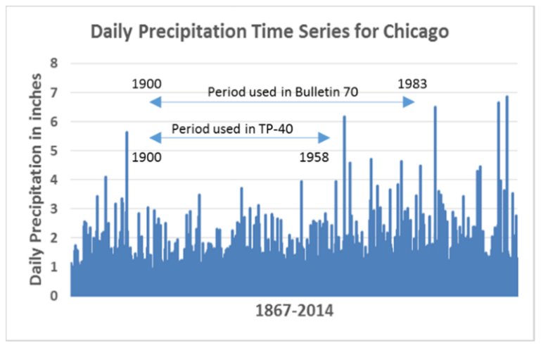

ON TO 2050 reaffirms GO TO 2040’s recommendation to integrate planning with water resource management. The region can advance stormwater and floodplain management in a variety of ways, starting with protecting the existing stormwater services provided by natural areas and open spaces, avoiding investments in areas where environmental conditions -- from floodplains to low-lying areas -- pose high urban and riverine flooding risks, and minimizing stormwater runoff volumes through development regulations and design standards. Integrating stormwater management into larger planning can help coordinate investments and leverage limited resources to address flooding while achieving other community goals. CMAP has developed a regional flooding susceptibility index to help prioritize areas for planning and mitigation investments, particularly in locations with municipal capacity constraints that make it difficult to address these challenges.

[graphic: Local strategy map, Regional urban flooding susceptibility index
Caption: CMAP developed the regional urban flooding susceptibility index to identify priority areas across the region for flooding mitigation activities. ON TO 2050 recognizes that continued urbanization and climate change are anticipated to bring more flooding to the Chicago region. This local strategy map can help identify those areas that are more susceptiblity to flooding and help prioritize planning and mitigation investments.]
Local strategy map - Regional urban flooding susceptibility index
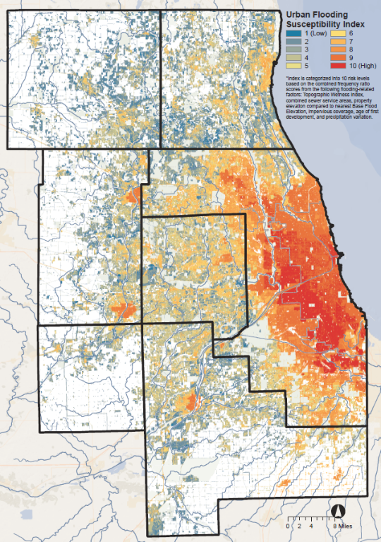
Source: Chicago Metropolitan Agency for Planning, 2017.

The following subsection outlines strategies and actions to implement this recommendation.

Identify and communicate flooding risk
Extreme precipitation events in the central U.S. increased as much as 40 percent between 1979 and 2009 compared to the previous 30 years (1948-1978). Yet the region’s infrastructure standards and our understanding of where flooding risk exists are based on older precipitation data. Reducing the region’s exposure to flooding and optimizing long term investments requires up-to-date understanding of where and when urban and riverine flooding could occur. Watershed plans, stormwater models, and other studies help the region identify the most effective stormwater solutions, and coordination of these tools can help address problems across jurisdictional boundaries. In the absence of more technical models, the regional flooding susceptibility index can help convey the potential risk of urban flooding.

Residents and business owners making important investment decisions often lack critical information about flooding risk. While established to provide affordable flood insurance, repair damaged homes and businesses, and promote floodplain management, the National Flood Insurance Program (NFIP) has the undesired effect of perpetuating development in flood-prone areas. The current NFIP does not adequately communicate the level of risk, set premiums to reflect the full risk of loss, or provide options for low income property owners.

IDNR should regularly update precipitation data and explore options to account for future climate scenarios.
FEMA, IDNR, and County stormwater agencies should update floodplain maps to reflect current development conditions as well as current and future precipitation.
County stormwater agencies and municipalities should continue advancing watershed and sewer modeling efforts to identify areas of riverine and urban flooding risk.
Local governments should communicate risk and possible solutions to residents and businesses, with particular attention to residents who may be more vulnerable to the impacts of flooding.
Partners should continue to develop planning tools to understand and plan for urban flooding risk.
IDNR should implement efforts to ensure that the sale of property is informed by accurate flood risk information.
Congress should reform the NFIP to adequately identify and communicate risk.

Improve planning and development techniques to reduce current and future flooding risk
Planning in advance of potential flooding can reduce risks to health and safety as well as costs and damages to private and public property and infrastructure. From hazard mitigation plans to development ordinance updates, many best practices are already being implemented at the local level and can be used throughout the region. Municipalities can steer development and critical facilities, such as treatment plants, hospitals, and civic institutions, away from floodplains and other floodprone areas to avoid future risk. Restoring the natural function of floodplains and wetlands enhances the ecosystem services these areas provide. Many of these best practices can also help communities achieve other community development goals. For example, applying floodplain management techniques can reduce the burden of flood insurance premiums, and reducing urban flooding can increase property values.

In the Chicago region, all counties have established minimum standards for stormwater management, limiting the amount of runoff that may be generated by new development or redevelopment. Continued advancements are needed to address urban flooding, incorporate current and projected precipitation data, and streamline volume reduction and green infrastructure techniques, among others. Municipal development ordinances also contain provisions that significantly affect stormwater runoff and management, such as the amount of impervious cover, building design, and street design requirements. Some communities in the region, such as Downers Grove, are leading the way in protecting their existing neighborhoods from urban flooding by recognizing local drainage problem areas in site plan review and encouraging redevelopment to avoid or account for increased stormwater flows in these locations.

Local governments should continue to update stormwater management ordinances and performance standards to reflect best practices, including green infrastructure solutions, and emerging information about climate change and development trends.
CMAP should convene county stormwater agencies and other partners to exchange information about regulatory updates that improve stormwater management practices.
IDNR and local governments should continue to improve floodplain management techniques and compliance.
Local governments should update plans and ordinances and design standards to improve stormwater and floodplain management.
Local governments should continue to develop pre-disaster plans for future flooding events.

Maintain and invest in gray and green infrastructure
In its current extent, the region’s gray and green stormwater infrastructure does not provide the capacity to handle the runoff from continued urbanization and current and projected precipitation. Green infrastructure has the potential to improve our flood control and stormwater system while achieving co-benefits unavailable with gray infrastructure solutions. Coordinating green and gray infrastructure solutions into other types of public investments -- including streets, parks, and public grounds and buildings, as well as encouraging retrofits of private property -- will be essential to increase the drainage capacity of our communities. This will allow the region to build a more distributed stormwater management system that is more resilient to disruptions or constraints. See the “Integrate stormwater management into transportation projects” recommendation for more information on street design.

Prioritizing investment in areas most in need will be critical. Watershed plans, modeling efforts, and the regional flooding susceptibility index, combined with information about vulnerable populations, can help inform regional and local priorities. In some situations, the best long term solution is to return flood prone land to open space through acquisition and restoration. These investments can remove people and property from harm’s way, eliminate repetitive losses, and use limited funds effectively. Federal resources that historically funded infrastructure improvements may be insufficient as sea level rise, storm surges, and flooding across the country strain disaster assistance resources. Dedicated revenue streams, such as stormwater utility fees, can support maintenance and expansion of gray and green infrastructure based on a long-term vision rather than isolated grant funded projects.

Local governments should use the regional flooding susceptibility index and modeling efforts to prioritize flood mitigation investments.
Counties, municipalities, and other infrastructure managers should enhance maintenance and monitoring of gray and green infrastructure.
Local governments should develop stormwater utility fees to cover the full costs of stormwater management and improve flood control infrastructure.
CMAP and partners should explore the use of transfers, credits, and water quality and volume trading programs to achieve regional water resource goals.
Local governments and other land managers should protect and expand open spaces to enhance natural stormwater management, recognizing additional resource management goals of parks and preserves.
Local governments should pursue property acquisition and buyouts to remove people and property from high flood risk areas.
Congress should reform the National Flood Insurance Program to prioritize assistance to address repetitive loss properties.

Address flooding vulnerability of critical transportation assets
Flooding affects the region’s transportation network through declining performance and increasing maintenance costs. Identifying locations at risk of flooding and then retrofitting these locations to handle current and future rain events can help maintain regional and local mobility and ensure that investments are built to last. In the Chicago region, the RTA, IDOT, and several county transportation agencies are already working to identify and plan for portions of the existing transportation system that are vulnerable to flooding. Nationwide, state DOTs and regional planning agencies are conducting vulnerability assessments and improving system resilience with projects recommended in long-range transportation plans. Municipalities also need to address flooding vulnerability of their streets and update capital improvement plans and corresponding design strategies. As new information on precipitation trends evolves and floodplain maps are updated, local and regional vulnerability assessments should be updated periodically to reflect changing conditions. Avoiding construction of new streets and highways in current floodprone areas is also critical and must be evaluated with future climate conditions in mind.

Transportation implementers should conduct studies to determine the flooding vulnerability of transportation infrastructure.

CMAP and partners should conduct a regional climate vulnerability assessment to inform long-range transportation planning and programming.

CMAP should assess flood vulnerability in its evaluation of regionally significant projects.

Transportation implementers should design transportation infrastructure to handle the projected precipitation during its designed lifespan.

CMAP should develop a regional pavement flooding reporting system to help plan for flood events.

Integrate stormwater management into transportation projects
As the intensity and frequency of storm events increases with climate change, the region will need strategies to better integrate stormwater management into transportation planning and design. Best practices often include drainage improvements that increase detention capacity or promote infiltration, as well as a series of protective measures to reduce exposure to flood waters. Recently, the FAST Act expanded the scope of the statewide and metropolitan transportation planning process to reduce or mitigate stormwater impacts of surface transportation. This provision could enhance how stormwater management is addressed in surface transportation projects as well as overall planning efforts. Recent updates to the region’s Surface Transportation Program (STP) program now incentivizes the use of green infrastructure to manage stormwater.

Currently, street design and reconstruction requirements do not reflect county-specific stormwater management goals or practices. Instead, they follow state design guidelines; which can limit the ability to implement innovative solutions or tailor design to local context and needs. In addition, many of our existing streets experience flooding due to development patterns in the surrounding area. This is particularly true in older communities where development occurred before modern stormwater management standards. Street flooding could be addressed through infrastructure retrofits in surrounding neighborhoods instead of within constrained rights-of-way. Projects that comprehensively address stormwater management solutions can improve the performance of our transportation system while also reducing flooding damages in nearby homes and businesses.

Local governments should support continued efforts to integrate stormwater management into land use and transportation planning projects.
IDOT should update design standards to reflect precipitation trends and green infrastructure techniques.
Transporation agencies should construct and maintain projects that can sufficiently manage current and future storm events and avoid downstream impacts on natural resources.
IDOT should support stormwater management planning to reduce flooding vulnerability of the transportation system and design transportation infrastructure for the climate of its designed lifespan.
Counties and municipalities should update development ordinances and reconstruction practices to improve stormwater management in new and reconstructed streets.

Protect and enhance the integrity of aquatic systems
The region’s wealth of water resources, including its many wetlands, lakes, rivers, and streams, contribute to the area’s growth, prosperity, and high quality of life. The integrity of these resources refers to the chemical, physical, and biological quality of these systems to support both human and non-human use, including the quality of the habitat itself. Maintaining these systems' health is important not only for communities and residents, but for the economic, habitat, and recreational values that they convey to the region. Lake Michigan is the single most significant water resource in our region, which plays a pivotal role in managing the lake's water quality and supply in partnership with other Great Lakes states and Canada. (See page 8 of the Water Resources Strategy paper for more details.) It is also important to note that the natural integrity of Lake Michigan's coastal environment is critical, not only for adjacent communities, but as nearshore and coastal habitat and a critical migratory flyway.

[graphic – photo essay of lake Michigan? CAWS?]

Though water quality and habitat have improved in parts of the region since adoption of the Clean Water Act, the majority of our aquatic, wetland, and riparian ecosystems remain in a poor to moderate state of health due to direct and indirect effects of development, agriculture, and other impacts on the quanity and quality of runoff. The value of clean, abundant, and reliable water resources tends to be taken for granted until shortages, flooding, or quality impairments make the water unfit for its intended use. See the Water Resources strategy paper for challenges to our water resources and how to address them. Climate change will put additional stress on our water resource systems, as higher water temperatures, more variable and extreme precipitation, and drought cycles alter existing habitats and make them inhospitable to aquatic plants and animals. More broadly, if climate impacts on other parts of the nation and world drive population to the water-rich Great Lakes region, the region should begin to prepare today.

[graphic – map showing location of higher quality streams and existing / recent development]

Some water resource challenges are the result of isolated actions that do not consider the interconnected nature of those resources. Individual development decisions can have significant and lasting impacts on neighboring communities -- including increased stormwater runoff and flooding, impaired water quality, and decreased drinking water quality and availability. For example, the extent of impervious surfaces associated with urban development is highly correlated with the quality of a watershed’s streams and other resources. The Watershed Integrity local strategy map illustrates the region's percentage of impervious surface by watershed, while the stream quality map shows the location of higher quality aquatic resources. Both maps demonstrate the impact of urban development on aquatic resources. Because most of the remaining higher quality aquatic systems are found in the collar counties where imperviousness remains relatively low, future development in those areas will have negative consequences for these aquatic systems. Even the way we manage our water systems is fragmented, through separate agencies and programs with their own missions. In addition, other sectors such as public health, energy, agriculture, and transportation make policy decisions that influence water resource outcomes.

[graphic: watershed diagram with interventions for water quality]

Effective water resource management can address some of these challenges and improve the region’s natural assets. ON TO 2050 reaffirms the GO TO 2040 recommendation to integrate planning with water resource management, while suggesting the conceptual goal of an integrated water resource framework for managing the region’s water assets. This framework requires careful assessment and consideration of water resource impacts and coordination among decision makers to protect ecosystem health and ensure sustainable use. The region can advance integrated water resource management in a number of ways. Coordination among existing state and federal programs can identify cost-effective ways to maintain water and wastewater infrastructure while protecting natural assets. Watershed plans help identify cross-jurisdictional solutions and can be expanded beyond water quality goals to address additional water resource objectives. Local planning and development practices can ensure that redevelopment improves water quality and that new development minimizes impacts. Water infrastructure decisions in particular can have lasting effects on the sustainable management of water systems, as described in greater detail below and in the other two water related strategies. Updating federal programs is a long term goal, but the region and state can take more immediate actions to improve coordination and decision making that reflect the interconnected nature of water resources.

[graphic: Local strategy map - Watershed integrity
Caption: ON TO 2050 calls for preservation and enhancement of the region's aquatic systems and identifies strategies that are particilary relevant in specific areas. The watershed integrity local strategy map identifies catchments with low imperviousness, where the focus should be on land preservation, compact and conservation design development, and green infrastructure. Policy recommendations for areas with high imperviousness would emphasize green infrastructure retrofits and waterway restoration that improves habitat.
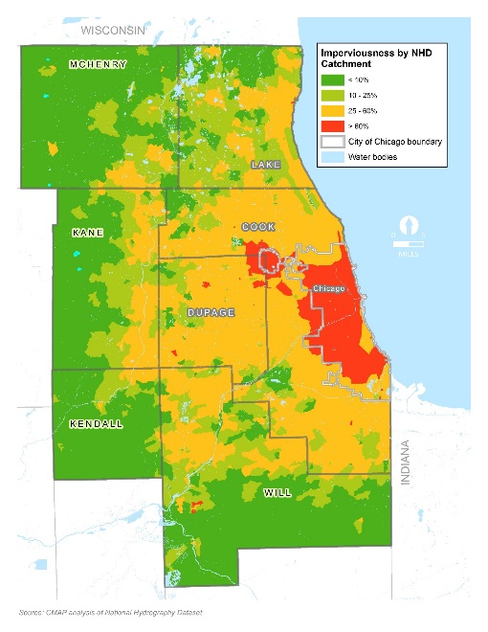

The following subsection outlines strategies and actions to implement this recommendation.

Improve water resource management and coordination
Institutional barriers hinder the region’s ability to sustainably manage water resources. From the siloing of different policy sectors to disconnected decision making across jurisdictions, there are many ways to improve efficiency, effectiveness, and coordination of water resource management efforts. Numerous agencies oversee the varied aspects of water resource management, including flood mitigation, wastewater and water quality, water supply, and aquatic habitats. As a result, water resources are often managed in isolation, missing opportunities for more cost-effective, integrated solutions. Updating federal programs is a long term goal, but the region and state can take more immediate actions to improve coordination and decision making. State agencies are already seeking out such opportunities, including cross-jurisdictional efforts to advance the state’s Nutrient Loss Reducation Plan, and new approaches to finance stormwater management projects, including through the State Revolving Fund.

A comprehensive water planning agenda and funding program at the state level could improve coordination of water supply, stormwater and wastewater management, and habitat protection and stewardship efforts. Better data collection and analysis about the condition of our water resources is an important foundation for integrated water resource management and performance-based decision-making based on sound science. At the local level, many communities have separate entities managing water supply, stormwater, and wastewater, each with its own governance structure and mission, with limited connection to land use and transportation planning functions.

The State should develop a comprehensive water planning agenda and funding programs to integrate water supply, water quality, stormwater, and aquatic habitat objectives.
The State should support and coordinate data collection and research among various agencies, including IEPA, IDNR, ISWS, and ISGS.
IDNR and IEPA should increase the number of streams surveyed and rated, and work with partners to develop a regionwide index for headwater streams.
The State should provide funding for CMAP to prepare an integrated water resource management plan for the region, addressing water quality, water supply, and stormwater management and including a focus on natural areas and green infrastructure.
CMAP and partners should coordinate a cross-jurisdictional platform to engage local governments, conservation organizations, and community water resource managers (supply, stormwater, wastewater) to advance integrated, innovative, and watershed-based management across sectors and agencies.
CMAP and partners should explore the use of transfers, credits, and water quality and volume trading programs to achieve regional water resource goals.
The U.S. EPA and federal partners should advance stormwater management reform (see stormwater management recommendation) to better address non-point source pollution and flooding.

Incorporate water resource management into local planning
As the primary land use and development authorities in the region, municipalities and counties have significant responsibility to integrate water resource management considerations into planning efforts. The region can accommodate new households and jobs while protecting water resources with a variety of best management techniques. Existing natural areas, open spaces, headwaters, high quality lakes and streams, and riparian zones can be protected through land use planning and land acquisition. To maintain and improve water resources, new development should protect natural drainage and hydrology, minimize the impact of impervious surfaces, and provide natural buffers along waterways and waterbodies. At the site scale, county and municipal development ordinances can encourage or require the use of green infrastructure practices to minimize the impact of impervious surfaces and improve the quality and reduce the volume of stormwater runoff. Infill and reinvestment in existing developed areas can actually improve water management in older neighborhoods by triggering the installation of stormwater best management practices.
Local governments should identify and protect water resources and the water protection services provided by natural areas and open space through the use of practices that minimize the expansion of impervious areas and encourage infill, compact, and contiguous development.
Local governments and other open space protection and management entities should prioritize land acquisition and stewardship to maintain and enhance high quality water resources, including large contiguous areas of hydric soils.
Local governments should integrate watershed plan recommendations and other water quality improvements into development ordinances.
Local governments should continue to update stormwater management plans and ordinances to reflect stormwater best management practices and performance standards.
CMAP should continue to integrate water resource management considerations into LTA projects and seek funding to do so.
CMAP, local governments, and transportation agencies should evaluate and minimize the direct and indirect water resource impacts of regionally significant transportation projects and of the development they induce.

Create and implement multi-objective watershed plans
Improving the quality of our water resources requires a comprehensive view to fully address the stresses that stormwater runoff, combined sewer overflows, and wastewater and industrial discharges place on our water systems. While watershed plans are an important mechanism for addressing water quality concerns, they typically lack the authority and funding to achieve significant water quality improvement. To date, the most successfully implemented watershed plans are the result of committed watershed groups that include municipal, county, and industry leaders collaborating on broad activities to advance water quality goals. The DuPage River Salt Creek Working Group and the Fox River Study Group are models that should be extended throughout the region to invest in watershed restoration that addresses water quality concerns. Also, multiple objectives including open space protection, flood control, priority pollutants (chlorides and nutrients), and water supply protection can be addressed through watershed planning. Plan implementation requires open space protection, changes in development and transportation design, gray and green infrastructure investments, and operational changes in asset management.

CMAP, IEPA, stormwater and wastewater managers, and watershed management entities should engage a diverse set of stakeholders in workgroups to plan and implement watershed plans.
CMAP should continue to advance the state of watershed planning science and to develop and help implement watershed plans in the region.
CMAP and partners should explore funding and financing strategies to support collaborative efforts -- such as the State Revolving Fund and the use of transfers, credits, and water quality -- and volume trading programs to achieve regional water resource goals.
Wastewater managers, stormwater managers, conservation organizations, and local governments should focus efforts on addressing priority pollutants through watershed planning and implementation: nutrients, chlorides, and emerging pollutants such as pharmaceuticals.

Optimize water infrastructure investment
The region’s aging water infrastructure systems -- including drinking water, wastewater, and stormwater -- are in need of significant investment. More broadly, resource managers can shift their approach towards an integrated water resource management framework that protects, conserves, and reuses water resources and invest public and private funds in a way that achieves multiple benefits, leverages multiple funding sources, and improves resilience. Shrewd water managers such as MWRD are already recognizing wastewater as a resource, making significant investments to remove nutrients and biosolids from waste streams, directing treated wastewater back into circulation for industrial use or landscape irrigation, and capturing excess heat and natural gas as a source of energy. Nationwide, communities and industries are identifying uses of rainwater and graywater that can reduce both demands on drinking water and volumes of stormwater and wastewater.
In this era of limited resources, infrastructure investment must be strategic and help the region address multiple objectives. Reinvestment in existing infrastructure before expanding these systems is essential to reduce maintenance and replacement costs over the long term and to create incentives for infill development that helps capture infrastructure costs. The region must connect infrastructure investments to sound planning and prioritize funds to upgrade, rehabilitate, and optimize the use of existing system capacity. When expansion is considered, the long-term asset management and maintenance costs should inform decision making, as described in the “Incorporate market and fiscal feasibility into planning and development process” recommendation of the Land Use chapter. CMAP supports efforts to make the State Revolving Loan funds (SRF) for both drinking water and wastewater investments more accessible and streamlined for communities to pursue. In some cases, the best approach for managing the region’s infrastructure systems is to identify collaborative strategies for optimizing investments and effieciencies, including consolidation and service sharing arrangements.
The infrastructure and service recommendations of this Environment chapter and the Governance chapter include a number of crossover strategies. For example, see "Encourage shared services, consolidation of local services, and local government consolidation" and "Coordinate and cooperate on operating and maintaining the region’s infrastructure," as well as the recommendation about implementing user fees.
The state, local governments, utility and water management entities should pursue resource recovery and close water system loops (use, capture, recovery, and reuse) -- including updating codes and standards such as the state plumbing code -- that would allow for such activities.
Wastewater managers should continue to explore the use of constructed wetlands and land application to help treat and manage wastewater.
The State should continue to improve the State Revolving Fund loan program criteria and incorporate flexible approaches to achieve water supply, water quality, and stormwater management goals.
The State, CMAP, and local governments should connect infrastructure investments with sound planning, consider long-term asset management and maintenance costs of infrastructure expansion, and prioritize use of infrastructure funds to upgrade, rehabilitate, and optimize the use of existing system capacity before investing in expansion.
CMAP and the IEPA should explore innovative wastewater planning approaches that protect water quality and satisfy other regional planning goals.
CMAP, local governments, and watershed groups should consider the protection of water resources when making wastewater service planning and infrastructure investment decisions, including separation of combined sewers and strategies to reduce frequency of overflows.
Local governments and other utility service providers should consider shared services, consolidation of local services, and other efficiency strategies in investment decisions to improve community fiscal health and resilience.

Be a steward of Lake Michigan, the Great Lakes, and the Chicago Area Waterway System
Our location on the Lake Michigan shoreline demands collective action to maintain and enhance the lake's health and help the state meets its commitments to national and international partners. As the region's main water source, Lake Michigan should be strategically managed to ensure a sustainable supply. The lake faces significant pollution challenges from urban, agricultural, and industrial sources that can be addressed by improving stormwater management and reducing combined sewer overflows. Our state's nearshore and shoreline habitat, which is entirely within the Chicago metropolitan region, is degraded and fragmented. Preventing the introduction of additional aquatic invasive species, which have already affected the Lake’s natural ecology and native species dynamics, should be a high priority. The region should be engaged in solutions that help protect the Great Lakes from Asian Carp and other such species while also maintaining the services currently provided by the Chicago Area Waterway System: the Chicago and Calumet Rivers, and the North Shore, Cal-Sag, and Chicago Sanitary and Ship Canal. The "Our Great Rivers" initiative is intended to focus attention and investment on improving these legacy resources, and the Great Lakes and Mississippi River Interbasin Study focused on the interaction between these water systems.

CMAP, USACE, IDNR, MWRD, MPC, CCT, and other stakeholders should continue to explore solutions to manage and provide access to the Chicago Area Waterways System, including implementation of the Our Great Rivers initiative and the Great Lakes and Mississippi River Interbasin Study.
Congress should continue to fund investments that maintain the health of the Great Lakes, such as the Great Lake Restoration Initiative, the Water Resources Development Act, and efforts to prevent invasive species transfer.
CMAP, IDNR Coastal Management Program, Chicago, and coastal communities and landowners should increase efforts to focus and coordinate high-priority coastal issues such as protecting shorelines and coastal infrastructure, supporting resource-compatible recreational activities and access to the lake, and restoring natural resources.
IDNR, Chicago and other local governments, and coastal landowners should work together to protect and restore coastal nearshore and shoreline aquatic and terrestrial habitat, ravines, and migratory flyways.
CMAP should work with regional partners to implement or incorporate the Lake Michigan Lakewide Management Plan update (anticipated for 2018) into local planning efforts.
Lake county stormwater agencies, MWRD, and other wastewater managers should continue to reduce stormwater runoff and combined sewer overflows into the lake and the region’s waterways.

Coordinate and conserve shared water supply resources
High quality water resources play an essential role in sustaining economic prosperity, environmental health, and quality of life within the Chicago region. After Lake Michigan, the leading sources of water used in the region are groundwater and the Fox and Kankakee Rivers. Access to Lake Michigan water has been critical to regional development and, if well managed, will continue to provide a sustainable supply of water into the future for much of the region. Because Illinois withdraws, uses, and then diverts Lake Michigan water out of the Great Lakes Basin to the Mississippi River system, our state’s access to the lake's water is governed by a U.S. Supreme Court Consent Decree and managed by the Illinois Department of Natural Resources (IDNR). Over the years, access to Lake Michigan water has been extended to additional communities, providing a more sustainable drinking water source, yet there are limits to the physical extension as well as the allocation.

[graphic – water source “flows” diagram]

CMAP is currently updating the regional water demand forecast first developed as part of
Water 2050, which examined how population and employment, development patterns, climate dynamics, and conservation and efficiency efforts could affect future water usage. Per capita usage has been declining due in part to conservation and efficiency gains, and continued improvements will be necessary to manage the region’s water demand. However, the total demand for water is anticipated to increase with population growth and climate change. The location of future water demand will significantly influence whether the region can maintain a sustainable water supply. Population growth and industrial development, particularly in the collar counties, has led to increasing withdrawals from constrained groundwater resources. Continued use of groundwater sources will require coordinated management throughout the region in the future, especially during droughts. Water supply management will help to maintain water supplies, support community livability, and mitigate potential conflicts arising from water shortages.

[graphic: map of water use by community, with per capita consumption for 2013 and 2050.
Caption: Water demand varies from community to community based on housing density, conservation practices, and industrial and commercial users, among other factors. CMAP updated the regional water demand forecast based on the ON TO 2050 socioeconomic forecast with critical support from IDNR and assistance from Illinois-Indiana Sea Grant. Overall, regional water demand is anticipated to increase, but the rate of growth will slow due water conservation and efficiency trends. For more information see the ON TO 2050 Regional Water Demand Forecast.]

Inland surface water and groundwater generally supply communities in the collar counties of the region. In some areas, groundwater is being withdrawn at a rate that exceeds the recharge rate. This net drawdown of the aquifers may result in decreasing yields, increasing pumping demands, increases in salinity, and the search for alternative water sources, all of which increase the cost of providing water. For example, increasing withdrawals from community water suppliers as well as industrial users in the western Will County and northern Kendall County are posing significant risks to the existing quantity and quality of water supply as portions of the aquifer become desaturated. Similarly, shallow aquifer withdrawals in northeastern Kane County and southeastern McHenry County are exceeding the recharge rate, which may result in neighboring wells competing for less water and impacts to nearby streams and rivers dependent on groundwater flows. Land use and transportation decisions affect the amount of water replenishing shallow aquifers as well as the quality of the water entering our groundwater reservoirs. For example, roads and conventional road and parking lot salting practices are linked to rapidly rising chloride levels in some parts of the region.

At the same time, climate change is likely to create further stress for the region’s water supply resources. Increasing air and water temperatures, more intense precipitation and runoff, and intensifying droughts can affect both water demand and supply. Heat waves and periods of drought could increase residential and agricultural demand on existing water supplies. More communities may explore surface waters as an alternative to groundwater sources, yet climate change may cause these waters to experience more frequent low-flow conditions, increased pollutant and sediment concentrations, and higher probability of toxic "cyanobacteria" blooms . Increased storm intensity and flooding may also increase the frequency of combined sewer overflow events and affect critical water infrastructure, including intakes, treatment, and distribution systems. National and global water scarcity has the potential of attracting new residents to the region, which makes coordination and conservation of water resources even more important.

[graphic – Local strategy map, drinking water source coordination
Caption: ON TO 2050 calls on the region to coordinate shared water supply resources for long-term sustainability and identifies strategies that are particularly relevant for specific sources. The drinking water source coordination local strategy map identifies the different sources of water supply for municipalities in the region in recognition of the unique challenges and management needs associated with different sources.]
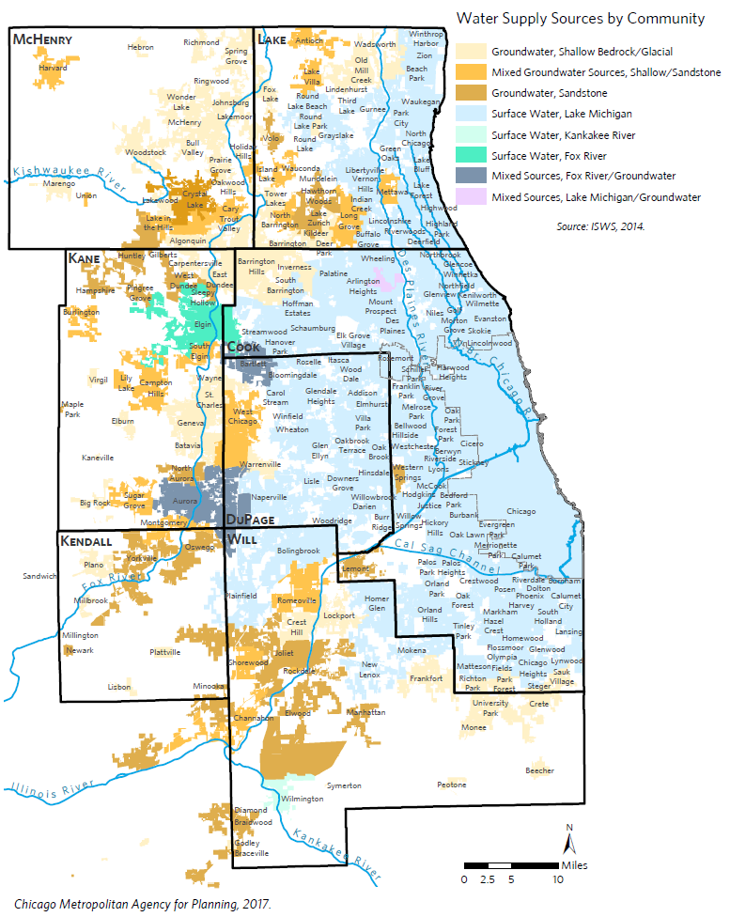

Community water suppliers provide an essential service and are a key part of the region's economic framework. They must maintain safe, efficient infrastructure at affordable prices while also managing water use to ensure a long-term supply. Aging infrastructure requires major capital improvements, a challenge compounded by high levels of water loss, lack of full-cost pricing, and increasing focus on replacement of lead and copper infrastructure. Some community water suppliers also struggle with large shifts in demand, such as new development or the closing of major industries, while others have to make long term decisions in the face of near term supply uncertainties. In addition, some municipal leaders and local residents do not understand the implications of the source, usage, or cost of their water service. Low-income residents, people of color, and the elderly may be disproportionately affected by deferred maintenance and service costs. The region must pursue strategies that maintain and improve drinking water infrastructure and sourcing to maintain its economic competitiveness and quality of life.

The following subsection outlines strategies and actions to implement this recommendation.

Incorporate water supply and demand considerations into local and regional planning
Understanding both the available supply of water and the current and future demand are critical to making informed land use, transportation, and infrastructure investment decisions. Today several different state agencies collect and analyze information about the use and condition of our region’s drinking water supply. This dynamic leads to duplicative efforts and gaps in planning and responsibilities. A coordinated and properly funded approach could enhance regional understanding of and planning for water supply and demand. For more context, see the “Improve Water Resource Management and Coordination” strategy.

Working together, land use planners and water utility managers can align local planning efforts within current and future water supply constraints. Assessing forecasted demand scenarios against available water supply and infrastructure capacity can inform regional and local planners about the sufficiency of water supply and encourage actions that conserve water, protect supply, and/or pursue alternative drinking water sources. In particular, local water demand forecasts can help bridge land use, transportation, and municipal finance and asset management decisions as development patterns affect water use and also long-term infrastructure maintenance costs. Avoiding expensive capacity expansions can help maintain municipal fiscal stability but requires coordination across municipal departments to reduce water demand. For land use planning techniques to protect water supply, see the “Incorporate water resource management into local planning” strategy.

The State should coordinate community water supplier reporting requirements and improve data sharing across agencies and partners.
The U.S. Geological Survey, State, and Counties should fund critical surface and groundwater supply research and expand groundwater quality and quantity monitoring.
Local governments should protect water sources and integrate demand management and conservation strategies into local ordinances guiding new development.
CMAP should regularly update the regional water demand forecast in conjunction with socioeconomic forecast updates and incorporate projected impacts of climate change.
Local governments and other community water suppliers should conduct local water demand forecasts and incorporate strategies to maintain a long term supply in land use and infrastructure planning efforts.
CMAP and partners should provide technical assistance to communities to incorporate water supply and demand management strategies in local plans, ordinances, and development review processes.
Local governments should carefully review the impacts of large scale water users and the expansion of drinking water services in new development with consideration of long-term water availability and infrastructure costs
CMAP, local governments, and transportation agencies should evaluate and minimize the direct and indirect water resource impacts of regionally significant transportation projects and of the development they induce in locations facing water supply constraints.

Strengthen regional water supply management
Illinois groundwater withdrawals are governed under the rule of reasonable use, with no statutory remedies for disputes and no permitting program for withdrawals. Building on the precedent of the Lake Michigan Allocation program, CMAP supports the development of a comprehensive groundwater management program to resolve conflicts and manage withdrawals for long-term sustainability. This will be particularly important in coming years as climate change is anticipated to diminish the amount and quality of water supplies while also increasing water demand. To implement such a program, critical elements of water supply management will need to strengthened, including more robust annual and monthly water reporting from communities, to inform the regional groundwater flow model, river water studies, and regional water demand forecast. Communities that coordinate with ISWS to review new public or private well proposals will have a better understanding of potential effects and can plan accordingly to reduce conflicts and shortages.

Communities are already organizing to protect water resources, with examples that include the Northwest Water Planning Alliance (NWPA), the Barrington Area Council of Governments, and communities and industrial partners in the Joliet area. As groundwater is a shared regional resource, withdrawals require coordination across jurisdictions; management systems can evolve as new information and policies become available. As groundwater-dependent communities face growing challenges due to over-withdrawal and contamination, some might pursue access to Lake Michigan water. As required by their permits, Lake Michigan communities can help make more of the state’s limited allocation available to others in the region by increasing conservation and efficiency and reducing water loss. Water 2050 and a subsequent CMAP report identified key strategies for water demand management and water loss reduction.

ISWS, IDNR, CMAP, and partners should continue to disseminate information to groundwater-dependent communities on the potential effects of continued groundwater withdrawals and ramifications for existing communities and future growth.
Community water suppliers should regularly report water use to the State and consult ISWS on groundwater impacts of new development and wells.
Community water suppliers dependent on constrained supplies should explore ways to coordinate withdrawals and management of shared water resources.
CMAP, NWPA, and partners should continue local and sub-regional coordination efforts, promote demand management strategies, and explore the development of plans for existing and future Fox and Kankakee River users.
CMAP and partners should explore the development of a comprehensive groundwater management program.
IDNR and the State Water Task Force should explore and advance specific legislative changes of the state-wide groundwater protection authority as part of a larger effort to improve state management of water resources.
Lake Michigan permittees should follow the Lake Michigan Allocation Program requirements to maintain compliance with provisions of the U.S. Supreme Court consent decree and the Great Lakes Compact.
Municipalities, working with counties and state partners, should develop contingency plans for droughts and other water emergencies that limit the availability of water.

Maintain drinking water infrastructure and manage demand
Regularly assessing, planning for, and investing in the long-term condition of systems for drinking water are an ongoing challenge for many communities. As a largely underground asset, water infrastructure has maintenance needs that are not as apparent as other community challenges. Addressing deferred maintenance can require substantial funding, and as the region’s infrastructure ages and faces increasing impacts from climate change, maintenance needs are anticipated to grow. CMAP supports state efforts to make the State Revolving Loan funds more accessible for communities and encourages the prioritization of projects based on realistic water demand projections and maintenance of existing water capacity before new capacity investments.

Managing water demand is another way community water suppliers can avoid expensive new expansion projects and focus on maintenance of existing assets. As outlined in Water 2050, foundational demand management strategies include annual water loss audits, full-cost pricing to set appropriate water rates based on infrastructure need, water reuse and conservation programs, and universal metering to accurately account and charge for water usage. For more information on full-cost pricing, see the “Local governments should implement user fees“ recommendation. Municipalities across the region are also updating ordinances to promote efficiency in landscaping and watering, for example, and are working with partners to educate customers on the need for water conservation and strategies.

Water affordability is a growing concern in many communities as continuing escalation of service and infrastructure costs translates directly into rising utility bills. Some communities with vulnerable populations, such as low-income residents, people of color, and the elderly, are disproportionately affected. Water pricing should be sensitive to the ability of the consumer to pay, yet small utilities with a low-income customer base may struggle to achieve a balance that pays for the system. Water utility consolidation is one strategy that can address the above challenges. The Chicago region has hundreds of community water supply systems, most of which are publicly owned and managed by a municipality. Small water suppliers are more likely to face significant capital constraints for maintenance and upgrades and often struggle to meet state standards. Communities are already exploring ways to gain efficiencies of scale through collaboration and consolidation, and should continue to investigate potential options among neighboring utilities.

Community water suppliers should implement asset management and water demand management strategies.
Community water suppliers should utilize the IEPA State Revolving Loan Fund for low interest loans.
IEPA and partners should continue asset management and water demand management training and support for community water suppliers.
U.S. EPA should continue to advance water conservation and efficency standards in plumbing fixtures and appliances and the State should explore further improvements to promote water reuse.
Community water suppliers should ensure safe, clean, abundant, and affordable water, and evaluate and address affordability impacts of rate increases on low-income customers.
IEPA, CMAP, and other partners should target assistance to communities facing water affordability challenges, as well as those with high maintenance needs.
Community water suppliers, particularly those contemplating alternative water sources or large-scale capacity changes, should work with nearby water suppliers to explore costs and benefits of service sharing and utility consolidation.
IEPA, IDNR, CMAP, and other partners should explore strategies, best practices, and appropriate conditions for water service consolidation.

Development practices that protect natural resources
To preserve the region’s highest-quality natural and agricultural areas, stakeholders must pursue conservation strategies and also promote reinvestment in existing communities. While preservation decisions are often driven by opportunity, strategic frameworks like the ON TO 2050 conservation areas local strategy map can help maximize the benefits of land protection by coordinating different actors and funding streams across jurisdictional boundaries. These efforts can occur anywhere but are particularly important at the region's developing edge. In addition, sensitive development techniques such as conservation design can ensure preservation of high-quality natural assets alongside growth in currently undeveloped areas near the perimeter of our region.

Reinvestment efforts, which help to accommodate growth in areas with existing infrastructure and services and reduce development pressures on natural and agricultural lands, may take many forms. Communities can increase employment densities and housing options in transit-rich areas, build up existing office and industrial centers, or redevelop formerly latent brownfields. Redevelopment brings the opportunity to improve the environmental performance of our communities and reap co-benefits. Integrating green infrastructure into the redevelopment process can result in additional parks and open spaces, tree-lined streets, and stormwater facilities, among others. Combined, these investments provide places for recreation, habitats for native flora and fauna, air pollutant filtration, flood reduction, and groundwater recharge, while at the same time creating more desirable and resilient communities.

Improve natural resources through the redevelopment process
Infill and redevelopment can provide a variety of benefits, such as leveraging and making efficient use of existing infrastructure and services, promoting walkability, spurring investment in disinvested areas and areas with stagnant growth, and helping to preserve key agricultural and natural lands by accommodating growth in already developed locations. The redevelopment process also presents unique opportunties to conserve, restore, and enhance natural resources in infill locations and to increase climate resilience. Given that most development happened before the advent of many environmental best practices, redevelopment can help tackle some of the region’s most persistent challenges.

GO TO 2040 emphasized many best practices to achieve this goal, which ON TO 2050 continues to promote. For example, GO TO 2040 noted that remediation of sites with significant contamination issues (such as brownfields) provides great environmental and social benefits and should be undertaken when conditions are favorable and resources are available. In addition, building renovations and construction of new buildings can result in improved environmental performance through the use of energy- and water-efficient systems and appliances, renewable energy, water reuse, recycled and sustainable materials, and other sustainable approaches.

[graphic - urban heat island map and urban tree canopy map with slider interaction]]
Caption: When ambient air temperature is the same across the region, areas with higher imperviousness experience hotter land surface temperatures that contribute to urban heat island effect. A regional analysis of land surface temperature demonstrates the correlation between impervious coverage and urban heat island effect. Lands with high- and medium-intensity developments, defined as having greater than 50 percent impervious surfaces, are five to six degrees hotter than the regional average. The urban tree canopy is one of the best strategies to address the urban heat island effect as well as clean our air and water, improve stormwater management, and create habitat for wildlife. Expanding and diversifying the urban tree canopy can also help the region adapt to a changing climate.

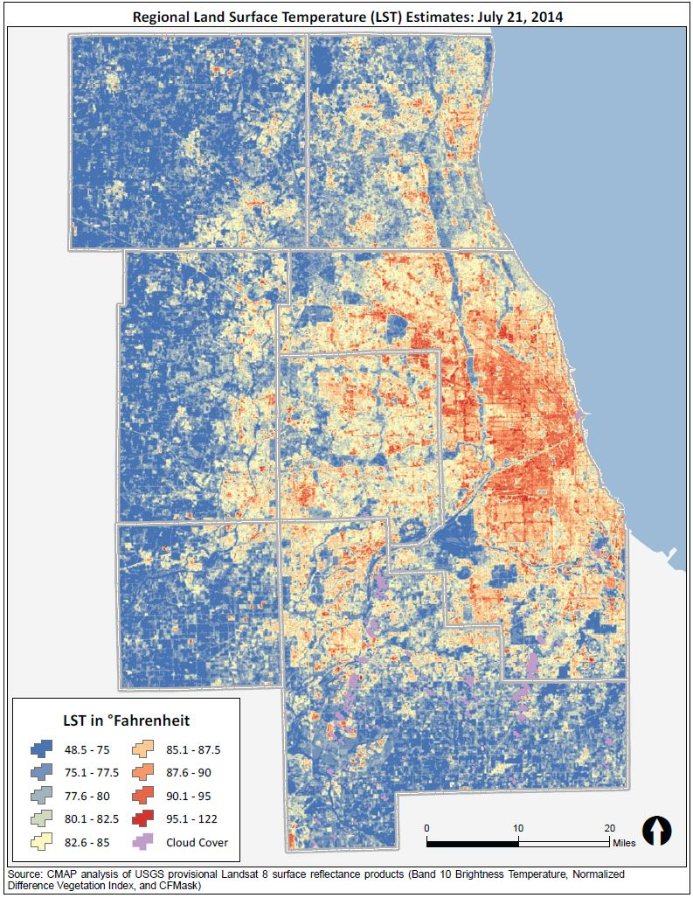

In addition, strategy development for ON TO 2050 has highlighted other specific environmental issues related to climate change and flooding, water quality, community greening and placemaking, and impacts to vulnerable populations that are particularly relevant to address during the redevelopment process. Climate change -- and its associated increases of urban heat island effect and flooding -- underscores the importance of expanding green infrastructure, tree canopy, and other community greening strategies. As recent analysis of land surface temperature shows, highly developed lands are 6.6 degrees Fahrenheit hotter while forested lands are 1.9 degree Fahrenheit cooler than the average regional temperature.

[graphic: access to parks map and/or inclusive growth indicator.]
Caption: Share of population in economically disconnected areas with access to four acres of parkland per 1,000 residents, 2004-2014
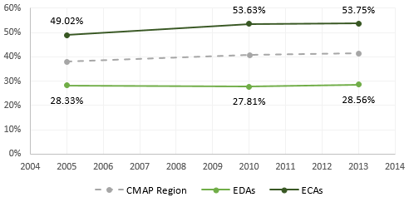
Source: Chicago Metropolitan Agency for Planning analysis of U.S. Census data and CMAP’s Land Use Inventory data.

With regard to vulnerable populations, review of the GO TO 2040 access to parks indicator revealed that the region’s economically disconnected areas (EDAs) have far lower access to parks -- in 2013, about 28.6 percent of the population had access to four or more acres of parkland per 1,000 residents -- than economically connected areas, where the figure was 53.8 percent. As EDAs redevelop, making a concerted effort to provide park space when possible will help to reduce this disparity over time. This recommendation area seeks to draw out and expand upon environmental strategies related to redevelopment to inform relevant local stakeholders, such as counties, municipalities, non-profit organizations, conservation organizations, and others who make development decisions.
The following subsection outlines strategies and actions to implement this recommendation.

Apply environmental best practices to the redevelopment process
Each redevelopment site represents an opportunity to enhance the environmental performance of a property and incrementally address local and regional natural resource challenges. Many aspects of development proposals, such as building design, landscape choices, and site planning, can improve climate resilience, water conservation, stormwater management, and water quality. Expansion of site-scale greening -- particularly with native and drought-tolerant landscape materials, and urban forestry -- can help to mitigate the urban heat island effect, store stormwater, and promote carbon sequestration. Avoiding reinvestment in flood prone areas stops the cycle of escalating damages. Local governments can be proactive about addressing flooding challenges by going beyond county requirements to require stormwater best management practices on smaller parcels. Encouraging green infrastructure practices as the first design option and enabling rainwater harvesting and reuse can help address concerns from neighbors that redevelopment could exacerbate existing stormwater problems.

Despite these real benefits, integration of sustainable practices in redevelopment is often perceived as more difficult or expensive. The most common example is with stormwater, where some small sites may have difficulty with meeting detention requirements. Yet the application of green infrastructure designs like permeable paving or bioswales can be incorporated in a variety of settings. For property owners with real space or other site constraints that would make meeting the requirements on their property difficult, credit trading programs can provide flexibility and increase implementation. In the stormwater example, trading programs allow eligible properties to meet a portion of their stormwater requirements by buying “credits” from other property owners. These programs could lead to dramatic improvements, especially if off-site installations are located within the same water- or sewer-shed. Municipalities can also take advantage of larger-scale redevelopment efforts to either make adjacent infrastructure improvements that relate to climate resilience, such as burying overhead utility lines, installing street trees, or increasing sewer capacity or developed shared stormwater solutions, or require developers to do so.

Local governments should align zoning, building, energy, and stormwater regulations to ensure sustainable development practices are implemented through redevelopment.
Counties should follow Cook and DuPage efforts and establish fee‐in‐lieu programs for detention and volume control for constrained infill sites.

Develop strategies for addressing environmental challenges that disproportionately affect certain populations
Environmental issues tend to have disproportionate impacts on some populations, including low-income residents and people of color. For example, water pricing can take a higher toll on those residents and the elderly as service and infrastructure costs continue to escalate. In addition, residents living in the region’s top 10 Census tracts with the hottest average land surface temperatures are disproportionately people of color, have limited English proficiency, have a family income below the poverty line, and have no health insurance coverage, putting them at increased exposure for the intense heat waves associated with climate change. Exposure to repetitive flooding damages appears to be greater among such populations as well. And the presence of freight facilities, which often cause pollution and congestion, drives down prices for nearby residential neighborhoods, drawing lower-income populations and exposing them further to environmental hazards. More research and analysis are needed to determine the impacts of various environmental issues on vulnerable populations. Any effort to address these issues must meaningfully engage the affected communities to ensure that solutions reflect local needs.

CMAP and partners should explore the impacts of priority issues, such as climate change, water loss and pricing, repetitive flooding, and freight, on vulnerable populations and develop recommended solutions.
CMAP and partners should align green and gray infrastructure investments to address the unique needs of disinvested areas.

Increase community greening efforts and expand neighborhood parks
Community greening involves increasing the amount of green coverage, including (but not limited to) recreational or passive park space, landscaping and tree canopy, and green infrastructure, in a community. These efforts can be particularly valuable in walkable downtowns, along major commercial corridors, and in other areas with a high proportion of impervious surface. Community greening efforts can achieve numerous benefits, including greater resilience, stormwater management, habitat, reduced heat island effect, and improved physical and mental health. GO TO 2040 recommended retrofitting developed areas with green infrastructure, which contributes to overall community greening, and these practices were explored in greater detail in the Integrating Green Infrastructure strategy paper.
Local governments, park districts, and other partners should expand access to neighborhood parks and community gardens, particularly in economically disconnected areas.
Local governments, park districts, and other partners should incorporate green infrastructure and other green strategies into neighborhood parks, corporate and office campuses, and other open lands to achieve multiple co-benefits.
Local governments, park districts, and transportation agencies should expand urban forestry efforts to protect existing trees and to increase and diversify the tree canopy.
Local governments, transportation agencies, and landowners should incorporate site-scale green infrastructure, trees, landscaping, etc. into non-park spaces, including street right-of-waysparking lots, and private property.

Prioritize natural and agricultural preservation alongside strategic growth
The Chicago region maintains many high-quality natural areas and has an incredibly high level of biodiversity. Over 800,000 acres of natural areas make up the region’s green infrastructure network and provide an array of ecosystem services, including flood control and carbon sequestration. A recent study estimated that a subset of these services provides approximately $6.4 billion annually in services that would be either expensive or impossible to replicate. However, because these natural areas are often isolated from one another by agriculture, roads, and development, they face particular challenges associated with fragmentation, pollution, invasive species, and climate change. For ON TO 2050, CMAP created the Conservation Areas Local Strategy Map, which presents local and regional conservation priorities and reflects current data on the region’s natural assets.

[graphic – Conservation Areas Local Strategy Map]
Caption: ON TO 2050 calls on the region to preserve natural areas through land acquisition, conservation easements, and land use planning techniques. The Conservation Areas Local Strategy Map provides a regional scale map of natural lands to assist stakeholders in coordinating both land preservation and development decisions. The Local Strategy Map uses updated regional data as well as county green infrastructure plans to identify protected and unprotected natural lands -- wetlands, floodplains, forests, and prairies -- that are considered priorities for conservation.

Farmland contributes to the rural character and economies of the region’s collar counties; nearly 900,000 acres or 35 percent of the region’s land area is in agricultural production. The diverse agriculture sector of Illinois, including all elements of production, processing, and distribution, contributes significant economic strength and employment to the state. Climate change is anticipated to alter the crop yields and economic returns of farms in our region. As crop production patterns shift nationally, the role of our region’s agricultural processing sector and transportation network will likely need to adapt to new products and routes.

[graphic – Newly developed and newly protected lands in the Chicago region, 2001-2015.
Caption: From 2001 to 2015, nearly 140,000 acres of agricultural and natural lands were developed while 61,500 acres of land were permanently protected. This additional development represents 12 percent of the total developed area of the region in 2015 and is roughly comparable to the land area of the City of Chicago. The additional land protection represents 22 percent of the total protected areas of the region, a substantial contribution in just 15 years. The regional total of 258,000 acres of conservation open space neared GO TO 2040’s target to permanently protect 275,000 acres by 2015.]
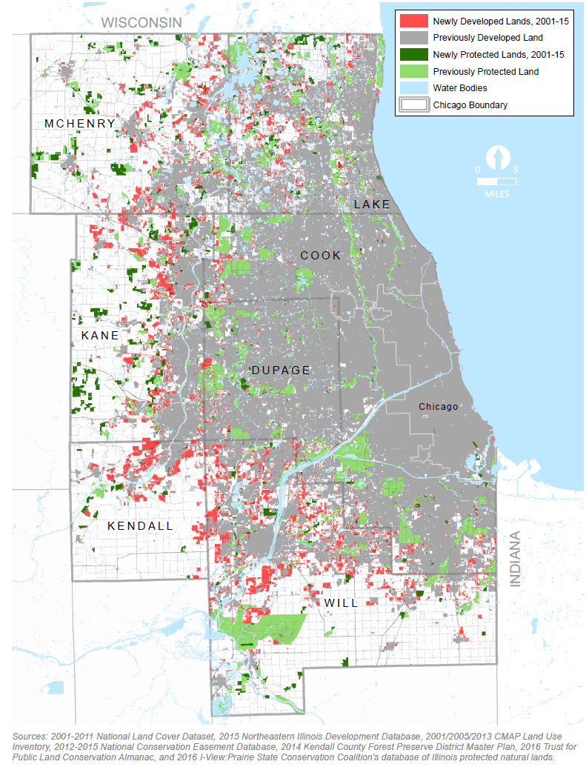

Between 2000 and 2015, the region developed 40,000 acres of natural areas and 100,000 acres of farmland. That represents 12 percent of the region’s overall development footprint and occurred during a time when employment remained flat, population increased by 4.6 percent, and many opportunities for infill development remained untapped. New development creates recurring expenses -- for streets, drinking water and wastewater services, and other necessities -- that can cause or exacerbate community struggles to maintain essential infrastructure and services. While development can add value to the region’s communities, it can also diminish natural resources by worsening habitat fragmentation, reducing core habitat size, and indirectly causing the spread of invasive plant and animal species. While the economic impact of 100,000 lost acres of agricultural lands in the region is not known, agricultural production requires a critical mass of farms and corresponding distribution and processing centers to remain viable.

[graphic – photos of new development with infrastructure]

ON TO 2050 reaffirms GO TO 2040’s recommendation to preserve the most important natural areas in the region, but our progress toward preserving key areas has been mixed. Despite its economic and cultural contributions, farmlands are often perceived as staging areas for future development and many economic assessments do not consider the role that agricultural production plays in the local economy. Similarly, natural areas are not widely called out for protection in local land use plans, and development review processes vary widely in how they identify and protect natural resources. From a land preservation perspective, 61,000 acres of land were protected between 2000 and 2015, marking a 22 percent increase and progress towards GO TO 2040 targets. Of the $1.15 billion used to protect natural lands, nearly 80 percent of funding came from open space referenda put forth by the region’s forest preserve and conservation districts -- a testament to how valuable conservation efforts are to local voters. However, funding for open space protection has dramatically dropped since the 2008 recession and state funding programs have been delayed or suspended. Funding for land protection and stewardship needs to be dramatically increased in order to reach regional goals. In coming years, stewardship funding is anticipated to become more critical as restoration efforts will need to respond to development, invasive species, and the changing climate.

[graphic – photos of preserved lands]

While agricultural and natural lands will likely continue to face challenges stemming from national and global forces such as climate change and market trends, development pressure is a significant challenge over which municipalities and counties have considerable influence. As the region is projected to add more than 1.9 million residents and 700,000 jobs by 2050, ON TO 2050 identifies communities with significant agricultural and natural assets in the Coordinated Growth Local Strategy Map. ON TO 2050 identifies strategies to minimize the potential negative effects of greenfield development with a goal of maintaining and enhancing the region’s agricultural systems and natural resources. New development on agricultural and natural lands should be located and designed in such a way to reduce impacts, maintain ecosystem functions and the local agricultural economy, build municipal financial health, and address other community goals.

[graphic – coordinated growth local strategy map, with conservation areas local strategy map also displayed.
Caption: ON TO 2050 continues to emphasize the importance of reinvesting in our existing communities and infrastructure. In recognition that some portions of Chicago region face greater greenfield development pressure, the Coordinated Growth Areas local strategy map identifies communities that have a significant amount of agricultural or natural lands within or adjacent to their boundaries. The local strategy map identifies locations where future land use plans and development ordinances should take into account larger scale open space protection, as shown in the conservation areas local strategy map, and long-term infrastructure costs associated with expansion decisions.]
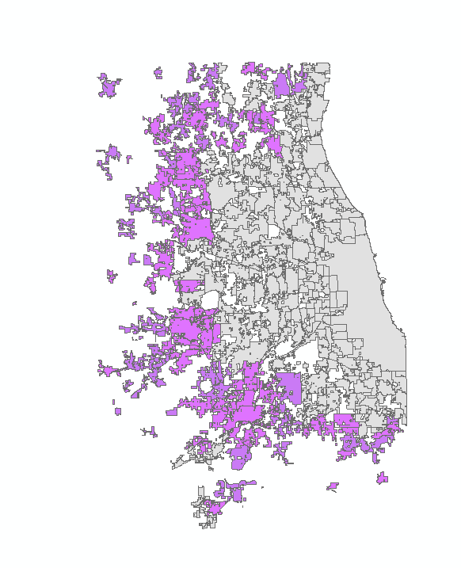

The following subsection outlines strategies and actions to implement this recommendation.

Identify high-priority natural areas and key agricultural lands
To effectively plan for and protect high-priority natural areas and key agricultural areas, it is first necessary to define where they exist. While the two types of areas differ significantly in form and function, each has particular needs and a distinct rationale for preservation. To date, far more analysis has made the case for natural areas. Many regional partners, including IDNR, county forest preserve and conservation districts, advocacy organizations, and local governments, produce strategic plans identifying high-priority natural assets for conservation. GO TO 2040 used the Green Infrastructure Vision (GIV), developed by a consensus-driven process and originally adopted in 2004, as a framework for preserving the most important core lands and corridors that form the basis of our regional green infrastructure network. Since GO TO 2040's adoption, CMAP has produced two new datasets to help communicate the importance of natural resources and prioritize land acquisition. GIV 2.3 represented an attempt to quantify ecosystem services provided by the region’s natural resources. For ON TO 2050, CMAP created the Conservation Areas Local Strategy Map, which builds on the GIV and uses updated data and county green infrastructure plans to identify regional priorities for conservation. This local strategy map provides a starting point for regional and local conservation partners to identify high-priority areas for land acquisition and assessment of development proposals. Regular updates of the conservation areas local strategy map will allow the dataset to reflect current conditions as well as new data on restoration and connectivity goals.

Achieving similar understanding of where important agricultural assets exist in the region would help facilitate farmland preservation and guide local and regional development and infrastructure investment decisions. As part of separate process to inform land use decision making, key agricultural lands should be identified using a methodology that reflects local conditions and goals. This assessment could include criteria related to the soil as well as the market and infrastructure conditions.

IDNR, counties, forest preserve and conservation districts, conservation organizations, land managers, and CMAP should collaborate to collect and share data needed to update the conservation areas local strategy map on a regular basis.
Counties, forest preserve and conservation districts, and municipalities should prepare and update green infrastructure plans to inform local priorities and provide inputs to the conservation areas local strategy map.
IDNR, CMAP, forest preserve and conservation districts, and conservation organizations should investigate criteria to define high-priority areas for restoration of natural resources within and between existing areas identified in the conservation areas local strategy map.
CMAP and partners such as Natural Resource Conservation Service (NRCS), local soil and water conservation districts, counties, the Illinois Farm Bureau and local chapters, Farm Illinois, and Openlands should work together to identify key agricultural lands and build consensus around those areas as regional priorities for preservation.

Plan for the protection of agricultural and natural lands
Recognizing that the region’s developed areas will continue to expand, ON TO 2050 recommends strategies to protect natural and agricultural assets in general as well as to ensure their fiscal stability. As the region’s population grows, valuable agricultural and natural resources will continue to face development pressure, particularly in locations within or adjacent to municipal boundaries, as highlighted in the Coordinated Growth Local Strategy Map. One way to signal the importance of agricultural and natural lands is to highlight these assets in local, county, and regional planning and development efforts. Including farmland and natural resources in plans encourages communities to reflect upon the lands' contributions to local and regional economies, ecosystems, and character. Kane and McHenry counties already identify extensive agricultural and natural lands in their future land use maps. While their plans acknowledge that anticipated population growth could result in the conversion of undeveloped land, much of the existing agricultural and natural land cover is anticipated to remain in its current use. These land use plans provide more targeted direction for new development in locations with or adjacent to existing infrastructure. For more information on infill and redevelopment strategies, see the Land Use chapter.

Updating development ordinances enables municipalities and counties to minimize the impact of new development on agricultural and natural resources. Municipal and county governments can use a number of different strategies, including agricultural and natural resource overlay zoning districts, modernized definitions and standards relating to agriculture and natural resources, updated protection measures within subdivision ordinances, and provisions for long-term stewardship of protected open space. This is particularly important in growing areas of the region, where development can have a significant negative effect. Likewise, including natural resources in transportation planning allows transportation agencies to avoid and mitigate impacts that could occur during construction and operation. Both the Conservation Areas local strategy map and the to-be-developed Key Agricultural Lands local strategy map will be valuable tools for better evaluating and planning for open space at the local and regional level.

Local governments should use the Conservation Areas local strategy map and the Key Agricultural Lands local strategy map, when available, to inform local planning and development efforts.
CMAP and counties should explore the types and value of ecosystem services provided by farmland, updating the ecosystem service valuation study for natural areas to help communicate the value of these resources to stakeholders.
CMAP and partners should quantify the agricultural system’s contribution to the regional and local economies to better inform local economic development strategies, land use planning, and transportation investments.
Local governments should consider the capacity of land and water resources to support growth in decisions about the intensity and extent of development.
CMAP should continue to evaluate regionally significant projects for their development impact on lands identified in the Conservation Areas local strategy map.

Fund preservation and stewardship of critical lands
While preservation decisions are often driven in part by opportunity, strategic frameworks like the Conservation Areas local strategy map and the future Key Agricultural Lands local strategy map can help maximize the benefits of land protection by coordinating efforts across jurisdictional boundaries to preserve large complexes of natural resources and connect them through greenways and along waterways. Local funding initiatives, such as local and county open space referenda, will likely continue to be the backbone of natural land protection and stewardship funding. While State and Federal funding has decreased in recent years, support via direct acquistion and management as well as providing funding assistance should be restored and increased. Similarly, a comprehensive farmland protection program with corresponding funding at the State level could provide needed resources to support local and county agriculture goals.

Additional funding will be needed for the region to achieve natural resources and farmland preservation goals. Innovative financing strategies -- such as public-private partnerships, transfer of development rights programs, water quality and stormwater volume control trading, greenhouse gas credit markets, and expanding the use of the State of Illinois Public Water Supply Loan Program for open space protection -- all offer promise to fund open space while also addressing other regional goals. For example, water quality trading programs can provide cost-effective solutions for wastewater treatment while also conserving valuable natural resources. The region should also explore creation of a regional fund for conservation open space, which could focus investments using a performance-based approach to most effectively and efficiently target conservation efforts to address local and regional priorities.

Forest preserve and conservation districts, municipalities, and counties should continue to raise essential funding through open space and agricultural easement referenda.
The State and federal governments, as well as philanthropic organizations, should continue to fund IDNR and land managers via OSLAD, NAAF, and other programs to acquire and maintain high-priority lands.
CMAP and partners should explore how innovative financing mechanisms, such as water resource trading, State Revolving Fund loan program, and transfer of development rights programs, could support open space protection efforts.
CMAP, forest preserve and conservation districts, and other conservation partners should explore the creation of a regional fund for conservation open space to focus investments on local and regional priorities.
Forest preserve and conservation districts, counties, and conservation organizations should work with landowners, land managers, and each other to establish large reserves that consist of mosaics of land uses oriented towards conservation, such as the Hackmatack National Wildlife Refuge, Liberty Prairie Reserve, and Prairie Parklands.
The State, forest preserve and conservation districts, and private philanthropy should work with land trusts to build their capacity, which will allow them to continue to engage and educate private landowners, accept more conservation easements of priority natural lands, and lead stewardship efforts.
The State should establish a comprehensive, statewide farmland protection policy, which could include an agricultural conservation easement program and provide counties with the authority to fund farmland protection programs through local referenda, potentially opening up access to federal funding.

Deploy sensitive development techniques in new development
While some loss of these resources is likely to occur, sensitive site-design techniques can help preserve natural resources while accommodating broader community goals for development. Conservation-oriented development clusters buildings on a development site to maintain larger agricultural or natural areas in perpetuity. By allowing flexibility in the lot and block layout and other design requirements, a similar number of housing units or amount of commercial square footage may be achieved while meeting agricultural preservation or habitat conservation objectives. The Chicago region has seen several conservation-oriented developments over the past 15 years, and numerous municipal and county subdivision ordinances now include or require such provisions for sites with significant natural resources. Even without clustering, developments can be designed to protect the existing natural resources and use them as inherent assets of the site.

In addition to using sensitive development techniques when development occurs in areas with natural and agricultural resources, growing communities should carefully weigh the long-term costs of maintaining and replacing infrastructure against the fiscal benefits of development. A lack of full-cost pricing and declining federal and state support have left many communities struggling to maintain infrastructure already in place. Regarding long-term financial health, communities can minimize their infrastructure maintenance costs by limiting expansion and building more compactly when they do extend roads and sewers to new locations. While some municipalities use development impact fees or fiscal impact analyses, these tools typically cover just the initial costs of service provision. For more information, see the “Municipalities should incorporate long-term infrastructure maintenance into development and expansion decisions” recommendation.

Local governments should adopt conservation-oriented development standards and avoid development on key natural areas.
Local governments should conduct detailed development site inventories and mitigate the natural resource impacts of development through actions such as protecting existing assets and conservation areas.
CMAP should investigate conservation design practices that work best with agricultural activities.
Local governments should review and revise development standards with attention to long-term maintenance costs.
Local governments should build on fiscal impact analyses to enact adequate taxes and fees to cover the cost of infrastructure and services over the lifespan of new development.
CMAP should explore ways to encourage development standards that minimize long term maintenance costs through existing transportation and infrastructure funding programs.

Chicago Metropolitan Agency for Planning, Green Infrastructure Vision Version 2.3 Ecosystem Service Valuation, 2014. https://datahub.cmap.illinois.gov/dataset/green-infrastructure-vision-2-3-ecosystem-valuation. This project explored ecosystem service values for six services within the CMAP 7-county region: water flow regulation/flood control, water purification, groundwater recharge, carbon storage, native flora and fauna, and recreation and ecotourism.
2014 National Climate Assessment, http://nca2014.globalchange.gov/report/sectors/transportation.
“ON TO 2050 Highway Operations Strategy Paper,” CMAP, http://www.cmap.illinois.gov/onto2050/strategy-papers/highway-operations
“ON TO 2050 Energy Strategy Paper,” CMAP, http://www.cmap.illinois.gov/onto2050/strategy-papers/energy
CMAP, November 2014, “Green Infrastructure Vision: Version 2.3 Ecosystem Service Valuation,” http://bit.ly/2fjk77S.
GO TO 2040, see “Manage and Conserve Energy and Water Resources”
Energy Efficiency for All, 2016. Lifting the high energy burden in America’s Largest Cities. http://energyefficiencyforall.org/resources/lifting-high-energy-burden-americas-largest-cities
United Nations, Climate Change Paris Agreement, December 2015 http://unfccc.int/paris_agreement/items/9485.php
https://www.epa.gov/energy-independence
U.S.Energy Information Administration, Annual Energy Outlook 2017. http://cmap.is/2snwnMk.
Ibid.
Center for Neighborhood Technology, “The Prevalence and Cost of Urban Flooding: A Case Study of Cook County, IL,” 2014, http://www.cnt.org/sites/default/files/publications/CNT_PrevalenceAndCostOfUrbanFlooding2014.pdf.
Federal Emergency Management Agency, “Make Your Business Resilient,” 2016, http://www.fema.gov/es/media-library/assets/images/116921.
Schwartz, H. G., M. Meyer, C. J. Burbank, M. Kuby, C. Oster, J. Posey, E. J. Russo, and A. Rypinski, 2014: Ch. 5: Transportation. Climate Change Impacts in the United States: The Third National Climate Assessment, J. M. Melillo, Terese (T.C.) Richmond, and G. W. Yohe, Eds., U.S. Global Change Research Program, 130-149. doi:10.7930/J06Q1V53. http://nca2014.globalchange.gov/report/sectors/transportation
Lowe, Dianne, Kristie L. Ebi, and Bertil Forsberg. “Factors Increasing Vulnerability to Health Effects before, during, and after Floods,” International Journal of Public Health, 2013. 10, 7015-7067; doi:10.3390/ijerph10127015.
Groisman, P.Y., Knight, R.W. & Karl, T.R., “Changes in intense precipitation over the central United States,” 2012, Journal of Hydrometerorology, 13, 47-66.
CMAP, Regional Flooding Susceptiblity Index, 2017, https://datahub.cmap.illinois.gov/dataset/on-to-2050-layer-flood-susceptibility-index
Groisman, P.Y., Knight, R.W. & Karl, T.R., “Changes in intense precipitation over the central United States,” 2012, Journal of Hydrometerorology, 13, 47-66.
“Stormwater and Flooding Strategy Paper,” Chicago Metropolitan Agency for Planning, page 25. http://www.cmap.illinois.gov/onto2050/strategy-papers/stormwater
“Vulnerabiltiy Assessment and Adaptation Framework, 3rd Edition,” U.S. Department of Transportation, Federal Highway Administration, FHWA-HEP-18-020, https://www.fhwa.dot.gov/environment/sustainability/resilience/adaptation_framework/
23 U.S.C. 135 (d)(I) and 23 CFR 450.306 (b)(9)
Memorandum of Agreement between the City of Chicago and the CMAP Council of Mayors regarding the distribution and active program management of locally programmed surface transportation block grant funds under the Fixing America’s Surface Transportation Act. October 11, 2017, http://www.cmap.illinois.gov/documents/10180/127961/2017+STP+Agreement.pdf/6b800a21-59fb-b538-a1c9-fa1342765355
http://www.glslcompactcouncil.org/Agreements.aspx
http://www.cmap.illinois.gov/documents/10180/653821/Water+Strategy+Paper_FINAL_+9-21-17.pdf/a54d17e1-a3fb-6bf7-1efb-f5515868ebeb
http://www.cmap.illinois.gov/documents/10180/653821/Water+Strategy+Paper_FINAL_+9-21-17.pdf/a54d17e1-a3fb-6bf7-1efb-f5515868ebeb
The Water Research Foundation defines integrated water resource management as “an integrated planning and implementation approach to managing finite water resoures for long-term resilience and reliability, meeting both community and ecosystem needs (Paulson, Broley, and Stephens 2017, 2), while the Water Environment and Reuse Foundation suggests the approach “considers the urban water cycle as a single integrated system, in which all urban water flows are recognized as potential resources, and the interconnectedness of water supply, groundwater, stormwater and wastewater is optimized, and their combined impact on flooding, water quality, wetlands, watercourses, estuaries and coastal waters is recognized” (Howe and Mukheibir 2015, 3.)
“American Planning Association Policy Guide on Water,” American Planning Association, July 2016, https://www.planning.org/policy/guides/adopted/water/.
“Water 2050: Northeastern Illinois Regional Water Supply/Demand Plan,” Chicago Metropolitan Agnecy for Planning, 2010, http://www.cmap.illinois.gov/programs/water/supply-planning/water-2050
Devin H. Mannix, Daniel B. Abrams, Daniel R. Hadley, George S. Roadcap, Walton R. Kelly, “Groundwater Availability in Northeastern Illinois from Deep Sandstone Aquifers,” Illinois State Water Survey Fact Sheet 2 from Contract Report 2015-02, https://www.isws.illinois.edu/gws/wsp/docs/FactSheet2_2015-02.pdf
2014 National Climate Assessment, Midwest, https://nca2014.globalchange.gov/highlights/regions/midwest
2014 National Climate Assessment, Water Supply, https://nca2014.globalchange.gov/highlights/report-findings/water-supply
“Water 2050: Northeastern Illinois Regional Water Supply/Demand Plan,” Chicago Metropolitan Agnecy for Planning, 2010, http://www.cmap.illinois.gov/programs/water/supply-planning/water-2050
“An Assessment of Water Loss among Lake Michigan Permittees in Illinois,” Chicago Metropolitan Agency for Planning, June 2014, http://www.cmap.illinois.gov/programs/water/supply-planning/loss
“An Assessment of Water Loss among Lake Michigan Permittees in Illinois,” Chicago Metropolitan Agency for Planning, June 2014, http://www.cmap.illinois.gov/programs/water/supply-planning/loss
The Chicago Regional Trees Initiative, http://chicagorti.org/interactivemap.
CMAP Integrating Green Infrastructure strategy paper, http://www.cmap.illinois.gov/onto2050/strategy-papers/green-infrastructure
Will Allen, Ted Weber, Jazmin Varela, CMAP Technical Committee, “Green Infrastructure Vision 2.3: Ecosystem Service Valuation,” The Conservation Fund, November 2014, http://cmap.is/1J5CicR.
“Integrating Green Infrastructure,” Chicago Metropolitan Agency for Planning, 2016, http://cmap.is/1qqq5K9.
“Conservation Almanac,” The Trust for Public Land, accessed October 15, 2016, http://cmap.is/2qLYAxK. The expenditure of $1.15 billion for the protection of open space occurred from 2001 to 2013.

